REVIEW OF DA HERDING RULES & REGS FOR HERDING TRIALS – 2023

First Page (Cover Page)

Rules and Regulations for HERDING TRIALS Effective 1 January 202 ………

(QLD) Proposed change First Page (Cover Page)
Rules and Regulations for HERDING TRIALS and TESTS Effective 1 January 202 ………

(QLD) Rationale First Page (Cover Page)

These Rules and Regulations cover both Dogs Australia Herding Trials and Tests, so ‘Tests’ should be part of the title of the publication.

CHAPTER 3 HERDING TESTS…….17 (Pages 2 to top of page 3)

Section 5. Instinct Test (Certificate only - not a Title) OPTIONAL 18
Section 6. Instinct Test Description and Test Elements 18
Section 7. Herding Test (HT) Title. Optional 20
Section 8. Herding Test Description and Test Elements 20
Section 9. Pre-Trial Test (PT) Title 23
Section 10 Pre-Trial Course Requirements (With and Without Boundary) 23
Section 11. Pre-Trial Test, Description and Test Elements 24

(QLD) Proposed change CHAPTER 3 HERDING TESTS…….17 (Pages 2 to top of page 3)

Section 5. Instinct Test (Certificate only - not a Title) OPTIONAL (With and Without Boundary) 18
Section 6. Instinct Test Description and Test Elements (With and Without Boundary) 18
Section 7. Herding Test (HT) Title. Optional (With and Without Boundary) 20
Section 8. Herding Test Description and Test Elements (With and Without Boundary) 20
Section 9. Pre-Trial Test (PT) Title. (With and Without Boundary) 23
Section 10 Pre-Trial Course Requirements (With and Without Boundary) 23
Section 11. Pre-Trial Test, Description and Test Elements (With and Without Boundary. 24

(QLD) Rationale CHAPTER 3 HERDING TESTS…….17 (Pages 2 to top of page 3)

Establishing With - and Without - Boundary options at all Test levels mirrors the structure already used at Trial level, giving tending breeds a fair, predictable pathway from first exposure through to competition. Recognising the heritage of boundary-style breeds helps preserve the traditional tending work they were developed for. This is on the condition that Boundary Tests for Instinct Test and Herding Test are accepted as on pages 8 and 17 to 22 of the 2023 Rules and Regulations.

Section 4. Making Application (Page 8)

1.4.7 Affiliates may or may not choose to offer Pre-Trial Test (Boundary Style). The schedule must state if Boundary Tests will be offered.

(QLD) Proposed change Section 4. Making Application (Page 8)

1.4.7 Affiliates may or may not choose to offer Instinct Test, Herding Test and Pre-Trial Test (Boundary Style Styles). The schedule must state if Boundary Tests will be offered.

(QLD) Rationale Section 4. Making Application (Page 8)

Allowing the Instinct (HIC) and Herding Test (HT) boundary option is essential to ensure tending breeds are assessed safely and appropriately in the style they were bred to perform. It closes the current gap at entry level and establishes a clear, progressive pathway from Herding Instinct Test through Herding Test and Pre-Trial Test to Course C, maintaining fairness and consistency in boundary-style assessment.

SECTION 12. Absences, Retirements, etc. (Page 10)
1.12.3 The Judge must remove any dog which after a period of 3 minutes fails to show productive work or is unable to move stock forward on the course of a Test or Trial.

(QLD) Proposed change 1.12.3 Page 10)
1.12.3 The Judge must remove any dog which after a period of 3 minutes fails to show productive work or is unable to move stock forward on the course of a Test or Trial. This does not apply to the B Course Advanced Shedding obstacle where more time may be necessary.

(QLD) Rationale 1.12.3 (Page 10)

Three minutes may be much too short a time for the shedding of stock in the Shedding Ring of B Course Advanced. As much time as needed should be allowed, up to the total of the 12 (twelve) minute time limit for the course.

SECTION 10. Livestock 2.10.14 (Page 16)
2.10.14 A minimum of 25 and a maximum of 100 sheep must be provided for each run on Course C.
On Course C, no single head of stock may be used more than 8 times in one day on courses up to 710 metres, or more than 6 times in one day on courses over 710 metres.
Larger flocks give the best opportunity for success. Sheep used for Course C must be physically conditioned to travelling the distance required at a trial. Clubs must ensure fitness of sheep.

(QLD) Proposed change SECTION 10. Livestock 2.10.14 (Page 16)
2.10.14 A minimum of 25 and a maximum of 100 sheep must be provided for each run on Course C.
On Course C, no single head of stock may be used more than 8 times in one day on courses up to 710 metres, or more than 6 times in one day on courses over 710 metres.
Larger flocks give the best opportunity for success. Sheep used for Course C must be physically conditioned to travelling the distance required at a trial. Clubs Affiliates must ensure fitness of sheep.
A minimum of 10 and a maximum of 25 sheep can be used for Instinct Certificate (HIC).
A minimum of 10 and a maximum of 25 sheep can be used for Herding Test (HT).
A minimum of 10 and a maximum of 25 sheep can be used for Pre-Trial Test (PT).

For the HIC and HT, there is no maximum times sheep may be used in a day.

For PT Boundary Test, the maximum number of times a head of stock may be used in a day is 15, with a minimum of a 15-minute break between runs.

(QLD) Rationale SECTION 10. Livestock 2.10.14 (Page 16)

- Boundary work relies on a stable, naturally flocking group so the dog can patrol and contain calmly; very small groups are flightier and more prone to fence‑sticking, which increases risk to sheep and dog. Setting larger minimums at HIC/HT levels produces more realistic tending conditions, reduces stress responses, and yields fairer, more reliable assessments of a dog’s boundary aptitude.

- There should be no reason to state a maximum number of times in a day that sheep can be used for HIC and HT Boundary Tests. The sheep are not actually being moved by the dog as they are contained within the boundary area and are able to eat or graze the whole time. Once the dog has completed its Test, it goes out of the arena, and another is brought in for its Test.

- For PT Boundary Test, the sheep are only walking up to a maximum of 100 metres per run.

- Breed and herding associations are known as ‘Affiliates’ under the Dogs Australia umbrella, not as ‘Clubs’.

CHAPTER 3 HERDING TESTS (Page 17)
3.1.3 Clubs may or may not choose to offer HT/PT boundary style. The schedule must state if boundary tests will be offered.

(QLD) Proposed change CHAPTER 3 HERDING TESTS (Page 17)
3.1.3 Clubs Affiliates may or may not choose to offer HIC/HT/PT boundary style. The schedule must state if boundary tests will be offered.

(QLD) Rationale CHAPTER 3 HERDING TESTS (Page 17)

- Allowing the Instinct (HIC) and Herding Test (HT) boundary option is essential to ensure tending breeds are assessed safely and appropriately in the style they were bred to perform. It closes the current gap at entry level and establishes a clear, progressive pathway from Herding Instinct Certificate through Herding Test and Pre-Trial Test to Course C, maintaining fairness and consistency in boundary-style assessment.

- Breed and herding associations are known as ‘Affiliates’ under the Dogs Australia umbrella, not as ‘Clubs’.

Section 2. Test Arena Conditions, Dimensions and Fencing (Page 17)

3.2.1 The arenas for all Test classes shall be fenced with adequate fencing, shall not contain any unsafe
conditions and shall be free of dangerous protrusions and materials.
3.2.2 The arena for Instinct Testing must be 9 metres by 9 metres up to 30 metres x 30 metres. An oval or
round arena is acceptable. Square corners must be rounded. Terrain for duck arena should be very
smooth and firm with only a slight slope.
3.2.3 The arena for a Herding Test must measure approximately 15 metres x 15 metres for ducks and no
less than 15 metres x 15 metres or greater than 30 metres x 30 metres for all other stock.
An oval or round arena is acceptable. Square corners must be rounded. Terrain for duck arenas should be very smooth and firm and with only a slight slope.

3.2.4 The arena for the Pre-Trial Test shall be approximately 15 metres x 30 metres for ducks. For all other stock, the minimum shall be approximately 30 metres x 60 metres and the maximum up to 60 metres x 120 metres. Corners need not be rounded.

(QLD) Proposed change Section 2. Test Arena Conditions, Dimensions and Fencing (Page 17)

Section 2a. Test Area (No Boundary) Requirements
3.2.1 The arenas for all Test classes shall be fenced with adequate fencing, shall not contain any unsafe
conditions and shall be free of dangerous protrusions and materials.
3.2.2 The arena for Instinct Testing must be 9 metres by 9 metres up to 30 metres x 30 metres. An oval or
round arena is acceptable. Square corners must be rounded. Terrain for duck arena should be very smooth and firm with only a slight slope.

3.2.3 The arena for a Herding Test must measure approximately 15 metres x 15 metres for ducks and no less than 15 metres x 15 metres or greater than 30 metres x 30 metres for all other stock.
An oval or round arena is acceptable. Square corners must be rounded. Terrain for duck arenas should be very smooth and firm and with only a slight slope.

3.2.4 The arena for the Pre-Trial Test shall be approximately 15 metres x 30 metres for ducks. For all other stock, the minimum shall be approximately 30 metres x 60 metres and the maximum up to 60 metres x 120 metres. Corners need not be rounded.

Section 2b Test Area (With Boundary) Requirements

3.2.5 The arenas for all Test classes shall be fenced with adequate fencing, shall not contain any unsafe conditions and shall be free of dangerous protrusions and materials.
The arena for Instinct Testing must be 1-sided border and be a minimum of 15m and a maximum of 50m long border and with approximately 4 metres of narrow road, A narrow road approximately 4 metres wide must run directly in front of this boundary to allow the dog to demonstrate tending behaviour.

The dog is permitted to follow the boundary around either corner at the end of the straight boundary (i.e. a “1-sided border”).
The arena for a Herding Test shall provide a three-sided graze area measuring a minimum of 15 metres by 15 metres and not exceeding 15 metres by 30 metres.
The arena for the Pre-Trial Test shall be approximately 30 metres x 60 metres and for the 3-sided graze area is a minimum of 15m X 15m and a maximum of 15m x 30m. Corners are not rounded.

(QLD) Rationale Section 2. Test Arena Conditions, Dimensions and Fencing (Page 17)

- One-Sided Border in Instinct Testing – A one-sided border in the Instinct Test reflects the traditional
work of boundary-style breeds, allowing assessment of their natural edge-tending behaviour in line
with recognised breed heritage.
- Three-Sided Graze for Herding Test – A three-sided graze in the Herding Test reflects the historical
role of boundary breeds in managing multiple edges and provides a heritage-aligned progression
toward Pre-Trial requirements.
- Pre-Trial Test for Herding Test – Clarifying the Pre-Trial dimensions maintains consistency with
traditional tending work and provides judges with a clear basis for assessing heritage-appropriate boundary skills.

- We are suggesting that, for the Three-Sided Graze for the Herding Test that the Graze area inside the Pre-Trial Test could be used. It would be of ideal size and the dog can patrol along the three sides of the Graze area.

Section 4. Qualifications (Page 18)
3.4.3 In Herding Tests and Pre-Trial Tests, dogs must demonstrate the ability to move and control livestock
by fetching or driving and be sufficiently trained to work at the proper balance point to move the stock forward on the course. Dogs that constantly prevent the stock from being moved in a controlled fashion, or that chase or harass the stock, will not qualify.

(QLD) Proposed change Section 4. Qualifications (Page 18)
3.4.3 In Herding Tests and Pre-Trial (Non-Boundary) Tests, dogs must demonstrate the ability to move and
control livestock by fetching or driving and be sufficiently trained to work at the proper balance point to move the stock forward on the course. Dogs that constantly prevent the stock from being moved in a controlled fashion, or that chase or harass the stock, will not qualify.

With Boundary Herding Tests and Pre Trial (Boundary) Tests, dogs must demonstrate the ability to tend and control livestock and be sufficiently trained to maintain and work along a defined boundary.

(QLD) Rationale Section 4. Qualifications 3.4.3 (Page 18)

- Explicit recognition of tending separates it from fetching/driving so boundary dogs are not penalized for performing their correct function.

- Judging then focuses on maintaining a defined border and permitting grazing, which will produce the outcomes that protect stock and reflect the historical role of these breeds.

Section 6. INSTINCT TEST (Optional) DESCRIPTION AND TEST ELEMENTS (Page 18)
3.6.1 Judging and timing commence when the handler and dog enter the ring. Time allowed is five (5)
minutes with no minimum time for completion.
The dog is brought into the arena containing the livestock on a long line, approximately 2-5 metres in length.
At some point while on the long line, the dog must demonstrate a stop (down, sit or stand) and a call to handler before the long line is dropped or removed.
A dog which cannot be recalled shall not be let off the long line and will not qualify.
The dog should show sustained interest in the stock for the majority of the time it is in the arena. Dogs must be immediately removed from the ring if physical force is necessary to protect the stock from the dog.

3.6.2. A dog, which cannot be called off the stock, shall not be let off the long line and will not qualify. Dogs must be immediately removed from the ring if physical force is necessary to protect stock from the dog.

3.6.3. To end the Test, the Judge will ask the Handler to call their dog off the stock. The dog is to be leashed if it is off the long line. The test ends at the Judges adjudication with testing and timing to cease once the dog is leashed.
A dog which does not return to its handler or cannot be caught will not qualify.

(QLD) Proposed change INSTINCT TEST (Optional) DESCRIPTION AND TEST ELEMENTS (Page 18)

Section 6. INSTINCT TEST (Optional) DESCRIPTION AND TEST ELEMENTS (WITHOUT BOUNDARY) (Page 18)
3.6.1 Judging and timing commence when the handler and dog enter the ring. Time allowed is five (5) minutes with no minimum time for completion.
The dog is brought into the arena containing the livestock on a long line, approximately 2-5 metres in length.
At some point while on the long line, the dog must demonstrate a stop (down, sit or stand) and a call to handler before the long line is dropped or removed.
A dog which cannot be recalled shall not be let off the long line and will not qualify.
The dog should show sustained interest in the stock for the majority of the time it is in the arena. Dogs must be immediately removed from the ring if physical force is necessary to protect the stock from the dog.
3.6.2. A dog, which cannot be called off the stock, shall not be let off the long line and will not qualify. Dogs must be immediately removed from the ring if physical force is necessary to protect stock from the dog.

3.6.3. To end the Test, the Judge will ask the Handler to call their dog off the stock. The dog is to be leashed if it is off the long line. The test ends at the Judges adjudication with testing and timing to cease once the dog is leashed.
A dog which does not return to its handler or cannot be caught will not qualify.
Section 6. INSTINCT TEST (Optional) DESCRIPTION AND TEST ELEMENTS (WITH BOUNDARY) (Page 18)

3.6.4 Judging and timing commence when the handler and dog enter the ring. Time allowed is five (5) minutes with no minimum time for completion.
The dog is brought into the arena containing the livestock on a long line, approximately 2-5 metres in length and may walk the one-sided border on lead prior to commencing the Test.
At some point while on the long line, the dog must demonstrate a stop (down, sit or stand) and a call to handler before the long line is dropped or removed.
A dog which cannot be recalled shall not be let off the long line and will not qualify.
The dog should show sustained interest in stock for the majority of the time while on a 1-sided border.
Dogs must be immediately removed from the ring if physical force is necessary to protect the stock from the dog.

3.6.5 To end the Test, the Judge will ask the Handler to call their dog off the stock. The dog is to be leashed if it is off the long line. The test ends at the Judges adjudication with testing and timing to cease once the dog is leashed.
A dog which does not return to its handler or cannot be caught will not qualify.

(QLD) Rationale Section 6. INSTINCT TEST (Optional) DESCRIPTION AND TEST ELEMENTS (Page 18)

- Introducing a boundary-style Instinct Test provides the fundamental first step in teaching tending breeds the concept of a border. This reflects the traditional boundary work expected of these breeds, provides a clear structure for assessing heritage-based boundary behaviours, and establishes the correct progression toward the Herding Test, Pre-Trial Test, and ultimately Course C trialling.

- With the present HIC (without Boundary), the maximum time allowed is five (5) minutes, with no minimum time, at the discretion of the judge, provided the dog shows sustained interest in the stock for the majority of the time. We are suggesting that the identical criteria be used for judging the HIC (with Boundary).

INSTINCT TEST – (Diagram on Page 19.)

Time Allowed: 5 minutes

Course Size: Sheep and Cattle Minimum 9m x 9m
Maximum 30m x 30m
Ducks Approx. 9m x 9m

Note: Moderated corners on all Instinct Test arenas

(QLD) Proposed change INSTINCT TEST (Without Boundary) – (Diagram on Page 19.)

Time Allowed: 5 minutes

Course Size: Sheep and Cattle Minimum 9m x 9m
Maximum 30m x 30m
Ducks Approx. 9m x 9m

Note: Moderated corners on all Instinct Test arenas

INSTINCT TEST (With Boundary) – (Diagram on Page 19.)

Time Allowed: 5 minutes

Course Size: Sheep and Cattle Minimum 9m x 9m
Maximum 30m x 30m
Ducks Approx. 9m x 9m

Note: Moderated corners on all Instinct Test arenas

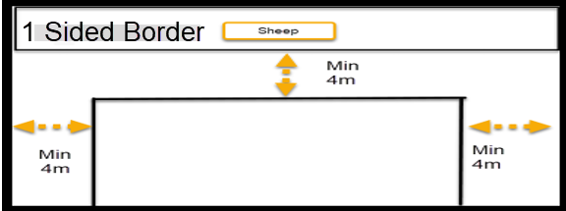

(QLD) Rationale INSTINCT TEST – (Diagram on Page 19.)

- Only sheep are used as stock for C Course, so ducks and cattle are deleted from this INSTINCT TEST (With Boundary) diagram. (See Rule 7.1.2 under CHAPTER 7. C COURSE, page 60).

- The above Instinct Test diagram is self-explanatory.

- Providing both Without-Boundary and With-Boundary Instinct options ensures tending breeds can be assessed safely and fairly in the style they were bred to perform. The defined 15–50m one-sided border and minimum 4m road allow judges to evaluate true boundary behaviour that cannot be demonstrated in a rounded working arena, while maintaining consistent dimensions that support clear progression into PT and C-Course work.

- We are suggesting that, for the Three-Sided Graze for the Herding Test that the Graze area inside the Pre-Trial Test could be used. It would be of ideal size and the dog can patrol along the three sides of the Graze area.

Section 8. Herding Test Description and Test Elements (Page 20)
3.8.1 Two pylons or similar markers are placed on the (longer) centreline of fenced arena approximately 3 metres in from the fences at opposite ends of the arena. When there are entries that wish to be tested in boundary style, a boundary line will be placed at approximately 4 meters in from the side, and across the arena.

3.8.2 Time allowed is ten (10) minutes with no minimum time for completion. A dog must complete all Test elements within the allotted ten (10) minutes to qualify.
3.8.3 The handler will enter the arena with the dog on lead and, with the Judge, will move to a position appropriate for the start of the Test.
The Judge establishes that the dog is under control. When the Judge determines that the dog is under control, the Test may begin.
The handler is instructed to place the dog in a sit, stand or down/stay position and remove the lead.

3.8.4 Testing and time commence when the lead is removed. The dog must demonstrate a controlled pause (stay in position until released or sent). Once the lead is removed, the handler may assume a position away from the dog and appropriate in relation to the stock, but the dog must remain in position.
The judge then signals or instructs the handler to send the dog.

A dog that ‘breaks the stay’ shall not fail for that reason alone.

3.8.5 During the Test, the Judge should be positioned so as, to observe the dog and provide verbal
assistance but shall not interfere with the movement of the stock, handler or dog unless as necessary to remove the dog from the arena.

3.8.6 The dog must be under control and demonstrate controlled movement of the stock from the first pylon to the second pylon, turn the stock at or near the second pylon, and move the stock back to the first pylon, where they are again turned (at or near the pylon) and moved back to the second pylon.
At the handler's option, the dog may work the stock across the open arena or along the fence line. After completing the controlled movement of the stock between the pylons, the dog is required to demonstrate a stop followed by a call to handler.
The call to handler should not be in a direct line with the stock, but away from the position of the stock.
The Judge indicates completion of the Test, timing ceases, and the handler leashes the dog and leaves the arena.

(QLD) Proposed change Section 8. Herding Test Description and Test Elements (Page 20)
Section 8. Herding Test Description and Test Elements (Without Boundary Requirements)
3.8.1 Two pylons or similar markers are placed on the (longer) centreline of fenced arena approximately 3
metres in from the fences at opposite ends of the arena. When there are entries that wish to be tested in boundary style, a boundary line will be placed at approximately 4 meters in from the side, and across the arena.

3.8.2 Time allowed is ten (10) minutes with no minimum time for completion. A dog must complete all Test elements within the allotted ten (10) minutes to qualify.

3.8.3 The handler will enter the arena with the dog on lead and, with the Judge, will move to a position appropriate for the start of the Test.
The Judge establishes that the dog is under control. When the Judge determines that the dog is under control, the Test may begin.
The handler is instructed to place the dog in a sit, stand or down/stay position and remove the lead.

3.8.4 Testing and time commence when the lead is removed. The dog must demonstrate a controlled pause (stay in position until released or sent). Once the lead is removed, the handler may assume a position away from the dog and appropriate in relation to the stock, but the dog must remain in position.
The judge then signals or instructs the handler to send the dog.

A dog that ‘breaks the stay’ shall not fail for that reason alone.

3.8.5 During the Test, the Judge should be positioned so as, to observe the dog and provide verbal assistance but shall not interfere with the movement of the stock, handler or dog unless as necessary to remove the dog from the arena.

3.8.6 The dog must be under control and demonstrate controlled movement of the stock from the first pylon to the second pylon, turn the stock at or near the second pylon, and move the stock back to the first pylon, where they are again turned (at or near the pylon) and moved back to the second pylon.
At the handler's option, the dog may work the stock across the open arena or along the fence line. After completing the controlled movement of the stock between the pylons, the dog is required to demonstrate a stop followed by a call to handler.
The call to handler should not be in a direct line with the stock, but away from the position of the stock.
The Judge indicates completion of the Test, timing ceases, and the handler leashes the dog and leaves the arena.

Section 8a Herding Test Description and Test Elements (With Boundary Requirements)

3.8.6a When there are entries that wish to be tested in Boundary Style, a 3-sided graze is to be used.
Time allowed is ten (10) minutes with no minimum time for completion. A dog must complete all Test elements within the allotted ten (10) minutes to qualify. The two corners should be marked by a cone on each corner.
The handler shall enter the arena with the dog on lead and may walk the three-sided border on lead prior to commencing the Test. The Judge shall position themselves appropriately within the three-sided graze for the start of the Test only if required.
The Judge establishes that the dog is under control. When the Judge determines that the dog is under control, the Test may begin. The handler is instructed to place the dog in a sit, stand or down/stay position on the border and remove the lead.
Testing and time commence when the lead is removed. The dog must demonstrate a controlled pause (stay in position until released or sent). Once the lead is removed, the handler may assume a position inside the graze away from the dog and appropriate in relation to the stock, but the dog must remain in position.
The judge then signals or instructs the handler to work the dog. A dog that ‘breaks the stay’ shall not fail for that reason alone.
During the Test, the Judge should be positioned to observe the dog and provide verbal assistance but shall not interfere with the movement of the stock, handler or dog unless as necessary to remove the dog from the arena.
The dog contains the sheep inside the 3-sided graze for four (4) minutes and should demonstrate the ability to work along the border and not be in a static position or balancing to the handler. After completing the controlled border work the dog is required to demonstrate a stop followed by a call to handler outside of the 3-sided graze.
The call to handler should not be in a direct line with the stock, but away from the position of the stock.
The Judge indicates completion of the Test, timing ceases, and the handler leashes the dog and leaves the arena.

(QLD) Rationale Section 8. Herding Test Description and Test Elements (Page 20)

- A 3-sided graze reflects the traditional boundary work of tending breeds, provides a clear structure for assessing heritage-based boundary behaviours, establishes the correct progression toward Pre-Trial requirements, and by distinguishing With Boundary and Without Boundary tests ensures clarity for judges and fairness for all breeds.

- We have shown this proposed amendment as Rule 3.8.6a. However, this whole amendment could be put after Rule 3.8.9 on Page 21, so making it Rule 3.8.10. If so, it could be broken down to sub-rules, such as 3.8.10, 3.8.11, 3.8.12, etc.

- The time for the HT graze should be defined as four (4) minutes as this is the natural progression from this Test to the PT which also has a graze time of four (4) minutes but then adds the ‘narrow road’ work to the Test.

- We are suggesting that, for the Three-Sided Graze for the Herding Test that the Graze area inside the Pre-Trial Test could be used. It would be of ideal size and the dog can patrol along the three sides of the Graze area.

Section 8. Herding Test Description and Test Elements (Page 21)

3.8.7 The five elements of the Test, which must be executed, are:
1. A controlled pause or stop at the beginning
2 Two (2) changes in direction at or near the pylons
3. Controlled movement of the stock
4. A stop
5. Followed by a ‘call to handler’ at the conclusion of the run

(QLD) Proposed change Section 8. Herding Test Description and Test Elements (Page 21)

3.8.7 7A The five elements of the Test, which must be executed, are:
1. A controlled pause or stop at the beginning
2. Two (2) changes in direction at or near the pylons
3. Controlled movement of the stock
4. A stop
5. Followed by a ‘call to handler’ at the conclusion of the run
3.8.7B The five four elements of the Boundary Herding Test which must be executed are:
- A controlled pause or stop at the beginning
- Containing the sheep in the graze
- A stop
- Followed by a ‘call to handler’ at the conclusion of the run

QLD Rationale Section 8. Herding Test Description and Test Elements (Page 21)

Separating the standard and boundary elements ensures that heritage-based tending behaviours can be assessed accurately. The boundary list reflects the traditional work of boundary-style breeds, where maintaining borders, containing stock, and disengaging calmly from the boundary were core functions. This distinction provides judges with a clear framework for evaluating these inherited skills independently of standard test elements. As the sheep are not required to move, the third point becomes redundant.

HERDING TEST (Page 22)

Time Allowed: 10 minutes Note: Moderated corners on all Herding Test arenas

Course Size: Sheep and Cattle Minimum 15m x 15m
Maximum 30m x 30m
Ducks Approx. 9m x 9m

(QLD) Proposed change HERDING TEST – (Without Boundary) (Page 22)

Time Allowed: 10 minutes Note: Moderated corners on all Herding Test arenas

Course Size: Sheep and Cattle Minimum 15m x 15m
Maximum 30m x 30m
Ducks Approx. 15m x 15m

HERDING TEST – (With Boundary)

Time Allowed: 10 minutes Note: Moderated corners on all Herding Test arenas

Course Size: Sheep and Cattle Minimum 30m x 60m
Maximum 60m x 120m
Ducks Approx. 15m x 15m

Cones are to be placed at the two corners of the graze.

The stock and two pylons should be removed from this diagram.

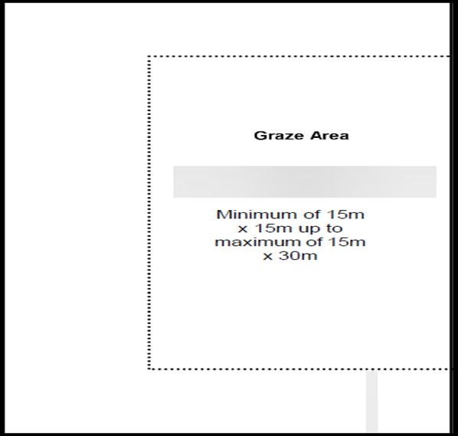

(QLD) Rationale HERDING TEST – (Diagram on Page 22.)

- Only sheep are used as stock for C Course, so ducks and cattle are deleted from this HERDING TEST (With Boundary) diagram. (See Rule 7.1.2 under CHAPTER 7. C COURSE, page 60).

- The above Instinct Test diagram is self-explanatory.

- Providing both Without-Boundary and With-Boundary options at Herding Test level allows tending breeds to be assessed in a manner consistent with their traditional boundary work. The defined graze-area dimensions ensure consistent judging and create a clear progression from Instinct level into PT and C-Course tending requirements.

- The stock and pylons shown in the above Instinct Test (with boundary) diagram should be removed (as shown).

- We are suggesting that, for the Three-Sided Graze for the Herding Test that the Graze area inside the Pre-Trial Test could be used. It would be of ideal size and the dog can patrol along the three sides of the Graze area.

Section 10b Pre-Trial Course (With Boundary) Requirements (Page 23.)

3.10.4 A 2 metre to 4 metre free swinging reopen gate is recommended.

3.10.5 Two panels are placed on the far (narrow) end of the arena opposite the pen, one placed on each side of the arena. The panels are placed parallel to and approximately 8 metres in from the back (narrow) wall. The panel edges must be approximately 4 metres in from the sidewalls, forming 4 metre "gates" or openings between the panel edges and the long wall on each side of the arena.

3.10.6 Depending upon the configuration of the arena, the graze area should be a minimum of 15 metres x
15 metres and not exceed approximately 15 metres x 30 metres and is set up along the long wall on the same side of the arena as the second of two gates.
The graze area must be marked with a visible and tactile material, so it is readily discernible to the dog, handler, and judge.

(QLD) Proposed change Section 10b Pre-Trial Course (With Boundary) Requirements (Page 23.)

3.10.4 A 2 metre to 4 metre free swinging reopen gate is recommended.

3.10.5 Two panels are Cones can be placed on the far (narrow) end at the two corners of the 3-sided graze.
3.10.6 Depending upon the configuration of the arena opposite the pen, one placed on each side, the graze
area should be a minimum of the arena. 15 metres x 15 metres and not exceed approximately 15 metres x 30 metres and is set up along the long wall.
The panels are placed parallel graze area must be marked with a visible and tactile material, so it is readily discernible to and approximately 8 metres the dog, handler, and judge. If there is no/little forage in from the back (narrow) wall. The panel edges must be approximately 4 metres in from the sidewalls, forming 4 metre "gates" or openings between the panel edges and the long wall on each side of the arena.
3.10.6 Depending upon the configuration of the arena, the graze area should be a minimum of 15 metres x 15 metres and not exceed approximately 15 metres x 30 metres and is set up along the long wall on the same side of the arena as the second of two gates.
The graze area must be marked the graze, seeding the graze with a visible and tactile material, so it is readily discernible to the dog, handler, and judge. hay may be permitted.

(QLD) Rationale Section 10b Pre-Trial Course (With Boundary) Requirements (Page 23.)

Cones provide clear definition of the three-sided graze boundaries corners and gate work used in Without-Boundary courses is not required in any With-Boundary Test or C-Course Trials, where the assessment focuses on maintaining borders rather than driving stock through gates.

Section 11. Pre-Trial Test, Description and Test Elements (Pages 24 to 25)

3.11.1 Time allowed is ten (10) minutes once the lead is removed with no minimum time for completion. A
dog must complete all Test elements within the allotted ten (10) minutes to qualify.

3.11.2 A dog is not required to work in a particular style of Herding according to its breed. The entry form must be marked "Boundary" if the handler wishes the dog to be tested in a boundary situation.

3.11.3 A handler may not excessively touch or correct the dog once the stock begins moving. The dog must respond in a reasonably prompt manner without threatening actions or movements by the handler.

3.11.4 A minimum of 10 sheep may be used for Boundary Tests. Other stock requirements are as stated in Chapter 2, Section 10 of these Regulations.

3.11.5 The Judge must observe the handler and the dog and may not physically assist the handler and/or the dog in controlling the livestock. The Judge may advise the handler on how best to encourage the dog to move the stock and how to manoeuvre around the course. The dog should be permitted to work the stock as much as possible with a minimum of commands by the handler.

3.11.6 The same procedures and general positions assumed by the Judge and handler for starting the Herding Test apply to the Pre-Trial course. Stock should be freestanding at the top of the arena.

3.11.7 When a dog is being tested in the boundary, the stock is held within the graze at the commencement of the test.

3.11.8 The dog will enter the arena on lead. The judge instructs the handler when to remove the lead. Testing and timing commence when the lead is removed. The dog must demonstrate a controlled pause (stay in position until released or sent). Once the lead is removed the handler may assume a position away from the dog and in relation to the stock, but the dog must remain in position. The judge then signals or instructs the handler to send the dog. A dog that “breaks the stay” shall be asked to demonstrate a stay or controlled pause at the beginning of the test in order demonstrate control.

3.11.9 If the dog is being tested on the boundary, the dog will contain stock within the graze for four minutes before exiting the graze to move the stock through both gates to the pen. The handler may take any position relative to the stock and dog throughout the course. If there is no/little forage in the graze, seeding the graze with hay may be permitted. The boundaries must be clearly discernible. The dog should show clear tending abilities and demonstrate understanding of working a border, i.e. the dog should not just be put into a long down or sit to ‘hold’ the stock within the graze area.

3.11.10 The dog must be under control and move the stock under control, either on or off the fence, throughout the course. The dog will move the stock through the first gate at the side of the arena, across the narrow end of the arena through the second gate.
Direction is reversed at approximately the midpoint of the long side of the arena. The stock moves back through the second gate, across the narrow end, through the first gate and to the pen. While the handler opens the gate the dog will sit, stand or down/stay until commanded to pen the stock.
The dog should be positioned to allow the stock to settle off the pen and not be habitually moving the stock while the gate is being opened.

Four gate passes are required and at some point, on the course that handler must demonstrate that the dog can hold a stop (controlled pause).
The Test is completed, and timing ceases when the gate to the pen is closed.

(QLD) Proposed change (Pages 24 to 25)

Section 11. Pre-Trial Test, Description and Test Elements (pages 24 to 25)
Section 11a Pre-Trial Test Description and Test Elements (Without Boundary)
3.11.1 Time allowed is ten (10) minutes once the lead is removed with no minimum time for completion. A
dog must complete all Test elements within the allotted ten (10) minutes to qualify.

3.11.2 A dog is not required to work in a particular style of Herding according to its breed. The entry form
must be marked "Boundary" if the handler wishes the dog to be tested in a boundary situation.
3.11.3 A handler may not excessively touch or correct the dog once the stock begins moving. The dog must
respond in a reasonably prompt manner without threatening actions or movements by the handler.
3.11.4 A minimum of 10 sheep may be used for Boundary Tests. Other All stock requirements are as stated
in Chapter 2, Section 10 of these Regulations.
3.11.5 The Judge must observe the handler and the dog and may not physically assist the handler and/or
the dog in controlling the livestock. The Judge may advise the handler on how best to encourage the dog to move the stock and how to manoeuvre around the course. The dog should be permitted to work the stock as much as possible with a minimum of commands by the handler.
3.11.6 The same procedures and general positions assumed by the Judge and handler for starting the
Herding Test apply to the Pre-Trial course. Stock should be freestanding at the top of the arena.
3.11.7 When The dog will enter the arena on lead. The judge instructs the handler when to remove the lead.
Testing and timing commence when the lead is removed. The dog must demonstrate a dog controlled
pause (stay in position until released or sent). Once the lead is being tested removed the handler
may assume a position away from the dog and in the boundary relation to the stock, the stock is held
within the graze but the dog must remain in position. The judge then signals or instructs the handler
to send the dog. A dog that “breaks the stay” shall be asked to demonstrate a stay or controlled
pause at the commencement beginning of the test in order demonstrate control.
3.11.8 The dog must be under control and move the stock under control, either on or off the fence,
throughout the course. The dog will move the stock through the first gate at the side of the arena,
across the narrow end of the arena through the second gate.
Direction is reversed at approximately the midpoint of the long side of the arena. The stock moves back through the second gate, across the narrow end, through the first gate and to the pen. While the handler opens the gate the dog will sit, stand or down/stay until commanded to pen the stock.
The dog should be positioned to allow the stock to settle off the pen and not be habitually moving the stock while the gate is being opened.
Four gate passes are required and at some point on the course that handler must demonstrate that the dog can hold a stop (controlled pause).
The Test is completed and timing ceases when the gate to the pen is closed.

Section 11b Pre-Trial Test, Description and Test Elements (With Boundary)
3.11.9 Time allowed is ten (10) minutes once the lead is removed with no minimum time for
completion. A dog must complete all Test elements within the allotted ten (10) minutes to qualify.
A dog is not required to work in a particular style of Herding according to its breed. The entry form must be marked "Boundary" if the handler wishes the dog to be tested in a boundary situation.
A handler may not excessively touch or correct the dog once the stock begins moving. The dog must respond in a reasonably prompt manner without threatening actions or movements by the handler.
A minimum of 10 sheep may be used for Boundary Tests. Other stock requirements are as stated in Chapter 2, Section 10 of these Regulations.

Ducks and cattle are not used for ‘Tending’ Tests.
The Judge must observe the handler and the dog and may not physically assist the handler and/or the dog in controlling the livestock. The Judge may advise the handler on how best to encourage the dog to move the stock and how to manoeuvre around the course. The dog should be permitted to work the stock as much as possible with a minimum of commands by the handler.
The same procedures and general positions assumed by the Judge and handler for starting the Herding Test apply to the Pre-Trial course.
3.11.10 The stock is held within the graze at the commencement of the test.

The handler shall enter the arena with the dog on lead . and may walk the three-sided border on lead prior to commencing the Test. The handler is instructed to place the dog in a sit, stand or down/stay position on the border.
The judge instructs the handler when to remove the lead. Testing and timing commence when the lead is removed. The dog must demonstrate a controlled pause (stay in position until released or sent). Once the lead is removed, the handler may assume a position inside the graze away from the dog and appropriate in relation to the stock, but the dog must remain in position.
The judge then signals or instructs the handler to send work the dog. A dog that “breaks the stay” shall be asked to demonstrate a stay or controlled pause at the beginning of the test in order demonstrate control.

3.11.9 If the The dog will contain the stock within the graze for four minutes before moving the stock from the graze within the 4 metre borders to the pen. The dog is being tested allowed inside the graze at the conclusion of the allotted 4 minutes if the sheep will not exit the graze. At some point on the boundary course the handler must demonstrate that the dog can hold a stop (controlled pause). the dog will contain This could be done while sheep were exiting the graze.
The handler may take any position relative to the stock within the graze for four minutes before exiting the graze to move the stock through both gates to the pen. The handler may take any position relative to the stock and dog throughout the course. If there is no/little forage in the graze, seeding the graze with hay may be permitted. The boundaries must be clearly discernible. The dog should show clear tending abilities and demonstrate understanding of working a border, i.e. the dog should not just be put into a long down or sit to ‘hold’ the stock within the graze area.

3.11.10 The dog must be under control and move the stock under control, either on or off the fence,
throughout the course. The dog will move the stock through the first gate at the side of the arena,
across the narrow end of the arena through the second gate.
Direction is reversed at approximately the midpoint of the long side of the arena. The stock moves back through the second gate, across the narrow end, through the first gate and to the pen. While the handler opens the gate the dog will sit, stand or down/stay until commanded to on the border. The dog should be positioned to allow the stock to settle near the pen and not be habitually moving the stock while the gate is being opened.
The Test is completed and timing ceases when the gate to the pen, and not be habitually moving the stock while the gate is being opened.
Four gate passes are required and at some point on the course that handler must demonstrate that the dog can hold a stop (controlled pause).
The Test is completed and timing ceases when the gate to the pen is closed.

(QLD) Rationale Section 11. Pre-Trial Test, Description and Test Elements (pages 24 to 25)

- Separating the standard and boundary elements ensures that heritage-based tending behaviours can be assessed accurately. This distinction provides judges with a clear framework for evaluating these inherited skills independently of standard test elements.

- Allowing the dog to enter the graze after the allotted time prevents penalising normal stock hesitation and ensures the Pre-Trial Test reflects realistic boundary-style tending behaviour.

- Only sheep are used as stock for C Course, so ducks and cattle are deleted from this PRE-TRIAL TEST (With Boundary) description. (See Rule 7.1.2 under CHAPTER 7. C COURSE, page 60).

SECTION 11. Pre-Trial Test, Descriptions and Test Elements (Page 25)
3.11.11 The five elements of the test which must be executed, are:
1. A stay (a controlled pause)
2. Controlled passage of the stock (which includes clearing four gates and a change of direction)
3. One stop on the course
4. One stop while the handler opens the pen gate
5. Penning the stock.

The five elements of the Boundary Test which must be executed are:
- A stay (controlled pause)
- Containing the stock in the graze for four minutes
- Controlled passage of stock (which included clearing two gates)
- One stop while the handler opens the pen gate
- Penning the stock

(QLD) Proposed change 3.11.11 (Page 25)
3.11.11 The five six elements of the test which must be executed, are:
1. A stay (a controlled pause)
- Controlled passage of the stock (which includes clearing four gates and a change of direction)
3. Change of direction
4. One stop on the course
5. One stop while the handler opens the pen gate
6. Penning the stock.

The five six elements of the Boundary Test which must be executed are:

- A stay (controlled pause)
- Containing the stock in the graze for four minutes
- One stop on the course
- Controlled passage of stock (which included clearing two gates)
- One stop while the handler opens the pen gate
- Penning the stock

(QLD) Rationale 3.11.11 (Page 25)

- These present rules show the five elements of the Pre-Trial Test listed. However, the Pre-Trial Test Official Judge’s Evaluation Form (Page 75) shows six elements, with Number 3 being Change of Direction. This element should be shown as the third (3) element at Rule 3.11.11, so the elements 3, 4 and 5 should be re-numbered as 4, 5 and 6.

- The updated list for the PT Boundary aligns the judged elements with boundary priorities containment, a stop on the course, calm passage and a stop near the pen gate improving fairness and clarity.

COURSE A, STARTED (Page 35)

Lift Area
The stock should be positioned 10m off the top fence line and approximately 4m to the left of the Centreline Gate panels for sheep and cattle, 2m to the left of the Centreline gate panels for ducks

(QLD) Proposed change to COURSE A, STARTED (Page 35)
Lift Area
The stock should be positioned 10m off the top fence line and approximately 4m to the left of the Centreline Gate panels for sheep and cattle, 6m off the top fence line and approximately 2m to the left of the Centreline Gate panels for ducks.

(QLD) Rationale COURSE A, STARTED (Page 35)

The Lift Area should also state that ducks should be positioned 6 metres off the top fence line. This is stated in the last paragraph of Rule 5.2.1 (page 31).

COURSE A, NOVICE (Page 37)
The Handler’s Zone is shown as dotted lines within the zone between Post A and Post B.

(QLD) Proposed change to COURSE A, NOVICE (Page 37)
The Handler’s Zone is shown as dotted lines within the zone between Post A and Post C.

(QLD) Rationale COURSE A, NOVICE (Page 37)

The rule states, on Page 36, that ‘the handler may move within the zone between Posts A & C during the gather.’ Therefore, the diagram’s lower dotted line should be moved from Post B to Post C.

COURSE A, NOVICE (Page 37)

Lift Area
The stock should be positioned 10m off the top fence line and approximately 4m to the left of the Centreline Gate panels for sheep and cattle, 2m to the left of the Centreline gate panels for ducks

(QLD) Proposed change to COURSE A, NOVICE (Page 37)
Lift Area
The stock should be positioned 10m off the top fence line and approximately 4m to the left of the Centreline Gate panels for sheep and cattle, 6m off the top fence line and approximately 2m to the left of the Centreline Gate panels for ducks.

(QLD) Rationale COURSE A, NOVICE (Page 37)

The Lift Area should also state that ducks should be positioned 6 metres off the top fence line. This is stated in the last paragraph of Rule 5.2.1 (page 31).

COURSE A, INTERMEDIATE (Page 39)

Lift Area
The stock should be positioned 10m off the top fence line and approximately 4m to the left of the Centreline Gate panels for sheep and cattle, 2m to the left of the Centreline gate panels for ducks

(QLD) Proposed change to COURSE A, INTERMEDIATE (Page 39)
Lift Area
The stock should be positioned 10m off the top fence line and approximately 4m to the left of the Centreline Gate panels for sheep and cattle, 6m off the top fence line and approximately 2m to the left of the Centreline Gate panels for ducks.

(QLD) Rationale COURSE A, INTERMEDIATE (Page 39)

The Lift Area should also state that ducks should be positioned 6 metres off the top fence line. This is stated in the last paragraph of Rule 5.2.1 (page 31).

Advanced Class Course A – Description (Top of page 40, first paragraph)

Time allowed: 10 minutes for sheep and ducks, 12 minutes for cattle. Timing starts when the
handler sendstheir dog, and finishes when the handler closes the gate

(QLD) Proposed change Advanced Class Course A – Description (Top of page 40, first paragraph)

Time allowed: 10 minutes for sheep and ducks, 12 minutes for cattle. Timing starts when the handler sends their dog and finishes when the handler closes the gate.

(QLD) RATIONALE Advanced Class Course A – Description (Top of page 40, first paragraph)

There should be a space between ‘sends’ and ‘their’ in the third line. Also, a full stop at the end of the sentence.

COURSE A, ADVANCED (Page 41)

Lift Area
The stock should be positioned 10m off the top fence line and approximately 4m to the left of the Centreline Gate panels for sheep and cattle, 2m to the left of the Centreline gate panels for ducks

(QLD) Proposed change to COURSE A, ADVANCED (Page 41)
Lift Area
The stock should be positioned 10m off the top fence line and approximately 4m to the left of the Centreline Gate panels for sheep and cattle, 6m off the top fence line and approximately 2m to the left of the Centreline Gate panels for ducks

(QLD) RATIONALE COURSE A, ADVANCED (Page 41)

The Lift Area should also state that ducks should be positioned 6 metres off the top fence line. This is stated in the last paragraph of Rule 5.2.1 (page 31).

CHAPTER 6. COURSE B (Page 45)
Section 1. Course B

6.1.7 All outruns start, and all course measurements originate, from the handler's post.

Panels used to form the gates maybe2.5-4m long for sheep and cattle, 1.2 – 2m long for ducks, at the prescribed angles to the course line. The pen shall be from 2m x 2m up to 2.5m x 2.5m for sheep, 3m x 3m up to 4mx4m for cattle, or 1.2mx 1.2m for ducks, with a freely swinging gate.

The gate, at the opening end, must have a 2 metre securely attached rope for sheep and cattle, 0.6m for ducks.

The shedding ring shall be clearly marked, and no less than 9m or more than 18m in diameter for Started, Novice and Intermediate and 18m – 36m in Advanced or 6m-12m in diameter for ducks.

(QLD) Proposed change CHAPTER 6. COURSE B (Page 45)
Section 1. Course B

6.1.7 All outruns start, and all course measurements originate, from the handler's post.

Panels used to form the gates maybe 2.5-4m long for sheep and cattle, 1.2 – 2m long for ducks, at the prescribed angles to the course line. The pen shall be from 2m x 2m up to 2.5m x 2.5m for sheep, 3m x 3m up to 4mx4m for cattle, or 1.2mx 1.2m for ducks, with a freely swinging gate.

The gate, at the opening end, must have a 2 metre securely attached rope for sheep and cattle, 0.6m for ducks.

The holding ring shall be clearly marked, and no less than 9m or more than 18m in diameter for sheep and cattle and 6m – 12 m for ducks for Started, Novice and Intermediate Courses. For the Advanced Course, the shedding ring shall be clearly marked and be 18m – 36m in Advanced for sheep and cattle or 6m-12m in diameter for ducks.

(QLD) Rationale CHAPTER 6. COURSE B (Page 45)
Section 1. Course B
Rule 6.1.7

- The rule does not differentiate between the Holding Ring dimensions for the Started, Novice and Intermediate Courses and the Shedding Ring dimensions for the Advanced Course. Also, it does not explicitly state the difference dimensions for sheep and cattle, and then ducks. It also does not show how the names of this ring change according to the Courses. It states ‘The shedding ring shall be clearly marked …. for Started, Novice and Intermediate …’ These courses use a Holding Ring.

- Line 2, there should be a space between the ‘be’ and ‘2.5m’ – so should read ‘to form the gates may be 2.5-4 m long for sheep…’

Section 2. Course Layout (Page 46)
6.2.4 The shedding ring shall be in front of or behind the handler's post. It must be convenient to the pen.

(QLD) Proposed change Section 2. Course Layout (Page 46)
6.2.4 The holding ring or shedding ring shall be in front of or behind the handler's post. It must be convenient to the pen.

(QLD) Rationale Section 2. Course Layout 6.2.4 (Page 46)

As explained in Rationale for 6.1.7 above, this ring has different names according to the Courses being run. Therefore, both names should be shown so that the reader knows that they are the same obstacle.

Section 2. Course Layout (Page 46)
The exhaust pen shall be located at the bottom end of the course and must be sufficient distance from the pen and shedding ring so as not to interfere in any way with the dog’s working area.

(QLD) Proposed change Section 2. Course Layout (Page 46)
The exhaust pen shall be located at the bottom end of the course and must be sufficient distance from the pen and holding ring or shedding ring so as not to interfere in any way with the dog’s working area.

(QLD) Rationale Section 2. Course Layout 6.2.6 (Page 46)

As explained in Rationale for 6.1.7 above, this ring has different names according to the Courses being run. Therefore, both names should be shown so that the reader knows that they are the same obstacle.

Section 3. Description of Exercises. (Page 47)
6.3.1 The Outrun

- The timing of the entire run and the scoring for this exercise begins when the handler sends the dog, and the dog leaves the handler's side to begin the outrun.

- From a position near the handler standing at the post, the dog begins its outrun, either right or left, in a cast which is neither too straight nor too wide, arriving behind the livestock at a sufficient distance from them to not unduly disturb them. Should the livestock have moved, or be moving, the correct end to the outrun should be when the dog is at the head of the livestock and in a position to bring them on to the course line.

- The outrun ends when the dog is in position behind the stock to start the lift.

6.3.2 Outrun Starting Position

- Started class: dog at handler post. Handler anywhere between handler post and halfway to stock setting point.

- Novice, Intermediate and Advanced: dog is sent from within 3 metres of the handler’s side.

(QLD) Proposed change Section 3. Description of Exercises. (Page 47)
6.3.1 The Outrun

- The timing of the entire run and the scoring for this exercise begins when the handler sends the dog, and the dog leaves the handler's side post to begin the outrun.

- From a position near the handler standing at the post, handler’s post, the dog begins its outrun, either right or left, in a cast which is neither too straight nor too wide, arriving behind the livestock at a sufficient distance from them to not unduly disturb them. Should the livestock have moved, or be moving, the correct end to the outrun should be when the dog is at the head of the livestock and in a position to bring them on to the course line.

- The outrun ends when the dog is in position behind the stock to start the lift.

6.3.2 Outrun Starting Position

- Started class: dog at handler post. Handler anywhere between handler post and halfway to stock setting point.

- Novice, Intermediate and Advanced: dog is sent from within 3 metres of the handler’s side post.

(QLD) Rationale Section 3. Description of Exercises. (Page 47)

- There is inconsistency in these rules about where the dog starts its run in B Course. The dog has to start near the handler’s post for Started as the handler can be between the handler’s post and half way to stock setting point. However, the other levels state that the dog should start from the handler’s side. We must also realise the distance from the handler to the Handler’s post is poorly defined. Therefore for consistency, all dogs at all levels should start from the Handler’s post.

- All measurements for B Course start from the Handler’s post. This is backed up in Rules 6.1.4, 6.1.5 and 6.1.7. In fact, Rule 6.1.7 specifically states ‘All outruns start, and all course measurements originate, from the handler’s post.’ Therefore this is where the dog should start from.

- Also, if you look at Section 5. Judging Course B (page 57) for scoring A. Outrun, the first item for scoring specifically states ‘Up to 1 point deducted for the dog being too far away from the post, more than 3 metres’.

6.3.8 Drive (Advanced Class) (for Course B) (Page 48)
The drive begins as the stock come out from behind the handler's post in a clockwise direction. The stock is driven through gate #1 and are turned to cross-drive through gate #2.
The handler may leave the post after the livestock have passed through gate #2 and may then proceed to the pen.
The stock will then be fetched directly to the pen.
All movement of the stock drive must be quiet, steady, on straight lines with the dog in control always. There will be no more than 2 attempts at each gate.
The drive ends when the stock enters the working area in front of the pen.

(QLD) Proposed change to 6.3.8 Drive (Advanced Class) (for Course B) (Page 48)
The drive begins as the stock come out from behind the handler's post in a clockwise direction. The stock is driven through gate #1 and are turned to cross-drive through gate #2.
The handler may leave the post after the livestock have passed through gate #2 and may then proceed to the pen.
The stock will then be fetched driven directly to the pen.
All movement of the stock drive must be quiet, steady, on straight lines with the dog in control always. There will be no more than 2 attempts at each gate.
The drive ends when the stock enters the working area in front of the pen.

(QLD) RATIONALE 6.3.8 Drive (Advanced Class) (for Course B) (Page 48)

The stock, after leaving gate #2 proceed to the working area in front of the pen, having been driven by
the dog. The handler, after the stock leave gate #2 proceeds directly to the pen, so meeting the stock
in the working area in front of the pen. The handler is never able to be in a position to be ‘fetching’ the stock from gate #2.

Section 4 Classes (Page 49)
Started Class Course B - Description
Second paragraph –
The handler may move along the centerline to any point from the handlers’ post to a distance halfway to the Outrun marker. From a position near the post, the dog begins its outrun when the Handler sends them to lift and fetch the stock.

(QLD) Proposed changes – Section 4 Classes (Page 49)
Started Class Course B - Description
Second paragraph –
The handler may move along the centerline to any point from the handlers’ post to a distance halfway to the Outrun marker. From a position near the post, the dog begins its outrun when the Handler sends them it (or the dog) to lift and fetch the stock.

(QLD) Rationale for Section 4 Classes, Started Class Course B – Description second paragraph (Page 49)

The word ‘them’ should be singular, either as ‘it’ or ‘the dog’. By making the word plural may be interpreted as sending the stock.

Section 4 Classes (Page 49)
Started Class Course B - Description
Third paragraph –
The handler then moves to the starting post and may aid the dog by fetching the stock as they move to the starting post.

(QLD) Proposed changes – Section 4 Classes (Page 49)
Started Class Course B - Description
Third paragraph –
The handler then moves to the starting Handler’s post and may aid the dog by fetching the stock as they move to the starting Handler’s post.

(QLD) Rationale for Section 4 Classes (Page 49)
Started Class Course B - Description
Third paragraph –

Up to this point in the description of B Course, it talks about the Handler’s post as where all
measurements are taken from and where the dog starts from. This is shown in Rules 6.1.4, 6.1.5 and 6.1.7. This is also shown in all the B Course diagrams on pages 50, 52, 54 and 56. Therefore to be consistent the rules should be saying ‘Handler’s post’ in the above third paragraph instead on ‘starting post’.

Section 4 Classes Started Class Course B – Description (Page 49)
Sixth and seventh paragraphs –
The handler may not enter the pen. After penning the stock, the dog takes the stock from the pen to the shedding ring.

The dog must hold the stock to the handler within the shedding ring until the Judge says, "That's a hold”. Time ends and the run is completed

(QLD) Proposed changes – Section 4 Classes Started Class Course B – Description (Page 49)
Sixth and seventh paragraphs –
The handler may not enter the pen. After penning the stock, the dog takes the stock from the pen to the shedding holding ring.

The dog must hold the stock to the handler within the shedding holding ring until the Judge says, "That's a hold”. Time ends and the run is completed.

(QLD) Rationale for Section 4 Classes, Started Class Course B – Description (Page 49)
Sixth and seventh paragraphs –

This ring is the Holding Ring at the Started B Course, not Shedding Ring.

COURSE B, STARTED (Page 50)
HOLDING RING
The Holding Ring diameter shall be 9m – 18m for started sheep and cattle and 6m for ducks.

(QLD) Proposed change to COURSE B, STARTED (Page 50)
HOLDING RING
The Holding Ring diameter shall be 9m – 18m for started sheep and cattle and 6m – 12m for ducks.

(QLD) RATIONALE COURSE B, STARTED (Page 50)

The Holding Ring is stated as being 6m for ducks. However, Rule 6.1.7 states that the Holding Ring should be 6m – 12m for ducks.

Novice Class Course B – Description (Optional class) (Page 51)
Fifth and sixth paragraphs –
The handler may not enter the pen. After penning the stock, the dog takes the stock from the pen to the shedding ring.

The dog must hold the stock to the handler within the shedding ring until the Judge says, "That's a hold”. Time ends and the run is completed

(QLD) Proposed changes – Novice Class Course B – Description (Optional class) (Page 51)
Fifth and sixth paragraphs –
The handler may not enter the pen. After penning the stock, the dog takes the stock from the pen to the shedding holding ring.

The dog must hold the stock to the handler within the shedding holding ring until the Judge says, "That's a hold”. Time ends and the run is completed.

(QLD) Rationale for Novice Class Course B – Description (Optional class) (Page 51)

This ring is the Holding Ring at the Novice B Course, not Shedding Ring.

COURSE B NOVICE Diagram (Page 52)
The diagram shows that the dog can either move the stock in a Drive or a Fetch II from the Handler’s
Post to Gate 1.

(QLD) COURSE B NOVICE Diagram (Page 52)
The diagram should only show Drive (not Fetch II) between the Handler’s Post and Gate 1.

(QLD) Rationale COURSE B NOVICE Diagram (Page 52)

The 4th paragraph, 3rd line of Novice Class Course B – Description on previous page (Page 51) states
that ‘The handler may leave the Handlers Post but must walk behind the stock to Gate #1.’ In other
words, the stock must be driven by the dog in this section. This is backed up on Page 51 where it
shows, under ‘The exercises are:’ ‘5) Drive through Gate #1’.

COURSE B NOVICE Diagram (Page 52)
HOLDING RING
The Holding Ring diameter shall be 9m-18m (Started & Intermediate) or 18m-36m (Advanced) for
sheep and cattle, 6m-12m for ducks.

(QLD) Proposed change to COURSE B NOVICE Diagram (Page 52)
HOLDING RING
The Holding Ring diameter shall be 9m-18m for Novice sheep and cattle (started & Intermediate) or
18m-36m (Advanced) or and 6m-12m for ducks.

(QLD) Rationale for COURSE B NOVICE Diagram (Page 52)

This section should only be giving dimensions for Novice classes for stock. These dimensions
are given on Page 45 (Rule 6.1.7).

Intermediate Class Course B – Description (Page 53)
Fourth and fifth paragraphs –
The handler may not enter the pen. After penning the stock, the dog takes the stock from the pen to the shedding ring.

The dog must hold the stock to the handler within the shedding ring until the Judge says, "That's a hold”. Time ends and the run is completed

(QLD) Proposed changes – Intermediate Class Course B – Description (Page 53)
Fourth and fifth paragraphs –
The handler may not enter the pen. After penning the stock, the dog takes the stock from the pen to the shedding holding ring.

The dog must hold the stock to the handler within the shedding holding ring until the Judge says, "That's a hold”. Time ends and the run is completed.

(QLD) Rationale for Intermediate Class Course B – Description (Page 53)

This ring is the Holding Ring at the Intermediate B Course, not Shedding Ring.

COURSE B INTERMEDIATE Diagram (Page 54)
The diagram shows that the dog can only move the stock in a Fetch from Gate 1 to Gate 2.

(QLD) Proposed change – COURSE B INTERMEDIATE Diagram (Page 54)
The diagram should show ‘Drive/Fetch II’ from Gate 1 to Gate 2.

(QLD) Rationale for COURSE B INTERMEDIATE Diagram (Page 54)

The Intermediate Class Course B – Description on the previous page (Page 53) in paragraph 4
states that ‘The handler will remain at the handler's post until the stock clears Gate #1.
The handler may then leave the handler's post and walk to any appropriate position to meet the
dog and stock and will fetch and/or drive the stock to and through Gate #2 and to the pen.’
This is backed up with the exercises listed at the bottom of this page that states ‘6) Drive and/or Fetch to Gate #2’

COURSE B INTERMEDIATE Diagram (Page 54)
HOLDING RING
The Holding Ring diameter shall be no smaller than 9m (Started, Novice & Intermediate) or 18m
(Advanced) for sheep and cattle, 6m for ducks.

(QLD) Proposed change to COURSE B INTERMEDIATE Diagram (Page 54)
HOLDING RING
The Holding Ring diameter shall be no smaller than 9m-18m for Intermediate sheep and cattle
(Started, Novice & Intermediate) or 18m (Advanced) or and 6m-12m for ducks.

(QLD) Rationale for COURSE B INTERMEDIATE Diagram (Page 54)

This section should only be giving dimensions for Intermediate classes for stock. These dimensions
are given on Page 45 (Rule 6.1.7).

COURSE B INTERMEDIATE Diagram (Page 54)
The third paragraph starts ‘Each DRIVE leg shall be 1/3 the total ….’

(QLD) Proposed change to COURSE B INTERMEDIATE Diagram (Page 54)
The third paragraph should start ‘Each Drive/Fetch II leg shall be 1/3 the total ….’

(QLD) Rationale for COURSE B INTERMEDIATE Diagram (Page 54)

As the course between Gate 1 and Gate 2 can be taken as a drive or a fetch, this line should reflect this, as shown in the corresponding sentences on the diagrams for Started (Page 50) and Novice (Page 52) in the same position.

COURSE B ADVANCED Diagram (Page 56)
HOLDING RING
The Holding Ring diameter shall be no smaller than 9m (Started, Novice and Intermediate) or 18m (Advanced) for sheep and cattle, 6m for ducks

(QLD) Proposed change to COURSE B ADVANCED Diagram (Page 56)
HOLDING SHEDDING RING
The Holding Shedding Ring diameter shall be no smaller than 9m (Started, Novice and
Intermediate) or 18m-36m (Advanced) for sheep and cattle, 6m-12m for ducks

(QLD) Rationale for COURSE B ADVANCED Diagram (Page 56)

- This is a SHEDDING RING in Advanced, so should NOT be referred to as the Holding Ring.

- These measurements are given in Rule 6.1.7 on Page 45 so should be stated here, as they are for the Started, Novice and Advanced diagrams (Pages 50, 52 and 54).

Section 5. Judging Course B – SUGGESTED SCORING: - Part E (Page 58)
E. | Hold (Started and Intermediate)
1. | Up to 3 points deducted for the stock moving outside of the shedding ring.
2. | Up to 3 points deducted for stock not settling.
3. | Up to 3 points deducted for ragged work.

Proposed change to Section 5. Judging Course B – SUGGESTED SCORING: - Part E (Page 58)
E. | Hold (Started Novice and Intermediate)
1. | Up to 3 points deducted for the stock moving outside of the shedding holding ring.
2. | Up to 3 points deducted for stock not settling.
3. | Up to 3 points deducted for ragged work.

(QLD) Rationale for Section 5. Judging Course B – SUGGESTED SCORING: - Part E (Page 58)

- NOVICE should be included in the Courses that this section refers to.

- It is the HOLDING ring for these Courses, not the SHEDDING ring.

Section 5. Judging Course B Maximum Points Available – All Classes – 100 points (bottom of
Page 59)
- Outrun - 20 points
- Lift - 10 points
- Fetch - 20 points
- Drive (Fetch II in Started Class) - 25 points
- Pen - 15 points
- Hold (Started/Novice/Intermediate) – 10 points
- Advanced – Shed – 5 points
Hold – 5
Total – 100 points.

(QLD) Proposed change to Section 5. Judging Course B Maximum Points Available – All Classes – 100 points (bottom of Page 59)
- Outrun - 20 points
- Lift - 10 points
- Fetch - 20 points
- Drive/ (Fetch II in Started/Novice/Intermediate Classes) - 25 points
- Pen - 15 points
- Hold (Started/Novice/Intermediate) – 10 points
- Advanced – Shed–5 points – Hold – 5 points
Total – 100 points.

(QLD) Rationale – Section 5. Judging Course B Maximum Points Available – All Classes – 100
points (bottom of Page 59)

- The passage of stock can be as a drive or fetch for the Started, Novice and Intermediate Classes from the Handler’s Post to the exit of Gate #2, depending on the course. This Fetch will be Felch II (as the movement of stock from the Lift to the Handler’s Post is the first Fetch).

- There should be the word ‘points’ after the word ‘Hold – 5’ in the second last line.

The last two paragraphs (four lines) of 7.2.2 (Page 61)
7.2.2 If on exiting, the sheep fail to follow the handler, and if the handler deems it necessary, the dog may be called out of the pen to control the flock.

If on exiting, the sheep fail to follow the handler, and if the handler deems it necessary, the dog may
be called out of the pen to control the flock.

(QLD) Proposed change – to the last two paragraphs (four lines) of 7.2.2 (Page 61)
7,2,2 If on exiting, the sheep fail to follow the handler, and if the handler deems it necessary, the dog may be called out of the pen to control the flock.

If on exiting, the sheep fail to follow the handler, and if the handler deems it necessary, the dog may be called out of the pen to control the flock.

(QLD) Rationale – to the last two paragraphs (four lines) of 7.2.2 (Page 61)

These two paragraphs are duplicated so one paragraph should be deleted.

CHAPTER 7. COURSE C 7.2.8 Wide Graze (Page 63)

7.2.8 Wide Graze
Scoring for both wide and narrow grazes begin approximately 6 metres before the graze and ends when the last sheep or the dog exits the graze area. The wide graze may be laid out in a meadow, a field of stubble, lawn or pasture.
The wide graze areas may be adjacent or parallel to the narrow road. Depending on the natural features, the individual wide graze areas may be grouped but need not be. Natural features such as a creek, a forest line, a strip of mown grass, a ploughed furrow, sawdust or shavings may mark the boundaries of each area. The area must be free of fresh manure.
Since no single graze area may be used more than three times, the number of wide graze areas will be determined by the number of dogs entered. Each area will have a width of 20 metres to 45 metres and a length of 45 metres to 70 metres. The size of the graze is determined by the number of sheep used. i.e. the more sheep used the bigger the graze area should be.
While Clubs must make every effort to use natural grazing condition, should there be little or no forage, the seeding of the grazes with hay is then permitted.
If a Club must seed the graze area the following policies apply:

- The hay should be distributed evenly throughout the graze area to simulate natural conditions as much as possible.

- No piles of hay should be within the graze or surrounding area.

- The graze area must be seeded prior to each run.

- The graze area may be used more than 3 times.
The handler may lead the flock into the assigned graze area. Once the sheep are in the graze area, the handler moves to the inside edge of the graze boundary. The handler may position themself to be opposite the area the dog is working and move along the edge as needed.
The handler may not walk among the sheep without penalty during the graze.
If the dog is working opposite the handler, it should not be “constantly balancing”.
The dog will move to the graze boundary, where it will patrol or move as needed to keep the flock within the assigned area. The sheep should not be disturbed while grazing nor permitted to stray over the boundary of the assigned area.
The time for the wide graze is 10 minutes, at the Judge's discretion, and must be consistent for each run in a class.

(QLD) Proposed changes CHAPTER 7. COURSE C 7.2.8 Wide Graze (Page 63)

7.2.8 Wide Graze
Scoring for both wide and narrow grazes begin approximately 6 metres before the graze and ends when the last sheep or the dog exits the graze area. The wide graze may be laid out in a meadow, a field of stubble, lawn or pasture.
The wide graze areas may be adjacent or parallel to the narrow road. Depending on the natural features, the individual wide graze areas may be grouped but need not be. Natural features such as a creek, a forest line, a strip of mown grass, a ploughed furrow, sawdust or shavings may mark the boundaries of each area. The area must be free of fresh manure.
Since no single graze area may be used more than three times, the number of wide graze areas will be determined by the number of dogs entered. Each area will have a width of 20 metres to 45 metres and a length of 45 metres to 70 metres. The size of the graze is determined by the number of sheep used. i.e. the more sheep used the bigger the graze area should be.
While Clubs Affiliates must make every effort to use natural grazing condition, should there be little or no forage, the seeding of the grazes with hay is then permitted.

If a Club an Affiliate must seed the graze area the following policies apply:

- The hay should be distributed evenly throughout the graze area to simulate natural conditions as much as possible.

- No piles of hay should be within the graze or surrounding area.

- The graze area must can be seeded prior to each run.

- The graze area may be used more than 3 times.

The handler may lead the flock into the assigned graze area. Once the sheep are in the graze area, the handler moves to the inside edge of the graze boundary. The handler may position themself to be opposite the area the dog is working and move along the edge as needed.
The handler may not walk among the sheep without penalty during the graze.
If the dog is working opposite the handler, it should not be “constantly balancing”.

The dog will move to the graze boundary, where it will patrol or move as needed to keep the flock within the assigned area. The sheep should not be disturbed while grazing nor permitted to stray over the boundary of the assigned area.

The dog may be called in to the graze at the conclusion of allotted time if the sheep will not exit the graze with the handler alone.

The time for the wide graze is 10 minutes for Started and 15 minutes for Intermediate and Advanced. at the Judge's discretion, and must be consistent for each run in a class.

(QLD) Rationale CHAPTER 7. COURSE C 7.2.8 Wide Graze (Page 63)

- Allowing the dog to enter the graze after the allotted time allowed for the Wide Graze prevents penalising normal stock hesitation and ensures the Test reflects realistic boundary-style tending behaviour.

- There may not be a need to seed the graze after each run, at the discretion of the Judge.

- Breed and herding associations are known as ‘Affiliates’ under the Dogs Australia umbrella, not as ‘Clubs’.

- Ten minutes for the Wide Graze should be the standard for Started runs. Less than this may mean that the dog does not settle well. Also, if a dog is to become frustrated and run into the graze area where the sheep are, it is more likely to do this between the 5 and 10 minute times. One of the most important (and highest scoring) parts of this Trial is the Wide Graze so should be given proportionate time.

- Fifteen minutes should be allowed for the Wide Graze for Intermediate and Advanced levels. This allows at least 10 minutes for the boundary work on the Wide Graze as for Started. This would then allow extra time to perform the Placement as this may well take some time – getting the dog into position, stopping on the boundary, coming in with two stops and then returning to the boundary and settling down again.

7.2.10 Placement before the Flock (Intermediate and Advanced only) (Page 64)

The handler will decide when this exercise will be performed and will so notify the Judge. The exercise demonstrates the dog's ability to be placed outside and inside the graze and to change the direction of the grazing sheep.

The handler sends the dog along the boundary to the head of the flock. At the handler's signal, the dog stands with its attention on the flock. The dog enters the graze and approaches the flock slowly.

The approach is stopped three times with the dog standing, until the dog reaches the head of the flock. The last stop will be at the point where the dog is in contact with and turning the heads of some of the flock.

Once the flock has turned, the dog will exit the graze on command in the same area it used to enter the graze. At Intermediate level only, the handler may enter the graze to help the dog perform the placement but must not interfere with the stock.

(QLD) Proposed change 7.2.10 (Page 64)

7.2.10 Placement before the Flock (Intermediate and Advanced only)

The handler will decide when this exercise will be performed and will so notify the Judge. The exercise demonstrates the dog's ability to be placed outside and inside the graze and to change the direction of the heads of some of the grazing sheep.

The handler sends the dog along the boundary to the head of the flock. At the handler's signal, the dog stands with its attention on the flock (first stop). The dog enters the graze and approaches the flock slowly.

The approach is stopped three two more times within the graze with the dog standing, until the dog reaches the head of the flock. The second stop will be at the point where the dog is in contact with and turning the heads of some of the flock.

Once some of the heads are turned, the flock has turned, the dog will exit the graze on command in the same area it used to enter the graze. At Intermediate level only, the handler may enter the graze to help the dog perform the placement but must not interfere with the stock.

(QLD) Rationale 7.2.10 Placement before the Flock (Intermediate and Advanced only) (Page 64)

- The present rule is vague about how many stops are needed. It states that, after the stop on the boundary, the dog enters the graze and approaches the stock and the approach is stopped three times, with the final stop at the point where the dog is in contact with the stock. If the stop on the boundary is classed as the first stop, only two more stops are needed. In practice, only one stop after the stop on the boundary before the stop when the dog is in contact with the stock is the more practical and efficient way of performing this task and this demonstrates adequate ability to perform this task. An extra stop is not needed in practice and often there is insufficient room to perform this.

- The first paragraph states ‘…. to change the direction of the grazing sheep.’, and the fourth paragraph states ‘Once the flock has turned, …’ This implies that all or almost all the sheep in the flock have to change direction. This is not feasible nor practical nor wanted nor needed. The idea of bringing the dog in until some of the heads of the sheep are turned is that some of the sheep are now aware of the dog and are preparing to move accordingly. Once they start to move, the rest of the flock would follow.

Section 3. Classes. (Page 65)
Started Class Course C – Description
Time Allowed: 30 Minutes
Directions: The distance for this course will be between 400 to 490 linear metres. The handler may assist the dog in removing the stock from pen but may not touch the dog or stock without penalty once the stock has left the pen.
1) Exit from the pen.
2) Narrow road - connects all phases of work.
3) Bridge
4) Pause/Traffic
5) Wide Graze
6) Re-Pen

(QLD) Proposed change Section 3. Classes. (Page 65)
Started Class Course C – Description

Time Allowed: 30 35 Minutes
Directions: The distance for this course will be between 400 to 490 linear metres. The handler may assist the dog in removing the stock from pen but may not touch the dog or stock without penalty once the stock has left the pen.
1) Exit from the pen.
2) Narrow road - connects all phases of work.
3) Bridge
4) Pause/Traffic
5) Wide Graze
6) Re-Pen

(QLD) Rationale Section 3. Classes. (Page 65)
Started Class Course C – Description

- When Started course is worked at the maximum 490 linear metres and the Intermediate minimum is also 490 linear metres, adding five minutes allows Started dogs to demonstrate competence without undue pressure and complete the required boundary sequences safely and in the time allowed.

- The old rule stated the wide graze time was to be ‘10 minutes at the Judge’s discretion’. If that Rule is to be changed to 10 minutes only, this will ensure there is adequate time to complete this Started course.

Section 3. Classes. (Page 65)
Advanced Class Course C – Description

Time Allowed: 45 Minutes
Directions: The distance for this course will be between 710 and 800 linear metres.
The handler may not assist the dog in removing the stock from the pen and may not touch dog or stock without penalty.
1) Exit from the pen
2) Narrow road - connects all phases of work
3) Bridge
4) Pause/Traffic
5) Wide graze/Narrow graze
6) Placement before the flock
7) Re-Pen

(QLD) Proposed change Section 3. Classes. (Page 65)
Advanced Class Course C – Description

Time Allowed: 45 50 Minutes
Directions: The distance for this course will be between 710 and 800 linear metres.
The handler may not assist the dog in removing the stock from the pen and may not touch dog or stock without penalty.
1) Exit from the pen
2) Narrow road - connects all phases of work
3) Bridge
4) Pause/Traffic
5) Wide graze/Narrow graze
6) Placement before the flock
7) Re-Pen

(QLD) Rationale Section 3. Classes. (Page 65)
Advanced Class Course C – Description

- When the course is worked at the maximum 800 linear metres, the additional time accommodates the more complex boundary sequences required at Advanced level, allowing dogs to demonstrate competence without haste. Providing an extra five minutes prevents rushing, supports stock welfare, and ensures the placement element can be demonstrated cleanly and safely.

- If the Wide Graze is to be 15 minutes for Advanced (to cater for the Placement as part of the Wide Graze) then the extra 5 minutes of time should be more than adequate to complete this Advanced course.

COURSE C STARTED & INTERMEDIATE Page 66)
STARTED Time: 30 minutes Length: 400 to 490 linear metres
INTERMEDIATE Time: 45 minutes Length: 490 to 710 linear metres
This course may be set up in any order, so long as all exercises and obstacles are included.
Graze area size depends on number of sheep used.
Grazing areas are to be numbered and their use rotated.

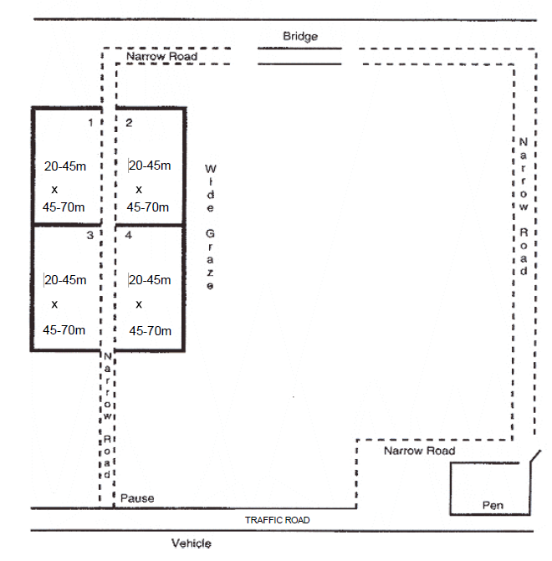

(QLD) Proposed change COURSE C STARTED & INTERMEDIATE (Page 66)
STARTED Time: 30 35 minutes Length: 400 to 490 linear metres
INTERMEDIATE Time: 45 minutes Length: 490 to 710 linear metres

This course may be set up in any order, so long as all exercises and obstacles are included.
Graze area size depends on number of sheep used.
Grazing areas are to be numbered and their use rotated.

(QLD) Rationale COURSE C STARTED & INTERMEDIATE (Page 66)

- When the Started course is worked at the maximum 490 linear metres and the Intermediate minimum is also 490 linear metres, adding five minutes allows Started dogs to demonstrate competence without undue pressure and complete the required boundary sequences safely. It also allows the Wide Graze (including the Placement) to be 15 minutes for Intermediate level.

COURSE C ADVANCED (Page 67)
Time: 45 minutes Length: 710 to 800 linear metres
This course may be set up in any order, so long as all exercises and obstacles are included.
Graze area size depends on number of sheep used.
13-18 metres x 55- 90 metres is an adequate narrow graze area for 25 sheep.

Grazing areas are to be numbered and their use rotated.

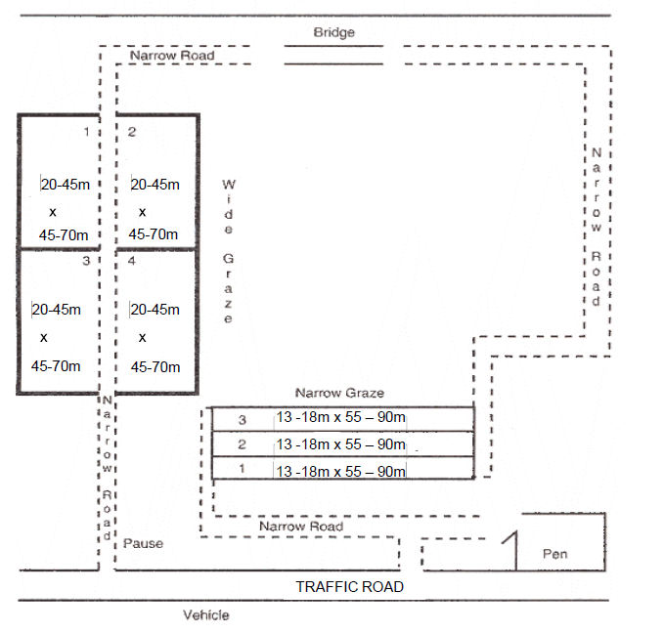

(QLD) Proposed change COURSE C ADVANCED (Page 67)
Time: 45 50 minutes Length: 710 to 800 linear metres
This course may be set up in any order, so long as all exercises and obstacles are included.
Graze area size depends on number of sheep used.
13-18 metres x 55- 90 metres is an adequate narrow graze area for 25 sheep. Grazing areas are to be numbered and their use rotated.

(QLD) Rationale COURSE C ADVANCED (Page 67)

- When the course is worked at the maximum 800 linear metres, the additional time accommodates the more complex boundary sequences required at Advanced level, allowing dogs to demonstrate competence without haste. Providing an extra five minutes prevents rushing, supports stock welfare, and ensures the placement element can be demonstrated cleanly and safely, and within the time limit.

- It also allows the Wide Graze (including the Placement) to be 15 minutes.

- This time of 50 minutes also allows for the correct speed of the stock through the Narrow Graze section of the course. As quoted in the last paragraph of Rule 7.2.9 (on page 64), ‘The purpose of this exercise is to move the stock sufficiently slowly so that the sheep may graze on the move without stopping.’ In other words, the sheep should be able to graze on the move which means they are moving at a much slower speed than they would be on the Narrow Road sections.

Section 4 Judging Course C – SUGGESTED SCORING (Page 68)

Exit from the pen
  - Up to 2 points deducted if the flock escape the pen while the handler is opening the gate.
  - Up to 2 points deducted for the dog not entering the pen on command or not jumping in if commanded to do so.
  - Up to 2 points deducted for disturbing the flock upon entering the pen.
  - Up to 2 points deducted for stock hitting, banging or crowding the gate.
  - Up to 2 points deducted for the dog leaving the pen before the last sheep, unless directed by the handler.
  - Up to 10 points deducted when the dog fails to respond to situations on its own initiative.
  - (Re-pen) Up to 2 points deducted for the dog quitting before all the sheep have entered the pen.

(QLD) Proposed change to – Section 4 Judging Course C – SUGGESTED SCORING (Page 68)

Exit from the pen
  - Up to 2 points deducted if the flock escape the pen while the handler is opening the gate.
  - Up to 2 points deducted for the dog not entering the pen on command or not jumping in if commanded to do so.
  - Up to 2 points deducted for disturbing the flock upon entering the pen.
  - Up to 2 points deducted for stock hitting, banging or crowding the gate.
  - Up to 2 points deducted for the dog leaving the pen before the last sheep, unless directed by the handler.
  - Up to 10 points deducted when the dog fails to respond to situations on its own initiative.
  - (Re-pen) Up to 2 points deducted for the dog quitting before all the sheep have entered the pen.

(QLD) Rationale – Section 4 Judging Course C – SUGGESTED SCORING (Page 68)

This Point Number 7 is for the re-penning exercise and is listed under H. Re Pen, number 1 on Page 69, so should not be in this section A.

Section 4 Judging Course C – SUGGESTED SCORING (Page 69)

E. Wide and Narrow Grazes
1. Up to 3 points deducted for the dog working inside the line, too close to the flock.
2. Up to 3 points deducted for the dog working too far outside the line.
3. Up to 10 points deducted if the dog causes or allows the flock to split or leave the graze area.
4. Up to 10 points deducted for the dog disturbing the stock and preventing it from grazing.
5. Up to 10 points deducted for the handler out of position.
6. Up to 10 points deducted for the dog constantly going around the graze.
7. Up to 10 points deducted if the dog fails to work on its own initiative.

(QLD) Proposed change to – Section 4 Judging Course C – SUGGESTED SCORING (Page 69)

E. Wide and Narrow Grazes
1. Up to 3 points deducted for the dog working inside the line, too close to the flock.
2. Up to 3 points deducted for the dog working too far outside the line.
3. Up to 10 points deducted if the dog causes or allows the flock to split or leave the graze area.
4. Up to 10 points deducted for the dog disturbing the stock and preventing it from grazing.
5. Up to 10 points deducted for the handler out of position.
6. Up to 10 points deducted for the dog constantly going around the graze.
7. Up to 10 points deducted if the dog fails to work on its own initiative.
8. Up to 5 points deducted for sheep, whilst not stopping, being moved too fast so that they are
unable to graze.

(QLD) Rationale – Section 4 Judging Course C – SUGGESTED SCORING (Page 69)

- In this section E about judging the Wide and Narrow Grazes, there is no specific scoring about the Narrow Graze. As quoted in the last paragraph of Rule 7.2.9 (on page 64), ‘The purpose of this exercise is to move the stock sufficiently slowly so that the sheep may graze on the move without stopping.’ In other words, the sheep should be able to graze on the move which means they are moving at a much slower speed than they would be on the Narrow Road sections. In the suggested scoring in Section E, many of the points can be applied to the Narrow Graze but the speed of movement and the ability to graze on the move are not mentioned, so should be able to be scored by the Judge.

Section 4 Judging Course C – SUGGESTED SCORING (Page 69)

F. Placement before the Flock (Intermediate/Advanced)
1. Up to 2 points deducted for the dog not stopping promptly.
2 Up to 3 points deducted for the dog disturbing the flock while being sent for the placement.
3. Up to 3 points deducted if the dog does not exit on the same boundary as it entered.
4. Up to 10 points deducted if the handler is unable to send the dog for the placement.

(QLD) Proposed change Section 4 Judging Course C – SUGGESTED SCORING (Page 69)

F. Placement before the Flock (Intermediate/Advanced)
1. Up to 2 points deducted for the dog not stopping promptly.
2. Up to 3 points deducted for the dog disturbing the flock while being sent for the placement.
3. Up to 3 points deducted if the dog does not exit on in approximately the same boundary area
as it entered.
4. Up to 10 points deducted if the handler is unable to send the dog for the placement.

(QLD) Rationale Section 4 Judging Course C – SUGGESTED SCORING (Page 69)

Using “approximately the same area” acknowledges natural drift yet still requires correct boundary
exit behaviour.

INSTINCT TEST OFFICIAL JUDGE’S EVALUATION FORM (Page 73)

This shows the ‘Time Allowed:’ as 10 minutes

(QLD) Proposed change to – INSTINCT TEST OFFICIAL JUDGE’S EVALUATION FORM (Page 73)

This should show the ‘Time Allowed:’ as 10 minutes 5 minutes

(QLD) Rationale – INSTINCT TEST OFFICIAL JUDGE’S EVALUATION FORM (Page 73)

Rule 3.6.1 states that the time allowed is five (5) minutes for an Instinct Test.

INSTINCT TEST OFFICIAL JUDGE’S EVALUATION FORM (Page 73)

Under TEST ELEMENTS, No. 4 states ‘Shows interest in stock’

(QLD) Proposed change to – INSTINCT TEST OFFICIAL JUDGE’S EVALUATION FORM (Page 73)

Under TEST ELEMENTS, No. 4 should state ‘Shows interest in stock. (WITH BOUNDARY) while on a 1-sided border’.

(QLD) Rationale – INSTINCT TEST OFFICIAL JUDGE’S EVALUATION FORM (Page 73)

This proposal to include ‘(WITH BOUNDARY) while on a 1-sided border’ is conditional on the Boundary Instinct Test being accepted in the discussions earlier about pages 17, 18 and 19 of the 2023 Rules and Regulations.

HERDING TEST OFFICIAL JUDGE’S EVALUATION FORM (Page 74)

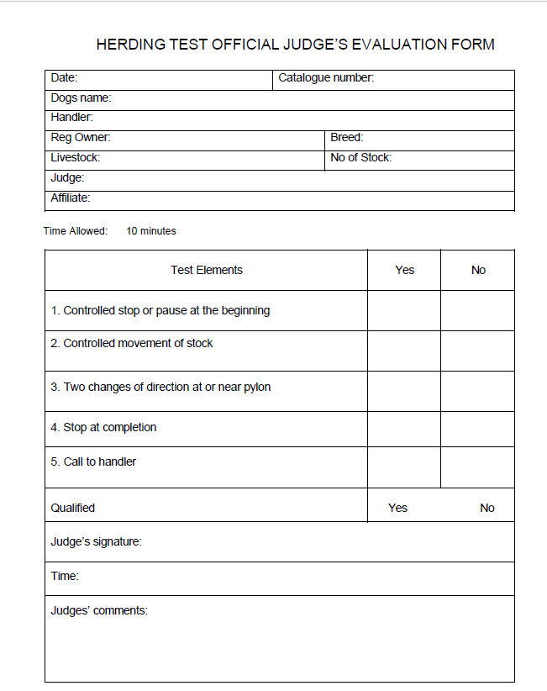

(QLD) Proposed change HERDING TEST OFFICIAL JUDGE’S EVALUATION FORM (Page 74)

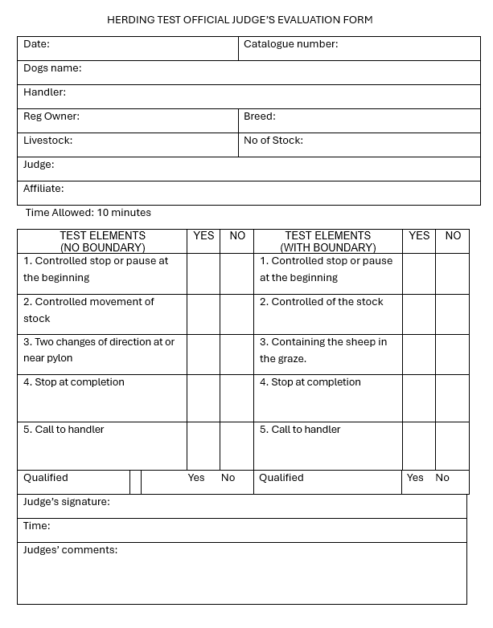
‘No.2. Controlled movement of the stock’ should not be here.

(QLD) Rationale HERDING TEST OFFICIAL JUDGE’S EVALUATION FORM (Page 74)

- This proposal to include ‘TEST ELEMENTS (WITH BOUNDARY)’ is modelled off the PRE TRIAL TEST OFFICIAL JUDGE’S EVALUATION FORM. This would be conditional on the Boundary Herding Test being accepted in the discussions earlier about pages 17 to 22 of the 2023 Rules and Regulations.

- The four TEST ELEMENTS (WITH BOUNDARY) should be –
- Controlled stop or pause at the beginning
- Containing the sheep in the graze
- Stop at completion
- Call to handler

HERDING TRIAL OFFICIAL SCORESHEET: COURSE A (Page 76)
Between the two boxes, it states –

Time Allowed: Started and Intermediate: 10 minutes Advanced: 12 minutes
Qualifying Score: 65 points (not less than half of the points in each category)

(QLD) Proposed change to – HERDING TRIAL OFFICIAL SCORESHEET: COURSE A (Page 76)
Between the two boxes, it should state –

Time Allowed: For sheep and ducks: All courses – 10 minutes. For cattle: All courses – 12 minutes. Started and Intermediate: 10 minutes Advanced: 12 minutes
Qualifying Score: 65 points (not less than half of the points in each category)

(QLD) Rationale – HERDING TRIAL OFFICIAL SCORESHEET: COURSE A (Page 76)

This is per the first paragraph of the Rules on pages 34, 36, 38 and 40 (descriptions of the four classes for Course A where the rules talk about the times allowed for different stock). Also shown at the top of each of the A Course diagrams on pages 35 (Started), 37 (Novice), 39 (Intermediate) and 41 (Advanced) of the 2023 Rules and Regulations.

HERDING TRIAL OFFICIAL SCORESHEET: COURSE B (Page 77)
Under Section 4, it states ‘4. Drive Fetch in Started – 25 Points Available’

(QLD) Proposed change to – HERDING TRIAL OFFICIAL SCORESHEET: COURSE B (Page 77)
Under Section 4, it should state ‘4. Drive Fetch II in Started/Novice/Intermediate – 25 Points Available’

(QLD) Rationale – HERDING TRIAL OFFICIAL SCORESHEET: COURSE B (Page 77)

This Section 4 should reflect that Fetch II can be in the Novice and Intermediate Classes as well as Started.

HERDING TRIAL OFFICIAL SCORESHEET: COURSE B (Page 77)
Between the two boxes, it states –

Time Allowed: Started and Intermediate: 10 minutes Advanced: 12 minutes
Qualifying Score: 65 points (not less than half of the points in each category)

(QLD) Proposed change to – HERDING TRIAL OFFICIAL SCORESHEET: COURSE B (Page 77)
Between the two boxes, it should state –

Time Allowed: Started, Novice and Intermediate: 10 minutes Advanced: 12 minutes
Qualifying Score: 65 points (not less than half of the points in each category)

(QLD) Rationale – HERDING TRIAL OFFICIAL SCORESHEET: COURSE B (Page 77)

The Novice Class should be included. This time for Novice Class (10 minutes) is shown in the first paragraph of the Rule on page 51 (Novice Class Course B – Description) and the top of the Course B Novice diagram on page 52.

HERDING TRIAL OFFICIAL SCORESHEET: COURSE C (Page 78)

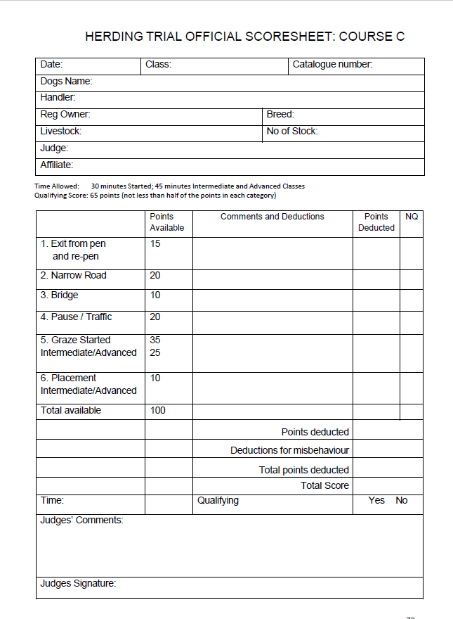

(QLD) Proposed change HERDING TRIAL OFFICIAL SCORESHEET: COURSE C (Page 78)
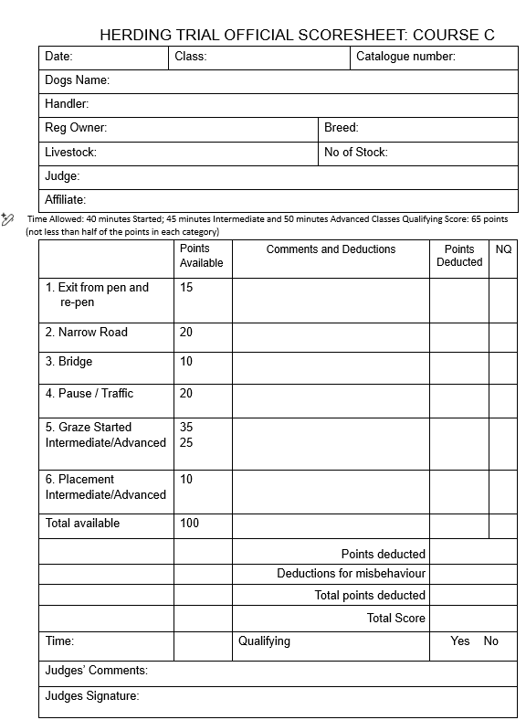
These times should be:
Started 35 mins
Intermediate 45 mins
Advanced 50 mins

(QLD) Rationale HERDING TRIAL OFFICIAL SCORESHEET: COURSE C (Page 78)

The ‘Time Allowed’ section reflects the extra time allowed for Started (from 30 to 35 minutes), Intermediate (45 minutes) and Advanced (from 45 to 50 minutes) C-Course events. This would be
dependent on the discussions about this on pages 66 and 67 of the 2023 Rules and Regulations.

DOGS AUSTRALIA HERDING JUDGE REPORT FORM (Page 81)
Section 3 states ‘STOCK INSPECTED BEFORE COMMENCEMENT OF TESTS/TRIAL’

(QLD) Proposed change to – DOGS AUSTRALIA HERDING JUDGE REPORT FORM (Page 81)
Section 3 should state ‘STOCK INSPECTED BEFORE COMMENCEMENT OF TESTS/TRIALS’

(QLD) Rationale – DOGS AUSTRALIA HERDING JUDGE REPORT FORM (Page 81)

In Section 3, the word ‘TRIALS’ at the end should be plural.

DOGS AUSTRALIA HERDING JUDGE REPORT FORM (Page 81)
Section 4 states ‘STOCK INSPECTED A CONCLUSION OF TESTS/TRIAL’

(QLD) Proposed change to – DOGS AUSTRALIA HERDING JUDGE REPORT FORM (Page 81)
Section 4 should state ‘STOCK INSPECTED AT CONCLUSION OF TESTS/TRIALS’

(QLD) Rationale – DOGS AUSTRALIA HERDING JUDGE REPORT FORM (Page 81)

- The word ‘TRIALS’ at the end should be plural.

- The ‘A’ between ‘INSPECTED’ and ‘CONCLUSION’ should be ‘AT’.

