
Australian National Kennel Council Ltd ABN 77 151 544 679 trading as Dogs Australia

Rules and Regulations for

HERDING TRIALS

Effective 1 January 2023

Amended October 2022
October 2025

DOGS AUSTRALIA

TABLE OF CONTENTS

INTRODUCTION 5
CHAPTER 1. GENERAL REGULATIONS 5
Section 1. Purpose 5
Section 2. Herding Tests and Herding Trials 5
Section 3. Eligibility of Dogs 7
Section 4. Making Application 8
Section 5. Veterinarian 8
Section 6. Ribbons and Rosettes etc 8
Section 7. Risk 8
Section 8. Closing of Entries and Entry Draw 9
Section 9. Test and Trial Catalogue 9
Section 10. Submission of Records and Catalogue Preparation. 9
Section 11. Disturbances 10
Section 12. Absences, Retirements, Removals, Excusals, Disqualifications and Re-evaluations 10
Section 13. Exercise of Judgment, Affiliate Members and Judges 11
CHAPTER 2. REGULATIONS APPLYING TO BOTH HERDING TESTS AND TRIALS 12
Section 1. Judges 12
Section 2. Judge’s Scribe and Trainee Judge 12
Section 3. Judges and Affiliate Members Responsibilities 12
Section 4. Number of dogs that can be judged 13
Section 5. Interference and Double Handling 13
Section 6. Qualifications 14
Section 7. Re-Judging 14
Section 8. Equipment 14
Section 9. Scoring. 14
Section 10. Livestock 15
Section 11. Fencing 16
CHAPTER 3 HERDING TESTS 17
Section 1. Scoring, Announcements of Scores 17
Section 2. Test Arena Conditions, Dimensions and Fencing 17
Section 3. Livestock Requirements 17
Section 4. Qualifications 17
Section 5. Instinct Test (Certificate only - not a Title) OPTIONAL 18
Section 6. Instinct Test Description and Test Elements 18
Section 7. Herding Test (HT) Title. Optional 20
Section 8. Herding Test Description and Test Elements 20
Section 9. Pre-Trial Test (PT) Title 23
Section 10. Pre-Trial Course Requirements (With and Without Boundary) 23
Section 11. Pre-Trial Test, Description and Test Elements 24
CHAPTER 4. HERDING TRIALS 27
Section 1. Trial Classes 27
Section 2. Qualifying Scores 27
Section 3. Herding Trial Titles 28
Section 4. Herding Champion 28
Section 5. Trial Field Conditions, Cancellations 30
Section 6. Courses 30
Section 7. Livestock Requirements 30
Section 8 General Course Requirements 30
Section 9. Ties 30
CHAPTER 5. COURSE A 31
Section 1. Course A 31
Section 2. Course A Layout 31
Section 3. Posts 31
Section 4. Obstacles 31
Section 5. Markers 32
Section 6. Pen 33
Section 7. Classes 34
Section 8. Judging Course A 42
CHAPTER 6. COURSE B. 45
Section 1. Course B 45
Section 2. Course Layout 46
Section 3. Description of Exercises 47
Section 4. Classes 49
Section 5. Judging Course B 57
CHAPTER 7. COURSE C. 60
Section 1. Course C 60
Section 2. Course Layout 60
Section 3. Classes 65
Section 4. Judging Course C 68
CHAPTER 8. BREEDS ELIGIBLE FOR HERDING PROGRAM 70
GLOSSARY OF HERDING TERMS 71
INSTINCT TEST OFFICIAL JUDGE’S EVALUATION FORM 73
HERDING TEST OFFICIAL JUDGE’S EVALUATION FORM 74
PRE-TRIAL TEST OFFICIAL JUDGE’S EVALUATION FORM 75
HERDING TRIAL OFFICIAL SCORE SHEET - COURSE A 76
HERDING TRIAL OFFICIAL SCORE SHEET - COURSE B 77
HERDING TRIAL OFFICIAL SCORE SHEET - COURSE C 78
HERDING QUALIFYING CERTIFICATE 79
HERDING EXCUSAL / RE-EVALUATION FORM 80
DOGS AUSTRALIA HERDING JUDGE’S REPORT FORM 81

INTRODUCTION

Around the world, herding dogs have proven themselves to be essential in improving man’s ability to control and move stock. Many herding dogs have working styles very different to the modern sheep dogs we see in Australia today. These different herding styles developed in response to local situations and needs.
As the breeding, pedigree recording, and exhibition of these dogs progressed, many have been accepted as pure breeds. Herding instinct is a precious part of a herding breed’s heritage. It is also a vital component that can be easily lost when breeding for exhibition in the show ring.
The Dogs Australia Herding Program is designed to preserve the traditional style and herding instincts of these many breeds. Herding Tests and Trials provide standardised gauges by which a dog’s basic instinct and ability can be measured and allow dogs to demonstrate the useful functions for which they were originally developed using differing Trial courses.

Clarification of these Rules should not be necessary, however should there be a need for individuals to seek clarification, application must be made by the Controlling Body to the appropriate Committee of Dogs Australia, whose decision shall be binding.

AIMS

- Preserve the working instinct and ability of the working breeds.
- The training and education of administration, judging and scribing personnel, for the purposes of Herding Tests and Trials.

CHAPTER 1. GENERAL REGULATIONS

Wherever the word 'dog" is used in these Regulations, it includes both sexes. Section 1. Purpose.
    - The purpose of non-competitive Herding Tests is to offer owners of herding breeds a standardised gauge by which a dog's basic instinct and trainability are measured.
    - The purpose of the competitive Herding Trial program is to preserve and develop the herding skills inherent in the herding breeds and to demonstrate that they can perform the useful function for which they were originally bred. The layout of each course is designed to assess a different type of work. One, at least should suit any herding breed. Although Herding Trials are artificial simulations, they are standardised Tests to measure and develop the characteristics of the Herding breeds.
    - Dogs MUST have herding training and prior exposure to the appropriate livestock before entering in a Test and/or Trial.
    - A dog is not required to work in a particular breed style according to its breed.
    - A dog may compete on which ever course the handler chooses, subject to its eligibility.

    - Herding Tests and Trials are sports, and all participants should be guided by the principles of good sportsmanship both in and outside of the Test and Trial arenas.
    - Where interpretation or clarification of any rule is required, a letter or email can be sent through the member body to Dogs Australia for determination with the Dogs Australia Herding Committee. Once a definition has been created, it shall be circulated to all Herding Committees Australia wide.

Section 2. Herding Tests and Herding Trials
    - An Instinct Test is a Test conducted at a sanctioned event by a Club which is an affiliated member of the Controlling Body at which a pass gains a Certificate.

    - A Herding Test is a Test conducted at a sanctioned event by a Club which is an affiliated member of the Controlling Body at which a pass towards a Title may be gained.
    - A Pre-Trial Test is a Test conducted at a sanctioned event by a Club which is an affiliated member of

    - A Herding Trial is a sanctioned event conducted by a Club or Association which is affiliated with a Controlling Body which is a member of Dogs Australia at which qualifying scores towards titles are awarded.

    - Sanctioned Herding Tests and Trials are formal herding events at which dogs may participate, for championship scores or qualifying scores toward titles, conducted by a Club or Association by obtaining the sanction of the Controlling Body.
    - Certificate and Title Descriptions Tests:
Instinct Test - Certificate (not a title) Optional
Herding Test- HT Title Optional Pre-Trial Test - PT title

Trials:
Herding Started - HS Title
Herding Started Masters – HSM Title Herding Novice HN Title Optional Herding Intermediate - HI Title
Herding Intermediate Masters – HIM Title Herding Advanced - HX Title
Herding Champion - HCH
Grand Herding Champion – GR HCH Versatile Herding Champion – VHCH
Versatile Herding Champion Excellent – VHCHX

Each title is to be accompanied by type of stock used:
sheep – s cattle – c ducks – d

Each title is to be accompanied by course type:
A Course – A
B Course – B
C Course – C

For example:
- Herding Started Title on A Course with sheep– HSAs
- Herding Novice Title A Course with Sheep HNAs
- Herding Intermediate Title on B Course with sheep and Herding Advanced Title on A Course on cattle – HIBs HXAc
- Herding Started Title on A Course on ducks and sheep, Herding Started Title on C Course on sheep and Herding Intermediate Title on B Course on sheep – HSAds HSCs HIBs

Section 3. Eligibility of Dogs
    - All dogs nine (9) months of age or older that are registered with Dogs Australia as per Chapter 8 are eligible to participate in Herding Tests and Trials. However, dogs may enter an Optional Instinct test at six months of age.

    - Before a dog is eligible to compete in a Herding Started (HS) Trial, it must have qualified for a Pre-Trial Test title. The Pre-Trial Test Title must be applied for within one month of Qualification for the dog to continue to trial at the next level. Dogs with a qualification at Trial level are no longer eligible to compete at Test level.

    - Before a dog is eligible to compete in a Herding Novice (HN) Trial, it must have qualified 3 times under at least 2 different Judges in the Started Trial Class (same course and stock). This will qualify for the application and issue of a Herding Started Title (HS). Dogs which have qualified in a Novice Trial are no longer eligible to compete at Started level on the same stock type as the Novice qualification.
    - Before a dog is eligible to compete in a Herding Intermediate (HI) Trial, it must have qualified 3 times under at least 2 different Judges in the Started Trial Class (same course and livestock). This will qualify for the application and issue of a Herding Started Title (HS). Dogs which have qualified in an Intermediate Trial are no longer eligible to compete at Started or Novice level on the same course and stock types as the Intermediate qualification
    - Before a dog is eligible to compete in a Herding Advanced (HX) Trial, it must have qualified for 3 passes under at least 2 different Judges in the Intermediate Trial Class. This will qualify for the application and issue of a Herding Intermediate Title (HI). Dogs which have qualified in an Advanced Trial are no longer eligible to compete at Started, Novice or Intermediate level on the same course & stock types as the Advanced qualification.
    - De-sexed dogs, dogs with Limited Registration and dogs that have faults which would disqualify them under their breed standards may participate in Tests and Trials, if otherwise eligible under these Regulations.
    - Dogs disfigured as the result of an accident but otherwise qualified shall be eligible, provided the disfigurement does not interfere with functional movement. Dogs that are lame shall be allowed to compete if a veterinary certificate is supplied to verify that this dog has a permanent limp that does not cause any pain. Lame means any derangement of normal movement, disabled or with impaired freedom of movement.
    - Deaf dogs shall be permitted to participate providing the dog is obedient. Deaf dogs may compete if it can be demonstrated they can work safely to hand or staff signals. Deaf, in this context, means without useful hearing.
    - Blind dogs shall not be permitted to participate. Blind, in this context, means without useful vision.
    - Special training devices that are used to control and train dogs, including but not limited to muzzles and head collars, collars with prongs, electronic collars used with transmitters may not be used on dogs at Dogs Australia events
SA Proposed Changes - Special training devices that are used to control and train dogs, including but not limited to muzzles head collars, collars with prongs, electronic collars used with transmitters may not be used on dogs at Dogs Australia events.
SA Rationale - muzzles should be permitted as an option in tests and trials. They are required in some working aspects in real life stock management and in some circumstances required.
    - A dog will be allowed to compete in a Test or Trial wearing protective footwear if it is deemed appropriate to the terrain.
    - Vetting of all bitches prior to competition will mean that bitches in season shall be eligible and must run at the completion of each course, provided that the area within the course is not being used for another trial or test on the same day.
    - Dogs should enter an arena on lead for all Trials. This should be removed immediately after the gate is closed. Penalties will apply if a dog is subsequently taken to the starting position on lead
    - Once a dog has qualified in a class it is no longer eligible to enter a test or trial at a lower level.

Section 4. Making Application
    - Affiliated Members may apply to the relevant Controlling Body for:
- One day event
- Multiple day event
- Multiple events per day
Details shall be published in the schedule.
    - An approved Trial need not include all classes. All classes below the highest scheduled class must be offered. Novice class is optional.
When multiple days are combined into one event there is one set of trophies. Alternates must be run on the same day as the absentee occurs.
    - Herding tests and/or trials shall be open to all eligible breeds except that a specialty affiliate (or group of affiliates) formed for any one of the eligible breeds may be approved to hold a herding trial in which only that breed(s) may participate. When a specialty affiliate elects to restrict entry to its own breed(s) it must specify in the schedule that the event is only open to that breed(s).
    - An Affiliate Member may be approved to hold a Test and Trial on the same day provided that the total number of livestock meets the requirements for both events. If anticipated combined entry numbers are more than 50 dogs, the Affiliate Member must provide a separate Judge for the Test & Trial.
    - An Affiliate member may be approved to conduct multiple trials on the same day provided that Rule
2.10.1 & 2.10.16 are adhered to.
    - An application for the conduct of a National Trial is to be received by Dogs Australia at least 18 months in advance of the proposed event.
    - Affiliates may or may not choose to offer Pre-Trial Test (Boundary Style). The schedule must state if Boundary Tests will be offered.

Section 5. Veterinarian

    - Every Affiliate Member holding herding events shall arrange to have one or more veterinarians in attendance or on call throughout the duration of the event. If the veterinarian(s) are “on call”, the Affiliate Member must ensure that veterinary assistance will be available within a reasonable time should it be needed.

Section 6. Ribbons and Rosettes etc.

    - High in Trial and Reserve may be awarded for each kind of stock and/or course.
    - Trials. Scores shall be posted for the public viewing after each dog is scored.

Section 7. Risk

    - Owners or Handlers of the dog/s in a Herding Test or Trial shall agree to assume responsibility for any damage or injury to stock.

Section 8. Closing of Entries and Entry Draw

    - If entries are to be limited, the numerical limitation(s) must be stated in the schedule.
    - When limits apply, a draw from all entries received on or prior to the closing date will decide those who run. Except for advanced classes, untitled dogs shall be given entry preference for classes in which they are qualified to enter but have not gained the title. Additional entries shall be added to an alternates list for each class that exceeds the published limit(s).
    - The alternates list shall be used to fill vacancies that occur, being added to the end of the class and additional alternates are to follow in the same order for all Trials and Tests.
    - Entrants on the alternates list must check in with the Herding Secretary on the grounds no later than 30 minutes before the commencement of their class.
    - The Affiliate's Trial Secretary shall officiate over the draw and determine the running order.

Section 9. Test and Trial Catalogue

    - An Affiliate Member conducting an approved Herding Test and /or Trial must prepare, after the entries have been drawn, a catalogue showing the classes and the running order of all dogs entered in each class. Catalogues must contain notification of a handlers meeting.
    - When the same stock is used for all classes in a Trial, Trial class running order is to be the highest class first and Started class last.

Section 10. Submission of Records and Catalogue Preparation

    - The Affiliate Member must supply the standard copy of the Dogs Australia Judge Sheets for Herding Tests and Trials.
    - A Judge's decision as marked on the official judging sheet cannot be changed after filing with the Test/Trial Secretary, except in the case of an arithmetical error.
    - Entries will be printed in the Catalogue by Class, with the Judges Name.
    - Multiples of a class are listed in order of livestock - sheep, cattle and ducks.
    - Courses may be listed in any order but must be stated in the schedule as to which course/s will be run.
    - An Affiliate member can elect to run any Tests or Trials in whichever order the secretary deems appropriate and can run them simultaneously where two Judges are contracted, provided Rule 1.9.2 is adhered to.
    - Additional information shall be provided for qualification, Trial class score and awards.
    - Move-ups are permitted at the discretion of the Trial secretary where time and stock numbers permit.

    - A separate catalogue for each test and/or trial event marked with all qualifications, awards and absent dogs shall be sent to the controlling body. Excusals or disqualifications under Chapter 1, section 12 must be clearly marked and provide the reason for the excusal or disqualification.

Section 11. Disturbances

    - All dogs which are not being worked in the arena must be kept quiet, off course and a minimum of 5m away from the arena fences.

    - Barking dogs outside the Test or Trial arena are to be removed from the area but shall not be physically disciplined for barking.
    - The Judge must promptly remove from participation any dog which cannot be controlled, or which he or she considers unfit to participate
    - The Judge must also promptly remove any handler who willfully interferes with another dog or handler, or who abuses his or her dog in the Test or Trial arena/area, or in any way displays conduct prejudicial to the sport of Herding and/or the Controlling Body. The Judge must report such incidents to the appropriate body for further action in accordance with their rules.
    - The handler may not hit, shake, or physically discipline a dog except that a dog may be reasonably constrained in the case of an attack on a person or livestock.
    - Whenever a handler has been expelled, all dogs run by that handler shall also be removed from participation and the entry fees for those dogs shall be forfeited.
    - Impugning a Judge’s decision will result in immediate disqualification and reporting to the Controlling Body.

Section 12. Absences, Retirements, Removals, Excusals, Disqualifications and Re-evaluations.

    - Any Handler who does not answer the Stewards third call must be marked ‘absent’ on the Judge’s score sheet unless previously arranged with the steward.
    - A Handler may retire a dog from the course at a Test or Trial for unsatisfactory performance at any time during its run. The Judge shall mark the dog "retired" in the Judge's sheet.
    - The Judge must remove any dog which after a period of 3 minutes fails to show productive work or is unable to move stock forward on the course of a Test or Trial.
    - The Judge must order the removal and disqualification from all Competition on the day any dog which willfully, aggressively, or viciously attacks livestock, and must lodge a report with the Controlling Body in accordance with their rules.
    - A dog that grips abusively shall be immediately excused. The Judge shall complete and sign a Dogs Australia excusal form (attached) that must be lodged with the Controlling Body within 3 days. Any excusal by a Judge will be recorded on the Dogs Australia Computer system. If a dog is excused the judge must notify the exhibitor of the excusal, notify the stock owner, and inspect the stock for damage.
    - A dog that has been reported as excused for unacceptable abusive gripping or for attacking or attempting to attack livestock on two occasions (any combination) will no longer be eligible to be entered in the Dogs Australia Herding events.
    - A dog reported under Regulation 1.12.6 remains ineligible until the owner has applied to and been notified by the Controlling Body that the dog is now eligible to demonstrate corrected behaviour to three different Judges.
A dog becomes eligible to be re-evaluated six (6) months after its second excusal. An excusal at any of its three re-evaluation events permanently renders the dog ineligible for entry in Dogs Australia Herding events. The Judge shall complete and sign a Dogs Australia Excusal Form that must be lodged with the Controlling Body within 3 days.
The excusal by a Judge will be recorded on the Dogs Australia Computer System showing that the dog is permanently ineligible to enter any Dogs Australia Herding events. The owner of the dog being re-

    - The owner is also responsible for applying for re-evaluation and for notifying the Controlling Body of the events that will be entered for re-evaluation. Dogs must be re-evaluated in the same Test or Trial class from which they were excused.
A dog should not be re-evaluated by any of the Judges that excused the dog. Judges will receive notification that a dog will be re-evaluated at their assignment and shall have the option to decline the re-evaluation.
    - A dog that passes a Test or qualifies in a Trial class at an affiliated member event during its re-evaluation period will receive credit toward the respective title. Failure to pass or qualify will not count against the dog unless it is excused.
    - The Judge must order the removal and disqualification from all competition on the day any dog that attacks or attempts to attack any person in the arena at a Test or Trial, and lodge a report with the Controlling Body in accordance with their rules.

    - If a dog leaves the arena before the completion of the test or trial, it will be disqualified.

Section 13. Exercise of Judgment, Affiliate Members and Judges

    - Because there are many variables in the conduct of Tests and Trials, especially the weather and the conditions of the livestock, Herding Trial Managers and Judges must exercise their good judgment in modifying any Test or Trial courses.

    - The placement of the obstacles may be changed as needed, and other necessary modifications made, provided the Test and Trial courses contain the minimum essential elements required by these regulations. Each dog at a Test and Trial must be Judged equally and fairly under conditions that are, as nearly as possible, consistent for every participating dog.

    - Modifications that may in any way jeopardize the safety and wellbeing of the livestock or the dogs shall not to be made, and Tests and Trials may never be conducted with fewer than the required minimum number of stock on hand.

    - The safety and wellbeing of the livestock and the dogs is of paramount importance and must be always kept in mind.

    - Each jurisdiction shall require a Judge to report at the conclusion of each Trial in a form prescribed by the jurisdiction.

CHAPTER 2.

REGULATIONS APPLYING TO BOTH HERDING TESTS AND TRIALS
Whenever the word "ducks" is used in the following regulations it is understood that geese and turkeys may be used in place of ducks, provided the schedule states that geese or turkeys will be used.
Whenever the word 'sheep" is used in these regulations it is understood that goats may be used in place of sheep provided the schedule states that sheep and / or goats will be used.

Section 1. Judges
    - Any person judging an approved Herding Test and or Trial must be a licensed Dogs Australia Judge.
    - Licensed Dogs Australia Judges are required to attend a Controlling Body Herding Clinic at least every three years to maintain their license.
    - Qualified Herding Judges of overseas countries are eligible to apply for temporary approval by the Dogs Australia Overseas Herding Approval Board.
    - No Judge shall require any dog or handler to do anything, nor penalize a dog or handler for failing to do anything, that is not required by these regulations.

    - The decisions of the Judges shall be final in all matters relating to the Herding Test and Trial performance of the dogs and no discussion will be entered into.
    - Trial Judges shall have the power to withhold any or all awards and placements for want of merit.
    - Judging Restrictions and Eligibility
      - No dog owned or co-owned by the judge or any member of their family or household may be entered under that judge at a test or trial for which they have been advertised as a judge.
      - Dogs owned by a judge or member of a judge’s family or household may be entered under other judges at the event.

Section 2. Judge’s Scribe and Trainee Judge

    - A Scribe / Timer shall be assigned to each Judge. The Scribe shall mark the score sheets as instructed by the Judge. The Judge is responsible for checking the accuracy and correctness of the scores.
    - At the Judge's discretion, Trainee Judges may be in the judging area. A Trainee Judge may serve as the Judge's Scribe, but in such case will score only as instructed by the Judge.
    - Trainee Judges shall provide their own Scribes and shall score participating dogs independently. They shall not communicate with the officiating Judge until the conclusion of a run. They may listen as the Judge explains the results of the run to the participants but may not offer any additional comments to participants. Trainee Judges’ score sheets shall not be distributed to participants.

Section 3. Judges and Affiliate Members Responsibilities

    - The Affiliate Member is responsible for providing the stock, fencing, facilities, and equipment which meet the requirements of these regulations. The Affiliate Member is responsible for providing adequate livestock handling crews, particularly when more than one ring is used at an event. It is strongly recommended that they arrange to have one or two experienced stock dogs and their

handlers present throughout the Test or Trial.
The stock dog(s) may be entered in the Test or Trial provided the dog(s) has already competed in the Test or Trial. Stock handlers who are entered in the event must not have been involved in the selection of the stock for their run.

    - Judges may provide the stock, fencing and other equipment, in which case the Judge must ensure compliance with all these regulations.

    - The Judge is responsible for ensuring compliance with these regulations throughout a Herding Test/ Trial, and that the livestock are properly cared for and rotated as needed. The Judge must check the stock, fencing, facilities, and equipment provided for use before starting to Judge. If the Judge deems either the stock, fencing, facilities, or equipment inadequate for the event and no corrections or modifications can be made, the Judge in consultation with the Affiliate Member may cancel the Test/ Trial class/course. Entry fees shall be refunded by the Affiliate Member, and the Judge reimbursed their expenses, but the Judge shall not receive any additional fees previously been agreed upon.

    - The Judge will hold a handlers’ meeting with all entrants before the start of each class and at the time explain how participants are expected to execute the course. Handlers may walk the course without their dogs prior to the start of each class.

Section 4. Number of dogs that can be judged

    - The maximum number of runs that may be judged by a Judge in one day is 50. Adequate time, up to one hour for rest and meals (not including time when the stock is rotated) must be allowed during the day. The total time for any one event should not exceed eight hours including rest and meal breaks.
    - When a Judge has set a lower limit on the number of dogs he or she will judge in one day, the Affiliate Member must be informed of the lower limits at the time the Judge accepts the invitation to officiate. If the Affiliate Member receives an entry in excess of the maximum number, an additional Judge may be appointed, provided the facilities are adequate and there is sufficient additional livestock available. Prompt notification shall be sent to the Controlling Body, in advance of the Test/Trial, of the appointment of any additional Judge.

Section 5. Interference and Double Handling

    - A Judge who is aware of any assistance, coaching, interference, double handling or attempts to control a dog from outside the ring must act promptly to stop such behaviour and shall mark the score sheet so as to non-qualify the dog, regardless as to whether the dog completes the requirements of the course or not. If in the Judge’s opinion the circumstances warrant, the run may be stopped, and the dog removed from the ring. Unless the Judge is of the opinion that the interference was caused to disadvantage the run, in which case the Judge at their discretion, can offer a re-run. A handler may request the removal of anyone within or outside the arena who is interfering with their run.

Section 6. Qualifications

    - If the stock simply follows the handler through the course, it is to the Judge’s discretion to offer a re-run with different stock and a sufficient break for the dog. If the dog simply heels through a course, the dog will not qualify. The Judge must determine whether the dog is doing the work in moving the livestock.

Section 7. Re-Judging

    - If in the Judge’s opinion, a dog performance was prejudiced by peculiar and unusual conditions, the Judge at his or her discretion, may re-Judge the dog (immediately or later in the day) commencing from the beginning of the course.

Section 8. Equipment
    - At the handler’s option, a dog may be run in any Trial or Test without a collar. If a collar is worn, it must be a simple well-fitting buckle, snap lock or limited slip collar without ID, name, or council tags.

    - Handlers and Judges may carry a staff or crook which shall be no longer than approximately 1.65 metres. PVC is not permissible in the arena. The staff or crook is intended as an aid in controlling livestock as a visual aid to signal a command to the dog and not as a training device and shall never be used to touch the dog, except in an extreme situation involving the safety of another dog, a person or the livestock.

Section 9.
Scoring
    - The scoring of the dog's behaviour begins when the dog enters the arena. Timing of the run begins at the Judge's signal for the dog to leave the handler or at the Judge’s discretion after the Handler signals for the dog to start.

Tests
The number of the dogs that have qualified shall be posted promptly for public viewing after the completion of each Test. Judges should immediately inform handlers whether they qualified but should discuss decisions only after completion of the class.

Trials
Scores shall be posted for the public viewing after each dog is scored. If more than one type of stock is used, High-in-Trial and Reserve may be awarded for each kind of stock.

Section 10. Livestock

    - The suitability and quality of the livestock used in Tests and Trials is of paramount importance. Stock should be worked by a non-entered dog the day before the Test /Trial. Horned stock can be used but must be well accustomed to being worked by dogs and exhibit reasonable behaviour.
    - The Affiliate Member must ensure that the stock, are of such suitability as to provide uniform workability at all levels. Suitable livestock used for Testing are healthy, non-combative (docile) and accustomed to being worked by all styles of Herding breeds. Livestock for Testing must flock (group) easily and be accustomed (in the case of the fetching dog) to approaching the handler as soon as the dog gets behind them or (in the case of the driving dog) willing to move away from the handler.
It is preferable that Test stock be easily moved but not flighty or excessively light. Orientation to the handler should be reliable and representative of the type of stock that would be used at the initial training stages the Tests are set to assess.
For their own protection, sheep used for Tests should not be overly pressure sensitive. They need to be accustomed to being worked in small yards. Sheep not so accustomed will be unfairly hard or impossible to work by many beginner handlers and dogs. They may crash in to or jump over the fence, risking injury to themselves.
They may also choose to 'stick' on the fence refusing to be moved by dog or handler. In Tests, dogs and handlers are 'only' expected to display basic stock control as described by the Test Rules. They are not required to show more advanced skills, such as reading and reacting to the needs of 'spooked' stock or peeling recalcitrant or shocked stock off fences.

    - The Affiliate Member must ensure that the stock, are of such suitability as to provide uniform workability at all levels. Livestock used for Trials should be healthy and accustomed to being worked by all styles of herding breeds.
Trial Livestock should flock (group) adequately when pressured by the dog and be accustomed to approaching and being handled by people. They should not be knee huggers and should accept driving as easily as fetching. Trial stock should be pliable and manoeuvrable enough to permit a Trial dog to show its natural ability and Instinct to read and direct the stock. Stock for the Started and Intermediate Classes should be of the same workability as that which is provided for the Advanced Class.
Stock used on A Course need to be accustomed to being worked in a confined area. It is to be remembered there is no room for a powerful dog to get off its stock in the smaller arenas.
B Course has space for the dog to get off its stock so acclimatization to pressure for stock is as not important. B Course stock should not be any harder for any one breed of dog. eg: Sheep that panic and run as soon as a large or coated breed takes the field are not correct.
Sheep used for C Course must be willing to follow the Shepherd (handler), and accept the close, fast, constant moment of the boundary dog without undue reaction.
SA Proposed changes – 1.10.3 The Affiliate Member must ensure that the stock, are of such suitability as to provide uniform workability at all levels. Livestock used for Trials should be healthy and accustomed to being worked by all styles of herding breeds.
Trial Livestock should flock (group) adequately when pressured by the dog and be accustomed to approaching and being handled by people. They should not be knee huggers and should accept driving as easily as fetching. Trial stock should be pliable and manoeuvrable enough to permit a Trial dog to show its natural ability and Instinct to read and direct the stock. Stock for the Started, Novice and Intermediate Classes should be of the same workability as that which is provided for the Advanced Class.
SA Rationale – Addition of Novice

    - Fresh water must be always available for both livestock and participating dogs during an event.

    - Judges may use a trained backup dog in settling or controlling the stock. Backup dogs must be held quietly outside the arena.

    - If a backup dog is used it should be removed from the arena before the entered dog begins its run.
If it is not possible to remove the backup dog before the entered dog contacts the stock, the backup dog should be held quietly at the side of the arena and be removed as quickly and as discreetly as possible.

    - Livestock handlers may use food to control the stock in the arena, but the dog's handler shall not carry food in the arena.

    - Judges may authorize that the stock be held and/or settled in Test classes and on Courses A and B by one or more persons with grain in a bucket or low feed pan, or by a backup dog. The person(s) or the dog will withdraw as soon as is feasible.

    - Cattle should be over six (6) months of age. Calves should be weaned
Lambs should be at least six (6 )months old, and ducks should be at least four (4) months old. Ewes with nursing lambs should not be used.
    - Sheep: Three head per run for three runs per day, or
Three to five head per run for four runs per day with at least half hour rest between runs or five head per run for five runs per day with at least 45 minutes between runs
Three to five sheep may be reused for 3 consecutive runs in Instinct (HIC) and Herding Test (HT).

    - Cattle: Three to five head per run for five runs per day, with at least 30 minutes rest between runs.

    - Ducks: Five per run for three runs per day.

    - Regardless of the type of stock used, Affiliate Members must arrange to have sufficient stock on reserve.

    - A minimum of 25 and a maximum of 100 sheep must be provided for each run on Course C.
On Course C, no single head of stock may be used more than 8 times in one day on courses up to 710 metres, or more than 6 times in one day on courses over 710 metres.
Larger flocks give the best opportunity for success. Sheep used for Course C must be physically conditioned to travelling the distance required at a trial. Clubs must ensure fitness of sheep.
SA Proposed changes - minimum of 25 and a maximum of 100 sheep must be provided for each run on Course C.
On Course C, no single head of stock may be used more than 8 10 times in one day on courses up to 710 metres, or more than 6 8 times in one day on courses over 710 metres.
Larger flocks give the best opportunity for success. Sheep used for Course C must be physically conditioned to travelling the distance required at a trial. Clubs must ensure fitness of sheep
SA Rationale - Due to the time required between runs to set up with next handler, usually 15 to 20 mins due to course size, swapping over handler/dogs etc. The stock need to be fit enough for the course. In the real world the stock may be walked all day in the attempt to get from A to B. The stock should be able to handle a couple of more runs.

Section 11. Fencing.

    - All A and B Course arenas must have a physical boundary on all four sides. Temporary fencing may be used provided it complies with regulation 2.11.2 of this rule book.

    - Whenever stock is worked in adjacent arenas or held adjacent to the working area, visibility screens must be used. Arena fencing must be the minimum height specified; 1 metre for ducks; 1.2 metres for sheep and 1.3 metres for cattle.

    - Obstacles for sheep and cattle should be constructed of readily visible material such as slatted wood, pipe panels or equivalent. Obstacle panels for sheep should be approximately 1.2 metres in height. Obstacle panels for cattle should be 1.3 metres in height. Obstacle panels for ducks should be approximately 1.2 metres long and 0.6 metres high and may be reinforced with wire fencing to keep the ducks from escaping.
SA Suggested changes - 2.11.3 Obstacles for sheep and cattle should be constructed of readily visible material such as slatted wood, pipe panels or equivalent. Obstacle panels for sheep should be a minimum of approximately 1.2 metres in height. Obstacle panels for cattle should be a minimum of 1.3 metres in height. Obstacle panels for ducks should be a minimum of approximately 1.2 metres long and 0.6 metres high and may be reinforced with wire fencing to keep the ducks from escaping.
SA Rationale – This allows for multiple stock type to be used in the same area with/or the same equipment. Minimum sizes are required but there should be no maximum height size. This allows for the same equipment to be used where suitable without the need to have extra equipment specific to stock.

    - Obstacle dimensions should be the same for all classes/courses

SA Proposed Changes – 2.11.4 Obstacle dimensions should be the same for all classes/ within the courses

SA Rationale – to distinguish between the courses

CHAPTER 3 HERDING TESTS

Section 1. Scoring, Announcements of Scores

    - Herding Tests shall be judged on a pass or fail basis. Judges may start judging Herding Tests from inside or outside the arena and may leave or stay in the arena at their discretion.
    - Only the dog, the Judge, the stock, and the handler are permitted in the Test arena.
    - Clubs may or may not choose to offer HT/PT boundary style. The schedule must state if boundary tests will be offered.

Section 2. Test Arena Conditions, Dimensions and Fencing

    - The arenas for all Test classes shall be fenced with adequate fencing, shall not contain any unsafe conditions and shall be free of dangerous protrusions and materials.
    - The arena for Instinct Testing must be 9 metres by 9 metres up to 30 metres x 30 metres. An oval or round arena is acceptable. Square corners must be rounded. Terrain for duck arena should be very smooth and firm with only a slight slope.

    - The arena for a Herding Test must measure approximately 15 metres x 15 metres for ducks and no less than 15 metres x 15 metres or greater than 30 metres x 30 metres for all other stock.
An oval or round arena is acceptable. Square corners must be rounded. Terrain for duck arenas should be very smooth and firm and with only a slight slope.

    - The arena for the Pre-Trial Test shall be approximately 15 metres x 30 metres for ducks. For all other stock, the minimum shall be approximately 30 metres x 60 metres and the maximum up to 60 metres x 120 metres. Corners need not be rounded.

Section 3. Livestock Requirements

    - The stock to be used for Herding Tests and Pre-Trial Tests are sheep and/or ducks and/or cattle. Affiliate Members holding Tests for one breed of dog only may apply for permission to use other types of livestock.

Section 4. Qualifications

    - The total number of qualifications required for issuance of the Certificates/Titles shall be:
      - for Instinct Certificate – Not a Title - Optional
      - for Herding Test (HT) – Optional 2 for Pre-Trial (PT)

    - The Judge's certification of qualification for any dog constitutes certification to Dogs Australia that the dog on this occasion has evidenced abilities at least in accordance with minimum standards and that the abilities demonstrated would justify the awarding of the title associated with the particular Test class. A dog which does not exhibit abilities which meet minimum requirements must never receive qualification.

    - In Herding Tests and Pre-Trial Tests, dogs must demonstrate the ability to move and control livestock by fetching or driving and be sufficiently trained to work at the proper balance point to move the stock forward on the course. Dogs that constantly prevent the stock from being moved in a controlled fashion, or that chase or harass the stock, will not qualify.
    - Dogs may continue to enter Tests to gain experience after the title for that class is earned with no entry preference, except for the Instinct Test for which they are no longer eligible.

Section 5. Instinct Test (Certificate only - not a Title) Optional

    - Dogs Australia will issue an Instinct Test Certificate to an eligible dog that has been certified by a Judge to have qualified by passing an Instinct Test.

    - A dog may enter an Instinct Test more than once at a single event provided each Test is judged by a different Judge. It will qualify for an Instinct Certificate provided it qualifies under one Judge.

Section 6. INSTINCT TEST (Optional) DESCRIPTION AND TEST ELEMENTS

    - Judging and timing commence when the handler and dog enter the ring. Time allowed is five (5) minutes with no minimum time for completion.
The dog is brought into the arena containing the livestock on a long line, approximately 2-5 metres in length.
At some point while on the long line, the dog must demonstrate a stop (down, sit or stand) and a call to handler before the long line is dropped or removed.
A dog which cannot be recalled shall not be let off the long line and will not qualify.
The dog should show sustained interest in the stock for the majority of the time it is in the arena. Dogs must be immediately removed from the ring if physical force is necessary to protect the stock from the dog.
SA Proposed changes – 3.6.1 Judging and timing commence when the handler and dog enter the ring. Time allowed is five (5) minutes with no minimum time for completion.
The dog is brought into the arena containing the livestock on a long line, approximately 2 - 5 metres in length.
At some point while on the long line, the dog must demonstrate a stop (down, sit or stand) and a call to handler before the long line is can be dropped or removed.
A dog which cannot be recalled shall not be let off the long line and will not qualify.
SA Rationale – for dogs training in boundary herding and maybe other styles of herding when/if it becomes available, the dog is to remain on lead at this stage of its training learning the boundary, the dog is not to be encouraged onto the stock at all but to learn the area the stock is allowed or moved in. It is a detrimental rule to dogs learning boundary herding. As this is a program for all breeds and different styles of herding this needs to be changed to be in line with natural progression of all styles of training.

    - A dog, which cannot be called off the stock, shall not be let off the long line and will not qualify. Dogs must be immediately removed from the ring if physical force is necessary to protect stock from the dog.
SA Proposed changes – 3.6.2 A dog, which cannot be called off the stock, shall not be let off the long line and will not qualify. Dogs must be immediately removed from the ring if physical force is necessary to protect stock from the dog.
SA Rationale – 3.6.2 is covered in 3.6.1, removal of repeated rule.

    - To end the Test, the Judge will ask the Handler to call their dog off the stock. The dog is to be leashed if it is off the long line. The test ends at the Judges adjudication with testing and timing to cease once the dog is leashed.
A dog which does not return to its handler or cannot be caught will not qualify.

INSTINCT TEST
Time Allowed: 5 minutes
Course Size: | Sheep and Cattle  Ducks | Minimum Maximum Approx. | 9m x 9m 30m x 30m 9m x 9m

Note: Moderated corners on all Instinct Test arenas

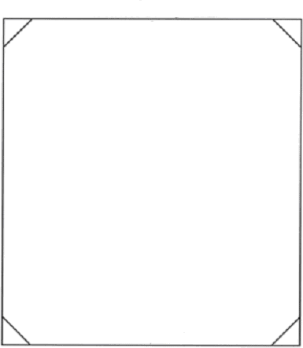

Section 7. Herding Test (HT) Title: Optional

    - Dogs Australia will issue a Herding Test certificate to an eligible dog and will permit the use of the letters HT following the name of a dog that has been certified by two different Judges to have qualified by passing two Affiliated Herding Tests.
    - A dog may enter a Herding Test more than once at a single event (provided that the Herding Test is run with more than one judge) and earn an HT provided it qualifies under two different Judges at that event.

Section 8. Herding Test Description and Test Elements

    - Two pylons or similar markers are placed on the (longer) centre line of fenced arena approximately 3 metres in from the fences at opposite ends of the arena. When there are entries that wish to be tested in boundary style, a boundary line will be placed approximately 4 meters in from the side, and across the arena.
SA Proposed changes – 3.8.1 Two pylons or similar markers are placed on the (longer) centre line of fenced arena approximately 3 metres in from the fences at opposite ends of the arena. When there are entries that wish to be tested in boundary style, a boundary line will be placed approximately 4 meters in from the side, and across the arena. Only sheep are to used for boundary style.
SA Rationale – Clarification on stock type for boundary herding.

    - Time allowed is ten (10) minutes with no minimum time for completion. A dog must complete all Test elements within the allotted ten (10) minutes to qualify.
    - The handler will enter the arena with the dog on lead and, with the Judge, will move to a position appropriate for the start of the Test.
The Judge establishes that the dog is under control. When the Judge determines that the dog is under control, the Test may begin.
The handler is instructed to place the dog in a sit, stand or down/stay position and remove the lead.
    - Testing and time commence when the lead is removed. The dog must demonstrate a controlled pause (stay in position until released or sent). Once the lead is removed, the handler may assume a position away from the dog and appropriate in relation to the stock, but the dog must remain in position.
The judge then signals or instructs the handler to send the dog. A dog that ‘breaks the stay’ shall not fail for that reason alone.

    - During the Test, the Judge should be positioned so as to observe the dog and provide verbal assistance but shall not interfere with the movement of the stock, handler or dog unless as necessary to remove the dog from the arena.

    - The dog must be under control and demonstrate controlled movement of the stock from the first pylon to the second pylon, turn the stock at or near the second pylon, and move the stock back to the first pylon, where they are again turned (at or near the pylon) and moved back to the second pylon.
At the handler's option, the dog may work the stock across the open arena or along the fence line. After completing the controlled movement of the stock between the pylons, the dog is required to demonstrate a stop followed by a call to the handler.
The call to the handler should not be in a direct line with the stock, but away from the position of the stock.
The Judge indicates completion of the Test, timing ceases and the handler leashes the dog and leaves the arena.

SA Proposed changes - 1) The dog must be under control and demonstrate controlled movement of the stock from the first pylon to the second pylon, turn the stock at or near the second pylon, and move the stock back to the first pylon, where they are again turned (at or near the pylon) and moved back to the second pylon.
At the handler's option, the dog may work the stock across the open arena or along the fence line. After completing the controlled movement of the stock between the pylons, the dog is required to demonstrate a stop followed by a call to the handler.
The call to the handler should not be in a direct line with the stock, but away from the position of the stock.
2) If being tested in boundary style the dog is to demonstrate a willingness to boundary patrol along the marked boundary line while showing interest in the stock.
The Judge indicates completion of the Test, timing ceases and the handler leashes the dog and leaves the arena.

SA Rationale - It is impossible for the dog to move the sheep in boundary style at this stage without moving behind the sheep to move them or turn them, a position a boundary herding dog should NOT be put in.

    - The five elements of the Test, which must be executed, are:
1 . A controlled pause or stop at the beginning
2 Two (2) changes in direction at or near the pylons
- Controlled movement of the stock
- A stop
- Followed by a ‘call to handler’ at the conclusion of the run
SA Proposed changes - The five elements of the Test, which must be executed, for non boundary are:
      - . A controlled pause or stop at the beginning
      - Two (2) changes in direction at or near the pylons
      - Controlled movement of the stock
- A stop
- Followed by a ‘call to handler’ at the conclusion of the run
The Five elements of the Test, which must be executed, for Boundary are:
- A controlled pause or stop at the beginning
- Some independent boundary work
- Stained interest in the stock
- A stop
- Followed by a ‘call to handler’ at the conclusion of the run
SA Rationale – Change scoring sheets to also reflect boundary herding requirements.

    - Once a dog has attempted or completed all the Test elements, regardless of whether it qualified, the Judge calls an end to the Test and the dog must leave the arena. It may not repeat the test, attempting a different path through the course or repeat the same path using a different style of herding under that Judge at that event.

    - The timer shall give no warning of time remaining but shall announce when time has expired.

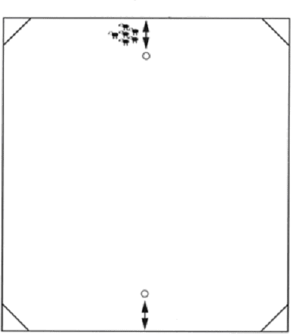

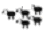
HERDING TEST

Time Allowed: 10 minutes Note: Moderated corners on all Herding Test arenas

Course Size: | Sheep and Cattle | Minimum | 15m x 15m
 |  | Maximum | 30m x 30m
 | Ducks | Approx. | 15m x 15m

Section 9. Pre-Trial Test (PT) Title.
    - The Pre-Trial Test is designed to help guide owners into a knowledge of, and participation in Herding activities, and will provide a dog that, while not fully refined by training, is demonstrably capable of performing Herding work at a level just below the beginning Trial level.

    - Dogs Australia will issue a Pre-Trial Test title to an eligible dog and will permit the use of the letters PT after the name of a dog that has been certified by two different Judges to have qualified by passing two Affiliated Club Pre-Trial Tests.

    - The Pre-trial Title shall supersede the Herding Test Title when the Herding Test has previously been awarded.
Inexperienced handlers are encouraged to work first for the Herding Tested Title so that they may benefit from the educational experience each Test provides.

    - Qualification for a PT Title is a prerequisite for participation in herding Started (HS) trials.

Section 10. Pre-Trial Course Requirements

Section 10a Pre-Trial Course (No Boundary) Requirements

    - A 2 metre to 4 metre free swinging reopen gate is recommended.
SA Proposed changes – 3.10.1 A 2 metre to 4 metre free swinging reopen gate is recommended to the exhaust pen
SA Rationale – Gate should be enough description with exhaust pen added to clarify where.

    - Two panels are placed on the far (narrow) end of the arena opposite the pen, one placed on each side of the arena. The panels are placed parallel to and approximately 8 metres in from the back (narrow) wall. The panel edges must be approximately 4 metres in from the sidewalls, forming 4 metre "gates" or openings between the panel edges and the long wall on each side of the arena.

    - In duck arenas, panels are to be placed proportionally, 4 metres in from the back wall and 2 metres in from the sides.

Section 10b Pre-Trial Course (With Boundary) Requirements

    - A 2 metre to 4 metre free swinging reopen gate is recommended.
SA Proposed changes – 3.10.1 A 2 metre to 4 metre free swinging reopen gate is recommended to the exhaust pen
SA Rationale – Gate should be enough description with exhaust pen added to clarify where.

    - Two panels are placed on the far (narrow) end of the arena opposite the pen, one placed on each side of the arena. The panels are placed parallel to and approximately 8 metres in from the back (narrow) wall. The panel edges must be approximately 4 metres in from the sidewalls, forming 4 metre "gates" or openings between the panel edges and the long wall on each side of the arena.

    - Depending upon the configuration of the arena, the graze area should be a minimum of 15 metres x 15 metres and not exceed approximately 15 metres x 30 metres and is set up along the long wall on the same side of the arena as the second of two gates.
The graze area must be marked with a visible and tactile material, so it is readily discernible to the dog, handler, and judge.

    - When there are entries which wish to be tested in boundary style, a line marked in the same manner as the graze area will be placed at approximately 4 metres in from the sidewalls around the perimeter of the arena.

    - If there are no entrants who wish their dogs to be tested in the boundary style, the Club need not add this line.
    - Only sheep are to be used for the Pre-Trial Course (With Boundary).

Section 11. Pre-Trial Test, Description and Test Elements

SA Proposed change Section 11 (a). Pre-Trial Test, Description and Test Elements (Non Boundary)

SA Rationale – As there is significant difference between boundary PT and Non Boundary PT we suggest there be a separate PT boundary rules section to help differentiate the two.

    - Time allowed is ten (10) minutes once the lead is removed with no minimum time for completion. A dog must complete all Test elements within the allotted ten (10) minutes to qualify.

    - A dog is not required to work in a particular style of Herding according to its breed. The entry form must be marked "Boundary" if the handler wishes the dog to be tested in a boundary situation.

    - A handler may not excessively touch or correct the dog once the stock begins moving. The dog must respond in a reasonably prompt manner without threatening actions or movements by the handler.

    - A minimum of 10 sheep may be used for Boundary Tests. Other stock requirements are as stated in Chapter 2, Section 10 of these Regulations.

SA Proposed Changes – 3.11.4 A minimum of 10 sheep may be used for Boundary Tests. Other stock requirements are as stated in Chapter 2, Section 10 of these Regulations.
SA Rationale – Remove this section and put under boundary requirements

    - The Judge must observe the handler and the dog and may not physically assist the handler and/or the dog in controlling the livestock. The Judge may advise the handler on how best to encourage the dog to move the stock and how to maneuver manoeuvre around the course. The dog should be permitted to work the stock as much as possible with a minimum of commands by the handler. spelling

    - The same procedures and general positions assumed by the Judge and handler for starting the Herding Test apply to the Pre-Trial course. Stock should be freestanding at the top of the arena.

    - When a dog is being tested in the boundary, the stock is held within the graze at the commencement of the test.
SA Proposed changes – 3.11.7 When a dog is being tested in the boundary, the stock is held within the graze at the commencement of the test.
SA Rationale – move to boundary requirements

    - The dog will enter the arena on lead. The judge instructs the handler when to remove the lead. Testing and timing commence when the lead is removed. The dog must demonstrate a controlled pause (stay in position until released or sent). Once the lead is removed the handler may assume a position away from the dog and in relation to the stock, but the dog must remain in position. The judge then signals or instructs the handler to send the dog. A dog that “breaks the stay” shall be asked to demonstrate a stay or controlled pause at the beginning of the test in order demonstrate control.

    - If the dog is being tested on the boundary, the dog will contain stock within the graze for four minutes before exiting the graze to move the stock through both gates to the pen. The handler may take any position relative to the stock and dog throughout the course. If there is no/little forage in the graze, seeding the graze with hay may be permitted. The boundaries must be clearly discernible. The dog should show clear tending abilities and demonstrate understanding of working a border, i.e. the dog should not just be put into a long down or sit to ‘hold’ the stock within the graze area.
SA Proposed changes – 3.11.9 If the dog is being tested on the boundary, the dog will contain stock within the graze for four minutes before exiting the graze to move the stock through both gates to the pen. The handler may take any position relative to the stock and dog throughout the course. If there is no/little forage in the graze, seeding the graze with hay may be permitted. The boundaries must be clearly discernible. The dog should show clear tending abilities and demonstrate understanding of working a border, i.e. the dog should not just be put into a long down or sit to ‘hold’ the stock within the graze area.
SA Rationale – move to boundary requirements

    - The dog must be under control and move the stock under control, either on or off the fence, throughout

the course. The dog will move the stock through the first gate at the side of the arena, across the narrow end of the arena through the second gate.
Direction is reversed at approximately the midpoint of the long side of the arena. The stock moves back through the second gate, across the narrow end, through the first gate and to the pen. While the handler opens the gate the dog will sit, stand or down/stay until commanded to pen the stock.
The dog should be positioned to allow the stock to settle off the pen, and not be habitually moving the stock while the gate is being opened.
Four gate passes are required and at some point on the course that handler must demonstrate that the dog can hold a stop (controlled pause).
The Test is completed and timing ceases when the gate to the pen is closed.

SA Proposed changes - Section 11 (b) Pre-Trial Test, Description and Test Elements Boundary Style

SA Rationale – Addition of Boundary PT rules section.

    - Time allowed is ten (10) minutes once the lead is removed with no minimum time for completion. A dog must complete all Test elements within the allotted ten (10) minutes to qualify.

    - A dog is not required to work in a particular style of Herding according to its breed. The entry form must be marked "Boundary" if the handler wishes the dog to be tested in a boundary situation.

    - A handler may not excessively touch or correct the dog once the stock begins moving. The dog must respond in a reasonably prompt manner without threatening actions or movements by the handler.

    - A minimum of 10 sheep may be used for Boundary Tests. Other stock requirements are as stated in Chapter 2, Section 10 of these Regulations.

    - The Judge must observe the handler and the dog and may not physically assist the handler and/or the dog in controlling the livestock. The Judge may advise the handler on how best to encourage the dog to move the stock and how to maneuver manoeuvre around the course. The dog should be permitted to work the stock as much as possible with a minimum of commands by the handler. Spelling
SA Proposed changes – 3.11.5 The Judge must observe the handler and the dog and may not physically assist the handler and/or the dog in controlling the livestock. The Judge may advise the handler on how best to encourage the dog to move the stock and how to maneuver manoeuvre around the course. The dog should be permitted to work the stock boundary as much as possible with a minimum of commands by the handler. Spelling
SA Rationale – the dog works the boundary not the stock.

    - The same procedures and general positions assumed by the Judge and handler for starting the Herding Test apply to the Pre-Trial course. Stock should be freestanding at the top of the arena.
SA Proposed changes – 3.11.6 The same procedures and general positions assumed by the Judge and handler for starting the Herding Test apply to the Pre-Trial course. Stock should be freestanding at the top of the arena. Shall be in the graze area.
SA Rationale – the stock need to be in the graze area for the beginning of the PT boundary.

    - When a dog is being tested in the boundary, the stock is held within the graze at the commencement of the test.
SA Suggested changes – 3.11.7 When a dog is being tested in the boundary, the stock is held within the graze at the commencement of the test.
SA Rationale – 3.11.7 this is covered in 3.11.6

    - The dog will enter the arena on lead. The judge instructs the handler when to remove the lead. Testing and timing commence when the lead is removed. The dog must demonstrate a controlled pause (stay in position until released or sent). Once the lead is removed the handler may assume a position away from the dog and in relation to the stock, but the dog must remain in position. The judge then signals or instructs the handler to send the dog. A dog that “breaks the stay” shall be asked to demonstrate a stay or controlled pause at the beginning of the test in order demonstrate control.
SA Proposed changes – 3.11.8 The dog will enter the arena on lead. The judge instructs the handler when to remove the lead. Testing and timing commence when the lead is removed. The dog must demonstrate a controlled pause (stay in position until released or sent). Once the lead is removed the handler may assume a position away from the dog and in relation to the stock within the graze along the boundary line, but the dog must remain in position. The judge then signals or instructs the handler to send the dog. A dog that “breaks the stay” shall be asked to demonstrate a stay or controlled pause at the beginning of the test in order to demonstrate control
SA Rationale – 3.11.8 make position relevant to starting in boundary.

    - If the dog is being tested on the boundary, the dog will contain stock within the graze for four minutes before exiting the graze to move the stock through both gates to the pen. The handler may take any position relative to the stock and dog throughout the course. If there is no/little forage in the graze, seeding the graze with hay may be permitted. The boundaries must be clearly discernible. The dog should show clear tending abilities and demonstrate understanding of working a border, i.e. the dog should not just be put into a long down or sit to ‘hold’ the stock within the graze area.
SA Proposed changes – 3.11.9 If the dog is being tested on the boundary, the dog will contain stock within the graze for four minutes before exiting the graze to move the stock through both gates to the pen. The handler may take any position relative to the stock and dog throughout the course. If there is no/little forage in the graze, seeding the graze with hay feed may be permitted. The boundaries must be clearly discernible. The dog should show clear tending abilities and demonstrate understanding of working a border independent work of the boundary, i.e. the dog should not just be put into a long down or sit to ‘hold’ the stock within the graze area.
SA Rationale – 3.11.9 removal of association to boundary as this is the boundary section, change hay to feed as there could be a hay shortage and other feed should be able to be used i.e. scattered pellets or grain etc. A change of the wording from understanding to independent to reflect correct terminology.

    - The dog must be under control and move the stock under control, either on or off the fence, throughout

the course. The dog will move the stock through the first gate at the side of the arena, across the narrow end of the arena through the second gate.
Direction is reversed at approximately the midpoint of the long side of the arena. The stock moves back through the second gate, across the narrow end, through the first gate and to the pen. While the handler opens the gate the dog will sit, stand or down/stay until commanded to pen the stock.
The dog should be positioned to allow the stock to settle off the pen, and not be habitually moving the stock while the gate is being opened.
Four gate passes are required and at some point on the course that handler must demonstrate that the dog can hold a stop (controlled pause).
The Test is completed and timing ceases when the gate to the pen is closed.

SA Proposed changes – 3.11.10 The dog must be under control and move the stock under control, either on or off the fence, throughout
the course. The dog will move the stock out of the graze through the first gate at the side of the arena, across the narrow end of the arena and through the second gate Direction is reversed at approximately the midpoint of the long side of the arena. The stock moves back through the second gate, across the narrow end, through the first gate and then to the pen. While the handler opens the gate the dog will sit, stand or down/stay until commanded to pen the stock.
The dog should be positioned to allow the stock to settle off the pen and not be habitually moving the stock while the gate is being opened. The dog is to perform a stop at the pen.
Four gate passes are required and at some point on the course that handler must demonstrate that the dog can hold a stop (controlled pause).
SA Rational – make relevant for boundary.

The Test is completed and timing ceases when the gate to the pen is closed.

    - The five elements of the test which must be executed, are:
      - A stay (a controlled pause)
      - Controlled passage of the stock (which includes clearing four gates and a change of direction)
      - One stop on the course
      - One stop while the handler opens the pen gate
      - Penning the stock.

The five elements of the Boundary Test which must be executed are:

- A stay (controlled pause)
- Containing the stock in the graze for four minutes
- Controlled passage of stock (which included clearing two gates)
- One stop while the handler opens the pen gate
- Penning the stock

    - Retries at the gates and pen are a judgmental consideration and there is no general limit on retries except as dictated by the time allowed when the dog's attempts are non-productive or the stock exhibits lack of forward progress.
SA Proposed changes - 3.11.12 Retries at the gates and pen are a judgmental consideration and there is no general limit on retries except as dictated by the time allowed when the dog's attempts are non-productive or the stock exhibits lack of forward progress (refer to rule 1.12.3).
SA Rationale – 3.11.12 addition of clarification to previous rule.

    - Recalcitrant stock is a consideration, and a dog can be considered as having met the requirements if all but one head pass through the gates and are penned, provided the dog qualifies in all other aspects of its work. Generally, the majority of stock should be penned.

SA Proposed changes – 3.11.13 Recalcitrant stock is a consideration, and a dog can be considered as having met the requirements if all but one majority of head pass through the gates and are penned, provided the dog qualifies in all other aspects of its work. Generally, the majority of all stock should be penned.

SA Rationale – 3.11.13 using the terminology of majority instead of all but one is fairer as there may be 3, 5 or 10+ stock used. The idea is to pen all the stock as it is easier to keep them all together than have break aways so generally one would want to have all stock penned as that is the goal.

PRE – TRIAL TEST

Time Allowed – 10 minutes

Arena Size - | Sheep & Cattle | Minimum 30m x 60m Maximum 60m x 120m
 | Ducks | Minimum 15m x 30m Maximum 30m x 60m
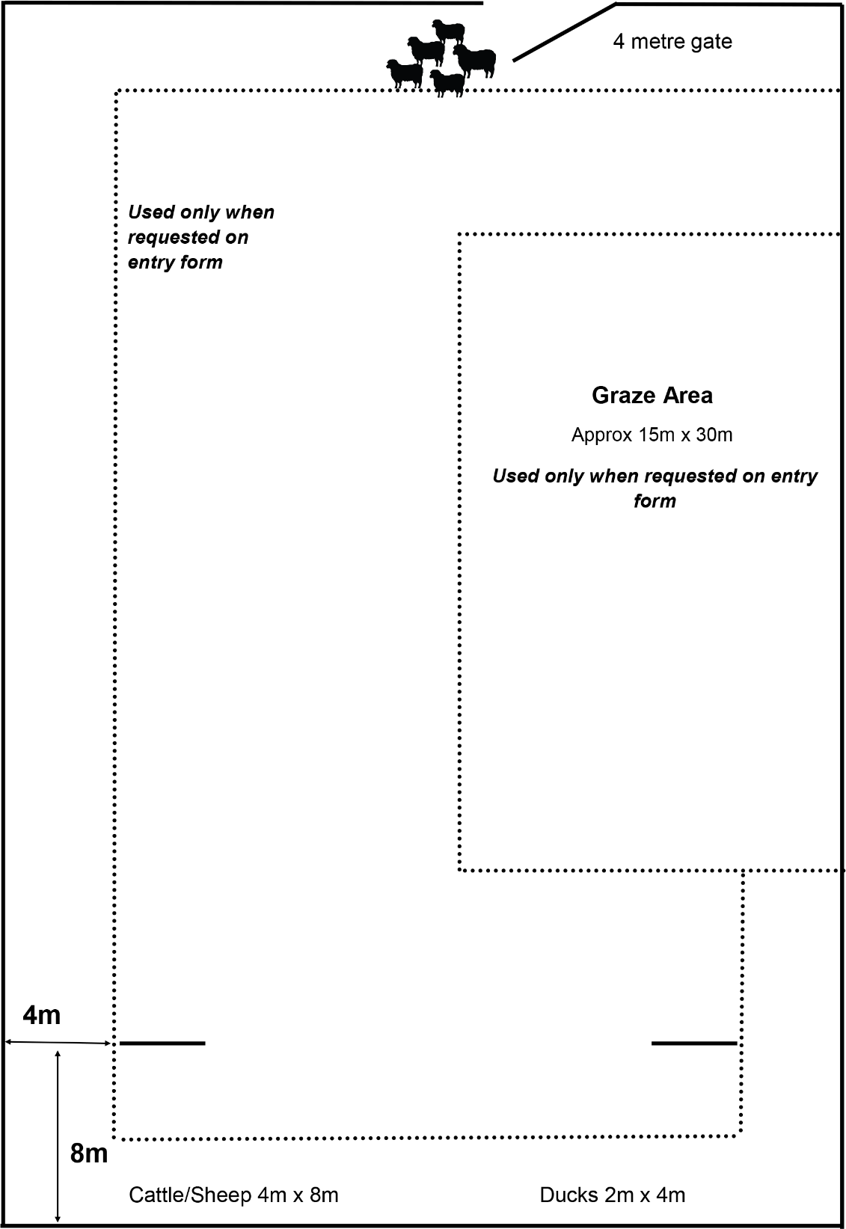

Minimum of 15m x 15m up to maximum of 15m x 30m
2-4 metre gate

CHAPTER 4. HERDING TRIALS

Section 1. Trial Classes.
The classes at a Herding Trial are graduated as Started, then Novice or Intermediate and Advanced. Affiliates have the option to offer the Novice class for Course A and B. An exhibitor may enter a dog in any Trial class for which it is eligible however once that dog has acquired a qualifying score in such level, it shall be ineligible to be entered in Instinct, Herding or Pre-Trial Tests and any lower Trial level (on that course/stock).
Qualifications up to and including the date of closing of entry shall count as eligibility to compete in any class. Titles must be applied for within one month of qualification for the dog to continue to trial at the next level.

    - A dog must qualify on three occasions in the respective Trial class to become eligible for the title in the class.

    - A minimum of two Judges must award qualification within each level of Trial class for the dog to be eligible to claim title in the class.

    - A dog may be entered in more than one class at an event, subject to qualification and entry limitations.

    - Sequence of Trial classes and eligibility to compete:
      - Entry into Started class requires qualification at Pre-Trial (PT) Test level.
      - Entry into Novice class requires qualification at Herding Started (HS) Trial level.
      - Entry into Intermediate class requires qualification at Herding Started (HS) Trial level.
      - Entry into Advanced class requires qualification at Herding Intermediate (HI) Trial level.

    - An approved Trial need not include all classes but in order to hold a Novice class the trial must include the Started class. If Intermediate is offered the trial must include Novice and Started. If an Advanced class is offered, Intermediate, Novice and Started classes must also be offered at approved Trials.

    - Dogs may not be entered in the same class under the same judge on the same livestock more than once at an event.

Section 2. Qualifying Scores.

    - A qualifying score shall be 65 or more points in all classes, provided no single point category is scored at less than one-half the available points (Non-Qualifying).
No dog shall be credited with a leg toward a title or a Herding Championship unless it receives a qualifying score.

Section 3. Herding Trial Titles

    - Dogs Australia will issue a Herding Started certificate designating the specific course and livestock type for an eligible dog, and will identify the title by the use of HS (course and livestock) after the name of that dog in all official Dogs Australia records, once the dog has been certified by at least two different Judges to have received three qualifying scores in the Started classes, same course and livestock type, at Affiliated Member Herding Trials.

    - Dogs Australia will issue a Herding Started Master certificate designating the specific course and livestock type for an eligible dog, and will identify the title by the use of HSM (course and livestock) after the name of that dog in all official Dogs Australia records, once the dog has been certified to have received eight (8) additional qualifying scores in the Started classes of 90 or above, same course and livestock type, at Affiliated Member Herding Trials.

    - Dogs Australia will issue a Herding Novice certificate designating the specific course and livestock type for an eligible dog, and will identify the title by the use of HN (course and livestock) after the name of that dog in all official Dogs Australia records, once the dog has been certified by at least two different Judges to have received three qualifying scores in the Novice classes, same course and livestock type, at Affiliated Member Herding Trials.

    - Dogs Australia will issue a Herding Intermediate certificate designating the specific course and livestock type for an eligible dog, and will identify the title by the use of HI (course and livestock) after the name of that dog in all official Dogs Australia records, once the dog has been certified by at least two different Judges to have received three qualifying scores in the Intermediate classes, same course and livestock type, at Affiliated Member Herding Trials.

    - Dogs Australia will issue a Herding Intermediate Master certificate designating the specific course and livestock type for an eligible dog, and will identify the title by the use of HIM (course and livestock) after the name of that dog in all official Dogs Australia records, once the dog has been certified to have received eight (8) additional qualifying scores in the Intermediate classes of 85 or above, same course and livestock type, at Affiliated Member Herding Trials.

    - Dogs Australia will issue a Herding Advanced certificate designating the specific course and livestock type for an eligible dog, and will identify the title by the use of HX (course and livestock) after the name of that dog in all official Dogs Australia records, once the dog has been certified by at least two different Judges to have received three qualifying scores in the Advanced classes, same course and livestock type,at Affiliated Member Herding Trials.

    - For the purposes of title application: Novice, Started Masters and Intermediate Masters are optional classes and remain on the formal titles of the dogs after higher titles are earned.

Section 4. Herding Champion

    - Dogs Australia will issue a Herding Champion (HCH) Certificate for an eligible dog that has acquired a Herding Advanced (HX) Title and earned at least another 5 further qualifying passes with scores of 85 points or more, all on the same course and stock type that the HX was earned.
Examples.
      - Once a dog has gained a HXAs title, it is required to gain at least 5 more passes in Herding Advanced A course on sheep, with scores of 85 points or more from Herding Advanced A course on sheep.
      - Once a dog has gained a HXBs title, it is required to gain at least 5 more passes in Herding Advanced B course on sheep, with scores of 85 points or more from Herding Advanced B course on sheep.
      - Once a dog has gained a HXCs title, it is required to gain at least 5 more passes in Herding Advanced C course on sheep, with scores of 85 points or more from Herding Advanced C course on sheep. The same examples apply for cattle and duck titles.

    - Dogs Australia will issue a Grand Herding Champion certificate for an eligible dog, and will identify the title by the use of GRHCH before the name of that dog in all official Dogs Australia records once the dog has achieved all the following requirements: The dog has achieved HCH and earned a least another 5 qualifying scores of 85 points or more after submission for HCH whilst competing in Advanced in the same course & with the same stock as the Herding Champion title was gained.

    - Dogs Australia will issue a Versatile Herding Champion certificate for an eligible dog and will identify the title using VHCH before the name of that dog in all official Dogs Australia records once the dog has achieved Herding Champion Status on two course or stock types. Upon receiving the title of Versatile Herding Champion, a dog may continue to compete in Advanced classes.

    - Dogs Australia will issue a Versatile Herding Champion Excellent certificate for an eligible dog and will identify the title using VHCHX before the name of that dog in all official Dogs Australia records once the dog has achieved Herding Champion Status on three course or stock types. Upon receiving the title of Versatile Herding Champion Excellent, a dog may continue to compete in Advanced classes.

    - Dual Champions
      - Dogs Australia will issue a Dual Champion certificate to a dog which has been awarded the titles of Conformation Champion and Herding Champion (HCH, inclusive of the course & stock), and will identify the title using Dual Champion (H) in all official Dogs Australia records.
      - Dogs Australia will issue a Dual Champion certificate to a dog which has been awarded the titles of Conformation Champion and Versatile Herding Champion (VHCH, inclusive of the course & stock), and will identify the title using Dual Champion (VH) in all official Dogs Australia records.
      - Dogs Australia will issue a Dual Champion certificate to a dog which has been awarded the titles of Conformation Champion and Versatile Herding Champion Excellent (VHCHX, inclusive of the course & stock), and will identify the title using Dual Champion (VHX) in all official Dogs Australia records.

    - Triple Champions
      - Dogs Australia will issue a Triple Champion certificate to a dog which has been awarded the titles of Conformation Champion, any other Dogs Australia Performance Champion title and Herding Champion (HCH, inclusive of course & stock), and will identify the title using Triple Champion (H) in all official Dogs Australia records.
      - Dogs Australia will issue a Triple Champion certificate to a dog which has been awarded the titles of Conformation Champion, any other Dogs Australia Performance Champion title and Versatile Herding Champion (VHCH inclusive of course & stock) and will identify the title using Triple Champion (VHCH inclusive of course & stock) in all official Dogs Australia records.
      - Dogs Australia will issue a Triple Champion certificate to a dog which has been awarded the titles of Conformation Champion, any other Dogs Australia Performance Champion title and Versatile Herding Champion Excellent (VHCHX, inclusive of course & stock), and will identify the title using Triple Champion (VHX inclusive of course & stock) in all official Dogs Australia records.

    - Dogs Australia will issue Herding Champion Certificates for eligible dogs and will identify the title inclusive of Course & Stock before the name of that dog in all official Dogs Australia records. Titles at the end of the dog’s registered name associated with the Herding Champion title must be removed. Titles under 4.3.7 are an exception.

Section 5. Trial Field Conditions, Cancellations

    - Any area used for a Herding Trial must have a perimeter fence to prevent livestock escaping from the arena.
    - All natural obstacles such as trees, rocks, hills, and valleys are permitted on the course. The Judge and the Trial Manager may reverse the direction of the course and modify the location of the obstacles as necessitated by local circumstances, provided such changes are in keeping with the basic character of the course.

The Judges and Trial Committee shall have the option of cancelling or rescheduling the Trial if dangerous and unanticipated conditions warrant.
The conditions described in Chapter 2, Section 3 of these regulations regarding Judges and Affiliates Responsibilities and cancellations and refunds shall apply should a Trial be cancelled.

Section 6. Courses

    - Each Trial class shall offer at least one of three courses, Course A, Course B, or Course C as hereinafter described. A Club need not offer all three courses at a Trial, but schedules and catalogues must clearly specify which courses are offered, the Judges of each course, and the type and number of livestock that will be used for each course.

    - Whenever stock is to be worked in adjacent arenas or held adjacent to the working area, visibility screens must be used.

SA Proposed changes – 4.6.2 Whenever stock is to be worked in adjacent arenas or held adjacent to the working area, visibility screens must be used (refer to 2.11.2).
SA Rationale – 4.6.2 addition of clarification to previous rule.

Section 7. Livestock Requirements

    - All of the general and minimum livestock requirements contained in Chapter 2, Section 10 of these Regulations shall apply to all classes in all Courses. Stock shall be rotated so that a rested group is used for each run in Course A and B.

Section 8 General Course Requirements

    - A dog shall not be given a re-run if the stock completes the course without guidance from the dog.

SA Proposed Changes – 4.8.1 A dog shall not be given a re-run if the stock completes the course without guidance from the dog
SA Rationale – 4.8.1 if the stock completes the course without the dog then they would be deemed unsuitable for trialing.

    - The timer shall signal a two-minute warning and shall also signal the end of the run

    - In all classes the lead is removed at the gate after the gate is closed to the arena.

SA Proposed Changes – 4.8.3 In all classes the lead is removed at the gate after the gate is closed to the arena. unless used to walk the dog to the start peg which attracts penalties
SA Rationale – Clarification that the lead can be used to the start point but will attract penalties.

Section 9. Ties.
    - All Ties shall be allowed.

CHAPTER 5. COURSE A.

Section 1. Course A.
    - Course A is an all-around farm or property course designed to demonstrate the versatility of the Herding dog. Handlers shall not enter any obstacles, in any class, except as otherwise provided in these regulations.

    - Course A shall consist of a minimum fenced area of 30 m x 60m, not to exceed a maximum fenced area of approximately 60m x 120m for sheep and cattle. For ducks, Course A should measure approximately 15m x 30m to approximately 30m x 60m. An oval or rectangular arena is acceptable.

SA Proposed changes – Addition or 5.1.3 & 5.1.4
    - The course is to be traversed within a 4m (2m for ducks) corridor from the pickup point along the path as shown in the diagram from number marker to number marker

    - The markers 1, 2, 3, 4 and 5 marks the beginning of the obstacles (#1 the start of the Y chute, #2 marks the end of the Y chute and the start of the Z chute, #3 marks the end of the Z chute and the beginning of the Hold/Exam Pen, (Panel Runway in Started and Novice), #4 marks the end of the Hold/Exam Pen, (Panel Runway in Started and Novice) and the beginning of the Centre line gates, #5 marks the end of the Centre line gates and the start of the Pen). Hence this is where the scoring for these sections start and finish.

SA Rationale – 5.1.3 & 5.1.4 This detail has been lost over the rule changes, this helps to clarify what, how and why the course is negotiated, scored and traversed with the width of 2m for ducks to accommodate the use of larger fowl. See section 5.2.1 where it mentions the positioning for ducks being 6m and 2m, this brings the rules into line with the sheep cattle being 10m and 4m with the 4m corridor also re 5.2.1 where the panels are placed 2m from the sides for ducks..

Section 2. Course A Layout.
    - The course includes three centre line locations ("lettered posts"), Y Chute, Z Chute, Holding pen or runway, centre line gates and exhaust pen and five numbered markers.
The "near side" of the arena is the long fence where the "Y chute" is located; the "far side" of the arena is the long fence where the runway or hold/exam pen is located; the "top" of the arena is the shorter fence nearest to the centre line panels; the "bottom" of the arena is the shorter fence where the "Z" chute is located.
The stock should be positioned 10 metres (6 m for ducks) from the top fence line and 4 m (2 m for ducks) from the centre line toward the far side of the arena

Section 3. Posts

    - Posts: Letters, of sufficient size to be clearly seen, are placed on posts or cones as shown in the diagrams.

    - Post A (which defines the approach limit of the handler in the Started Class) is on the centre line 14 m for sheep and cattle (8 m for ducks) from the top of the arena.

    - Post B is located immediately beside the far side of the bottom end of the centre line panels

    - Post C is located on the centre line, in line with the bottom end of the "Y" chute panels.

Section 4. Obstacles

    - The Centre line Gate – Two panels, recommended 2.4 to 4 metres (1-2 m for ducks) in length are placed on the centre line of the arena, approximately 5 metres apart, parallel with the long walls of the arena.
The midpoint of the 5 metre opening (gate) is approximately 1/3 the length of the arena, measured from the top of the arena. The opening for the centre line gate is 5 metres for sheep and cattle, 2 metres for ducks.
SA Proposed changes – 5.4.1 The Centre line Gate – Two panels, recommended 2.4 to 4 metres (1-2 m for ducks) in length are placed on the centre line of the arena, approximately 5 metres apart for sheep and cattle. 2m for ducks, parallel with the long walls of the arena.
The midpoint of the 5 or 2 metre opening (gate) is approximately 1/3 the length of the arena, measured from the top of the arena. The opening for the centre line gate is 5 metres for sheep and cattle, 2 metres for ducks
SA Rationale – 5.4.1addition of clarification for the course layout with regards to ducks being used. Last sentence is a repeat of previous sentence.

    - The "Y" Chute and Hold/Exam Pen – The top edges of the "Y" chute and the Hold/Exam pen (runway panel in Started and Novice Class) are at approximately 2/3 of the length of the arena, measured from the top of the arena. The length of the alleyway is from 5 to 7.5 metres for sheep and cattle and 2.5 to 4 metres for ducks.

    - The "Y" chute may be formed either by using the arena wall as one side of the obstacle, with three panels on the other side, or may be freestanding.
For example: When the arena fence is used on one side, two panels are placed end to end, parallel to and 1.2 metres (0.6 m for ducks) out from the arena fence, to form the chute. The third panel is attached to the top edge of the chute panels and slanted toward the centre of the arena to make a funnel opening 4 metres wide (1.2 m for ducks).
SA Proposed changes – 5.4.3 The "Y" chute may be formed either by using the arena wall as one side of the obstacle, with three panels on the other side, or may be freestanding.
For example: When the arena fence is used on one side, two panels are placed end to end, parallel to and 1.2 metres (0.6 0.8m for ducks) out from the arena fence, to form the chute. The third panel is attached to the top edge of the chute panels and slanted toward the centre of the arena to make a funnel opening 4 metres wide (1.2 2m for ducks)
SA Rationale – 5.4.3 increase width from fence for duck to allow for larger fowl and increase 1.2m to 2m for opening to bring in line with other areas of these rules and SA proposed changes where required re 2m corridor travel for ducks.

    - When the "Y" chute is freestanding, the two panels are placed end to end, parallel to and 1.2 m (0.6m for ducks) out from the arena fence. One panel is attached to the top edge of the chute panels and slanted to touch the arena fence. The two inside panels are arranged as described above, but placed
2.5 m (1.2 m for ducks) out from the fence line to make a chute that is 1.2 m wide (0.6 m for ducks). The remaining panels are attached to the top of the outside panels and slanted toward the centre of the arena to make a funnel opening 4 m wide (1.2 m for ducks). A short panel is attached at the bottom of the outside panels to block the dead space, so the stock will not become trapped if they retreat on the course.
SA Proposed changes – 5.4.4 When the "Y" chute is freestanding, the two panels are placed end to end, parallel to and 1.2m (0.6 0.8m for ducks) out from the arena fence. One panel is attached to the top edge of the chute panels and slanted to touch the arena fence. The two inside panels are arranged as described above, but placed
2.5 m (1.2 m for ducks) out from the fence line to make a chute that is 1.2 m wide (0.6 0.8m for ducks). The remaining panels are attached to the top of the outside panels and slanted toward the centre of the arena to make a funnel opening 4 m wide (1.2 2m for ducks). A short panel is attached at the bottom of the outside panels to block the dead space, so the stock will not become trapped if they retreat on the course.
SA Rationale – 5.4.4 change sizing to b ring in line with other areas of these rules and SA proposed changes where required re 2m corridor travel for ducks.

    - The "Z" Chute - The "Z" chute is placed adjacent to and in the middle of the fence line at the bottom end of the arena.
Example 1: Formed with 5 slatted panels of equal length and one shorter panel. The inside (arena side) uses three panels. The first forms the mouth of the chute and is set at an angle of 45 degrees from the fence line. The second panel attaches at a 90-degree angle to the first panel. The third panel is attached to the second panel, to run parallel to the fence line. The outside (fence line side) of the "Z" chute is formed with three panels. Two panels of equal length are set to form an alleyway parallel to the inside panels. The alleyway is 1.2 metres wide for sheep and cattle, 0.6 metres wide for ducks. Short panel(s) are attached to the last panel and the fence to block the dead space, so livestock cannot turn toward the fence and become trapped.
Example 2: Formed by 3 long panels of equal length and 2 shorter panels of equal length. The inside (arena side) uses 3 panels. The first forms the mouth of the chute and is set at an angle of 45 degrees from the fence line. The second attaches at a 90-degree angle to the first panel. The third attaches at a 90-degree angle to the second panel to form a "Z." The outside (fence line side) is 2 shorter panels attached together and to the fence line, to run parallel to the inside panels, forming an alleyway 1.2 metres wide for sheep and cattle, 0.6 metres wide for ducks.

SA Proposed changes – 5.4.5 The "Z" Chute - The "Z" chute is placed adjacent to and in the middle of the fence line at the bottom end of the arena.
Example 1: Formed with 5 slatted panels of equal length and one shorter panel. The inside (arena side) uses three panels. The first forms the mouth of the chute and is set at an angle of 45 degrees from the fence line. The second panel attaches at a 90-degree angle to the first panel. The third panel is attached to the second panel, to run parallel to the fence line. The outside (fence line side) of the "Z" chute is formed with three panels. Two panels of equal length are set to form an alleyway parallel to the inside panels. The alleyway is 1.2 metres wide for sheep and cattle, 0.6 0.8metres wide for ducks. Short panel(s) are attached to the last panel and the fence to block the dead space, so livestock cannot turn toward the fence and become trapped.
Example 2: Formed by 3 long panels of equal length and 2 shorter panels of equal length. The inside (arena side) uses 3 panels. The first forms the mouth of the chute and is set at an angle of 45 degrees from the fence line. The second attaches at a 90-degree angle to the first panel. The third attaches at a 90-degree angle to the second panel to form a "Z." The outside (fence line side) is 2 shorter panels attached together and to the fence line, to run parallel to the inside panels, forming an alleyway 1.2 metres wide for sheep and cattle, 0.6 0.8metres wide for ducks
SA Rationale – 5.4.5 change sizing to b ring in line with other areas of these rules and SA proposed changes where required re 2m corridor travel for ducks.

Hold/Exam Pen (or Panel Runway for Started and Novice)
A 4 m long (1.2 to 2 metres for ducks) panel(s) is placed parallel to the fence line to form a panel runway for Started and Novice.
For Intermediate and Advanced, another 4 metre long (1.2 to 2 metres long for ducks) panel(s) is attached toward the top of the arena to the fence and the freestanding panel. Together, with the fence, the two panels form a three-sided pen, open toward the bottom of the arena.

Section 5. Markers
    - Number Markers – Numbers, of sufficient size to be clearly seen, are placed on the fence as shown in the diagrams. Marker #1 is placed at Post C. Marker #2 is on the arena corner between the "Y" and the "Z" chute.
Marker #3 is on the arena corner between the "Z" chute and the panel runway or hold/exam pen. Markers #4 and #5 are opposite each other on the long fences, directly across from the opening of the centre line.

Section 6. Pen
    - Pen – A minimum 2 metre squared pen for sheep or cattle and a minimum of 1.2 metre squared for ducks is placed outside the top nearside (same side as the Y chute) of the arena.
The gate parallel with the near side fence should open towards the top side fence of the arena (as shown in the diagram)
The width of the gate should allow free flow of stock and be a recommended minimum of 2metres for sheep or cattle and 1 metre for ducks.

SA Proposed changes – 5.6.1 Pen – A minimum 2 metre to maximum 4m squared pen for sheep or cattle and a minimum of 1.2 metre to a maximum 2m squared for ducks is placed outside the top nearside (same side as the Y chute) of the arena.
The gate parallel with the near side fence should open towards the top side fence of the arena (as shown in the diagram)
The width of the gate should allow free flow of stock and be a recommended minimum of 2metres to a maximum 4m for sheep or cattle and a minimum 1.2 to maximum 2m 1 metre for ducks.
SA Rationale – 5.6.1 minimums are mentioned but maximums are not and should be added to balance the minimum example.

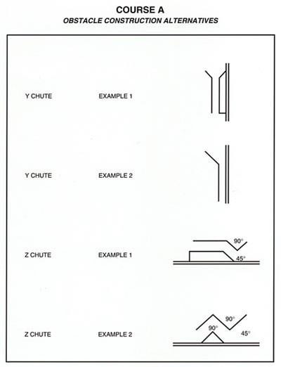

Section 7. Classes.

Started Class Course A – Description

Time Allowed: 10 minutes for sheep and ducks, 12 minutes for cattle. Timing starts when the handler sends their dog and finishes when the handler closes the pen gate.

Start
The dog enters the arena and is placed at Post B. The handler may move to any location on the centre line between Post A and Post B.

Gather
The dog begins the gather from Post B. The dog moves the stock down the arena on the far side of the centre line panels towards marker #1 (Post C).

The handler may move within the handler's zone between Posts A and B during the gather. After the stock reach Post A, it is the handler's option in which manner the course is executed: drive, fetch or a combination of both. The handler may walk to any position once the stock has moved past Post A.

SA Proposed changes – GATHER The dog begins the gather from Post B. The dog moves the stock down the arena in the 4m corridor on the far side of the centre line panels towards marker #1 (Post C).

The handler may move within the handler's zone between Posts A and B during the gather. After the stock reach Post A, it is the handler's option in which manner the course is executed: drive, fetch or a combination of both. The handler may walk to any position on the course once the stock has moved past over the handlers zone as marked in the following diagram, Post A
SA Rationale GATHER addition of the 4m corridor to clarify where the stock should be moved and clarification of the handlers zone and when the handler can move.

"Y" Chute
Turn stock around Post C and move the stock to the "Y" chute with a turn down the arena through the chute towards marker #2.

"Z" Chute
Turn stock toward the far side at marker #2 and move the stock through "Z" chute towards marker #3.

Panel Runway
Turn stock toward the top at marker #3 and move the stock straight through the panel runway towards marker#4.

Centre line Gate
Turn stock towards the near side at marker #4 and move the stock straight across arena through centre line gate to marker #5. The handler may pass through the centre line gate.

Pen
Turn stock towards the top of the arena at marker #5 and move the stock to near the exhaust pen. The dog holds the stock in a location near the exhaust pen but away from the gate while the handler opens the gate. The stock is penned. The handler closes the gate and completes the run. The dog must demonstrate it is willing to disengage with the stock.

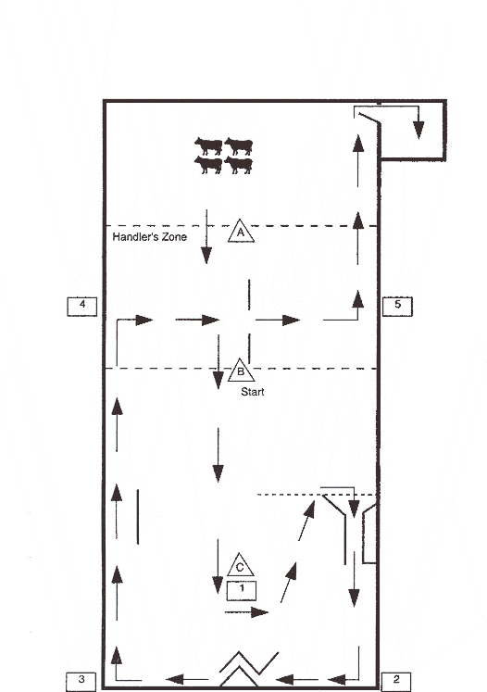

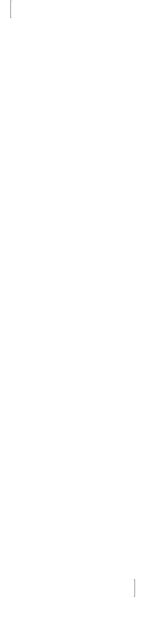
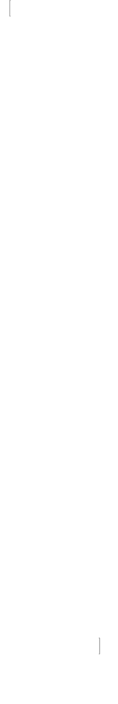
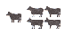
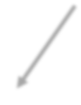
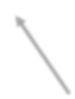
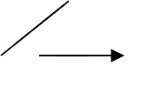
COURSE A STARTED

Time Allowed – 10 minutes (Sheep & Ducks)
12 minutes (Cattle)

Lift Area
Arena Size - Sheep & Cattle Minimum 30m x 60m Maximum 60m x 120m
Ducks Minimum 15m x 30m Maximum 30m x 60m

The stock should be positioned 10m off the top fence line and approximately 4m to the left of the Centre line Gate panels for sheep and cattle, 2m to the left of Centre line gate panels for ducks

Panel Runway The top edge is at 2/3 the total length of the arena. The runway is 4m for sheep and cattle,1.2m wide for ducks.

Z Chute
½ the arena width. The alleyway is
1.2m wide for sheep and cattle, 0.6m wide for ducks

Centre line Gate Centre of panels 1/3 total length of arena

Panels set 5m apart for sheep and cattle, 2m apart for ducks

Y Chute
The top of the chute is at 2/3 the total length of the arena.
The opening is 4m wide for sheep and cattle,
1.2m wide for ducks
.
The alleyway is
1.2m wide and from 5m to
7.5mlong for sheep and cattle, 0.6m wide and from
2.5m to 4m long for ducks.

Novice Class Course A - Description (Optional Class)

Time Allowed: 10 minutes for sheep and ducks, 12 minutes for cattle. Timing starts when the handler sends their dog and finishes when the handler closes the pen gate.

The drive legs (Post C/#1 to #2 and #2 to #3) must be performed at a drive for more than half of its distance in each scoring category. The dog must demonstrate its ability to drive stock forward on the course to qualify in this class.

Start
The dog enters the arena and is placed at Post C. The handler may move to any location on the centre line between Post A and Post C.

Gather
The dog begins the gather from Post C. The dog moves the stock down the arena on the far side of the centre line panels towards marker #1 (Post C).

The handler may move within the zone between Posts A & C during the gather. After the stock reach Post A, it is the handler's choice as to the way marker #1 is reached: drive, fetch or a combination of both.

"Y" Chute
Turn stock around Post C and move the stock to and through the "Y" chute towards marker #2.
The handler may be in any position to assist the dog to drive but must not lead the stock through the course between marker #1 and #3. The handler may choose to take the stock directly from the Y chute to the Z chute.

SA Proposed changes - "Y" Chute
Turn stock around Post C and move the stock to and through the "Y" chute towards marker #2.
The handler may be in any position to assist the dog to drive but must not lead the stock through the course between marker #1 and #3. The handler may choose to take the stock directly from the Y chute to the Z chute
SA Rationale – The course is to be negotiated from marker to marker through obstacles. A higher level should be able to negotiate the course as a lower level is expected to, there is no compensation in the Started rule that mentions one can miss markers #2 and #3. It is the course and making these markers are as important as making markers #4 and #5. Clear course direction helps negotiating the course easier for competitors and for judging by judges.

"Z" Chute
Turn stock towards the far side at marker #2, then move stock through the "Z" chute towards marker #3. The handler may choose to take the stock directly from the Z chute to the panel runway.

SA Proposed changes "Z" Chute
Turn stock towards the far side at marker #2, then move stock through the "Z" chute towards marker #3. The handler may choose to take the stock directly from the Z chute to the panel runway.
SA Rationale – The course is to be negotiated from marker to marker through obstacles. A higher level should be able to negotiate the course as a lower level is expected to, there is no compensation in the Started rule that mentions one can miss markers #2 and #3. It is the course and making these markers are as important as making markers #4 and #5. Clear course direction helps negotiating the course easier for competitors and for judging by judges.

Panel Runway
Turn stock toward the top at marker #3 and move the stock straight through the panel runway toward marker #4.

Centre line Gate
Turn stock towards the near side at marker #4 and move the stock straight across arena through centre line gate to marker #5. The handler may pass through the centre line gate.

Pen
Turn stock towards the top of the arena at marker #5 and move the stock to near the exhaust pen. The dog holds the stock in a location near the exhaust pen but away from the gate while the handler opens the gate. The stock is penned. The handler closes the gate and completes the run. The dog must demonstrate it is willing to disengage with the stock.

COURSE A NOVICE
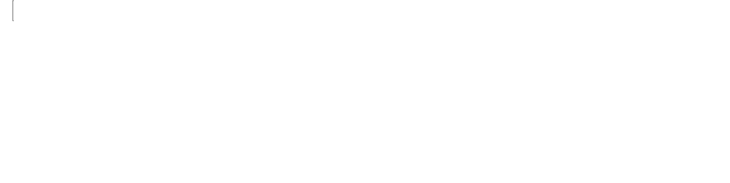
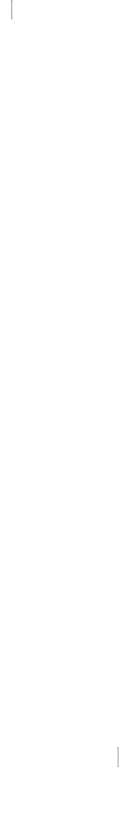
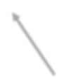
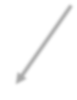
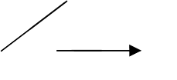
Time Allowed – 10 minutes (Sheep & Ducks)
12 minutes (Cattle)
Arena Size - Sheep & Cattle Minimum 30m x 60m Maximum 60m x 120m
Ducks Minimum 15m x 30m Maximum 30m x 60m
Lift Area

The stock should be positioned 10m off the top fence line and approximately 4m to the left of the Centre line Gate panels for sheep and cattle, 2m to the left of Centre line Gate panels
for ducks

Centre line Gate Centre of panels 1/3 total length of arena

Panels set 5m apart for sheep and cattle, 2m apart for ducks

Panel Runway The top edge is at 2/3 the total length of the arena. The runway is 4m for sheep and cattle, 1.2m wide for ducks.

Z Chute
½ the arena width. The alleyway is
1.2m wide for sheep and cattle, 0.6m wide for ducks

Start

Y Chute
The top of the chute is at 2/3 the total length of the arena.

The opening is 4m wide for sheep and cattle, 1.2m wide for ducks.

The alleyway is1.2m wide and from 5m to 7.5m long for sheep and cattle, 0.6m wide and from
2.5m to 4m long for ducks.

Intermediate Class Course A – Description

Time allowed: 10 minutes for sheep and ducks, 12 minutes for cattle. Timing starts when the handler sends their dog and finishes when the handler closes the gate.

Start
The dog enters the arena and is placed at Post C. The handler may move to any location on the centre line between Post B and Post C.

Gather
The dog begins the gather from Post C. The dog moves the stock down the arena on the far side of the centre line panels towards marker #1 (Post C).

The handler may move within the zone between Posts B & C during the gather. After the stock reach Post B, it is the handler's option in which manner marker #1 is reached: drive, fetch or a combination of both. The handler must be within a two metre arc of Post C before attempting the “Y" chute.

"Y" Chute
Turn stock around Post C and move the stock to and through the "Y" chute towards marker #2. The handler remains within a two metre arc of Post C (within the handler zone) until the stock have exited the "Y" chute. The handler may choose to take the stock directly from the Y chute to the Z chute.

The handler may move after completion of the "Y" chute but must remain in the zone between Post B and Post C until the stock reach marker #5.

SA Proposed changes - "Y" Chute
Turn stock around Post C and move the stock to and through the "Y" chute towards marker #2.
The handler may be in any position to assist the dog to drive but must not lead the stock through the course between marker #1 and #3. The handler may choose to take the stock directly from the Y chute to the Z chute
The handler may move after completion of the "Y" chute but must remain in the handler zone between Post B and Post C until the stock reach marker #5
SA Rationale – The course is to be negotiated from marker to marker through obstacles. A higher level should be able to negotiate the course as a lower level is expected to, there is no compensation in the Started rule that mentions one can miss markers #2 and #3. It is the course and making these markers are as important as making markers #4 and #5. Clear course direction helps negotiating the course easier for competitors and for judging by judges. Addition of handler to zone for clarification.

"Z" Chute
Turn stock towards the far side at marker #2, then move stock through the "Z" chute towards marker #3. The handler may choose to take the stock directly from the Z chute to the Hold/Exam Pen.

SA Proposed changes "Z" Chute
Turn stock towards the far side at marker #2, then move stock through the "Z" chute towards marker #3. The handler may choose to take the stock directly from the Z chute to the panel runway.
SA Rationale – The course is to be negotiated from marker to marker through obstacles. A higher level should be able to negotiate the course as a lower level is expected to, there is no compensation in the Started rule that mentions one can miss markers #2 and #3. It is the course and making these markers are as important as making markers #4 and #5. Clear course direction helps negotiating the course easier for competitors and for judging by judges.

Hold/Exam Pen
Turn stock towards the top at marker #3 and move the stock into the Hold/Exam pen. The dog will allow the stock to settle and hold them for 15 seconds after which the Judge indicates that the stock are to be moved out of the pen. After the hold, the stock are moved out of the hold pen and moved toward marker #4. The handler shall not enter the obstacle.

Centre line Gate
Turn stock towards the near side at marker #4 and move the stock straight across the arena, through the centre line gate to marker #5.

After the stock has reached marker #5, the handler proceeds directly to the exhaust pen gate and may pass through the centre line gate at his/her option.

Pen
Turn stock towards the top of the arena at marker #5 and move the stock to near the exhaust pen. The dog holds the stock in a location near the exhaust pen but away from the gate while the handler opens the gate. The stock is penned. The handler closes the gate and completes the run. The dog must demonstrate it is willing to disengage with the stock.

COURSE A INTERMEDIATE

Time Allowed – 10 minutes (Sheep & Ducks)
12 minutes (Cattle)
Arena Size - Sheep & Cattle Minimum 30m x 60m Maximum 60m x 120m
Ducks Minimum 15m x 30m Maximum 30m x 60m

Lift Area
The stock should be positioned 10m off the top fence line and approximately 4m to the left of the Centre line Gate
panels for sheep A
and cattle,2m to the left of Centre line Gate panels for ducks

Centre line Gate Centre of panels 1/3 total length of arena

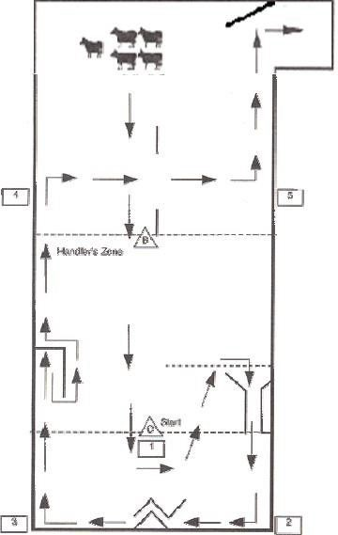
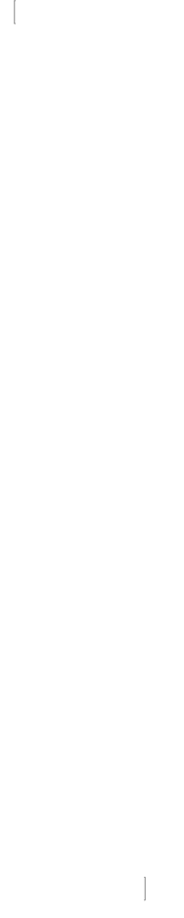
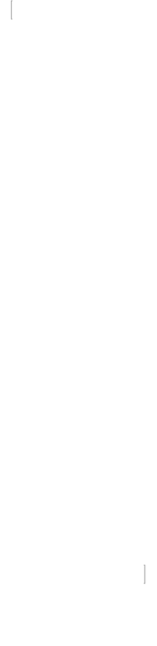




Hold Exam/Pen The top edge is at 2/3 the total length of arena.
Hold/Exam
is 4m x 4m for sheep and cattle,
1.2m x 1.2m for ducks.

Z Chute
½ the arena width. The alleyway i s
1.2m wide for sheep and cattle, 0.6m wide for ducks
Panels set 5m apart for sheep and cattle, 2m apart for ducks

Y Chute
The top of the chute is at 2/3 the total length of the arena
The opening is 4m
wide for sheep and cattle,
1.2m wide for ducks.

The alleyway is1.2m wide and from 5m to 7.5m long for sheep and cattle, 0.6m wide and from 2.5m to 4m long for ducks.

Advanced Class Course A – Description

Time allowed: 10 minutes for sheep and ducks, 12 minutes for cattle. Timing starts when the handler sends their dog, and finishes when the handler closes the gate

Start
The dog enters the arena. The dog and the handler begin the course at Post C.

Gather
The dog begins the gather from Post C. The dog moves the stock down the arena on the far side of the centre line panels towards marker #1 (Post C).

The handler remains at Post C during the gather. Once the dog moves the stock, the handler may move to the bottom corner of the hold/exam pen or remain at Post C. The handler must then maintain their position until the stock reach marker #3.

"Y" Chute
Turn stock around Post C and move the stock to the "Y" chute with a turn down the arena through the chute towards marker #2. The handler may choose to take the stock directly from the Y chute to the Z chute.

SA Proposed changes - "Y" Chute
Turn stock around Post C and move the stock to and through the "Y" chute towards marker #2.
The handler may be in any position to assist the dog to drive but must not lead the stock through the course between marker #1 and #3. The handler may choose to take the stock directly from the Y chute to the Z chute
SA Rationale – The course is to be negotiated from marker to marker through obstacles. A higher level should be able to negotiate the course as a lower level is expected to, there is no compensation in the Started rule that mentions one can miss markers #2 and #3. It is the course and making these markers are as important as making markers #4 and #5. Clear course direction helps negotiating the course easier for competitors and for judging by judges.

"Z" Chute
Turn stock towards the far side at marker #2 and move the stock straight through the "Z" chute towards marker #3. The handler may choose to take the stock directly from the Z chute to the Hold/Exam Pen.
Once the stock reach marker #3, the handler moves to hold/exam pen where the handler must remain until the stock is moved to marker #5. The handler may move/stand anywhere along the panel that runs parallel to the centre line.

SA Proposed changes "Z" Chute
Turn stock towards the far side at marker #2, then move stock through the "Z" chute towards marker #3. The handler may choose to take the stock directly from the Z chute to the panel runway.
SA Rationale – The course is to be negotiated from marker to marker through obstacles. A higher level should be able to negotiate the course as a lower level is expected to, there is no compensation in the Started rule that mentions one can miss markers #2 and #3. It is the course and making these markers are as important as making markers #4 and #5. Clear course direction helps negotiating the course easier for competitors and for judging by judges.

Hold/Exam Pen
Turn stock towards the top at marker #3 and move the stock into the Hold/Exam pen. The dog will allow the stock to settle and hold them for 15 seconds after which the Judge indicates that the stock is to be moved out of the pen. After the hold, the stock is moved out of the hold pen and moved toward marker #4. The handler shall not enter the obstacle.

Centre-line Gate
Turn stock towards the near side at marker # 4 and move the stock straight across the arena, through the centre line gate to marker #5.
After the stock has reached marker #5, the handler proceeds directly to the exhaust pen gate and may pass through the centre line gate at his/her option.

Pen
Turn stock towards the top of the arena at marker #5 and move the stock to near the exhaust pen. The dog holds the stock in a location near the exhaust pen but away from the gate while the handler opens the gate. The stock is penned.
The handler closes the gate and completes the run. The dog must demonstrate it is willing to disengage with the stock.

COURSE A ADVANCED
Time Allowed – 10 minutes (Sheep & Ducks)
12 minutes (Cattle)

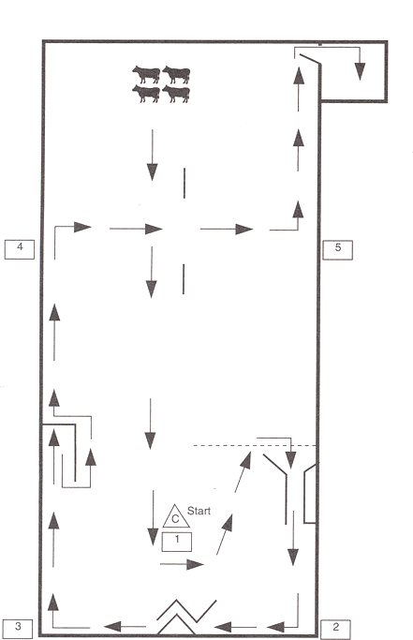
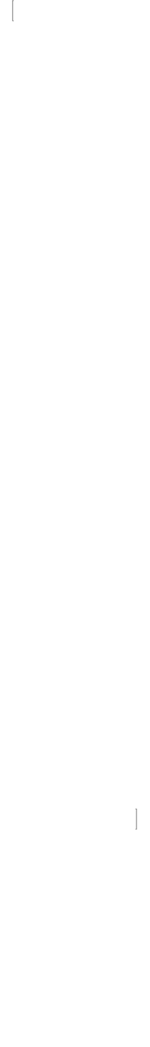
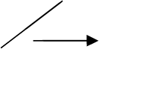
Arena Size - Sheep & Cattle Minimum 30m x 60m Maximum 60m x 120m
Ducks Minimum 15m x 30m Maximum 30m x 60m

Lift Area The stock should be
positioned 10m off the top fence line and approximately 4m to the left of the Centre line Gate panels for sheep and cattle, 2m to the left of Centre line Gate panels
for ducks

Hold Exam/Pen The top edge is at 2/3 the total length of the arena. The Hold/Exam Pen is 4m x 4m for sheep and cattle, 1.2m x
1.2m for ducks.

Z Chute
½ the arena width.
The alleyway is
1.2m wide for sheep and cattle, 0.6m wide for ducks

Centre line Gate
Centre of panels1/3 total length of arena
Panels set 5m apart for sheep and cattle, 2m apart for ducks

B

Y Chute
The top of the chute is at 2/3 the total length of the arena. The opening is
4m wide for sheep and cattle,
1.2m wide for ducks.
The alleyway is
1.2m wide and from 5m to 7.5m long for sheep and cattle, 0.6m wide and from 2.5m to 4m long for ducks.

Section 8. Judging Course A.

Points will be deducted in ½ point or whole point increments only. The centre line runs from one end of the arena to the other.

SUGGESTED SCORING

Gather:

  - Up to 1½ points deducted for a redirect while the dog is in motion.

  - Up to 3 points deducted for a stop and redirect.

  - Up to 10 points deducted if the handler leaves the handler's post prematurely.
  - Up to 10 points deducted for a crossover between the handler and the stock on the gather.

- Up to 5 points deducted if the dog starts straight ahead towards the stock and then completes the gather correctly.
SA Proposed changes – 5. Up to 5 points deducted if the dog starts straight ahead towards the stock and then completes the gather correctly
SA Rationale – This is a gather not outrun, lift and fetch. The gather should be allowed to happen in anyway suitable without disturbing stock and allowing the stock to be moved on the course in the required manner.

- Up to 10 points deducted if the dog runs straight up the middle on the gather.
SA Proposed changes – 5. Up to 10 points deducted if the dog runs straight up the middle on the gather
SA Rationale - This is a gather not outrun, lift and fetch. The gather should be allowed to happen in anyway suitable without disturbing stock and allowing the stock to be moved on the course in the required manner.

- Up to 20 points deducted if (caused by the dog) the stock run down the course out of control.

- Up to 5 points deducted for dog crossing behind the handler on the gather.

Drive/Fetch:

Note: Applies to movement of the stock over the entire course. Penalty is to be deducted under the exercise(s)where the error(s) occurs.
The correct path of the livestock through the course will be a zone approximately 4 metres wide, or 4 metres in from the fence line (1.2 metres for ducks). There are no off-line deductions for going directly to the "Z" chute or Hold/Exam pen (panel runway in Started & Novice).
SA Proposed changes - The correct path of the livestock through the course will be a zone approximately 4 metres wide, or 4 metres in from the fence line (1.2 metres for ducks). There are no off-line deductions for going directly to the "Z" chute or Hold/Exam pen (panel runway in Started & Novice)
SA Rationale – if changes get accepted for the course to be run as intended and as previously proposed this point is not need.

- Up to 1 point deducted each time for flanking the dog too far off the stock.

- Up to 1 point deducted each time for the dog allowing the stock to spread out.

- Up to 1 point deducted each time for causing the stock to weave by over-flanking.

- Up to 2 points deducted each time the dog circles the stock.
- Up to 3 points deducted each time the stock (one or more) is off-line.

- Up to 3 points deducted each time for the dog allowing or causing the stock to split.

- Up to 3 points deducted for retreating on the course.

- Up to 3 points deducted for the dog leaving the stock due to lack of interest or off contact.

Obstacles:

Retries are permitted at all obstacles. No obstacle may be attempted more than twice. After two attempts, the stock is moved to the marker which begins the next obstacle. It will be counted as an attempt if the stock runs past the obstacle.
Judges are to use retreat on course and off-line penalties, instead of a penalty for missing an obstacle, if the stock are not turned for the cross-drive.
SA Proposed changes - Retries are permitted at all obstacles. No obstacle may be attempted more than twice. After two attempts, the stock is moved to the marker which begins the next obstacle. It will be counted as an attempt if the stock runs past the obstacle.
It will be classed as Non-Qualifying if the majority of stock do not complete an obstacle.
Judges are to use retreat on course and off-line penalties, instead of a penalty for missing an obstacle on the centreline gates, if the stock are not turned for the cross-drive.
SA Rationale – If it is required majority of stock to be put through obstacles in a lower class (PT) then one would expect a higher level do to at least do the same. The task is for the sheep to be put through the obstacles following the required path, when tou are working livestock in the real world all stock needs to be put through the required obstacles, partially doing a job is not an option.
Adding Centreline gates for clarification.
- Up to 1 point per head, up to a maximum of 3 points in total, deducted for each attempt at an obstacle which is missed.
- Up to 1 point per head deducted for the dog bringing the stock back through an obstacle from the wrong direction.

- Up to 1 point per head deducted on the Hold/Exam pen for each head of stock leaving the pen before the Judge's signal to exit. The stock may leave in single file or as a group after the Judge's signal.

- Up to 7 points deducted if the handler crosses over the opening of the Hold/Exam pen or moves behind the pen before the Judge signals a hold.

- Up to 2 points deducted for handler forgetting to close the exhaust pen gate.
- Up to 5 Points deducted where no hold is attempted at the exhaust pen while the handler opens the gate.
- Up to 3 points deducted if the dog loses control of the stock while the handler opens the exhaust pen gate.

- Up to 5 points deducted if the dog brings the stock back out of the exhaust pen.

- Up to 5 points deducted if the dog voluntarily leaves the stock and accompanies the handler to the exhaust pen gate.
- Up to 5 points deducted where the dog enters the exhaust pen.
SA Proposed Change - 11. Up to 5 points deducted where the dog does not show willingness to disengage with the stock
SA Rationale – This point is highlighted in the Pen exercise so should carry a penalty.

- Non-qualifying - if the handler walks through an obstacle (except the centre line gate where indicated.)

General Deductions:
  - Up to 1 point deducted each time the dog stops to sniff.

  - Up to 3 points deducted for excessive commands.

  - Up to 3 points deducted each time the dog refuses to obey commands.
  - Up to 3 points deducted for the handler moving the stock.
  - Up to 5 points deducted each time the handler touches the dog or the stock.

  - Up to 5 points deducted or removed for unacceptable grip. The dog must be removed for a second unacceptable grip or excused for an abusive grip.

  - Up to 5 points deducted each time the dog fouls the course.
  - Up to 5 points deducted if the dog is taken to the start post on lead.

  - Up to 3 points deducted, each incident, for the excessive or threatening use of the crook or stock stick, or use of threats causing dog to cringe.

  - Up to 10 points deducted if the dog needs repeated commands to perform tasks.

  - Up to 10 points deducted if the dog fails to control situations on its own initiative.

Maximum Points Available All Classes -100 Points
Gather -20
"Y" Chute – 15 "Z" Chute – 15
Hold/Exam Pen (Panel Runway in Started & Novice) – 15 Centre-line gate – 25
Pen – 10

Total – 100

To receive a qualifying score in any class, a dog must have a total of at least 65 points, provided none of the above point categories are scored at less than ½ of the available points.

CHAPTER 6. COURSE B

Section 1. Course B

    - Course B is an open Field Trial demonstrating a dog's ability to control and move livestock in an extended area. Stock used for this course is sheep, ducks, or cattle.
At all levels, the length of each of the drive legs is to be approximately 1/3 of the total length of the outrun. The minimum length of a drive leg is 30m for sheep and cattle or 15m for ducks.

    - Course B will have a minimum and a maximum outrun distance for each of the classes as follows: The Started class minimum outrun shall be 18m for ducks and 45m for sheep and cattle.
The maximum outrun will be no more than 30m for ducks and 90 m for sheep and cattle. The Novice class minimum outrun shall be 20m for ducks and 65m for sheep and cattle. The maximum outrun will be no more than 40m for ducks and 130m for sheep and cattle.
The Intermediate class minimum outrun shall be 25m for ducks and 90m for sheep and cattle. The maximum outrun shall be no more than 45m for ducks and 180m for sheep and cattle.
The Advanced class minimum outrun shall be 30m for ducks and 105m for sheep and cattle. The maximum outrun shall be no more than 45m for ducks and 360m for sheep and cattle.

    - Started, Novice, Intermediate and Advanced outruns must be in proportional distances based on minimum and maximum allowable distances. For example, if a course is 80% of the maximum, all classes must be 80% of the maximum.

    - Outrun sizes must be stated in the schedule. The course is set up in fields which permit a clear view of all working areas. The field must be both wide and long enough to allow for unhampered stock and dog movement throughout the working area. For sheep and cattle, the field must allow 45m at the top above the area of the lift, 25m at the bottom below the shedding ring, which is in addition to the distance the stock will be placed from the handler's post, from 45m to 360m.
The width must allow 30m on each side of the gates.

    - For ducks, the field must allow 30m at the top and 15m at the bottom, which is in addition to the distance the stock, will be placed from the handler's post, from 18m to 45m. The width must allow 25m on each side of the gates, minimum.

    - The handler's post can be a stake driven into the ground, a pylon or other marker.

    - All outruns start, and all course measurements originate, from the handler's post.
Panels used to form the gates may be 2.5-4m long for sheep and cattle, 1.2 – 2m long for ducks, at the prescribed angles to the course line. The pen shall be from 2m x 2m up to 2.5m x 2.5m for sheep, 3m x 3m up to 4mx4m for cattle, or 1.2mx 1.2m for ducks, with a freely swinging gate.
The gate, at the opening end, must have a 2 metre securely attached rope for sheep and cattle, 0.6m for ducks.
The shedding ring shall be clearly marked, and no less than 9m or more than 18m in diameter for Started, Novice and Intermediate and 18m – 36m in Advanced or 6m-12m in diameter for ducks.

SA Proposed changes – 6.1.7 All outruns start, and all course measurements originate, from the handler's post.
Panels used to form the gates may be 2.5-4m long for sheep and cattle, 1.2 – 2m long for ducks, at the prescribed angles to the course line. The pen shall be from 2m x 2m up to 2.5m x 2.5m for sheep, 3m x 3m up to 4mx4m for cattle, or 1.2 1.8m x 1.2 1.8m for ducks, with a freely swinging gate.
The gate, at the opening end, must have a 2 metre securely attached rope for sheep and cattle, 0.6 0.8m for ducks.
The shedding ring shall be clearly marked, and no less than 9m or more than 18m in diameter for Started, Novice and Intermediate and 18m – 36m in Advanced or 6m-12m in diameter for ducks.

SA Rationale – 6.1.7 this allows space for lager fowl to be used

Section 2. Course Layout
    - The course is laid out in a triangular pattern with each angle approximately 60 degrees.
The handler's post is at the bottom, the drive to gate #1 is on the left, the cross-drive is a straight line to gate #2 on the right.
Each leg of the drive shall equal approximately 1/3 of the total outrun length (except for the minimum of 30m for sheep and cattle and 15m for ducks).
The lift area for the stock shall be in a straight line with the handler's post, intersecting the cross-drive line at the midpoint between the two gates to form the fetch line.
SA Proposed changes – 6.2.1 The course is laid out in a triangular pattern with each angle approximately 60 degrees.
The handler's post is at the bottom, the drive to gate #1 is on the left, the cross-drive is a straight line to gate #2 on the right.
Each leg of the drive shall equal approximately 1/3 of the total outrun length (except for the minimum of 30m for sheep and cattle and 15m for ducks).
The movement of the stock through the course will be a zone approximately 6 metres wide for sheep and cattle, 2.5 metres for ducks, with the centre of the line at the centre of each obstacle or working area.
The lift area for the stock shall be in a straight line with the handler's post, intersecting the cross-drive line at the midpoint between the two gates to form the fetch line
SA Rationale – 6.2.1 This should be here for the handler description on how the course is expected to be traversed.

    - Gate #1 shall be set to stand parallel to the cross-drive. The drive course line should be in the middle of the 6m opening for sheep and cattle, 2.5m opening for ducks.
Gate #2 shall be set to stand at approximately 45 degrees to the cross-drive course line so the handler can see through the gate opening from the handler’s post.
The top panel set to the inside of the course, the bottom panel to the outside of the course.
The cross-drive line shall be at the centre of the 6m opening for sheep and cattle, 2.5m for ducks.

    - The pen shall be located to the right of or behind and no more than 10.5m from the handler's post. The gate of the pen must be closed before the run begins and again after the stock leaves the pen when the exercise is completed.
The pen is generally oriented with the gate opening facing the second drive panels; however, the Judge may rotate the pen in another direction if deemed necessary.
SA Proposed Changes – 6.2.3 The pen shall be located to the right of or behind and no more than 10.5m from the handler's post. The gate of the pen must be closed before the run begins and again after the stock leaves the pen when the exercise is completed.
The working area of the Pen exercise begins within 6m for sheep and cattle and 2.5m for ducks of the pen
The pen is generally oriented with the gate opening facing the second drive panels; however, the Judge may rotate the pen in another direction if deemed necessary
SA Rationale – this clarifies where the working area for the pen begins.

    - The shedding ring shall be in front of or behind the handler's post. It must be convenient to the pen.

    - Stock release pens shall be located at the top end of the course and must be at a sufficient distance from the lift area so as not to interfere in any way with the dog’s outrun.

    - The exhaust pen shall be located at the bottom end of the course and must be sufficient distance from the pen and shedding ring so as not to interfere in any way with the dog’s working area.

SA Proposed change – 6.2.6 The exhaust pen shall be located at the bottom end of the course and must be sufficient distance from the pen and shedding ring so as not to interfere in any way with the dog’s working area

SA Rationale - 6.2.6 There is no requirement for the dog to pen the stock into an exhaust pen. There is no other mention of an exhaust pen so to insist on where an exhaust pen should be is not necessary. A judge should be able to request an exhaust pen position change if it is not in a suitable area and should come under course inspection from judge.

Section 3. Description of Exercises.
    - The Outrun

      - The timing of the entire run and the scoring for this exercise begins when the handler sends the dog, and the dog leaves the handler's side to begin the outrun.
      - From a position near the handler standing at the post, the dog begins its outrun, either right or left, in a cast which is neither too straight nor too wide, arriving behind the livestock at a sufficient distance from them to not unduly disturb them. Should the livestock have moved, or be moving, the correct end to the outrun should be when the dog is at the head of the livestock and in a position to bring them on to the course line.
      - The outrun ends when the dog is in position behind the stock to start the lift.

Outrun Starting Position

      - Started class: dog at handler post. Handler anywhere between handler post and halfway to stock setting point.
      - Novice, Intermediate and Advanced: dog is sent from within 3 metres of the handler’s side.

Lift
This exercise begins when the dog is in position to lift the livestock. The lift ends when the stock is put into motion.

Fetch
The fetch begins as the stock move down the course. Once the livestock are on the move (lifted) they should be brought at a steady pace to pass behind the handler's post, crossing the course centre line behind the post in a clockwise direction. The fetch ends when the stock is behind the handler's post.

Second Fetch/Drive (Started Class only)
The second phase of the fetch begins when the stock come out from behind the handler's post in a clockwise direction after which the handler may leave the post. The dog shall drive or fetch the stock from the post through gate #1 and gate #2 and to the pen in straight lines.
All movement of the stock drive must be quiet, steady, on straight lines with the dog in control always. There will be no more than 2 attempts at each gate. When the stock reaches the working area in front of the pen, Fetch II is completed.

Drive (Novice Class) -
The handler will remain at the Handlers Post until all stock have cleared the Handlers Post. The leg to Gate #1 must be performed with the handler behind the stock to Gate #1.
The handler may then fetch and/or drive the stock to and through Gate #2 and to the Pen. All movement of the stock must be quiet, steady, on straight lines with the dog in control at all times. There will be no more than 2 attempts at each gate. The drive ends when the stock enters the working area in front of the pen.

Drive (Intermediate Class)
The handler will remain at the handler's post until the stock clears Gate #1. The handler may then leave the handler's post and walk to any appropriate position to meet the dog and stock and will fetch and/or drive the stock to and through Gate #2 and to the pen.
All movement of the stock drive must be quiet, steady, on straight lines with the dog in control always. There will be no more than 2 attempts at each gate. The drive ends when the stock enters the working area in front of the pen.

Drive (Advanced Class)
The drive begins as the stock come out from behind the handler's post in a clockwise direction. The stock is driven through gate #1 and are turned to cross-drive through gate #2.
The handler may leave the post after the livestock have passed through gate #2 and may then proceed to the pen.
The stock will then be fetched directly to the pen.
All movement of the stock drive must be quiet, steady, on straight lines with the dog in control always. There will be no more than 2 attempts at each gate.
The drive ends when the stock enters the working area in front of the pen.

Pen
The penning exercise begins when the stock enters the working area in front of the pen. The livestock should move directly into the pen without leaving the working area in front of the pen gate.
The handler will take hold of the rope and may not drop it until the stock have been penned. Once the stock is in the pen, the gate must be closed without being slammed.
The gate must not be used to push the stock into the pen. The gate must be closed after the stock leaves the pen.

The Hold (Started, Novice and Intermediate)
The hold exercise begins after the dog takes the stock from the pen to the shedding ring.
The dog must hold the stock to the handler within the shedding ring until the Judge says, "That's a hold”. Time ends and the run is completed.
SA Proposed change – 6.3.10 The Hold (Started, Novice and Intermediate)
The hold exercise begins after the dog takes the stock from the pen to the shedding ring.
The dog must hold the stock to the handler within the shedding ring (the dog is permitted within the shed ring) until the Judge says, "That's a hold”. Time ends and the run is completed
SA Rationale – to clarify that the dog is allowed in the shed ring to execute and maintain the hold.

Shed (Advanced)
The shed begins after the dog takes the stock from the pen to the shedding ring.
Two head of livestock (when five head are used or one when three head are used) should be separated from the flock and held by the dog until the Judge states to the handler, "That's a shed”.
Time ends and the run is completed.

SA Proposed changes – 6.3.11 The shed begins after the dog takes the stock from the pen to the shedding ring.
Two head of livestock (when five head are used or one when three head are used) should be separated from the flock and held by the dog until the Judge states to the handler, "That's a shed”.
While the dog is holding the required stock to the handler the shed stock can leave the ring so long as the held stock continue to be held.
Time ends and the run is completed.

SA Rationale – This help clarify the intention for both handlers and judges, the intent is for the held sheep to be help for the handler to grab or manoeuvre and treat held stock. The stock not being held do not need to remain.

Section 4. Classes

Started Class Course B – Description

Time Allowed: 10 Minutes. When cattle are used on Course B one minute should be added to the course time for every additional 9m of outrun distance over the minimum.
The timer shall signal a two minute warning and shall signal the end of time for the run.

Outrun: Minimum Length – | 45 metres sheep and cattle  18 metres ducks
Maximum Length - | 90 metres sheep and cattle 30 metres ducks

The handler may move along the centre line to any point from the handlers’ post to a distance halfway to the Outrun marker. From a position near the post, the dog begins its outrun when the Handler sends them to lift and fetch the stock.

The Handler then moves to the starting post and may aid the dog by fetching the stock as they move to the starting post.

Once the stock has passed behind the handler's post, it is the handler’s option in which manner the course is executed; drive, fetch or a combination of both.

The handler may not enter the pen. After penning the stock, the dog takes the stock from the pen to the shedding ring.

The dog must hold the stock to the handler within the shedding ring until the Judge says, "That's a hold”. Time ends and the run is completed

Started Class Course B – Description

The exercises are:
- Started Outrun
- Lift
- Fetch
- Turn around the handler's post
- Fetch/Drive through Gate #1 and #2
- Pen
- Hold

COURSE B STARTED

Time allowed: 10 minutes. When cattle are used one minute should be added to the course time for every additional 9m of outrun distance over the minimum.
Course size: Sheep & Cattle: Minimum outrun 45m Maximum outrun 90m Ducks: Minimum 18m Maximum 30m
Each Drive/Fetch II leg shall be 1/3 the total length of the outrun with a minimum length of 30m for sheep and cattle, 15m for ducks.

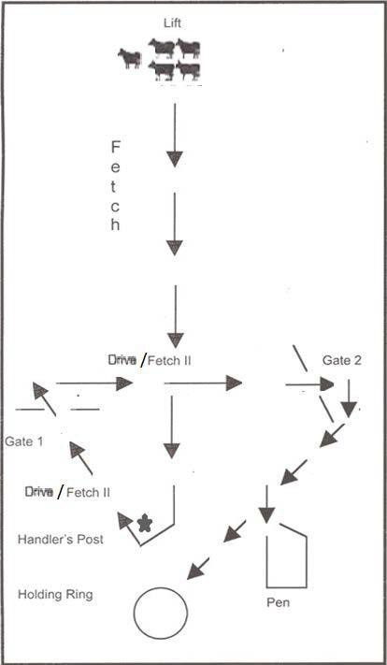

OUTRUN
Halfway point Handler may stand anywhere between handler’s post and this point on centre line.
The correct
path of the outrun may be to either side of the course and may be outside the drive panels depending on the width of the course.

GATES
The gate openings shall be 6m for sheep and cattle,
2.5m for ducks.

PEN
The pen shall be from 2m x 2m to 2.5m x 2.5m for sheep,
3m x 3m to 4m x 4m for cattle, or 1.2m x1.2m for ducks.

HOLDING RING
The Holding Ring diameter shall be 9m-18m for started sheep and cattle and 6m for ducks.

Novice Class Course B – Description (Optional class)

Time Allowed: 10 Minutes. When cattle are used on Course B one minute should be added to the course time for every additional 9m of outrun distance over the minimum.
The timer shall signal a two minute warning and shall signal the end of time for the run.

Outrun: Minimum Length - 65 metres sheep and cattle.
20 metres ducks.

Maximum Length - 130 metres sheep and cattle.
40 metres ducks.

The handler sends the dog on the outrun to lift and fetch the stock.
The handler will remain at the Handlers Post until the stock clears the Handlers Post. The handler may leave the Handlers Post but must walk behind the stock to Gate #1.
The handler may then fetch and/or drive the stock to and through Gate #2 and to the Pen.

The handler may not enter the pen. After penning the stock, the dog takes the stock from the pen to the shedding ring.

The dog must hold the stock to the handler within the shedding ring until the Judge says, "That's a hold”. Time ends and the run is completed

The exercises are:
- Outrun
- Lift
- Fetch
- Turn around the Handlers Post
- Drive through Gate #1
- Drive and/or Fetch to Gate #2
- Pen
- Hold

COURSE B NOVICE

Time allowed: 10 minutes. When cattle are used one minute should be added to the course time for every additional 9m of outrun distance over the minimum.

Course size: Sheep and Cattle | Minimum outrun | 65 m
 | Maximum outrun | 130m
Ducks | Minimum outrun | 20 m
 | Maximum outrun | 40 m

Each Drive/Fetch II leg shall be 1/3 the total length of the outrun with a minimum length of 30m for sheep and cattle, 15m for ducks.

OUTRUN
The correct path of the outrun may be to either side of the course and may be outside the drive panels depending on the width of the course.

GATES
The gate openings shall
be 6m for sheep and cattle,
2.5m for ducks.

PEN
The pen shall be from 2m x 2m to 2.5m x 2.5m for sheep,
3m x 3m to 4m x 4m for cattle,
or 1.2m x1.2m for ducks.

HOLDING RING
The Holding Ring diameter shall be 9m-18m (Started & Intermediate) or 18m-36m (Advanced) for sheep and cattle,
6m-12m for ducks.

Intermediate Class Course B – Description

Time Allowed: 10 Minutes.

When cattle are used on Course B one minute should be added to the course time for every additional 9 metres of outrun distance over the minimum.

The timer shall signal a two minute warning and shall signal the end of time for the run.

Outrun: Minimum Length – | 90 metres sheep and cattle  25 metres ducks
Maximum Length - | 180 metres sheep and cattle 45 metres ducks

The handler will remain at the handler's post until the stock clears Gate #1.
The handler may then leave the handler's post and walk to any appropriate position to meet the dog and stock and will fetch and/or drive the stock to and through Gate #2 and to the pen.

The handler may not enter the pen. After penning the stock, the dog takes the stock from the pen to the shedding ring.

The dog must hold the stock to the handler within the shedding ring until the Judge says, "That's a hold”. Time ends and the run is completed

The exercises are:
- Outrun
- Lift
- Fetch
- Turn around the handler's post
- Drive through Gate #1
- Drive and/or Fetch to Gate #2
- Pen
- Hold

COURSE B INTERMEDIATE

Time allowed: 10 minutes. When cattle are used one minute should be added to the course time for every additional 9m of outrun distance over the minimum.

Course size: Sheep and Cattle | Minimum outrun | 90m
 | Maximum outrun | 180m
Ducks | Minimum outrun | 25m
 | Maximum outrun | 45m

Each DRIVE leg shall be 1/3 the total length of the outrun with a minimum length of 30m for sheep and cattle, 15m for ducks

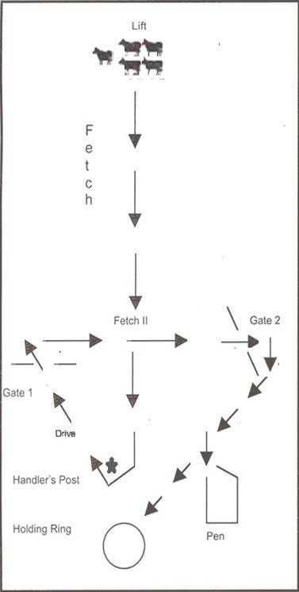
OUTRUN
The correct path of the outrun may be to either side of the course and may be on the outside of the drive panels depending on the width of the course

GATES
The gate openings shall be 6m for sheep and cattle,
2.5m for ducks.

PEN
The pen shall be from 2m x 2m to 2.5m x 2.5m for sheep, 3m x 3m to 4m x 4m for cattle, or 1.2m x 1.2m for ducks.

HOLDING RING
The Holding Ring diameter shall be no smaller than 9m (Started, Novice & Intermediate)
or 18m (Advanced) for sheep and cattle,
6m for ducks.

Advanced Class Course B – Description

Time Allowed: 12 minutes.
When cattle are used on Course B one minute should be added to the course time for every additional 9 metres of outrun distance over the minimum.

The timer shall signal a two minute warning and shall signal the end of time for the run.

Outrun: Minimum Length - | 105 metres sheep and cattle 30 metres ducks
Maximum Length - | 360 metres sheep and cattle 45 metres ducks

The handler will remain at the post until the stock have turned at Gate #2. The handler will then move to the pen to prepare for penning the stock.
After penning the stock the dog takes the stock from the pen to the shedding ring.
The dog must hold the stock to the handler within the shedding ring and perform a “Shed” until the Judge says, “That’s a shed.”
Time ends and the run is completed.

The exercises are:
- Outrun
- Lift
- Fetch
- Turn around the handler's post
- Drive through Gate #1
- Cross-drive through Gate #2
- Pen
- Shed

COURSE B ADVANCED

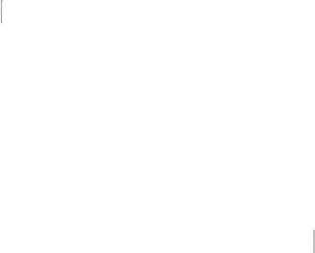
Time allowed: 12 minutes. When cattle are used one minute should be added to the course time for every additional 9m of outrun distance over the minimum.

Course size: Sheep and Cattle | Minimum outrun | 105m
 | Maximum outrun | 360m
Ducks | Minimum outrun | 30m
 | Maximum outrun | 45m

Each DRIVE leg shall be 1/3 the total length of the outrun with a minimum length of 30m for sheep and cattle, 15m for ducks
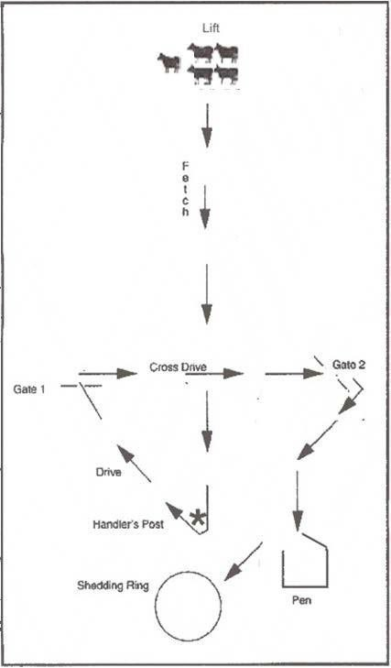
OUTRUN
The correct path of the outrun may be to either side of the course and may be on the outside of the drive panels depending on the width of the course
GATES
The Gate openings shall be 6 m for sheep and cattle,
2.5 m ducks
PEN
The pen shall be from 2m x 2m to 2.5 x 2.5 m for sheep, 3m x 3m to 4 x 4m for cattle and 1.2 x 1.2 for ducks
HOLDING RING
The Holding Ring diameter shall be no smaller than 9m (Started, Novice and Intermediate) or 18m (Advanced) for sheep and cattle, 6 m for ducks

Section 5. Judging Course B.

SUGGESTED SCORING:
Points will be deducted in one-half or whole point increments only

The Fetch/Drive applies to the movement of the stock over the entire course, and penalties are to be deducted under the exercise where the error(s) occur(s).
The movement of the stock through the course will be a zone approximately 6 metres wide for sheep and cattle, 2.5 metres for ducks, with the centre of the line at the centre of each obstacle or working area.

A dog may qualify (if more than 5 points remain) for attempting but not accomplishing a hold after the shed. There may be retries--the Judge decides whether the dog split or shed the stock.
SA Proposed changes – A split is where a dog just moves through the stock without pausing between the stock as apposed to the hold where the dog must maintain the paused and segregated stock. A shed is where the stock are divided in 2 groups and the dog does a short pause between the stock without holding the stock. A split is constant movement a shed is movement and pause between stock
SA Rationale – this makes it clear to both handlers and judges what is expected and the difference between a split and a shed.

Outrun:

    - Up to 1 point deducted for the dog being too far away from the post, more than 3 metres.

    - Up to 5 points deducted for the dog running to the exhaust pen and must be called back.

SA Proposed changes – A Outrun 2. Up to 5 points deducted for the dog running to the exhaust pen and must be called back.
SA Rationale – A Outrun 2. There is no defined exhaust pen for B course so there should be no scoring for it.

    - Up to ½ point deducted for the handler encouraging the dog on the run.

    - Up to ½ point deducted for a redirect on the outrun.

    - Up to 3 points deducted for the dog stopping and then receiving a redirect.

    - Up to 4 points deducted if the dog runs straight up the middle of the field and casts out.
    - Up to 4 points deducted for the dog running narrow.

    - Up to 5 points deducted for the dog being off contact with the stock, running too wide, fence or boundary running.
    - Up to 10 points deducted for the dog running straight up the middle of the field.

    - Up to a maximum of 10 points deducted if the dog crosses over the centre line on the outrun before passing behind the stock.

    - Up to 1 point deducted for the dog running to the dog holding the stock.

    - ½ point deducted for overrunning the stock.

    - Up to 2 points deducted for the dog stopping short.

    - Up to 2 points deducted for the dog too close to the stock at top of the outrun
.
    - Up to 5 points deducted for the dog running to the release pen and must be called back.

    - Up to 4 points deducted if the dog is tight at top, will not stop and rushes stock.

    - Up to 10 points deducted if the handler leaves the handler's post prematurely.

Lift
    - Up to 3 points deducted for requiring flanking commands to shift stock.

    - Up to 4 points deducted for the dog refusing to come in on the stock after a down/stand.

    - Up to 5 points deducted for a rushed lift, causing the stock to run or split.

    - Up to 5 points deducted for the dog causing off-line direction of the flock.

C. | Fetch/Drive
1. | Up to 1 point deducted for flanking the dog too far off the stock.
2. | Up to 1 point deducted for the dog allowing the stock to spread out.
3. | Up to 1 point deducted for the dog turning in circles.
4. | Up to 1 point deducted for the dog causing the stock to weave by over-flanking.
5. | Up to 3 points deducted each time the stock retreat on the course.
6. | Up to 3 points deducted if the dog leaves the stock due to lack of interest or is off contact.
7. | Up to 3 points deducted for excessive commands.
8. | Up to 2 points deducted each time the dog circles the stock.
9. | Up to 3 points deducted for the stock being off-line.
10. | Up to 3 points deducted for the dog allowing or causing the stock to split.
11. | Up to 1 point deducted per head of stock for missing the obstacle.
12. | Up to 1 point deducted per head of stock if the dog brings the stock back through the obstacle.
13. | Up to 2 points deducted for a wide turn.
D. | Pen
1. | Up to 1 point deducted per head of stock going around the pen.
2. | Up to 5 points deducted for the stock going into the pen and then escaping.
3. | Up to 1 point deducted for slamming gate.
4. | Non-qualifying for voluntarily dropping rope, before shutting the gate on stock.
5. | Up to 3 points for using the gate to push the stock into the pen.
6. | Up to 3 points for not closing the gate after the stock have exited the pen.
7. | Non-qualifying if the handler enters the pen.
E. | Hold (Started and Intermediate)
1. | Up to 3 points deducted for the stock moving outside of the shedding ring.
2. | Up to 3 points deducted for stock not settling.
3. | Up to 3 points deducted for ragged work.

Shed (Advanced)

A dog may qualify (if more than 5 points remain) for attempting but not accomplishing a hold after the shed. There may be retries--the Judge decides whether the dog split or shed the stock.
SA Proposed changes – A split is where a dog just moves through the stock without pausing between the stock as apposed to the hold where the dog must maintain the paused and segregated stock. A shed is where the stock are divided in 2 groups and the dog does a short pause between the stock without holding the stock. A split is constant movement a shed is movement and pause between stock,
SA Rationale – this makes it clear to both handlers and judges what is expected and the difference between a split and a shed

  - Up to 1 point deducted for shed being done by handler.

  - Up to 1 point deducted for dog turning tail.
  - Up to 1 point deducted for a missed opportunity.
  - Up to 5 points deducted for handler standing too long without trying to shed and hold.

  - Up to 3 points deducted if the stock cut off from the group, re-join the group (no hold following the shed).

  - Up to 5 points deducted for not trying to do a shed.

General Deductions
  - Up to 1 point deducted each time the dog stops and sniffs.

  - Up to 3 points deducted for each time the dog refuses to obey commands.
  - Up to 3 points deducted for the dog leaving the stock due to lack of interest
.
  - Up to 5 points or removed for an unacceptable grip. The dog must be excused for an abusive grip.

  - Up to 5 points deducted each time the handler touches the dog or stock.
  - Up to 5 points deducted each time the dog fouls the course.

  - Up to 5 points deducted if the dog is taken to the handler’s peg on lead.

  - Up to 3 points deducted, each incident, for excessive use of, or threatening the dog with the crook or stock stick, or use of threats causing dog to cringe.
  - Up to 10 points deducted if the dog needs repeated commands to perform tasks.

  - Up to 10 points deducted if the dog fails to control situations on its own initiative

Maximum Points Available All Classes - 100 points
- Outrun - 20 points
- Lift - 10 points
- Fetch - 20 points
- Drive (Fetch II in Started Class) - 25 points
- Pen - 15 points
- Hold (Started/Novice/Intermediate) - 10 points
- Advanced – Shed - 5 points Hold – 5
Total - 100 points.

To receive a qualifying score in any class, a dog must have a total of at least 65 points, provided none of the above point categories are scored at less than ½ of the available points.

CHAPTER 7. COURSE C

Section 1. Course C
    - Course C reflects a tending shepherd's day, as he/she accompanies the flock, moving to various unfenced grazing areas. The sheep must be allowed to graze peacefully, contained within specified unfenced areas, and safely guided on the roads between those areas. The dog patrols to guard against sheep trespassing onto the adjoining field, while the sheep graze and are moved along roads. The shepherd and dog are responsible for the safety and good health of the sheep, in addition to protecting adjoining lands from the sheep. Success in this type of grazing flock management requires harmony between shepherd, flock and dog.

    - Only sheep are used on Course C Although the minimum number of sheep allowed is 25, larger flocks give the best opportunity for success. The handler walks with the flock to lead or guide them along the roads and into graze areas. The Judge and Scribe also walk the course at a discreet distance. Spectators are not allowed on the course during the competition.

    - The site of the course should be like a farm or pasture area to allow the execution of all the exercises and obstacles. It should take advantage of as many natural features as possible. The order of the exercises and obstacles may be changed as necessary to accommodate the site, provided all are included in appropriate relation to each other. The scoring for each obstacle starts and ends 6 metres before and after the obstacle. The course should be designed to provide at least 15 metres between obstacles. This is especially important when larger flocks are used.

    - Course C shall cover a minimum distance of 400 linear metres and a maximum distance of 800 linear metres (see diagram).
Started 400 to 490 linear metres
Intermediate 490 to 710 linear metres
Advanced 710 to 800 linear metres

Section 2. Course Layout
    - The Freestanding Pen –
The pen is used for holding the sheep at the beginning of the run and for penning the sheep at the end of the run.
The pen fence is of an inflexible, substantial material which is sufficiently high to hold the stock, prevent their escape and permit clear visibility for the sheep and dog. The size is 10 metres x 10 metres to 14 metres x 14 metres depending on the number of sheep used. The gate is located on one corner of the pen and must open easily. It may swing or be a panel that lifts out.

Exit from the Pen –
Scoring for the pen begins when the handler opens the gate and ends when the last sheep or dog leaves the pen, whichever happens last. Before time begins, the handler and dog may walk around the pen to let the sheep become familiar with them. The dog may or may not be leashed. The handler may choose to enter the pen and walk through the flock.
The handler removes the lead from the dog before the gate is opened. The dog prevents the escape of the flock while the gate is being opened. The handler may command the dog to enter the pen, either by jumping in, or moving through the gate.

The handler will call the flock and set the sheep in motion. If the sheep do not begin the exit from the pen, the dog may move back from the entrance, to assist in getting the flock started. Once the flock begins to move, the dog protects the sheep and fence from possible damage.
The best position for this is inside the pen, close to the protruding edge of the fence. The dog's position should not be so far into the gate opening that it stops or inhibits the smooth exit of the sheep. The dog may follow the last sheep out of the pen.

If on exiting, the sheep fail to follow the handler, and if the handler deems it necessary, the dog may be called out of the pen to control the flock.

Re-Pen

Scoring begins approximately 6 metres before the pen and ends when the gate is closed. To return the flock to the pen, the handler leads the sheep a few steps into the pen and then stands by the gate on the outside of the pen.
The dog takes a position opposite the handler outside the pen to prevent any sheep from going past the gate. Should some sheep refuse to enter the pen, the dog may move along the flock to encourage forward movement.
Once the sheep are moving, the dog returns to stay at the gate. The dog does not enter the pen. The handler closes the gate, which concludes the run.

Narrow Road

Scoring encompasses all work between the exit of an exercise and the 6 metre beginning marker for the next exercise. The narrow road connects all phases of the course and should be no less than 3/4 of the length of the course. It can be a natural lane, a mowed path or marked by ploughed furrows. It should be about 4 to 4.5metres wide and have a proportion (1/3 in Started, 1/2 in Intermediate and 2/3 in Advanced) out in the open, at least 3 metres away from any fence line, to show the dog's ability to work both sides.

The dog works the side of the flock where the distractions and possible dangers may occur, where the stock could cause damage to crops or damage the property of others. The dog works on its own, without excessive, repeated commands from the handler.
In Started, the dog may receive some verbal commands from the handler, but excessive commands are to be severely penalized. It is the handler's responsibility to direct the dog to change sides as necessary. This action must not cause the flock to slow down, speed up or leave the road.
SA Proposed changes – Narrow Road Scoring encompasses all work between the exit of an exercise and the 6 metre beginning marker for the next exercise. The narrow road connects all phases of the course and should be no less than 3/4 of the length of the course. It can be a natural lane, a mowed path or marked by ploughed furrows. It should be about 4 to 4.5 6 to 6.5metres wide and have a proportion (1/3 in Started, 1/2 in Intermediate and 2/3 in Advanced) out in the open, at least 3 metres away from any fence line, to show the dog's ability to work both sides.

The dog works the side of the flock where the distractions and possible dangers may occur, where the stock could cause damage to crops or damage the property of others. The dog works on its own independently, without excessive minimal repeated commands from the handler.
In Started, the dog may receive some verbal commands from the handler, but excessive commands are to be severely penalized. It is the handler's responsibility to direct the dog to change sides as necessary. This action must not cause the flock to slow down, speed up or leave the road
SA Rationale – Narrow Road change the width of the road as working with a bigger flock and when the road is up against a fence it creates a huge pressure point where the sheep will try and create space for themselves and 4 to 4.5m is not quite enough without added pressure on both sheep and dog.
Change the terminology to independent work.

The Bridge

Scoring begins approximately 6 metres before the bridge. Scoring ends when the last sheep or the dog leaves the bridge, whichever happens last.

If a pre-existing bridge is not available, a freestanding substitute may be built. The bridge should be no longer than 6 metres, nor more than 4 metres wide. If the bridge has wings, they may be no wider than the width of the narrow road (approximately 4 to 4.5 metres) and the panels leading in no longer than approximately 2.5 metres.

The dog will stay on the side of the bridge that best protects the safety of the stock, close to the panel and will be sent to this position early enough to prevent sheep from going around the bridge. If all or part, of the flock are not crossing, the dog may go back along the flock to encourage forward motion, guiding the sheep on to the bridge.
Once the flock is moving, the dog returns to the wing to guard against sheep going around the bridge. After the flock has crossed over the bridge, the dog follows them over the bridge.
SA Proposed changes – The Bridge Scoring begins approximately 6 metres before the bridge. Scoring ends when the last sheep or the dog leaves the bridge, whichever happens last.

If a pre-existing bridge is not available, a freestanding substitute may be built. The bridge should be no longer than 6 metres, nor more than 4 6metres wide. If the bridge has wings, they may be no wider than the width of the narrow road (approximately 4 to 4.5 6 to 6.5metres) and the panels leading in no longer than approximately 2.5 metres.

The dog will stay on the side of the bridge that best protects the safety of the stock, close to the panel and will be sent to this position early enough to prevent sheep from going around the bridge. If all or part, of the flock are not crossing, the dog may go back along the flock to encourage forward motion, guiding the sheep on to the bridge.
Once the flock is moving, the dog returns to the wing to guard against sheep going around the bridge. After the flock has crossed over the bridge, the dog follows them over the bridge
SA Rationale – to come in line with Narrow Road suggested width change

Pause (of the flock), Traffic Road

Scoring begins approximately 6 metres before the entrance onto the traffic road and ends when the last sheep leaves the traffic road. The flock is an integral part of the traffic pattern and travels on the left hand side of the road, the same as a car.
The Traffic Road must be at least 6 to 7 metres wide. This exercise is performed on a paved road, farm road, a lane or mowed path with sufficient width to safely accommodate a vehicle while passing the flock. The length of this road varies, depending upon the class. In the Started Class, with a parked vehicle, the road may be 90 metres long. The same holds true for the Intermediate Class, where the vehicle passes once. However, a minimum of 140 metres is required for the Advanced Class since the vehicle passes twice.
For the Pause, the dog is brought into a position in front of and facing the flock to stop their forward motion. The dog will hold the sheep from following the handler while he/she moves away from the flock, a few metres, to check for traffic. The handler returns to the flock, the dog resumes its work.
The handler guides the flock onto the road while the dog works the roadside boundary. When there is no traffic, the flock may cover the entire traffic road. As the vehicle approaches the stock, the dog comes onto the road and moves the sheep to the left hand side of the road.
As the vehicle passes, the dog works between the vehicle and the stock to provide sufficient room for the vehicle to pass while protecting the stock and keeping all the sheep from moving in front of the moving vehicle. When the vehicle has passed the dog returns to the roadside boundary and the sheep may use the entire width of the traffic road.
In the Started Class, the vehicle will be parked with or without the engine running at the affiliate’s discretion. In Intermediate, the vehicle will pass once from the front of the flock. In Advanced, the vehicle will pass once from the front and once from the rear.

The Vehicle

The vehicle must be as quiet as possible and provide a maximum field of vision for the driver. A golf cart is the preferred vehicle. A compact or sub-compact car or van is preferable to a farm tractor because of the noise of the tractor. Bicycles and motorcycles are prohibited.

For the Intermediate and Advanced Class, if a car or truck is used, there must be two people in it when moving. The car may not be driven faster than 8 kph. A recognized motor vehicle department must license the driver.

Wide Graze

Scoring for both wide and narrow grazes begin approximately 6 metres before the graze and ends when the last sheep or the dog exits the graze area. The wide graze may be laid out in a meadow, a field of stubble, lawn or pasture.
The wide graze areas may be adjacent or parallel to the narrow road. Depending on the natural features, the individual wide graze areas may be grouped but need not be. Natural features such as a creek, a forest line, a strip of mown grass, a ploughed furrow, sawdust or shavings may mark the boundaries of each area. The area must be free of fresh manure.

Since no single graze area may be used more than three times, the number of wide graze areas will be determined by the number of dogs entered. Each area will have a width of 20 metres to 45 metres and a length of 45 metres to 70 metres. The size of the graze is determined by the number of sheep used. i.e. the more sheep used the bigger the graze area should be.

While Clubs must make every effort to use natural grazing condition, should there be little or no forage, the seeding of the grazes with hay is then permitted.

If a Club must seed the graze area the following policies apply:

      - The hay should be distributed evenly throughout the graze area to simulate natural conditions as much as possible.

      - No piles of hay should be within the graze or surrounding area.
      - The graze area must be seeded prior to each run.
      - The graze area may be used more than 3 times.

The handler may lead the flock into the assigned graze area. Once the sheep are in the graze area, the handler moves to the inside edge of the graze boundary. The handler may position themself to be opposite the area the dog is working and move along the edge as needed.
The handler may not walk among the sheep without penalty during the graze.
If the dog is working opposite the handler, it should not be “constantly balancing”.
The dog will move to the graze boundary, where it will patrol or move as needed to keep the flock within the assigned area. The sheep should not be disturbed while grazing nor permitted to stray over the boundary of the assigned area.
The time for the wide graze is 10 minutes, at the Judge's discretion, and must be consistent for each run in a class.
SA Proposed changes – Wide Graze Scoring for both wide and narrow grazes begin approximately 6 metres before the graze and ends when the last sheep or the dog exits the graze area. The wide graze may be laid out in a meadow, a field of stubble, lawn or pasture.
The wide graze areas may be adjacent or parallel to the narrow road. Depending on the natural features, the individual wide graze areas may be grouped but need not be. Natural features such as a creek, a forest line, a strip of mown grass, a ploughed furrow, sawdust or shavings may mark the boundaries of each area. The area must be free of fresh manure.

Since no single graze area may be used more than three times, the number of wide graze areas will be determined by the number of dogs entered More than one graze area can be available for use. Each area will have a width of 20 metres to 45 metres and a length of 45 metres to 70 metres. The size of the graze is determined by the number of sheep used. i.e. the more sheep used the bigger the graze area should be.

While Clubs must make every effort to use natural grazing condition, should there be little or no forage, the seeding of the grazes with hay, stock pellets or seed is then permitted.

If a Club must seed the graze area the following policies apply:

      - The hay, stock pellets or seed should be distributed evenly throughout the graze area to simulate natural conditions as much as possible.

      - No piles of hay should be within the graze or surrounding area.
      - The graze area must be seeded prior to each run.
      - The graze area may be used more than 3 times.

The handler may lead the flock into the assigned graze area. Once the sheep are in the graze area, the handler moves to the inside edge of the graze boundary. The handler may position themself to be opposite the area the dog is working and move along the edge as needed.
The handler may not walk among the sheep without penalty during the graze.
If the dog is working opposite the handler, it should not be “constantly balancing”.
The dog will move to the graze boundary, where it will patrol or move as needed to keep the flock within the assigned area. The sheep should not be disturbed while grazing nor permitted to stray over the boundary of the assigned area.
Within the 10 minutes of the wide gaze the placement is to happen. This will generally be done in the last 2 minutes as it simulates the removal of the sheep from the wide graze.
The time for the wide graze is 10 minutes, at the Judge's discretion, and must be consistent for each run in a class.
SA Rationale – Wide Graze Remove the restrictions on how many times a graze can be used, this is Australia and quite often if not all the time the graze needs to be seeded.
Addition of other product for seeding the graze should be available for when there are hay shortages and costs involved when buying hay when supply is low.
Addition of where the Placement is to happen (as opposed to the narrow graze) and reasoning behind why the placement is used.

Narrow Graze (Advanced class only)

The dimensions of the narrow graze are 13 metres to 18 metres wide, by 55 to 90 metres in length, this is in correlation to the number of stock used. Other than the size, the requirements of the narrow graze are the same as the wide graze.
While Clubs must make every effort to use natural grazing condition, should there be little or no forage, the seeding of the grazes with hay is then permitted.

If a Club must seed the graze area the following policies apply:

      - The hay should be distributed evenly throughout the graze area to simulate natural conditions as much as possible. It should not be distributed so that the sheep are enticed to run from one bit to another, nor should it be placed on or too close to the boundary.
      - No piles of hay should be within the graze or surrounding area.
      - The graze area must be seeded prior to each run
      - The graze area may be used more than 3 times.

The handler guides the stock to the assigned graze area. The flock is to graze in the narrow space, which causes them to spread out lengthwise.
The handler will stay on the edge of the grazing area, moving forward or backward to encourage the forward movement of the flock while the dog moves to the opposite side of the stock. If necessary, the dog may change sides, working the same side as the handler.
Throughout the exercise, the dog does not disturb nor permit the flock to turn around, fan out or leave the grazing area.
The purpose of this exercise is to move the stock sufficiently slowly so that the sheep may graze on the move without stopping.
The dimensions of the narrow graze are 13 metres to 18 metres wide, by 55 to 90 metres in length, this is in correlation to the number of stock used. Other than the size, the requirements of the narrow graze are the same as the wide graze.
While Clubs must make every effort to use natural grazing condition, should there be little or no forage, the seeding of the grazes with hay, stock pellets or seed is then permitted.
If a Club must seed the graze area the following policies apply:

      - The hay, stock pellets or seed should be distributed evenly throughout the graze area to simulate natural conditions as much as possible. It should not be distributed so that the sheep are enticed to run from one bit to another, nor should it be placed on or too close to the boundary.
      - No piles of hay should be within the graze or surrounding area.
      - The graze area must be seeded prior to each run
      - The graze area may be used more than 3 times.

The handler guides the stock to the assigned graze area. The flock is to graze in the narrow space, which causes them to spread out lengthwise.
The handler will stay on the edge of the grazing area, moving forward or backward to encourage the forward movement of the flock while the dog moves to the opposite side of the stock. If necessary, the dog may change sides, working the same side as the handler.
Throughout the exercise, the dog does not disturb nor permit the flock to turn around, fan out or leave the grazing area.
The purpose of this exercise is to move the stock sufficiently slowly so that the sheep may graze on the move without stopping
SA Rationale – Narrow Graze (advanced class only) If the restrictions are removed on how many times a graze can be used, then this is a moot point.
Addition of other product for seeding the graze should be available for when there are hay shortages and costs involved when buying hay when supply is low.

Placement before the Flock (Intermediate and Advanced only)

The handler will decide when this exercise will be performed and will so notify the Judge. The exercise demonstrates the dog's ability to be placed outside and inside the graze and to change the direction of the grazing sheep.
The handler sends the dog along the boundary to the head of the flock. At the handler's signal, the dog stands with its attention on the flock. The dog enters the graze and approaches the flock slowly.
The approach is stopped three times with the dog standing, until the dog reaches the head of the flock. The last stop will be at the point where the dog is in contact with and turning the heads of some of the flock.

Once the flock has turned, the dog will exit the graze on command in the same area it used to enter the graze. At Intermediate level only, the handler may enter the graze to help the dog perform the placement but must not interfere with the stock.

Section 3. Classes.
Started Class Course C – Description

Time Allowed: 30 Minutes
Directions: The distance for this course will be between 400 to 490 linear metres. The handler may assist the dog in removing the stock from pen but may not touch the dog or stock without penalty once the stock has left the pen.

- Exit from the pen.
- Narrow road - connects all phases of work.
- Bridge
- Pause/Traffic
- Wide Graze
- Re-Pen

Intermediate Class Course C – Description

Time Allowed: 45 Minutes

Directions: The distance for this course will be between 490 and 710 linear metres.

The handler may not assist the dog in removing the stock from the pen and may not touch dog or stock without penalty.

- Exit from the pen
- Narrow road - connects all phases of work.
- Bridge
- Pause/Traffic
- Wide graze
- Placement before the flock
- Re-Pen
Time Allowed: 45 Minutes

SA Proposed changes – Intermediate class course C description Directions: The distance for this course will be between 490 and 710 linear metres.

The handler may not assist the dog in removing the stock from the pen and may not touch dog or stock without penalty.
The handler may enter the graze to help the dog perform the placement but must not interfere with the stock

- Exit from the pen
- Narrow road - connects all phases of work.
- Bridge
- Pause/Traffic
- Wide graze
- Placement before the flock
- Re-Pen
SA Rationale – Intermediate class course C description the addition of this point helps outline what is acceptable and allowed.

Advanced Class Course C – Description

Time Allowed: 45 Minutes

Directions: The distance for this course will be between 710 and 800 linear metres.
The handler may not assist the dog in removing the stock from the pen and may not touch dog or stock without penalty.

- Exit from the pen
- Narrow road - connects all phases of work
- Bridge
- Pause/Traffic
- Wide graze/Narrow graze
- Placement before the flock
- Re-Pen

SA Proposed changes - Advanced Class Course C – Description
Time Allowed: 45 Minutes

Directions: The distance for this course will be between 710 and 800 linear metres.
The handler may not assist the dog in removing the stock from the pen and may not touch dog or stock without penalty.
The handler is not permitted in the graze to help the dog perform the placement.

- Exit from the pen
- Narrow road - connects all phases of work
- Bridge
- Pause/Traffic
- Wide graze/Narrow graze
- Placement before the flock
- Re-Pen

SA Rationale – Advanced Class Course C – Description the addition of this point helps outline what is acceptable and not acceptable.

COURSE C STARTED & INTERMEDIATE

STARTED | Time: 30 minutes | Length: 400 to 490 linear metres
INTERMEDIATE | Time: 45 minutes | Length: 490 to 710 linear metres

This course may be set up in any order, so long as all exercises and obstacles are included.
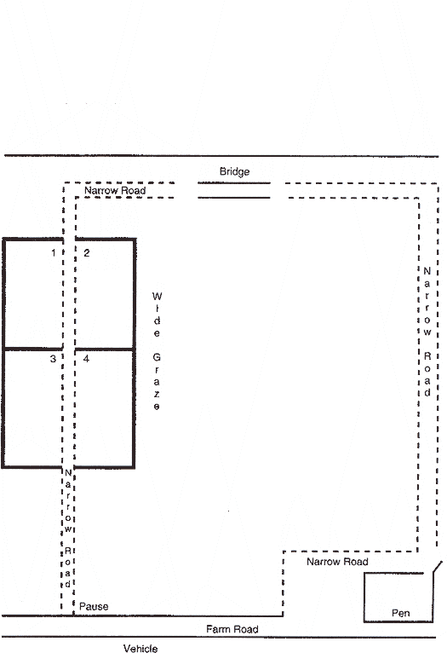
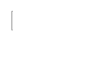
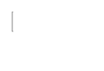
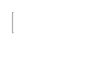
Graze area size depends on number of sheep used.

Grazing areas are to be numbered and their use rotated.
SA Proposed change - Grazing areas are to be numbered and their use rotated if the areas are not being seeded
SA Rationale - addition of seeding for clarification.
20-45m
20-45m
45-70m
45-70m
20-45m
20-45m
45-70m
45-70m
TRAFFIC ROAD

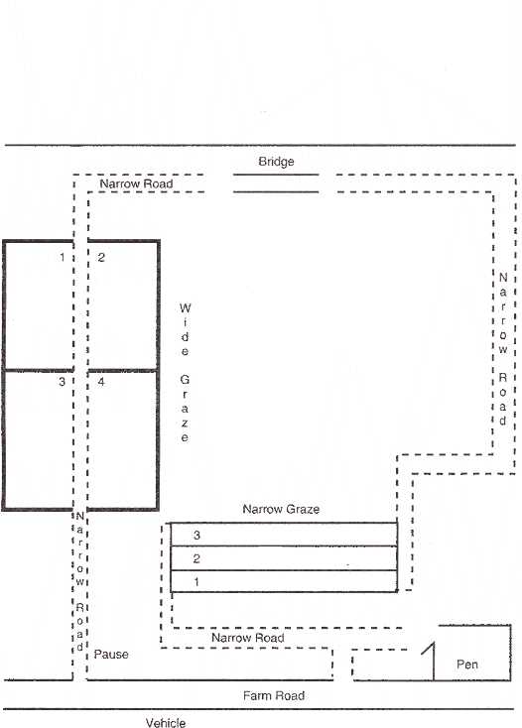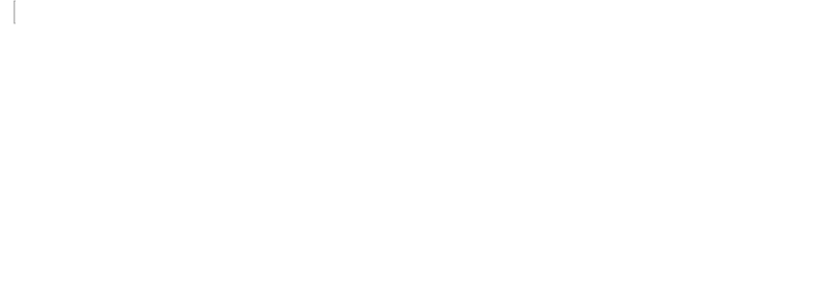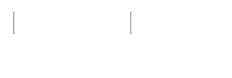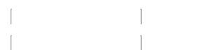
COURSE C
ADVANCED
Time: 45 minutes
Length: 710 to 800 linear metres
This course may be set up in any order, so long as all exercises and obstacles are included.
Graze area size depends on number of sheep used.
13-18 metres x 55- 90 metres is an adequate narrow graze area for 25 sheep. Grazing areas are to be numbered and their use rotated.
SA Proposed change - Grazing areas are to be numbered and their use rotated if the areas are not being seeded
SA Rationale - addition of seeding for clarification.
20-45m
20-45m
45-70m
45-70m
20-45m
20-45m
45-70m
45-70m
13 -18m x 55 – 90m
13 -18m x 55 – 90m
13 -18m x 55 – 90m
TRAFFIC ROAD

Section 4. Judging Course C.

SUGGESTED SCORING

Points will be deducted in ½ or whole point increments only. Scoring indicating point loss for the stock "speeding up and fanning out" refers to excess, not to any slight quickening of pace.

Scoring is for the actual obstacle, which is marked using a visible safe material indicating the beginning (approximately 6 metres before the obstacle) and ending as the sheep or dog exit, the obstacle. The rest of the scoring is under Narrow Road.

In all exercises and obstacles, a dog, which responds independently and properly to a problem, which arises, will receive a higher score than a dog, which must be directed by the handler.
SA Proposed changes - C Course Suggested Scoring Points will be deducted in ½ or whole point increments only. Scoring indicating point loss for the stock "speeding up and fanning out" refers to excess lack of control by the dog, not to any slight quickening of pace.

Scoring is for the actual obstacle, which is marked using a visible safe material indicating the beginning (approximately 6 metres before the obstacle) and ending as the sheep or dog exit, the obstacle. The rest of the scoring is under Narrow Road.

In all exercises and obstacles, a dog, which responds independently and properly to a problem, which arises, will receive a higher score than a dog, which must be directed by the handler
SA Rationale – C Course suggested scoring more clearly defines the intent of deduction.

Exit from the pen
  - Up to 2 points deducted if the flock escape the pen while the handler is opening the gate.
  - Up to 2 points deducted for the dog not entering the pen on command or not jumping in if commanded to do so.
  - Up to 2 points deducted for disturbing the flock upon entering the pen.
  - Up to 2 points deducted for stock hitting, banging or crowding the gate.
  - Up to 2 points deducted for the dog leaving the pen before the last sheep, unless directed by the handler.
  - Up to 10 points deducted when the dog fails to respond to situations on its own initiative.
  - (Re-pen) Up to 2 points deducted for the dog quitting before all the sheep have entered the pen.

Narrow Road
  - Up to 1 point deducted for stopping the sheep at undesignated places during their forward motion.
  - Up to 2 points deducted for the dog not working the complete length of the stock when necessary.
  - Up to 2 points deducted if the dog does not change sides when commanded.
  - Up to 3 points deducted for the dog splitting the flock.
  - Up to 3 points deducted for the dog causing the stock to speed up or fan out.
  - Up to 5 points deducted for the dog being off contact at an excessive distance from the sheep.
  - Up to 5 points deducted for the flock off the road (off-line).
  - Up to 5 points deducted if the movement of the stock is not peaceful because of concern about the dog's presence (crowding one another, packed tightly, nervous).
  - Up to 10 points deducted if the dog fails to guide the flock using its own initiative.

SA Proposed changes - Narrow Road
- Up to 1 point deducted for stopping the sheep at undesignated places during their forward motion.
- Up to 2 points deducted for the dog not working the complete length of the stock when necessary.
- Up to 2 points deducted if the dog does not change sides when commanded.
- Up to 3 points deducted for the dog splitting the flock.
- Up to 3 points deducted for the dog causing the stock to speed up or fan out.
- Up to 5 points deducted for the dog being off contact at an excessive distance from the sheep.
- Up to 5 points deducted for the flock off the road (off-line).
- Up to 5 points deducted if the movement of the stock is not peaceful because of concern about the dog's presence (crowding one another, packed tightly, nervous). when the unrest is caused by the dog and not suitability of the sheep
- Up to 10 points deducted if the dog fails to guide the flock using its own initiative.
SA Rationale – Narrow Road more clearly defines the intent of deduction.

Pause
  - Up to 2 points deducted for the dog being unable to stop the stock.
  - Up to 2 points deducted if the dog fails to hold the flock.
  - Up to 3 points deducted for the flock not settling.

Traffic
  - Up to 2 points deducted for the vehicle having to slow down due to dog or sheep.
  - Up to 10 points may be deducted if the dog runs around the vehicle.
  - Up to 5 points deducted if the stock stops its forward movement.
  - Up to 3 points deducted for dog failing to make room for the car.
  - Up to 1 point deducted for the dog not working the entire flock on traffic road.

Wide and Narrow Grazes
  - Up to 3 points deducted for the dog working inside the line, too close to the flock.
  - Up to 3 points deducted for the dog working too far outside the line.
  - Up to 10 points deducted if the dog causes or allows the flock to split or leave the graze area.
  - Up to 10 points deducted for the dog disturbing the stock and preventing it from grazing.
  - Up to 10 points deducted for the handler out of position.
  - Up to 10 points deducted for the dog constantly going around the graze.
  - Up to 10 points deducted if the dog fails to work on its own initiative.

SA Proposed changes - Wide and Narrow Grazes
- Up to 3 points deducted for the dog working inside the line, too close to the flock.
- Up to 3 points deducted for the dog working too far outside the line. and having no impact on the stock.
- Up to 10 points deducted if the dog causes or allows the flock to split or leave the graze area.
- Up to 10 points deducted for the dog disturbing the stock and preventing it from grazing.
- Up to 10 points deducted for the handler out of position.
- Up to 10 points deducted for the dog constantly going around the graze.
- Up to 10 points deducted if the dog fails to work on its own initiative independently.
SA Rationale – Wide and narrow grazes a dog can be a good distance and still have impact on the stock, the fault is loosing impact on the stock not distance
Change terminology to reflect independent work.

Placement before the Flock (Intermediate/Advanced)

  - Up to 2 points deducted for the dog not stopping promptly.
  - Up to 3 points deducted for the dog disturbing the flock while being sent for the placement.
  - Up to 3 points deducted if the dog does not exit on the same boundary as it entered.
  - Up to 10 points deducted if the handler is unable to send the dog for the placement.

Bridge

  - Up to 2 points deducted for disturbing the stock while they are entering or exiting.
  - Up to 2 points deducted for the dog breaking its stay while guarding the bridge wing, unless commanded by the handler or if the sheep have refused to cross the bridge.
  - Up to 2 points deducted for the dog crossing the bridge before all the sheep pass.
  - Up to 10 points deducted for the stock not crossing over the bridge or going around it.

Re Pen

  - Up to 2 points deducted for the dog quitting before all the sheep have entered the pen.
  - Up to 2 points deducted for the dog going into the pen.

General Deductions

  - Up to 5 points deducted for touching the dog or sheep.
  - Up to 5 points deducted or removed from course for an unacceptable grip. The dog must be excused for an abusive grip.
  - Up to 5 points deducted if the dog marks the course.
  - Up to 8 points deducted if stock does not respect dog.
  - Up to 10 points deducted if the dog needs repeated commands to perform tasks.
  - Up to 10 points deducted if the dog fails to control situations on its own initiative.

SA Proposed changes - General Deductions

- Up to 5 points deducted for touching the dog or sheep.
- Up to 5 points deducted or removed from course for an unacceptable grip. The dog must be excused for an abusive grip.
- Up to 5 points deducted if the dog marks the course.
- Up to 8 points deducted if stock does not respect dog.
- Up to 10 points deducted if the dog needs repeated commands to perform tasks.
Up to 10 points deducted if the dog fails to control situations on its own initiative.
SA Rationale - if the stock do not respect the dog they would not traverse the course and you would see a lot more handler involvement. So covered by other deductions, also how many judges /handlers would know what the stock not respecting the dog looks like?

Maximum Points Available

Course C - All Classes - 100 points
- Exit from Pen and Re-Pen - 15
- Narrow Road - 20
- Bridge – 10
- Pause/Traffic – 20
- Graze (Int. and Adv.) – 25 (Started) – 35
- Placement (Int. and Adv.) - 10 Total – 100
To receive a qualifying score in any class, a dog must have a total of at least 65 points, provided none of the above point categories are scored at less than ½ of the available points.

CHAPTER 8. BREEDS ELIGIBLE FOR HERDING PROGRAM

Australian Cattle Dog Australian Kelpie Australian Shepherd
Australian Stumpy Tail Cattle Dog Bearded Collie
Beauceron
Belgian Shepherds Dog [All Varieties] Bergamasco Shepherd Dog
Bernese Mountain Dog Border Collie
Bouvier des Flandres Briard
Collie Rough and Smooth Dutch Shepherd Dog Finnish Lapphund German Shepherd Dog
German Shepherd (Long Stock Coat) Giant Schnauzer
Icelandic Sheepdog Keeshond
Kerry Blue Terrier Komondor Kuvasz
Maremma Sheep Dog Miniature American Shepherd Mudi
Norwegian Buhund Norwegian Elkhound Old English Sheepdog
Polish Lowland Sheepdog Puli
Pumi
Pyrenean Sheepdog Longhaired Rottweiler (10/08) Eligible from 01.01.09 Samoyed (Approved for listing late 2005) Shetland Sheepdog
Soft Coated Wheaten Terrier
Spanish Water Dog (10/25 Eligible from 01.01.26
Standard Schnauzer Swedish Lapphund Swedish Vallhund Tatra Shepherd Dog Tibetan Terrier
Welsh Corgi Cardigan Welsh Corgi Pembroke White Swiss Shepherd Dog Yakutian Laika (EM#214, 09/25)

MIXED BREEDS
Mixed breeds may be accepted provided they are a mix or apparent mix of Herding breeds. These must be Associate Registered Dogs

HERDING DOGS
Dogs registered with a Dogs Australia recognized herding dog association or kindred body can compete in Herding Trials organized under the auspices of a Dogs Australia Body.

Such dogs must be registered with Dogs Australia, and the owner and handlers be members of a Member Body.

Such dogs are to be allowed to complete without prejudice to sexual status in that they are not required to be neutered and may be bred as acceptable by the herding registry they are registered with.

GLOSSARY OF HERDING TERMS

ATTEMPT: When the livestock runs past the exit of the obstacle.

BALANCE: The point at which the dog has the most influence on the stock, to control the behaviour of the stock and move them in the desired direction.

BOUNDARY (Tending): Natural features such as a creek, forest line or a strip of mown grass, a ploughed furrow or a line marked with a visible and tactile material which mark the edges of grazed areas and parallels to the road.

CAST: See OUTRUN

COURSE: A designated pattern of obstacles through which a handler directs the dog.

DISQUALIFIED – See REASONS FOR ENDING A RUN

DRIVING: The dog moving stock to a specified location along a drive line as directed.

EXCUSED - See REASONS FOR ENDING A RUN

FETCHING: Moving the stock toward the handler. When fetching, the dog is usually positioned so that the stock is between it and the handler.

FLANKING: Circling the stock from the right or left to keep them in a group or reposition in order to change their direction.

FLIGHT ZONE: An invisible area around a group of stock into which a dog cannot pass without causing the stock to feel threatened and attempt to escape from the dog.

FLOCKING: The tendency of the stock to instinctively cluster together in a compact group that functions as a unit. Generally, cattle do not have a strong flocking tendency.

GATHER: The dog collects the stock.

GRAZE: Allowing the stock time to settle and feed in a designated area.

HERDING INSTINCT: The inherited balance in a dog’s temperament, between the predatory drive and the dog’s biddability to its handler. The stronger the herding instinct, the stronger must be the desire to comply with the commands of the handler.

HOLD: The dog maintaining the stock in a stationary (minimal movement) position in a defined area.

LIFT: The moment at which the dog, having reached the opposite side of the stock, initiates the movement directly toward the handler.

OBSTACLES: Objects made of panels placed in strategic locations.

OFF CONTACT: When the dog loses control of the stock, either by being too far away or by losing concentration.
OUTRUN/CAST: The dog runs in an arc to move from the handler to the balance point on the far side of the stock, to move the stock back to the handler. A pear shaped or semi-circular course taken by the dog to get to the far side of the flock without alarming them.

PRESSURE/POWER: The influence of the dog’s presence on the stock. The authority of the dog’s character. The extent of this latent force within a dog will determine the behaviour of stock and their flight zone for that particular dog.

PRESSURE POINT: The exact position and distance the dog needs to be at in order to move livestock in the desired direction. This position is directly influenced by the livestock’s natural inclination to be drawn to the pen from which they were released, a gate to pasture, a known food source, other livestock or a water source if they are thirsty.

REASONS FOR ENDING A RUN

(To be noted on the official score sheet and catalogue)

  - DISQUALIFIED: A Judge’s decision to end the run because the dog has attacked or attempted to attack a person. A dog which is disqualified is to be immediately removed from the area and will be reported to the controlling body under its regulations.

  - EXCUSED: A Judge’s decision to end the run because the dog is attacking or attempting to attack the stock or gripping abusively. A separate report is made to Dogs Australia when a dog is excused. When a dog has been excused three times, the owner is advised by Dogs Australia that the dog is no longer eligible to be entered in Dogs Australia events until the dog has been successfully re-evaluated.

  - NON-QUALIFYING: Loss of scoring points, time elapsed; or a Judge’s decision to end the run because the dog is lame, sick, demonstrating unproductive behaviour, etc.

  - RETIRED: At the request of the handler, the run is ended.

READ: The ability of the handler to understand and anticipate the thoughts of the stock and/or the dog in order to maintain control over both. The ability of the dog to anticipate the behaviour of the stock.

SETTLE: Allowing the stock time to calm and adjust to the situation.

SHED: The dog separating the livestock and preparing to hold a group or individual.

SPLIT: When the dog causes one or more head of stock to leave group without direction.

TENDING: The supervision of the flock by the dog while the flock is grazing. A style of herding used when pastures are unfenced, and the dog serves as a living fence.

INSTINCT TEST OFFICIAL JUDGE’S EVALUATION FORM

Date: | Catalogue number:
Dogs name:
Handler:
Reg Owner: |  | Breed:
Livestock: |  | No of Stock:
Judge:
Affiliate:
Time Allowed: 5 minutes
TEST ELEMENTS |  |  | YES | NO
1. Controlled stop on long line
2. Call to handler on long line
3. Long line removed
4. Shows interest in stock
5. Call to handler
Qualified |  |  | Yes No
Judge’s signature:
Time:
Judges’ comments:

HERDING TEST OFFICIAL JUDGE’S EVALUATION FORM

Date: | Catalogue number:
Dogs name:
Handler:
Reg Owner: |  | Breed:
Livestock: |  | No of Stock:
Judge:
Affiliate:
Time Allowed: 10 minutes

Test Elements | Yes | No
1. Controlled stop or pause at the beginning
2. Controlled movement of stock
3. Two changes of direction at or near pylon
4. Stop at completion
5. Call to handler
Qualified | Yes No
Judge’s signature:
Time:
Judges’ comments:

PRE TRIAL TEST OFFICIAL JUDGE’S EVALUATION FORM

Date: | Catalogue number:
Dogs Name:
Handler:
Reg Owner: |  | Breed:
Livestock: |  | No of Stock:
Judge:
Affiliate:
Time Allowed: 10 minutes

TEST ELEMENTS (NO BOUNDARY) | YES | NO | TEST ELEMENTS (WITH BOUNDARY) | YES | NO
1. Controlled stop or pause at the beginning |  |  | 1. Controlled stop or pause at the beginning
2. Controlled movement of stock |  |  | 2. Contained stock in graze
3. Change of direction |  |  | 3. Controlled passage of stock
4. One stop on course |  |  | 4. Stop while handler opens gate to pen
5. Stop while handler opens gate to pen |  |  | 5. Pen the stock
6. Pen the stock
Qualified | Yes No |  | Qualified | Yes No
Judge’s signature:
Time:
Judges’ comments:

HERDING TRIAL OFFICIAL SCORESHEET: COURSE A

Date: | Class: |  | Catalogue number:
Dogs name:
Handler:
Reg Owner: |  | Breed:
Livestock: |  | No of Stock:
Judge:
Affiliate:
Time Allowed: Started and Intermediate: 10 minutes Advanced: 12 minutes Qualifying Score: 65 points (not less than half of the points in each category)

 | Points Available | Comments and Deductions | Points Deducted | NQ
1. Gather | 20
2. Y Chute | 15
3. Z Chute | 15
4. Hold/Exam Pen Runway in Started and Novice | 15
5. Centre line Gate | 25
6. Pen | 10
Total available | 100
 |  | Points deducted
 |  | Deductions for misbehaviour
 |  | Total points deducted
 |  | Total Score
Time: |  | Qualifying | Yes No
Judges’ comments
Judge’s signature

HERDING TRIAL OFFICIAL SCORESHEET: COURSE B

Date: | Class: |  | Catalogue number:
Dogs name:
Handler:
Reg Owner: |  | Breed:
Livestock: |  | No of Stock:
Judge:
Affiliate:
Time Allowed: Started and Intermediate: 10 minutes Advanced: 12 minutes Qualifying Score: 65 points (not less than half of the points in each category)

 | Points Available | Comments and Deductions | Points Deducted | NQ
1. Outrun | 20
2. Lift | 10
3. Fetch | 20
4. Drive  Fetch in Started | 25
5. Pen | 15
6. Hold Started/ Novice/Inter | 10
Advanced Shed  Advanced Hold | 5  5
Total available | 100
 |  | Points deducted
 |  | Deductions for misbehaviour
 |  | Total points deducted
 |  | Total Score
Time: |  | Qualifying | Yes No
Judges’ Comments:
Judges Signature:

HERDING TRIAL OFFICIAL SCORESHEET: COURSE C

Date: | Class: |  | Catalogue number:
Dogs Name:
Handler:
Reg Owner: |  | Breed:
Livestock: |  | No of Stock:
Judge:
Affiliate:

Time Allowed: 30 minutes Started; 45 minutes Intermediate and Advanced Classes
Qualifying Score: 65 points (not less than half of the points in each category)

 | Points Available | Comments and Deductions | Points Deducted | NQ
1. Exit from pen and re-pen | 15
2. Narrow Road | 20
3. Bridge | 10
4. Pause / Traffic | 20
5. Graze Started Intermediate/Advanced | 35  25
6. Placement Intermediate/Advanced | 10
Total available | 100
 |  | Points deducted
 |  | Deductions for misbehaviour
 |  | Total points deducted
 |  | Total Score
Time: |  | Qualifying | Yes No
Judges’ Comments:
Judges Signature:

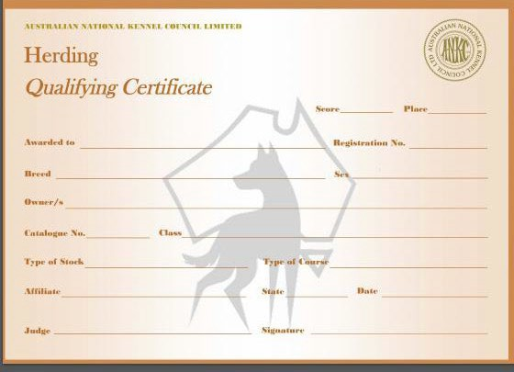

DOGS AUSTRALIA EXCUSAL / RE EVALUATIONFORM

TO BE COMPLETED BY THE JUDGE
FIXTURE:
DATE:
CLASS:
EXHIBIT NUMBER
REASON FOR EXCUSAL:
JUDGE’S NAME:
JUDGE’S SIGNATURE:

TO BE COMPLETD BY TRIAL SECRETARY/CONVENOR
DOG’S NAME:
BREED: | REGISTRATION NUMBER:
OWNER: | MEMBERSHIP NUMBER:
TO BE COMPLETED BY THE OFFICE OF THE CONTROLLING BODY
FIRST EXCUSAL: | SECOND EXCUSAL:
RE EVALUATION ON: | OUTCOME:
RE EVALUATION ON: | OUTCOME:
RE EVALUATION ON: | OUTCOME:
ACTIONED BY: | DATE:

DOGS AUSTRALIA HERDING JUDGE REPORT FORM

TO BE COMPLETED BY THE JUDGE
AFFILIATE:
DATE:
 | YES | NO | COMMENTS
SUFFICIENT STOCK PROVIDED
STOCK MET SUITABILITY REQUIREMENTS
STOCK INSPECTED BEFORE COMMENCEMENT OF TESTS/TRIAL
STOCK INSPECTED A CONCLUSION OF TESTS/TRIAL
SUITABLE FENCING AND OBSTACLES PROVIDED
WERE ANY DOGS EXCUSED?
IF SO, AN EXCUSAL FORM MUST BE
COMPLETED AND SUBMITTED WITH THIS REPORT.
ANY ADDITIONAL COMMENTS:
JUDGE’S SIGNATURE:

