**2025 NOTC MTG - ATTACHMENT 7g - All Rally submissions combined**

**ANKC RALLY AGENDA 2025**

**DOGS ACT**

**Table of Contents**

INTRODUCTION………………………………………………………………………………………… .5

GENERAL………………………………………………………………………………………………… .5

TITLES 6

Class Titles and Qualifying Performance: 6

Rally Novice Class – R.N. 6

Rally Advanced Class – R.A. 6

Rally Excellent Class – R.E. 6

Rally Advanced Excellent Title – R.A.E. 6

Rally Master - RM 6

Rally Champio**n - R CH**  5

CLASSES 7

Rally Novice 7

Rally Advanced 7

Rally Excellent 7

Rally Master 7

DECISIONS 8

RINGS 8

EXHIBITS 8

Bitches in Oestrum: 8

Dogs Wearing Protective Clothing: 8

Entry Number: 8

Judging Ring: 8

Removal of a Dog: 8

Withdrawal of Dog: 8

EXHIBITORS AND HANDLERS 8

Commands and Signals: 8

Dress Code: 9

Entering and Leaving the Ring: 9

Heel Position: 9

Praise, Food and Patting: 9

Rewards:.…………………………………………………………………………………………..........9

Incorrectly Performed Station: 9

Station Not Attempted:…..……………………………………………………………………………...9

Retry: 9

Non Qualifying Scores: 10

JUDGING PROCEDURES 10

Judging Standard: 10

Handler with Disabilities: 10

Judge’s Orders and Signals: 10

Catalogue Order: 10

Awards and Placings: 10

Re‑judging: 10

Ties: 10

Scores: 10

Scoring (all Classes): 11

Disqualification: 11

Timing: 12

Calls: 12

Certificates: 12

Charts ‑ Judging: 12

GUIDE TO JUDGES 12

Judge’s Charts: 12

Posting of the Course……………………………………………………………………………….…12

RING PROCEDURE 12

Signs………………………………………………………………………………………………………..12

Stationary Exercise…………………………………………………………………………………….….13

Walk Through……………………………………………………………………………………………...13

Distance Between Stations 13

Distance Markers……………………………………………………………………………………….....13

EQUIPMENT 13

Collars and Leads: 13

Signs and Holders: 13

Other Equipment: 13

Jumps: 13

Calculation of the Height and Width of Jumps: 13

Bar Jump: 14

~~Broad Jump: 14~~

Solid Jump: 14

Trial Procedures 14

Schedule: 14

Catalogue: 14

APPENDIX A 14

Appendix A - Rally Signs & Explanations: 15-29

APPENDIX B 30

ANKC LTD RALLY JUDGE’S CHART 30

ANKC LTD RALLY SCORE SHEET - INDIVIDUAL 31

**ACT Consequential amendment to Table of Contents if proposal to discontinue use of the Broad Jump succeeds.**

**INTRODUCTION**

**DOGS ACT**

The purpose of Rally is to demonstrate a dog’s usefulness as a companion of mankind, not merely the dog’s ability to follow specified routines in the ring. Dogs which compete in Rally are dogs that have been trained and conditioned to work with their handler, and in the presence of other dogs.

**Proposal:** The purpose of Rally is to demonstrate a dog’s usefulness as a companion in modern day society ~~of mankind~~, not merely the dog’s ability to follow specified courses ~~routines~~ in the ring. Dogs which compete in Rally are dogs that have been trained and conditioned to work with their handler, and in the presence of other dogs**.**

**Rationale:** Outdated language

Preferable to use language that is consistent with the purpose of the Rules.

**DOGS ACT**

The objective of Rally is to provide a fast-moving and motivational sport for both Handler and dog

that demonstrates competency in basic Obedience exercises without the precision of the formal Obedience Classes. Dogs in Rally events should demonstrate willingness and enjoyment. To that end, Handlers may use verbal praise and encouragement of the dog on the Rally course. All participants in the Rally Classes are required to perform the same exercises in substantially the same way so that the quality of the various performances may be compared and scored.

**Proposal:** The objective of Rally is to provide a fast-moving and motivational sport for both Handler and dog that demonstrates competency in the prescribed stations ~~basic Obedience exercises without the precision of the formal Obedience Classes~~. Dogs in Rally events should demonstrate willingness and enjoyment. To that end, Handlers may use verbal praise and encouragement of the dog on the Rally course. All participants in the Rally Classes are required to perform the same exercises in substantially the same way so that the quality of the various performances may be compared and scored.

**Rationale:** Once past Novice and Advanced, many of the prescribed stations are beyond ‘basic obedience exercises’. Rally has also sought to distance its self from ‘obedience’ by removal of the term obedience in its name.

The Rules talk about ‘stations’ and ‘exercises’ interchangeably. Pick one term and use it consistently for clarity.

**TITLES**

**DOGS ACT**

**1st Paragraph** - Only the highest Rally Title awarded to the dog will be used after the name of the dog or in the case of Rally Champion before the name of the dog. However Rally Advanced Excellent (RAE) and Rally Master (RM) Titles may appear together after the name of the dog.

**Proposal:** Only the highest Rally Title awarded to the dog will be used after the name of the dog or in the case of Rally Champion before the name of the dog. However the Rally Advanced Excellent (RAE) and Rally Master (RM) Title~~s~~ may appear together after the name of the dog. Once the dog achieves its Rally Champion Title, the Rally Master (RM) Title should no longer be displayed.

**Rationale:** Eligibility for the Rally Champion title requires an RM (plus additional qualifying scores). RM becomes defunct when the R Ch. Title is obtained. RAE is not an eligibility requirement for RM, it is considered a separate title in its own right.

**DOGS ACT**

**Classes and Qualifying Performance:**

Applications for all titles must be accompanied by the prescribed fee (where applicable) and, upon approval, a Certificate will be issued to the applicant authorising the use of the letters concerned.

**Proposal:** Applications for all titles must be accompanied by the prescribed fee (where applicable) and, upon approval, a Certificate will be issued to the applicant authorising the use of the title letters ~~concerned~~**.**

**Rationale: E**ditorial

**DOGS QLD**

**Proposal: New Title**

Only the highest Rally Title awarded to the dog will be used after the name of the dog or in the case of Rally Champion before the name of the dog. However, Rally Advanced Excellent (RAE) and Rally Master (RM) Titles may appear together after the name of the dog.

Applications for RN., R.I., R.A., R.E., and R.A.E. titles must be lodged indicating qualifying scores under at least two (2) different Judges.

Applications for R.M. and R. CH. titles must be lodged indicating qualifying scores under at least three (3) different Judges.

The Member Body will receive applications for the title “Dual Champion” in connection with each dog which, having gained its title of Conformation Ch. and Rally Champion (R. CH.)

**Class Titles and Qualifying Performance:**

All dogs eligible to be entered in Rally Trials in accordance with these Rules shall be eligible to receive Class Title Certificates upon qualification and application.

The Member Body will receive applications for the use of the letters:

**R.N.** – signifying Rally Novice - Three (3) qualifying scores of **75** points or more must be earned under at least two different Judges in Novice class to earn a title.

**R.I.** – Signifying Rally Intermediate – Three (3) qualifying scores of **80** points or more must be earned under at least two different Judges in Intermediate class to earn a title.

**R.A.** – signifying Rally Advanced - Three (3) qualifying scores of **80** points or more must be earned under at least two different judges in Advanced Class to earn a title.

**R.E.** – signifying Rally Excellent - Five (5) qualifying scores of **80** points or more must be earned under at least two different Judges in Excellent class to earn a title.

**R.A.E**. – signifying Rally Advanced Excellent - To qualify for the title of RAE a dog and Handler team must receive a minimum of five (5) qualifying scores, in both the Rally Advanced and Rally Excellent Classes at the same trial, of **80** points or more out of a possible perfect score of 100, under at least two different Judges.

All qualifications gained in the Advanced B and Excellent B Classes towards an R.A.E. Title that were gained prior to 1st January 2021 will remain valid. From 1st January 2021 any additional qualifying scores required for an R.A.E. Title will be gained from the Advanced & Excellent Classes at the same trial.

**R.M.** – signifying Rally Master - Seven (7) qualifying scores of **85** points or more must be earned under at least three different judges in Master class to earn a title.

**R. CH.** - signifying Rally Champion **-** Upon having been granted the Rally Master Title, in order to receive the R.CH Title, a dog must qualify a further ten (10) times with qualifying scores of **90** or more points in the Rally Master Class under at least (3) different Judges.

Applications for all titles must be accompanied by the prescribed fee (where applicable) and, upon approval, a Certificate will be issued to the applicant authorising the use of the letters concerned.

**NOTES:** An Exhibit which has gained sufficient awards to qualify for the title of R.N., R.A., or R.E. shall NOT be eligible to compete in a higher class at a Rally Trial until such time as the owner/s have lodged an application for recognition of the title with the Member Body in the State or Territory in which the registered owner/s reside.

**Rationale:** This is a new class to bridge the gap between Novice and Advanced. Presently there are 3 extra levels of skills required for the move from Novice to Advanced. Currently, the dog and handler are required to go Off Lead; to perform more difficult stations; and to perform more stations in progressing from Novice to Advanced. All other classes progress with only 2 increases in skills required being: more difficult stations and more stations in total.

Please see in ‘CLASSES’ for what this class could look like.

**DOGS NSW**

**RAE**

To qualify for the title of RAE a dog and Handler team having gained its Rally Excellent (RE) title, must receive an additional minimum of five (5) qualifying scores, in both the Rally Advanced and Rally Excellent Classes at the same trial, of **80** points or more out of a possible perfect score of 100, under at least two different Judges. All qualifications gained in the Advanced B and Excellent B Classes towards an R.A.E. Title that were gained prior to 1st January 2021 will remain valid. From 1st January 2021 any additional qualifying scores required for an R.A.E. Title will be gained from the Advanced & Excellent Classes at the same trial.

**Proposal:** To qualify for the title of RAE a dog and Handler team having gained its Rally Excellent (RE) title, must receive an additional minimum of five (5) qualifying scores, in both the Rally Advanced and Rally Excellent Classes at the same trial, of **80** points or more out of a possible perfect score of 100, under at least two different Judges. All qualifications gained in the Advanced**~~B~~**and Excellent **~~B~~** Classes towards an R.A.E. Title that were gained prior to 1st January 2021 will remain valid. From 1st January 2021 any additional qualifying scores required for an R.A.E. Title will be gained from the Advanced & Excellent Classes at the same trial.

**Rationale:** Advanced B and Excellent B Class no longer exists, Advanced Class and Excellent Class only. Housekeeping change only.

**DOGS QLD**

**Proposal: New Rule**

**Rally Masters R.M.- Multiplier suffixes** may be awarded for multiples of seven (7) Certificates gained with qualifying scores of **85** points or better and must be earned under at least three different judges in Master class to earn a title e.g. 21 Rally Masters qualifications is equal to RM 3.

**Rationale: for Rally Masters Multiplier suffixes:**

Rally is a dog competition open to all dogs and handlers. The sport requires a good rapport between dog and Handler.

The aim of this competition is for a Handler to direct his dog around a course of different obstacles to assess and enhance the ability of the dog and Handler to work as a team. It is an educational and sporting activity intended to improve the dog's integration into society.

This will encourage a continued graded progression through the sport.

To encourage continued participation of current and future competitors and the continuance of Rally as a unique canine discipline.

To encourage an increased level of fitness for dog and Handler.

To encourage safe and pleasant competition for all.

To have Rally Masters R.M.- Multiplier suffixes will align with other ANKC Disciplines such as in Agility where ADM/JDM and ADE/JDE can be applied for multiplier suffixes.

**DOGS WEST**

**Proposal: New Title**

R. GR CH – signifying Rally Grand Champion – Upon having been granted the title of Rally

Champion Title, in order to receive the R. GR CH Title, a dog must qualify a further 5 (five) times with qualifying scores of 98 points or more in the Rally Master Class under at least (3) different judges.

**Rationale**: The standard of the dog and handler combinations has increased and the higher title to recognise continued excellence should be introduced. The score of 98 means that a dog cannot gain the title with a retry which is commensurate with the title

**DOGS SA**

**Proposal: Rally Grand Champion**

R GR CH: The Member Body will receive applications for the title of RALLY GRAND CHAMPION (R GR CH) in connection with each dog, which has gained its ~~Obedience~~  Rally Champion title (R Ch) and thereafter gains a further ten (10) scores of 95 or above in the Rally masters ring under at least 3 different judges.

**Rationale:** To give competitors a purpose to continue competing in Rally after the dog has achieved its Championship. Clubs need as many entries as possible to try and cover the costs of running trials and this would create an encouragement to do so. It would also bring Rally into line with Obedience where the Grand Obedience Title already exists.

**DOGS QLD**

**SUBMISSION 1**

**Proposal: Rally Grand Champion Title:**

The Member Body will receive applications for the title of RALLY GRAND CHAMPION (R.GR.CH.) in connection with each dog, which has gained its Rally Masters Title (R.M.) and Rally Champion Title (R.CH.) and thereafter gains a further ten (10) qualifying scores of 95 points or better in the Rally Masters Class under at least three (3) different Judges.

The Member Body will, upon approval of such Title and payment of the prescribed fee, issue to the applicant an Australian National Kennel Council Ltd RALLY GRAND CHAMPION Certificate. The title of RALLY GRAND CHAMPION ‘R.GR.CH.' is to appear before the name of the dog.

**Rationale:** Grand Champion will provide a continued graded progression through the sport in which the dog must consistently perform to a higher standard.

It will also encourage continued participation of current and future competitors and the continuance of Rally as a unique canine discipline.

This will align Rally with other ANKC Disciplines which already provide a Grand Champion title as part of their sport. Rally has been going successfully for enough time to warrant this progression of titles.

**DOGS QLD**

**SUBMISSION 2**

**Proposal: Rally Grand Champion Title:**

The Member Body will receive applications for the title of RALLY GRAND CHAMPION (R.GR.CH.) in connection with each dog, which has gained its Rally Masters Title (R.M.) and Rally Champion Title (R.CH.) and thereafter gains a further five (5) qualifying scores of 95 points or better in the Rally Masters Class under at least three (3) different Judges.

The Member Body will, upon approval of such Title and payment of the prescribed fee, issue to the applicant an Australian National Kennel Council Ltd RALLY GRAND CHAMPION Certificate. The title of RALLY GRAND CHAMPION ‘R.GR.CH.' is to appear before the name of the dog.

**Rationale:** Grand Champion will encourage a continued graded progression through the sport.

To encourage continued participation of current and future competitors and the continuance of Rally as a unique canine discipline.

This will align Rally with other ANKC Disciplines which already provide a Grand Champion title as part of their sport. Rally has been going successfully for enough time to warrant this progression of titles.

**DOGS QLD**

**SUBMISSION 3**

**Proposal:** **Rally Grand Champion Title:**

The Member Body will receive applications for the title of RALLY GRAND CHAMPION (R.GR.CH.) in connection with each dog, which has gained its Rally Masters Title (R.M.) and Rally Champion Title (R.CH.) and thereafter gains a further five (5) qualifying scores of 90 points or better in the Rally Masters Class under at least three (3) different Judges.

The Member Body will, upon approval of such Title and payment of the prescribed fee, issue to the applicant an Australian National Kennel Council Ltd RALLY GRAND CHAMPION Certificate. The title of RALLY GRAND CHAMPION ‘R.GR.CH.' is to appear before the name of the dog

**Rationale:** Rally is a dog competition open to all dogs and handlers. The sport requires a good rapport between dog and Handler.

The aim of this competition is for a Handler to direct his dog around a course of different obstacles to assess and enhance the ability of the Dog and Handler to work as a team. It is an educational and sporting activity intended to improve the dog's integration into society.

This will encourage a continued graded progression through the sport.

To encourage continued participation of current and future competitors and the continuance of Rally as a unique canine discipline.

To encourage an increased level of fitness for dog and Handler.

To encourage safe and pleasant competition for all.

This will align Rally with other ANKC Disciplines for example : ANKC Obedience where they can apply for the title of OBEDIENCE GRAND CHAMPION (O.GR.CH.) in connection with each dog, which has gained its Obedience Champion Title (O.CH.) and its Utility Dog Excellent (U.D.X.)Title and thereafter gains a further five (5) scores in the Utility Dog Excellent ring with earning the same points value qualifying score as which they achieved for their Obedience Champion Title (O.Ch) Title under at least three different Judges.

Dances with Dogs Freestyle Grand Champion/Heelwork to Music Grand Champion in connection with, and before the name of, each dog which has gained its FS.Ch or HTM.Ch title respectively and thereafter gains a further five (5) Qualifying Certificates in the Advanced class in the relevant division, earning qualifying aggregate scores, under at least two (2) different Judging Panels.

**CLASSES**

**DOGS NSW**

***Rally Novice Class – RN***

**Rally Novice**

For Dogs six months of age or over and of either sex which are not eligible for the title of Rally Novice (RN). Under no circumstances except where an application for a RN Title has been rejected on a technicality, shall a dog which has competed in a Rally Advanced A Class be eligible to compete in the Rally Novice Class.

All exercises are judged on lead.

Rally Novice must have between ten (10) – fifteen (15) stations (start and finish not included); no more than five (5) stationary exercises.

**Proposal:** For Dogs six months of age or over and of either sex which are not eligible for the title of Rally Novice (RN). Under no circumstances except where an application for a RN Title has been rejected on a technicality, shall a dog which has competed in a Rally Advanced**~~A~~** Class be eligible to compete in the Rally Novice Class.

**Rationale:** Advanced A Class no longer exists. Housekeeping change only

**DOGS NSW**

***Rally Novice Class – R.N.***

**Rally Novice**

For Dogs six months of age or over and of either sex which are not eligible for the title of Rally Novice (RN). Under no circumstances except where an application for a RN Title has been rejected on a technicality, shall a dog which has competed in a Rally Advanced A Class be eligible to compete in the Rally Novice Class.

All exercises are judged on lead.

Rally Novice must have between ten (10) – fifteen (15) stations (start and finish not included);

no more than five (5) stationary exercises.

**Proposal:** For Dogs six months of age or over and of either sex which are not eligible for the title of Rally Novice (RN). Under no circumstances except where an application for a RN Title has been rejected on a technicality, shall a dog which has competed in a Rally Advanced Class be eligible to compete in the Rally Novice Class.

All exercises are judged on lead.

Rally Novice must have between ten (10) – fifteen (15) stations (start and finish not included), and use **a minimum of two (2)** to a maximum of five (5) stationary exercises.

**Rationale:** The proposed will bring Rally Novice in line with other levels, with a minimum and maximum number of stationary exercises required.

**DOGS QLD**

***Rally Novice Class – R.N.***

**Proposal: Rally Novice**

For Dogs ~~six~~ twelve months of age or over and of either sex which are not eligible for the title of Rally Novice (RN). Under no circumstances except where an application for a RN Title has been rejected on a technicality, shall a dog which has competed in a Rally Advanced A Class be eligible to compete in the Rally Novice Class.

**Rationale:** A dog must be a minimum of twelve (12) months of age to enter in a Rally Trial.

The education of dog breeding, psychology, growth and behaviour is more available to consumers today.

Education on the welfare of dogs, including their growth patterns, their mental abilities, and their physicality, gives proof that we should not put stress on the dog’s mental ability or physical structure until the growth plates have occurred.

Dogs Australia should be promoting the welfare and care of our dogs so that they have a long and healthy life.

**DOGS QLD**

**Proposal: NEW RULE**

**CLASSES**

All classes must be available for competition at the Trial and included on the Trial Schedule unless special permission is granted by the Member Body. No classes other than the following shall be provided or withdrawn without the special permission of the Member Body. Qualifications up to and including the date of closing of entry shall count as eligibility to compete in any class.

***Rally Novice Class – R.N.***

**Rally Novice**

For Dogs six months of age or over and of either sex which are not eligible for the title of Rally Novice (RN). Under no circumstances except where an application for a RN Title has been rejected on a technicality, shall a dog which has competed in a Rally Advanced A Class be eligible to compete in the Rally Novice Class.

All exercises are judged on lead.

Rally Novice must have between ten (10) – fifteen (15) stations (start and finish not included); no more than five (5) stationary exercises.

***Rally Intermediate Class – R.I.***

This class shall be for dogs that have qualified for the Rally Novice (R.N.) Title.

All exercises are judged on lead.

Rally Intermediate must have between twelve (12) – seventeen (17) stations (start and finish not included) and use a minimum of three (3) to a maximum of ten (10) stationary exercises; Courses shall have a minimum of three (3) Advanced level stations. Stations are to be drawn from the Novice and Advanced levels, with the exception of stations 46, 51 and 53 which are not to be used in this level.

***Rally Advanced Class – R.A.***

**Rally Advanced**

This class shall be for dogs that have qualified for the ~~Rally Novice (RN)~~ Rally Intermediate Title.

All exercises are judged off lead.

Rally Advanced must have between twelve (12) – seventeen (17) stations (start & finish not included) and use a minimum of 3 to a maximum of 10 stationary exercises; and requires one jump. Courses shall have a minimum of 4 Advanced level stations, including the jump.

***Rally Excellent Class – R.E.***

**Rally Excellent**

This class shall be for dogs that have qualified for the Rally Advanced (RA) Title.

All exercises are judged off lead.

The Excellent class must have fifteen (15) - twenty (20) stations (not including Start and Finish) and use a minimum of 3 to a maximum of 10 stationary exercises and requires two jumps (not consecutive). Courses shall have a minimum of 6 Advanced level stations and a minimum of 4 Excellent level stations, including the jumps.

Jumps may be a Broad Jump, Solid Jump, Bar Jump.

A station consists of a single jump.

One or two types of jump may be used on the course.

A single jump may be used in two stations.

Jumps must not be used consecutively on the course. ***Rally Master Class – R.M.***

**Rally Master**

This class shall be for dogs that have qualified for the Rally Excellent Title (R.E.).

All exercises are judged off lead and there will be no jumps in this class.

Rally Master must have between eighteen (18) and twenty four (24) stations (start and finish not included) with no more than ten (10) stationary exercises. The course must contain a minimum of 4 Excellent and 3 Master Class stations.

**Rationale:** This class would provide a logical progression from Novice to Advance. It requires the dog/handler team to learn more difficult stations and perform on a longer course without adding the off lead or jumping component. The Advance would still introduce new stations i.e. the Recall, Stay and Jump in addition to being off lead. This brings the progression into line with the other class progressions introducing 2 new skills at each level.

**DOGS ACT**

***Rally Excellent Class – R.E.***

Jumps may be a Broad Jump, Solid Jump, Bar Jump.

**Proposal:** Jumps may be a ~~Broad Jump,~~ Solid Jump~~,~~ or a Bar Jump.

**Rationale:** Consequential Amendment if proposal to discontinue use of Broad Jump is successful.

**DOGS VIC**

***Rally Excellent Class – R.E.***

Jumps must not be used consecutively on the course.

**Proposal:** Jumps **may** be used consecutively on the course.

**Rationale:** Maintaining control throughout the course is important. Being able to use the two jumps consecutively enable courses to be engaging, and fast moving whilst also demonstrating control over the dog.

**DOGS NSW**

***Rally Master Rally Master Class – R.M.***

This class shall be for dogs that have qualified for the Rally Excellent Title (R.E.). All exercises are judged off lead and there will be no jumps in this class. Rally Master must have between eighteen (18) and twenty four (24) stations (start and finish not included) with no more than ten (10) stationary exercises. The course must contain a minimum of 4 Excellent and 3 Master Class stations.

**Proposal:** This class shall be for dogs that have qualified for the Rally Excellent Title (R.E.). All exercises are judged off lead and there will be no jumps in this class. Rally Master must have between eighteen (18) and twenty four (24) stations (start and finish not included) **and use a minimum of 3 to a maximum of 10 stationary exercises**. The course must contain a minimum of 4 Excellent and 3 Master Class stations.

**Rationale:** With the introduction of Rally Master class in 2016 there did not seem to be provision included for a “minimum” number of stationary exercises. This amendment is to make it consistent with the Advanced and Excellent classes that there is a **minimum** and **maximum** requirement of stationary exercises.

**DECISIONS**

**DOGS ACT**

**3rd Paragraph** - Anyone taking part in a trial who openly impugns the actions or decisions of the Judge shall render himself liable to be debarred from further participation in the trial and may be ordered from the grounds and further dealt with at the discretion of the Member Body.

**Proposal:** Anyone taking part in a trial who openly impugns the actions or decisions of the Judge shall render themselves ~~himself~~ liable to be debarred from further participation in the trial and may be ordered from the grounds and further dealt with at the discretion of the Member Body.

**Rationale:** Global change in Rules – to replace any gender specific terms

**RINGS**

**DOGS QLD**

Unless special permission of the Member Body is obtained, the minimum size of an outdoor ring must be fifteen (15) metres by forty five (45) metres**.** If the trial is held indoors the ring shall be a minimum of fifteen (15) metres by thirty (30) metres**.** Where possible rings will have an entry and an exit gate. The non-slip floor covering or ground surface must be the same as would be suitable for an ANKC Ltd Obedience Trial.

**Proposal:** Unless special permission of the Member Body is obtained, the minimum size of an outdoor ring must be fifteen (15) metres by forty five (45) metres, with at least two (2) metres around the perimeter of the ring**.** If the trial is held indoors the ring shall be a minimum of fifteen (15) metres by thirty (30) metres, with at least one (1) metre around the perimeter of the ring**.** Where possible rings will have an entry and an exit gate. The non-slip floor covering or ground surface must be the same as would be suitable for an ANKC Ltd Obedience Trial.

**Rationale:** Currently there is no minimum distance between rings specified in the rules. Obedience has a recommendation of 2 metres, as do Tricks and Agility is 3 metres around rings.

As the rules currently stand 2 rings could share a boundary, which is definitely a concern with dogs potentially walking directly towards each other and being expected to pass each other shoulder to shoulder. We recognise that dogs need a reasonable distance from each other to feel safe as evidenced by giving 2.5m for stays in Obedience. It is therefore, in terms of safety, not reasonable to expect dogs, especially those in Novice, to move directly towards and to pass so close to another dog and maintain their attention on their handler, as could happen with the absence of this amendment

**EXHIBITS**

**DOGS ACT**

***Entry Number:***

The Handler must be provided with the dog's catalogue number which must be worn where it can be clearly seen. In the case of multiple entry, only the number pertaining to that particular entry is to be visible whilst in the ring.

**Proposal:** The Handler must be provided with the dog's catalogue number which must be worn where it can be clearly seen. In the case of multiple ~~entry~~, entries only the number pertaining to that particular entry is to be visible whilst in the ring.

**Rationale: Entry Number -** typo

**EXHIBITORS AND HANDLERS**

**DOGS VIC**

**Proposal: Glossary Inclusion into the Exhibitors and Handlers section.**

***How a station is performed.***

The text description given for a station shall be the definitive way in which a station is to be performed. The image shown is a visual guide only as to how a station will be performed.

**Rationale:** Inclusion of the item in the glossary clarifies how a station is to be performed when inconsistency between the image shown and the text description exists, without having to regenerate all existing signs with new images or changed text description.

Eg: Station 51 image text reads Leave Dog 5 Metres, About Turn, Return to Dog. However the image shows an about turn right, but the station text description states that the handler is to “about turn” and there is no specific about turn required. The intent of the image is to show that the handler has to return back to the dog, not that the turn must be a right about turn.

**DOGS ACT**

***Commands and Signals:***

Communication from the Handler to the dog is to be encouraged and not penalised. Unless otherwise specified in these Rules, Handlers may encourage their dog with verbal praise and patting. Where, in the opinion of the Judge, the Handler’s touch is being used to physically guide or correct the dog, the dog must be non-qualified for failure to meet minimum requirements.

Multiple commands and / or signals using one or both arms and hands are allowed although they will be penalised accordingly, the Handler’s arms need not be maintained in any particular position at any time. Where the dog is being substantially lured around the course, the dog must be non-qualified for failure to meet minimum requirements.

At any time during the course, loud or harsh commands, intimidating signals or physical guidance will be penalised.

All verbal commands must be in the English Language unless approved otherwise by the Judge.

**Proposal:** Communication from the Handler to the dog is allowed ~~to be encouraged~~ and shall not be penalised. Unless otherwise specified in these Rules, Handlers may verbally praise and pat ~~encourage~~ their dog ~~with verbal praise and patting~~. Where, in the opinion of the Judge, the Handler’s touch is being used to physically guide or correct the dog, the dog must be non-qualified for failure to meet minimum requirements. Where, in the opinion of the Judge, the Handler’s verbal communication is excessive and being used for the purposes of retaining the dog’s attention and continuation in the course, the dog must be non-qualified for failure to meet minimum requirements.

Multiple commands and / or signals using one or both arms and hands are allowed although they will be penalised accordingly. The Handler’s arms need not be maintained in any particular position ~~at any time~~. Where the dog is being substantially lured around the course (for example, excessive talking, finger clicking, static hand position in front of the dog), the dog must be non-qualified for failure to meet minimum requirements.

At any time during the course, loud or harsh commands, intimidating signals or physical guidance will be penalised.

All verbal commands must be in ~~the~~ English ~~Language~~ unless approved otherwise by the Judge.

**Rationale:** “Encourage’ implies that handlers should talk to and interact with their dog. ‘Allow’ gives the handler the discretion to talk and interact. Some handlers don’t see the need to do this. Some handlers have interpreted this as being able to talk to the dog all through the course.

This begs the question would the dog complete the course with less communication (e.g. half instead of the whole course). That is, has the dog been trained to complete the exercises in a course as required under the Rules, or are handlers ‘winging it’.

‘Luring’ should be clarified e.g. as excessive communication through the course, a handler clicking their fingers while completing the course or holding a finger in front of the dog’s nose. That is, without these behaviours from the handler, the dog would not complete the course as required under the Rules, i.e. they would have been lured.

***Entering and Leaving the Ring:***

**DOGS NSW**

***Entering and Leaving the Ring***

On the Steward's call of the dog's catalogue number, the Handler will enter the Ring and take up position at the "Start Station”. All dogs must enter and leave the ring on lead. In Exercises that require a dog to be off lead, the lead will be taken off upon instruction from the judge, and handed to the Steward.

**Proposal:** On the Steward's call of the dog's catalogue number, the Handler will enter the Ring and take up position at the "Start Station”. All dogs must enter and leave the ring on lead. In Exercises that require a dog to be off lead, the lead will be taken off upon instruction from the judge, and handed to the Steward. **For dogs that leave the ring off lead (other than accidental) this will incur a Non-Qualifying Score**

**Rationale:** Other disciplines for a dog that leaves the ring (other than accidental) it is a non-qualifying score. In the Rally Rules Page 9, it mentions that all dogs must enter and leave the ring on lead.

In NSW for a dog that leaves the ring it is a non-qualifying score, however this is not clear within the current rules.

**DOGS VIC**

**Proposal:** Entering and Leaving the Ring: On the Steward's call of the dog's catalogue number, the Handler will enter the Ring and take up position at the "Start Station”. All dogs must enter and leave the ring on lead. On direction from the Judge, the Handler shall remove the lead, where required. The lead will be retained by the Handler. It can be placed in a pocket or around their body, so it does not impede the dog’s performance.

**Rationale:** To retain the change taken up during COVID and continues on until the next rule review. This now needs to be including in the rule book.

**DOGS WEST**

## Entering and Leaving the Ring:

**Proposal**: On the Steward's call of the dog's catalogue number, the Handler will enter the Ring and take up

position at the "Start Station”. All dogs must enter and leave the ring on lead. In Exercises that require a dog to be off lead, the lead will be taken off upon instruction from the judge, ~~and handed to the~~

~~Steward.~~  and retained by the Handler

**Rationale**: This has been current practice since the Covid pandemic and has proven to be a successful addition to the ring procedure with no downside. In the event of a loss of control, the Handler is able to secure

their dog easily and immediately on the Judges orders and not have to wait on the steward to bring the lead in. It allows the steward to attend to other duties and not be required to wait on the handler at the start or need to place the lead at the end of the test.

**DOGS ACT**

***Entering and Leaving the ring***

**Proposal:**On the Steward's call of the dog's catalogue number, the Handler will enter the Ring and take up position at the "Start Station”. All dogs must enter and leave the ring on lead. In ~~Exercises~~ Classes that require a dog to be off lead, the lead will be taken off upon instruction from the judge and ~~handed to the Steward~~ retained by the handler.

**Rationale:** Handler to keep lead on their person. Handlers are more efficient moving in and out of the ring when they retain their lead. Reduces the risk of spreading communicable diseases especially to the more vulnerable triallers and their families. Stewards are often busy organising the next competitors, thus could be a delay in returning the lead to the handler. Also, if there is an incident, the handler has the lead on hand and can promptly and safely leash their dog.

**DOGS SA**

***Entering and Leaving the ring***

**The Lead**

Proposal: On the Steward's call of the dog's catalogue number, the Handler will enter the Ring and take up position at the "Start Station”. All dogs must enter and leave the ring on lead. In Exercises that require a dog to be off lead, the lead will be taken off upon instruction from the judge ~~and handed to the Steward~~ and secured as directed by the Judge.

**Rationale**: Currently provides that the “lead will be taken off upon instruction from the judge, and handed to the Steward”. This proposal leaves it up to the judge to decide if they wish the steward to take the lead, or, have the handler retain it. Retain the agreed “Covid” provision where the handler retains the lead once they enter the ring after the judge has order its removal.

**DOGS QLD**

**Proposal: *Entering and Leaving the Ring***

On the Steward's call of the dog's catalogue number, the Handler will enter the Ring and take up position at the "Start Station”. All dogs must enter and leave the ring on lead. In Exercises that require a dog to be off lead, the lead will be taken off upon instruction from the judge and ~~handed to the Steward~~ placed securely on the handler’s person. If the lead is dropped on the ground during the run, the team will incur a ten (10) point deduction.

**Consequential changes**

The list of deductions under Scoring (all Classes) and the Score Sheet – Individual will be required to be updated to include the ten (10) point deduction – Handler dropping the lead.

**Rationale:** The requirement for the Handler to hold on to the lead was brought in during COVID as a temporary rule. It has been successful in operation and there is a desire to make it permanent. It means the Handler has the lead ready in case there is an incident and does not have to rely on the Steward to return the lead or collect the dog. The ten (10) point deduction is because a dropped lead can be a safety hazard and a distraction to both Handler and dog.

**DOGS ACT**

***Heel Position:***

The team of dog and Handler moves at a brisk pace, with the dog under control at the Handler’s left side. There should be teamwork between the dog and Handler both during the numbered exercises and between the exercise signs; however, while perfect ‘heel position’ is not required to obtain a qualifying score, inaccuracy will be penalised*.*

**Proposal:** The heel position is the dog under control close to the Handler’s left side. Between stations, the team of dog and Handler must move at a brisk pace~~, with the dog under control at the Handler’s left side~~. There should be teamwork between the dog and Handler both during performance of the numbered ~~exercises~~ stations and between the ~~exercise~~ station signs.~~;~~ ~~however,~~ While perfect ‘heel position’ is not required to obtain a qualifying score, inaccuracy will be penalised*.*

**Rationale:** To provide greater clarity and simplify language on what the ‘heel position’ means/requires both between stations and when performing stations.

**DOGS SA**

***Praise, food and Patting***

Proposal: REMOVE: A dog whose handler takes food or other training aids into the ring at any time during the walkthrough or competition must be disqualified from that class.

ADD **Training Aids** A dog whose handler takes food or other training aids into the ring at any time during the walkthrough or competition must be disqualified from that class. Training aids includes ball, bumbags, toys, dummies, tug leads etc.

**Rationale:** There is no definition of a ‘training aid” in the rally rules. This proposed change picks up the wording from the current Obedience rules and inserts it into the Rally rules.

**DOGS NSW**

***Retry:***

Where a team attempts a station and fails to perform the elements of the station correctly on the first attempt, the Handler may choose to retry that station with a three (3) point deduction. The Handler must clearly indicate to the Judge that they are about to retry the station. The station must be retried immediately**,** in its entirety in the correct position in relation to the station sign.

Retries are not allowed if a team has already committed an error that would result in a non-qualifying score for the course, or if it is specified in an exercise description that retries are not allowed.

Any deductions incurred as the Handler repeats the station are added to the -3 points already incurred for attempting the retry. If the Handler fails to perform the station correctly on the second attempt, they will incur a total deduction of 13 points for that station.

A maximum of two (2) retries are allowed per course. Where a handler attempts more than two (2) retries they will incur a non- qualifying score.

**Proposal:** Where a team attempts a station and fails to perform the elements of the station correctly on the first attempt, the Handler may choose to retry that station with a three (3) point deduction. The Handler must clearly indicate to the Judge that they are about to retry the station. The station must be retried immediately**,** in its entirety in the correct position in relation to the station sign.

Retries are not allowed if a team has already committed an error that would result in a non-qualifying score for the course, or if it is specified in an exercise description that retries are not allowed.

Any deductions incurred as the handler repeats the station are added to the -3 points already incurred for attempting the retry. If the handler fails to perform the station correctly on the second attempt, they may request another retry with a further deduction of -3 points. If the handlers fails to perform the station on the third attempt, they will incur a total deduction of 16 points for that station (2 x retries & 1 x incorrectly performed station).

A maximum of two (2) retries are allowed per course. Where a handler attempts more than two (2) retries they will incur a non- qualifying score.

**Rationale:** The current rule it is not clear if the handler could retry a sign twice. Why couldn’t they? The current wording is a guide only on what the deduction would be if they retried and then performed an incorrectly Performed station, eg 3 points plus 10 points.

**DOGS QLD**

**Proposal: Retry**

Where a team attempts a station and fails to perform the elements of the station correctly on the first attempt, the Handler may choose to retry that station with a three (3) point deduction. The Handler must clearly indicate to the Judge that they are about to retry the station. The station must be retried immediately, in its entirety in the

correct position in relation to the station sign, including the heeling from the previous station.

**Rationale:** There are several exercises that require movement (heeling) at the start or leading into the exercise. Therefore, that heeling should also be judged during a retry and following on, for consistency, all retries should start from the previous sign.

**JUDGING PROCEDURES**

**DOGS ACT**

***Handler with Disabilities:***

Handlers with disabilities may compete, provided such Handlers can move about the ring without physical assistance. The use of a wheelchair, crutches or cane is acceptable.

When necessary, an exercise may be modified in order to help the Handler execute the exercise, but the modification must not aid the performance of the dog. The dog is required to perform all parts of the exercises as described in these rules.

The heeling exercises are expected to be performed at a brisk pace and there must be a definite change of pace during the slow and fast portion. Failure to do the above will result in a penalty, the same as for any Handler. Proper heel position must be determined prior to the commencement of the exercises and this position should be maintained throughout.

**Proposal:** The heeling exercises are expected to be performed at a brisk pace and there must be a definite change of pace ~~during~~ for the slow and fast pace ~~portion~~ stations. Failure to do the above will result in a penalty, the same as for any Handler. Proper heel position must be determined prior to the commencement of the exercises and this position should be maintained throughout.

**Rationale:** using language consistent with the rules.

**DOGS QLD**

***Scoring (all Classes):***

**Non-qualifying (NQ) scores shall be given for:**

- Handler error

**Proposal: REMOVE - *Scoring (all classes):***

**Non-qualifying (NQ) scores shall be given for:**

~~- Handler error~~

**Rationale:** The Handler error deduction is contradictory in the rules as the same descriptor is in both the 1-10 point penalty and non-qualifying penalty. It is proposed that it be removed as a non-qualifying penalty.

**Consequential Change**

Remove from Score sheet

***Certificates:***

**DOGS NSW**

A Rally Trial Certificate, signed by the Judge, showing the total number of points awarded, must be available to each qualifying exhibit in each Class.

**Proposal:** A Rally Trial Certificate, **bearing the name of the Judge**, showing the total number of points awarded, must be available to each qualifying exhibit in each Class.

**Rationale:** There has been a marked increase in the use of technology by both exhibitors and club officials in the running of not only Clubs but the events they hold. Schedules, entries, catalogues, exhibit cards and results are now commonly available on a number of increasingly sophisticated online sites. This has greatly reduced the workload which has been falling on a dwindling number of organisers ithin club affiliates.

Where it is possible for certificates to be produced and/or issued electronically Member Bodies should be able to take advantage of time and cost savings to their affiliates conducting trials.

**DOGS ACT**

**Proposal: *Certificates* -** A Rally Trial Certificate~~, signed by the Judge,~~ showing the printed name of the Judge and the total number of points awarded, must be available to each qualifying exhibit in each Class. The Judge must be given the opportunity to check Certificates before they are given to handlers.

**Rationale:** Consistent with Dogs Australia/Dogs ACT ruling that judges no longer need to sign certificates.

**DOGS WEST**

## Proposal: Certificates: A Rally Trial Certificate, ~~signed by the Judge~~, showing the total number of points awarded, and the Judges name must be available to each qualifying exhibit in each Class.

## Rationale: Dogs Australia, ANKC has determined that trial certificates no longer need be signed by the judge and e-certificates will now be issued so the requirement for the judge to sign a Rally Trial Certificate is now redundant

**DOGS SA**

***Scores***

Proposal: Delete this clause

Rationale: This rule makes no sense – not every team completes the course (they may be Disqualified or Withdraw during the course. Further, in SA we hand the competitor their individual score sheet which has their score, deductions and their time after the details are recorded by the Steward on the Judges Chart once they have left the ring, so they know their time for the course.

Currently the rules provide: Scores will be posted ringside after each dog and Handler team has completed the final exercise. Times will be recorded but not posted.

**DOGS SA**

***Scoring (all Classes)***

**Proposal:** Delete Sentence - Any faults in traditional Obedience that would be evaluated and scored as a one point deduction or more should be scored the same in Rally, unless otherwise mentioned in the Rally

Rationale: Rally is its own sport with its own rules. It makes no sense to be cross referencing “traditional obedience” in the rally rules. Some rally competitors will never step foot in an obedience ring, so referring to “traditional obedience” is just confusing and unnecessary. Further, the amount of points and the deduction for faults are clearly set out in the Rally rules so this sentence is unnecessary.

**DOGS SA**

***Timing:***

**Proposal:** Timing will begin when the Judge gives the order, Forward and will end when both dog and handler c~~ross the finish line~~ pass to the left of the Finish Sign (sign No. 2).

**Rationale:** The current rule refers to a “Finish Line”. We don’t have a Finish Line – we do have a Finish Sign and the Handler and dog must pass to the right of this sign for timing to stop.

**DOGS SA**

***Charts - Judging:***

**Proposal:** Delete the sentence

**Rationale:** The exclusion from posting of the time is not supported. Competitors have access to their individual score sheets as such there is no competitive advantage to not posting times.

Consequential on this is an amendment proposed below re Judge’s Charts.

**GUIDE TO JUDGES**

**DOGS ACT**

Judges must conduct themselves in a manner that is fair and not prejudicial to the sport.

The responsibility for making the test interesting to the public and worthwhile to the Exhibitor is left to the Judge who must not permit the judging to be prolonged so that Handlers and those watching become bored and to cause competing dogs to tire. Judges must remember that they are judging the dogs on their ability to perform the tests set for them. Judges must not be too lenient in their marking of exhibits, as dogs should not attain their Titles upon work of poor quality.

**Proposal:** The responsibility for making the test interesting to the public and worthwhile to the ~~Exhibitor~~ Handler is left to the Judge who must not permit the judging to be prolonged so that Handlers and those watching become bored and to cause competing dogs to tire. Judges must remember that they are judging the dogs on their ability to perform the tests set for them. Judges must not be too lenient in their marking of exhibits, as dogs should not attain their Titles upon work of poor quality.

**Rationale:** Consistent use of terminology is preferred – Exhibitor is only used in the table of contents, the heading of this section, and in this paragraph. Why introduce a new term at this point.

**DOGS SA**

***Judge’s Charts:***

**Proposal:** Amend to read - The Judge will verify the final scores on the Judges chart ~~and mark the time started and finished,~~ initial any corrections and sign the Chart.

**Rationale:** This change is to reflect what currently happens – judges don’t record a start time and finish time. Rather, we record the time taken to complete the course and it’s the steward who writes this on the judge’s chart taken from the Individual score sheet and the judge then signs it.

**RING PROCEDURE**

**DOGS SA**

***Distance Between Stations:***

Proposal: ADD

The distance from the station immediately before sign 53 (the jump) and the distance after sign 53 be a minimum of 5 metres.

Rationale: The minimum distance of 4 metres between signs is insufficient space for the bigger dogs to gather themselves for the jump and to land safely and be ready for the next station. It may be fine for the working breeds but for non-working breed, large dogs they are on top of the next station before they can be at heel.

**DOGS SA**

**Proposal: Amend**

**The throughout the Rule Book use the word “Station”**

**Rationale:** Standardise the language used throughout the rules – sometimes the rules state “sign” sometimes its “station”.

**EQUIPMENT**

**DOGS QLD**

***Collars and Leads:***

The minimum length of lead will be 750 mm and it will be fitted with a quick release fastener. The lead must be made of fabric or leather and must be long enough to provide adequate slack. All dogs must have a slip or fixed collar which fits loosely around only the dog's neck and which must remain on the dog at all times.

Proposal: The minimum length of lead will be 750 mm and it will be fitted with a quick release fastener for the Novice Class. All other classes may have a lead fitted with a quick release fastener or be a slip lead. The lead must not be made of ~~fabric or leather~~ chain and must be long enough to provide adequate slack. All dogs must have a slip or fixed collar which fits loosely around only the dog's neck and which must remain on the dog at all times.

**Rationale:** Leads are removed in all classes except Novice. For dogs with long hair, it often takes quite some time to find the collar and attach the lead. It would be simpler to slip a lead over the dog’s head. The dog would still need to wear a collar.

These days leads are often made of many materials, biothane being one. Under the current rules these would not be allowed as they are not made of material or leather. I believe the original intent was for the leads to not be chain leads as these could hurt handler’s hand.

**DOGS WEST**

***Jumps:***

It is the Judge’s responsibility to see that jumps are set for each dog in accordance with these Rules. All jumps must be white, except for the bar used in the Bar Jump.

***Calculation of the Height and Width of Jumps:***

The dog's height shall be measured at the withers to the nearest 10mm. The dog’s jump height shall be given on the entry form.

Height of Dog at Withers Height to be jumped Broad Jump # Broad Jump Hurdles

|  |  |  |  |
| --- | --- | --- | --- |
| Under 250mm | 150mm | 300mm | 2 |
| 250mm and under 380mm | 200mm | 400mm | 2 |
| 380mm and under 500mm | 300mm | 600mm | 3 |
| 500mm and over | 400mm | 800mm | 3 |

***Bar Jump:***

The Bar Jump must consist of two uprights 1200 mm high and a bar approximately 35 mm in diameter. The bar must be coloured black and white alternate sections of about 100 mm and be

between 1.2 and 2 metres in length. The Jump will be adjustable for height. Side post adjustment to be constructed so as the bar will fall off if hit hard enough, in either direction.

***Broad Jump:***

The Broad Jump must consist of three separate hurdles between 1.2 metres and 2 metres wide and 150 mm high at the highest point. For convenience, the three jumps may be built to nest together. When decreasing the number of hurdles in the jump, the highest hurdle will be removed first.

***Solid Jump:***

The Solid Jump must consist of two uprights 1200 mm high and between 1.2 metres and 2 metres wide with fill in panels of various sizes so as to provide adjustment for the jump to be set at the prescribed heights. The height in millimetres must be clearly visible on each side of each panel in

black figures. The figure on the base panel must represent the distance from the ground to the top of the panel. Suggested size of the panels 1 x 150 mm, 2 x 100 mm, 1 x 50 mm combined to make each dog’s required jump height.

**Proposal:** Delete jumps and all reference to jumps for Advance and Excellent courses

~~JProposed new siumps:~~

~~It is the Judge’s responsibility to see that jumps are set for each dog in accordance with these Rules.~~ ~~All jumps must be white, except for the bar used in the Bar Jump.~~

~~Calculation of the Height and Width of Jumps:~~

~~The dog's height shall be measured at the withers to the nearest 10mm. The dog’s jump height shall~~ ~~be given on the entry form.~~

~~Height of Dog at Withers Height to be jumped Broad Jump # Broad Jump Hurdles~~ Under 250mm 150mm 300mm 2

250mm and under 380mm 200mm 400mm 2

380mm and under 500mm 300mm 600mm 3

500mm and over 400mm 800mm 3

~~Bar Jump:~~

~~The Bar Jump must consist of two uprights 1200 mm high and a bar approximately 35 mm in~~ ~~diameter. The bar must be coloured black and white alternate sections of about 100 mm and be~~

~~between 1.2 and 2 metres in length. The Jump will be adjustable for height. Side post adjustment to~~ ~~be constructed so as the bar will fall off if hit hard enough, in either direction.~~

~~Broad Jump:~~

~~The Broad Jump must consist of three separate hurdles between 1.2 metres and 2 metres wide and~~ ~~150 mm high at the highest point. For convenience, the three jumps may be built to nest together.~~ ~~When decreasing the number of hurdles in the jump, the highest hurdle will be removed first.~~

~~Solid Jump:~~

~~The Solid Jump must consist of two uprights 1200 mm high and between 1.2 metres and 2 metres~~ ~~wide with fill in panels of various sizes so as to provide adjustment for the jump to be set at the~~ ~~prescribed heights. The height in millimetres must be clearly visible on each side of each panel in~~

~~black figures. The figure on the base panel must represent the distance from the ground to the top of~~ ~~the panel. Suggested size of the panels 1 x 150 mm, 2 x 100 mm, 1 x 50 mm combined to make each~~ ~~dog’s required jump height.~~

**Rationale:** Jumps can disadvantage both dogs and handlers. Handlers using a frame or crutches experience

difficulties negotiating the jumps considering the dog must come back to heel before the next station. This can cause some difficulty for the handler to proceed at a faster pace through the jump section which is sometimes not possible. Many heavier type breeds find the jumps more difficult and are unfairly prejudiced with a shorter lead in to the jump relative to their size.

**DOGS ACT**

***Calculation of the Height and Width of Jumps:***

The dog's height shall be measured at the withers to the nearest 10mm. The dog’s jump height shall be given on the entry form.

Height of Dog at Withers Height to be jumped Broad Jump # Broad Jump Hurdles

Under 250mm 150mm 300mm 2

250mm and under 380mm 200mm 400mm 2

380mm and under 500mm 300mm 600mm 3

500mm and over 400mm 800mm 3

**Proposal:** The dog's height shall be measured at the withers to the nearest 10mm. The dog’s jump height shall be given on the entry form.

Height of Dog at Withers Height to be jumped ~~Broad Jump~~ ~~# Broad Jump Hurdles~~

Under 250mm 150mm ~~300mm~~ ~~2~~

250mm and under 380mm 200mm ~~400mm~~ ~~2~~

380mm and under 500mm 300mm ~~600mm~~ ~~3~~

500mm and over 400mm ~~800mm~~ ~~3~~

**Rationale:** Calculation of the Height and Width of Jumps

Consequential amendment if the proposal to discontinue use of the Broad Jump is successful

**DOGS ACT**

***Broad Jump:***

The Broad Jump must consist of three separate hurdles between 1.2 metres and 2 metres wide and 150 mm high at the highest point. For convenience, the three jumps may be built to nest together. When decreasing the number of hurdles in the jump, the highest hurdle will be removed first.

**Proposal: *~~Broad Jump:~~***

~~The Broad Jump must consist of three separate hurdles between 1.2 metres and 2 metres wide and 150 mm high at the highest point. For convenience, the three jumps may be built to nest together. When decreasing the number of hurdles in the jump, the highest hurdle will be removed first.~~

**Rationale:** Remove the Broad Jump from Rally. The Broad Jump is an awkward obstacle in the flow of a Rally course, being both LONG and wide. The Solid Jump and Bar Jump provide ample opportunity to test a dog’s ability to jump**.**

**DOGS QLD**

**APPENDIX A**

***Appendix A - Rally Signs & Explanations:***

General Regulations:

• Heeling is from sign to sign in a continuous performance. Heeling from sign to sign is Judged. A minimum deduction will be one point.

• Handlers may praise and pat their dogs, repeating commands and signals if necessary.

• The Novice Class is performed on lead, using exercises 1 - 32. It consists of 10-15 stations (not including Start and Finish), with a maximum of 5 stationary exercises.

• The Advanced Class is performed off lead, using exercises 1 - 53. It consists of 12-17 stations (not including Start and Finish) with a minimum of 3 to a maximum of 10 stationary exercises. Courses shall have a minimum of 4 Advanced level stations, including one jump.

• The Excellent Class is performed off lead using exercises 1 - 65. It consists of 15-20 stations (not including Start and Finish) with a minimum of 3 to a maximum of 10 stationary exercises. Courses shall have a minimum of 6 Advanced level stations and a minimum of 4 Excellent level stations including two jumps.

• The Master Class is performed off lead using exercises 1 - 76. It consists of 18 – 24 stations (not including Start and Finish) with no more than 10 stationary exercises. The course must contain a minimum of 4 Excellent level stations and 3 Master level stations.

• Exercises marked with an asterisk (*) may be used more than once on a Rally course.

• Scoring – Each team begins with 100 points.

• The performance is timed.

The following exercises may be used in Novice, Advanced, Excellent and Master Classes:

**Proposal: Consequential Change**

***Appendix A - Rally Signs & Explanations****:*

General Regulations:

• Heeling is from sign to sign in a continuous performance. Heeling from sign to sign is Judged. A minimum deduction will be one point.

• Handlers may praise and pat their dogs, repeating commands and signals if necessary.

The Novice Class is performed on lead, using exercises 1 - 32. It consists of 10-15 stations (not including Start and Finish), with a maximum of 5 stationary exercises.

The Intermediate Class is performed on lead, using exercises 1 – 52 with the exception of 46 and 51. It consists of 12 -17 stations (not including Start and Finish) with a minimum of 3 to a maximum of 10 stationary exercises. Course shall have a minimum of 3 Advanced level stations.

• The Advanced Class is performed off lead, using exercises 1 - 53. It consists of 12-17 stations (not including Start and Finish) with a minimum of 3 to a maximum of 10 stationary exercises. Courses shall have a minimum of 4 Advanced level stations, including one jump.

• The Excellent Class is performed off lead using exercises 1 - 65. It consists of 15-20 stations (not including Start and Finish) with a minimum of 3 to a maximum of 10 stationary exercises. Courses shall have a minimum of 6 Advanced level stations and a minimum of 4 Excellent level stations including two jumps.

• The Master Class is performed off lead using exercises 1 - 76. It consists of 18 – 24 stations (not including Start and Finish) with no more than 10 stationary exercises. The course must contain a minimum of 4 Excellent level stations and 3 Master level stations.

• Exercises marked with an asterisk (*) may be used more than once on a Rally course.

• Scoring – Each team begins with 100 points.

• The performance is timed.

The following exercises may be used in Novice, Intermediate, Advanced, Excellent and Master Classes:

Rationale: The new class Rally Intermediate will use the Rally Advanced stations, with the exception, of the Recall Station (46), the Stay and Return Station (51) and the Handler Passes by (Jump Station 53). All other stations can be performed safely on lead. The length of course and difficulty of stations are the same as those for Advanced without the added skill of being off lead. As such it provides a logical progression from Novice to Advanced.

Although a new class, it would require very little change to go from Advanced to Intermediate or vice versa for course changes and therefore add very little time to the running of a trial. Reducing the minimum number of Advanced Challenges to 3, takes into account that that the 4th challenge in Advanced was the Jump, which has been removed.

Going off lead is often daunting for new handlers and this new class would provide an opportunity to master new signs whilst having the security of a lead. With multiple Rally Trials on the same weekend, it is quite possible for a dog/handler team to gain their Novice title in a couple of weekends, leaving them to currently go off lead, learn new signs, maintain connection for longer and add in a jump.

As dogs can start competing at 6 months, it is quite possible for a dog to gain its Novice title soon after 6 months and then be expected to start jumping. This is not desirable for young dogs. This new class allows them to remain competing without the jumping.

**PROPOSED CHANGES TO CURRENT SIGNS**

**DOGS VIC**

**Proposal: Rule change**

Suggest Novice signs are preceded by a N, Advanced by A then Excellent E and Masters M ie N.1, N.2, etc.

**Rationale:** so that stations can be added/removed from each level without renumbering all the stations

**DOGS VIC**

**Proposal: *Numbering of Stations***

Set each Class level station numbering starting at 1 – the highest number and then any new signs added at that given class level receive the next available number.

Ie currently this would make the stations at Class Level:

Novice N1 – N32

Advanced A1 - A21

Excellent X1 – X12

Master M1 – M11

**Rationale:** New signs are going to continue to be suggested at subsequent rule changes. There should be no reason why signs have to be inserted into class levels eg Novice and cause every level above to have to be reprinted. Making the change now as part of the 2025 rule change means that new signs added to any level in this rule change go at the end of the existing signs for the given level and so forth in future year changes.

There is no need to have to put N, A, X on a sign to denote that a station can be used at a lower level because that should be treated as a given that a higher class level can use a station from a lower level.

**DOGS VIC**

**Proposal: Novice class: Allocating other stations to Novice from Advanced**

Move station #47 (double right about turn) from Advanced to Novice (page 23)

Move station #48 (double left about turn) from Advanced to Novice (page 23)

Move station #49 (double left U turn) from Advanced to Novice (page 24)

**Rationale:** Moving these stations to Novice will assist handlers to develop heeling position and enable more moving stations. By having more of these moving stations, courses can be more engaging between handler and dog which will improve the connectivity in the team and motivation for a brisk moving course.

**DOGS NSW**

**Sign 13. Call Dog Front - Finish Right – Forward**

Whilst heeling, the Handler stops forward motion and calls the dog to the front position (dog sits in front and faces the Handler). The Handler may take several steps backward as the dog turns and moves to sit in the front position. Second part of the exercise directs the Handler to command and/or signal the dog to change from the front position by moving to the Handler’s right, around behind the Handler, toward heel position. As the dog clears the Handler’s path, the Handler moves forward before the dog has completely returned to the heel position. The dog does not sit before moving forward in heel position with the Handler. (Stationary exercise)

**Proposal:** Sign 13. Call Dog Front - Finish Right – Forward

Whilst heeling, the Handler stops forward motion and calls the dog to the front position (dog sits in front and faces the Handler). The Handler may take several steps backward as the dog turns and moves to sit in the front position. **Second part of the exercise, the Handler without moving their feet, commands and/or signal the dog to change from the front position by moving to the Handler’s right, around behind the Handler, toward heel position. As the dog clears the Handler’s path, the Handler moves forward before the dog has completely returned to the heel position.** The dog does not sit before moving forward in heel position with the Handler. (Stationary exercise)

**Rationale:** This is no change to how the sign is performed or judged, only a clearer description.

This is a stationary exercise. Once the dog sits in front of the handler the handler should not be guiding or assisting the dog by moving their feet for the second part of the exercise.

**DOGS NSW**

**Sign 14. Call Dog Front - Finish Left – Forward**

Whilst heeling, the Handler stops forward motion and calls the dog to the front position (dog sits in front and faces the Handler). The Handler may take several steps backward as the dog turns and moves to sit in the front position. Second part of the exercise directs the Handler to command and/or signal the dog to change from the front position by moving to the Handler’s left toward heel position. As the dog clears the Handler’s path, the Handler moves forward before the dog has completely returned to the heel position. The dog does not sit before moving forward in heel position with the Handler. (Stationary exercise)

**Proposal:** Sign 14. Call Dog Front - Finish Left – Forward

Whilst heeling, the Handler stops forward motion and calls the dog to the front position (dog sits in front and faces the Handler). The Handler may take several steps backward as the dog turns and moves to sit in the front position. **Second part of the exercise, , the Handler without moving their feet, commands and/or signal the dog to change from the front position by moving to the Handler’s left toward heel position. As the dog clears the Handler’s path, the Handler moves forward before the dog has completely returned to the heel position.** The dog does not sit before moving forward in heel position with the Handler. (Stationary exercise)

**Rationale:** This is no change to how the sign is performed or judged, only a clearer description.

This is a stationary exercise. Once the dog sits in front of the handler the handler should not be guiding or assisting the dog by moving their feet for the second part of the exercise.

**DOGS NSW**

**Sign 15. Call Dog Front - Finish Right – Halt**

Whilst heeling, the Handler stops forward motion and calls the dog to the front position (dog sits in front and faces the Handler). The Handler may take several steps backward as the dog turns and moves to sit in the front position. Second part is the finish to the right, where the dog must return to heel position by moving around the right side of the Handler. Dog must sit in heel position before moving forward with the Handler. (Stationary exercise)

**Proposal:** Sign 15. Call Dog Front - Finish Right – Halt

Whilst heeling, the Handler stops forward motion and calls the dog to the front position (dog sits in front and faces the Handler). The Handler may take several steps backward as the dog turns and moves to sit in the front position. **Second part of the exercise, the Handler without moving their feet, commands and or/or signals the dog to finish to the right, where the dog must return to heel position by moving around the right side of the Handler.** Dog must sit in heel position before moving forward with the Handler. (Stationary exercise)

**Rationale:** This is no change to how the sign is performed or judged, only a clearer description.

This is a stationary exercise. Once the dog sits in front of the handler the handler should not be guiding or assisting the dog by moving their feet for the second part of the exercise.

**DOGS NSW**

**Sign 16. Call Dog Front – Finish Left – Halt**

Whilst heeling, the Handler stops forward motion and calls the dog to the front position (dog sits in front and faces the Handler). The Handler may take several steps backward as the dog turns and moves to a sit in front position. Second part is the finish to the left where the dog must move to the Handler’s left, and sit in the heel position. Dog must sit in the heel position before moving forward with the Handler. (Stationary exercise)

**Proposal:** Sign 16. Call Dog Front – Finish Left - Halt

Whilst heeling, the Handler stops forward motion and calls the dog to the front position (dog sits in front and faces the Handler). The Handler may take several steps backward as the dog turns and moves to a sit in front position. **Second part of the exercise, the Handler without moving their feet, commands and or/or signals the dog to finish to the left, and sit in the heel position.** Dog must sit in the heel position before moving forward with the Handler. (Stationary exercise)

**Rationale:** This is no change to how the sign is performed or judged, only a clearer description.

This is a stationary exercise. Once the dog sits in front of the handler the handler should not be guiding or assisting the dog by moving their feet for the second part of the exercise.

**DOGS NSW**

**Sign 21. Spiral Right - Dog Outside**

This exercise requires three pylons or posts placed in a straight line with spaces between them of approximately 2.0 – 2.5 metres. Spiral right indicates the Handler must turn to the right when moving around each pylon or post. This places the dog on the outside of the turns. The exercise sign is placed near or on the first pylon or post where the spiral is started.

**Proposal:** Sign 211. Spiral Right - Dog Outside

This exercise requires three pylons or posts placed in a straight line with spaces between them of approximately 2.0 – 2.5 metres. Spiral right indicates the Handler must turn to the right when moving around each pylon or post. This places the dog on the outside of the turns. The exercise sign is placed near or on the first pylon or post where the spiral is started. **The team must maintain continuous motion throughout the spiral without partially sitting or stopping.**

**Rationale:** Consistency across similar stations – left/right turns, 270 left/right turns, about Turn Right/About U Turn left, 360 left/right Turns, where the team must maintain continuous motion throughout the exercise

**DOGS NSW**

**Sign 22. Spiral Left - Dog Inside**

This exercise requires three pylons or posts placed in a straight line with spaces between them of approximately 2.0 – 2.5 metres. Spiral left indicates that the Handler must turn to the left when moving around each pylon or post. This places the dog on the inside of the turns. The exercise sign is placed near or on the first pylon or post where the spiral is started.

**Proposal:** Sign 22. Spiral Left - Dog Inside

This exercise requires three pylons or posts placed in a straight line with spaces between them of approximately 2.0 – 2.5 metres. Spiral left indicates that the Handler must turn to the left when moving around each pylon or post. This places the dog on the inside of the turns. The exercise sign is placed near or on the first pylon or post where the spiral is started. **The team must maintain continuous motion throughout the entire station without partially sitting or stopping.**

**Rationale:** Consistency across similar stations – left/right turns, 270 left/right turns, about Turn Right/About U Turn left, 360 left/right Turns, where the team must maintain continuous motion throughout the exercise

**DOGS NSW**

**Sign 23. Straight Figure 8 Weave Twice**

This exercise requires four pylons or posts placed in a straight line with spaces between them of approximately 2.0 – 2.5 metres. The exercise sign is placed near or on the first pylon or post where the exercise is started. Entry into the weaving pattern is with the first pylon or post at the dog/Handler’s left side. The dog and Handler must complete the entire exercise by passing the last pylon or post.

**Proposal:** Sign 23. Straight Figure 8 Weave Twice

This exercise requires four pylons or posts placed in a straight line with spaces between them of approximately 2.0 – 2.5 metres. The exercise sign is placed near or on the first pylon or post where the exercise is started. Entry into the weaving pattern is with the first pylon or post at the dog/Handler’s left side. The dog and Handler must complete the entire exercise by passing the last pylon or post. **The team must maintain continuous motion throughout the entire station without partially sitting or stopping.**

**Rationale:** Consistency across similar stations – left/right turns, 270 left/right turns, about Turn Right/About U Turn left, 360 left/right Turns, where the team must maintain continuous motion throughout the exercise

**DOGS NSW**

**Sign 23. Straight Figure 8 Weave Twice**

This exercise requires four pylons or posts placed in a straight line with spaces between them of approximately 2.0 – 2.5 metres. The exercise sign is placed near or on the first pylon or post where the exercise is started. Entry into the weaving pattern is with the first pylon or post at the dog/Handler’s left side. The dog and Handler must complete the entire exercise by passing the last pylon or post.

**Proposal:** NAME CHANGE OF SIGN TO

**Sign 23. SERPENTINE WEAVE TWICE**

This exercise requires four pylons or posts placed in a straight line with spaces between them of approximately 2.0 – 2.5 metres. The exercise sign is placed near or on the first pylon or post where the exercise is started. Entry into the weaving pattern is with the first pylon or post at the dog/Handler’s left side. The dog and Handler must complete the entire exercise by passing the last pylon or post.

**Rationale:** Sign 23 Straight Figure 8 Weave Twice and Sign 24 Serpentine Weave Once are almost identical exercises, except one sign the team weaves once and the other they weave twice (up & back).

It is very confusing for handlers as they are named so different. Proposal for **Sign #23 STRAIGHT FIGURE 8 WEAVE TWICE** to be renamed to **Sign #23 SERPENTINE WEAVE TWICE**. This will make it clearer for handlers to distinguish between the two signs.

**DOGS NSW**

**Sign 24. Serpentine Weave Once**

This exercise requires pylons or posts placed in a straight line with spaces between them of approximately 2.0 – 2.5 metres. The exercise sign is placed near or on the first pylon or post where the exercise starts. Entry into the weaving pattern is with the first pylon or post at the dog/Handler’s left side. The dog and Handler must complete the entire exercise by passing the last pylon or post. It should be noted that in this exercise, the team does not weave back through the obstacles as they do in the Straight Figure 8.

**Proposal:** Sign 24. Serpentine Weave Once

This exercise requires pylons or posts placed in a straight line with spaces between them of approximately 2.0 – 2.5 metres. The exercise sign is placed near or on the first pylon or post where the exercise starts. Entry into the weaving pattern is with the first pylon or post at the dog/Handler’s left side. The dog and Handler must complete the entire exercise by passing the last pylon or post. It should be noted that in this exercise, the team does not weave back through the obstacles as they do in the Straight Figure 8. **The team must maintain continuous motion throughout the entire station without partially sitting or stopping.**

**Rationale:** Consistency across similar stations – left/right turns, 270 left/right turns, about Turn Right/About U Turn left, 360 left/right Turns, where the team must maintain continuous motion throughout the exercise

**DOGS NSW**

**Sign 36. Halt - Stand Dog - Walk Around**

The Handler halts and dog sits. With the dog sitting in heel position, the Handler stands the dog, commands and/or signals the dog to stay as the Handler walks around the dog to the left, returning to heel position. The Handler must become stationary in heel position before moving forward to the next station. (Stationary exercise)

**Proposal:** Sign 36. Halt - Stand Dog - Walk Around

The Handler halts and dog sits. With the dog sitting in heel position, the Handler **will stand the dog (without physical handling or moving forward)**, **then** commands and/or signals the dog to stay as the Handler walks around the dog to the left, returning to heel position. The Handler must become stationary in heel position before moving forward to the next station. (Stationary exercise)

**Rationale:** This sign previous in 2016 rules the handler was allowed to take a step forward to encourage the dog to stand, this wording has since been removed from the 2021 however there is still much confusion.

Additional wording will also be in line with similar stations within Excellent for consistency within the rules.

See below example of similar wording of sign within the Excellent class:

55. Halt - Stand - Down

The Handler halts and dog sits. With dog sitting in heel position, the Handler will stand the dog (without physical handling or moving forward), then command and/or signal the dog to down. The Handler must return to an upright stationary position before commanding and/or signalling the dog to heel forward from the down position. (Stationary exercise)

**DOGS NSW**

**Sign 39. Offset Figure 8**

This exercise requires two pylons or posts placed about 2.45 – 3.00 metres apart, around which the team will perform a complete Figure 8, crossing the centre line three times. Two distractions will be arranged to the sides of the Figure 8 about 1.55 – 1.85 metres apart. Entry may be between the pylons or posts and the distraction on either side. The distractions will consist of two securely covered containers with tempting dog treats; however, dog toys may replace one or both containers, or may be placed next to the containers. The exercise sign may be placed on or near the cone where entry is made into the Offset Figure 8.

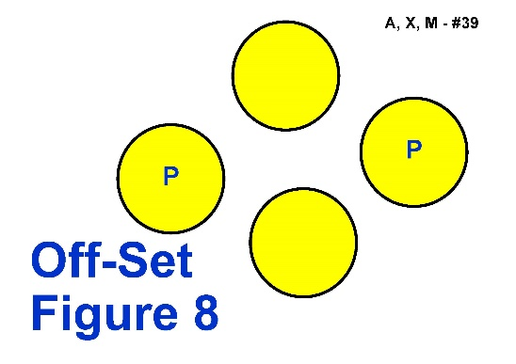

**Proposal:** Sign 39. Offset Figure 8 - Change of sign Image only, no change to description

**Rationale:** The current sign image is confusing for handlers, showing the Pylons/Posts on the wrong side to where they should be if approaching the sign from the front.

*PROPOSED NEW SIGN IMAGE*

This amended image will clearly depict what at the posts/pylons and also the distractions.

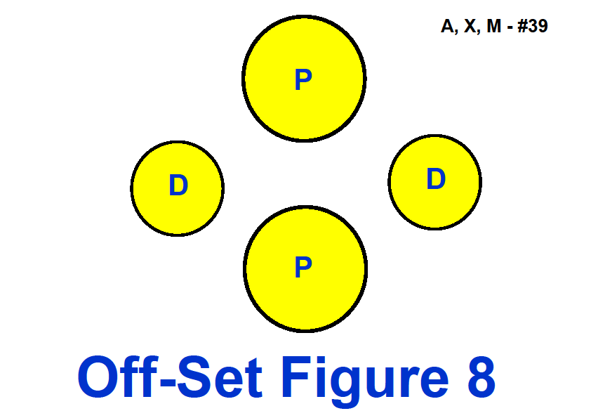

**DOGS NSW**

**Sign 41. Halt - Call Dog Front - Finish Right**

The Handler halts and dog sits. With the dog sitting in heel position, the Handler calls the dog to front and the dog sits in the front position, facing the Handler. On command, the dog then moves from the front position around the right of the Handler and sits in heel position. Handler must remain stationary. (Stationary exercise)

**Proposal:** Sign 41. Halt - Call Dog Front - Finish Right

The Handler halts and dog sits. With the dog sitting in heel position, **and without the handler moving their feet**, the Handler calls the dog to front and the dog sits in the front position, facing the Handler. **Without the handler moving their feet, the handler commands and/or signals the dog to move** from the front position around the right of the Handler and sits in heel position. Handler must remain stationary. (Stationary exercise)

**Rationale:** This is no change to how the sign is performed or judged, only a clearer description.

This is a stationary exercise. Once the dog sits in heel position the handler should not be guiding or assisting the dog by moving their feet for any parts of the exercise.

**DOGS NSW**

**42. Halt - Call Dog Front - Finish Left**

The Handler halts and dog sits. With the dog sitting in heel position, the Handler calls the dog to front and the dog sits in the front position facing the Handler. On command, the dog then moves to the Handler’s left and sits in heel position. Handler must remain stationary. (Stationary exercise)

**Proposal:**42. Halt - Call Dog Front - Finish Left

The Handler halts and dog sits. With the dog sitting in heel position, **and without the handler moving their feet,** the Handler calls the dog to front and the dog sits in the front position facing the Handler. **Without the handler moving their feet, the handler commands and/or signals the dog to move** to the Handler’s left and sits in heel position. Handler must remain stationary. (Stationary exercise)

**Rationale:** This is no change to how the sign is performed or judged, only a clearer description.

This is a stationary exercise. Once the dog sits in heel position the handler should not be guiding or assisting the dog by moving their feet for any parts of the exercise.

**DOGS VIC**

**Sign 46 Halt - Leave Dog - Recall**    
The current wording on the actual sign is :  
Leave Dog 3 metres  
About turn  
Recall Dog  
Handler Return  
  
**Proposal: wording on the actual sign:**Leave Dog 3 metres  
About turn  
Call Dog to Front  
Return to Dog  
  
**Rationale:**The exercises performed at station 46 (Adv) and station 57 (Exc) are identical apart from the distance you have to leave the dog (3m vs 5 m). Therefore the wording on the signs should be identical (apart from the distance)

**DOGS NSW**

**50. Call front, Handler Reverses Three Steps – Finish)**

The Handler calls the dog to the front, reverses three steps, with the dog moving with Handler. The dog returns to heel and continues heeling forward without stopping. The dog does not sit during this exercise. The team must maintain continuous motion throughout the turn without partially sitting or stopping

**Proposal:** 50. Call front, Handler Reverses Three Steps – Finish

The Handler calls the dog to the front, reverses **at least** three steps, with the dog moving with Handler. The dog returns to heel and continues heeling forward without stopping. The dog does not sit during this exercise. The team must maintain continuous motion throughout the turn without partially sitting or stopping

**Rationale:** Moving back exactly 3 steps becomes a balancing act for the handler rather than a training issue for the team. Also, in the space of exactly 2 steps many large dogs have barely moved into position and do not have a chance to move with the handler. Making the station “at least 3 steps” gives the handler a chance to change direction when they are balanced and permits them to move backwards with the dog in position in front before moving forward again.

**DOGS QLD**

**Proposal: 50. Call front, Handler Reverses Three Steps – Finish** - The Handler calls the dog to the front, reverses at least three steps, with the dog moving with Handler. The dog returns to heel and continues heeling forward without stopping. The dog does not sit during this exercise. The team must maintain continuous motion throughout the turn without partially sitting or stopping.

**Rationale:**  This exercise is currently hard to perform and judge – where exactly does the call front finish and the three reversing steps start? In Exercises #13, #14, #15 & #16 the handler “may take several steps backward” to perform the call front. In Exercise #72 the handler “reverses direction walking backward at least 3 steps”. There is differing interpretations of this exercise between various States, therefore adding the wording “at least” will provide consistency with the other exercises mentioned and clarify the differing interpretations.

**DOGS VIC**

Proposal: **50. Call front, Handler Reverses Three Steps - Finish** The *dog will be called to front position after which the Handler reverses at least three steps with the dog moving with them*. The dog returns to heel and continues heeling forward without stopping. The dog does not sit during this exercise. The team must maintain continuous motion throughout the turn without partially sitting or stopping

**Rationale:** The correction will allow large dogs to get into a correct front position before the backward steps are taken giving a more collected performance, ensuring the station is performed as was intended. Deductions are made if the dog sits crooked in the ‘front’ position with the ‘call front and recall stations, if the dog is not straight in front in this station then deductions should be made, this would greatly penalise the larger dogs that require more than three steps from the handler to become straight*.*

*note – there was a lot of investigation when introducing this station initially in the action of giant breeds and toy breeds, this is why the change should reflect the intention of the original submission

**DOGS AC T**

Proposal: 50 – See Chart of all signs

**DOGS ACT**

Proposal: 51 – See Chart of all signs

**DOGS SA**

**Sign 51. Leave Dog – About Turn – Return to Dog**

**Proposal: Amend the sign description.**

**51. Leave Dog - About Turn – Return to Dog -** The Handler halts and dog sits. The Handler leaves dog and walks forward 5 meters to the marker. The Handler performs an about turn **in either direction** then, facing the dog and without pausing, walks back toward dog. The Handler will return around the back of the dog to heel position. The Handler must become stationary and then command/cue the dog to move forward from the sit position. The dog must not move from the sit position and must not change position. (Stationary exercise).

**Rationale:** Makes no sense for this to be an Incorrectly Performed station because the handler briefly halts.

The arrow in the drawing for this sign, shows a right turn. As the dog is stationary in the sit, this can be interpreted as referring to the handler turning. I was recently told by an interstate judge that judges in that State have been told to IP if the handler does not turn in the direction of the arrow. I cannot see how it can possibly impact the performance whether the handler does a right or left turn, when turning to face their dog.

**DOGS NSW**

**51. Leave Dog - About Turn – Return to Dog**

The Handler halts and dog sits. The Handler leaves dog and walks forward 5 metres to the marker. The Handler performs an about turn then, facing the dog and without pausing, walks back toward dog. The Handler will return around the back of the dog to heel position. The Handler must become stationary and then command/cue the dog to move forward from the sit position. The dog must not move from the sit position and must not change position. (Stationary exercise)

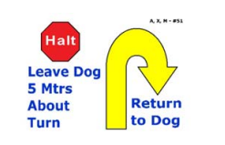

**Proposal:** 51. Leave Dog - About Turn – Return to Dog

The Handler halts and dog sits. The Handler leaves dog and walks forward 5 metres to the marker. The Handler performs an **ABOUT TURN** **RIGHT** then, facing the dog and without pausing, walks back toward dog. The Handler will return around the back of the dog to heel position. The Handler must become stationary and then command/cue the dog to move forward from the sit position. The dog must not move from the sit position and must not change position. (Stationary exercise)

**Rationale:** The description of this sign says “About Turn”, however the image depicted on this sign shows “About Turn Right”, in Rally Terminology for signage.

In Rally, the Handlers have always followed the direction of the arrows in all of the signs, however since the introduction of these new signs the descriptions do not match the depicted images and require modification as it is causing confusion with handlers.

*Refer to Rally Novice Sign #7 and Rally Advanced Sign #34 below for some examples*

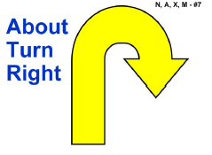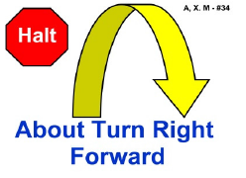

**DOGS ACT**

Proposal: 53 – See Chart of all signs

**DOGS NSW**

**Sign 53 – Send Over Jump**

No Current or Proposed Rule.

**Housekeeping change only**

**Sign 53 in Rule book (Page 24) still has #46 next to it, and not #53.**

**Full size signs for printing are ok, just the image within the rule book**

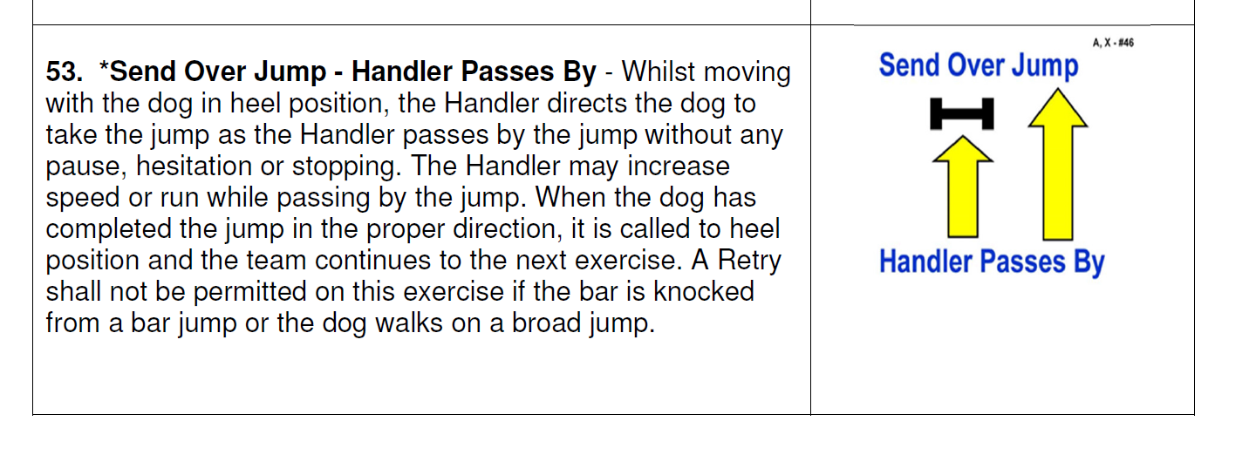

**DOGS VIC**

**Proposal: Excellent class -** Allocating other stations to Excellent from Masters

**Move station #69** (Moving Down, Walk around dog) from Masters to Excellent (page 28)

**Move station #70** (Moving Sit, Walk around dog) from Masters to Excellent (page 28)

**Rationale:** There is already the Moving stand, walk around dog (Station 56) in excellent. These two stations are the same principle where you leave a dog in a position and immediately move around them. With the introduction of new Masters stations that build upon these stations, it is necessary to move these back to Excellent so the teams can build up to them.

**DOGS NSW**

**Sign 56. Moving Stand - Walk Around Dog**

Whilst heeling and without pausing or stopping, the Handler will stand the dog and walk around the dog to the left **at an even pace**, returning to heel position. Once the Handler has reached the dog’s front left shoulder, the dog should be in a stand and not break position. The Handler must become stationary in heel position after returning to the dog. Dog must move forward from the standing position. (Stationary exercise)

**Proposal:** Sign 56. Moving Stand - Walk Around Dog

Whilst heeling and without pausing or stopping, the Handler will stand the dog and walk around the dog to the left at **A NORMAL PACE**, returning to heel position. Once the Handler has reached the dog’s front left shoulder, the dog mustbe in a stand and not break position. The Handler must become stationary in heel position after returning to the dog. Dog must move forward from the standing position. (Stationary exercise)

**Rationale:** Consistency of wording through all the signs

Amendment of wording from “At an even pace” to “At a Normal Pace”. An even pace could mean many things, there are three paces in Rally - slow place, normal pace, fast pace

**DOGS NSW**

**Sign 56. Moving Stand - Walk Around Dog**

Whilst heeling and without pausing or stopping, the Handler will stand the dog and walk around the dog to the left at an even pace, returning to heel position. Once the Handler has reached the dog’s front left shoulder, the dog **should be** in a stand and not break position. The Handler must become stationary in heel position after returning to the dog. Dog must move forward from the standing position. (Stationary exercise)

**Proposal:** Sign 56. Moving Stand - Walk Around Dog

Whilst heeling and without pausing or stopping, the Handler will stand the dog and walk around the dog to the left at a normal pace, returning to heel position. Once the Handler has reached the dog’s front left shoulder, the dog **must be** in a stand and not break position. The Handler must become stationary in heel position after returning to the dog. Dog must move forward from the standing position. (Stationary exercise)

**Rationale:** Amendment of wording from “should be” to “must be” in a Stand and not break position.

Consistency of wording through all the signs

“Should” is a suggestion, “must” means it is required.

This leaves difficulty for judges when wording is open to interpretation or discussion.

**DOGS ACT**

Proposal: 58 – See Chart of all signs

**DOGS NSW**

**Sign 58. Leave Dog - About Turn – Recall Dog – Finish Right**)

The Handler halts and dog sits. Handler leaves dog and walks forward 5 metres to the marker and does an about turn to face dog. Handler recalls dog. Dog comes briskly to sit in front of handler. The dog must return to heel position by moving around the right side of the Handler. Dog must sit in heel position before moving forward with the Handler. The dog must not anticipate the recall. (Stationary exercise)

**Proposal:** Sign 58. Leave Dog - About Turn – Recall Dog – Finish Right

The Handler halts and dog sits. Handler leaves dog and walks forward 5 metres to the marker and does an **ABOUT U TURN** to face dog. Handler recalls dog. Dog comes briskly to sit in front of handler. The dog must return to heel position by moving around the right side of the Handler. Dog must sit in heel position before moving forward with the Handler. The dog must not anticipate the recall. (Stationary exercise)

**Rationale:** The description of this sign says “About Turn”, however the image depicted shows “About U Turn”, in Rally Terminology for signage.

In Rally, the Handlers have always followed the direction of the arrows in all of the signs, however since the introduction of these new signs the descriptions do not match the depicted images and require modification as it is causing much confusion.

Signs 58 and 59, the Handlers objection is that the description says “About Turn”, and in traditional

obedience this is a “Right About Turn”, however the image is an “About U Turn”.

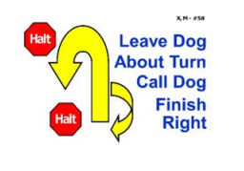

Refer to Rally Novice Sign #8, also Rally Advanced Sign #33 as examples about “About U Turn”

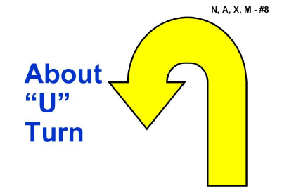 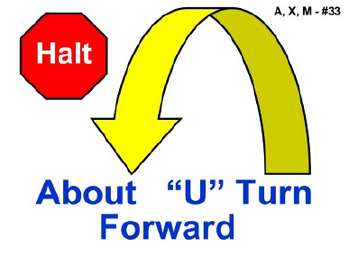

Or Remove the sign image all together and have description only as per example below of   
Sign 46 & Sign 57

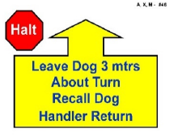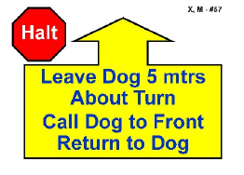

**DOGS ACT**

Proposal: 59 – See Chart of all signs

**DOGS NSW**

**Sign 59. Leave Dog - About Turn – Recall Dog – Finish Left**

The Handler halts and dog sits. Handler leaves dog and walks forward 5 metres to the marker and does an about turn to face dog. Handler recalls dog. Dog comes briskly to sit in front of handler. The dog must return to heel position by moving around the left side of the Handler. Dog must sit in heel position before moving forward with the Handler. The dog must not anticipate the recall. (Stationary exercise)

**Proposal:** Sign 59. Leave Dog - About Turn – Recall Dog – Finish Left

The Handler halts and dog sits. Handler leaves dog and walks forward 5 metres to the marker and does an ABOUT U TURN to face dog. Handler recalls dog. Dog comes briskly to sit in front of handler. The dog must return to heel position by moving around the left side of the Handler. Dog must sit in heel position before moving forward with the Handler. The dog must not anticipate the recall. (Stationary exercise)

**Rationale:** The description of this sign says “About Turn”, however the image depicted shows “About U Turn”, in Rally Terminology for signage.

In Rally, the Handlers have always followed the direction of the arrows in all of the signs, however since the introduction of these new signs the descriptions do not match the depicted images and require modification as it is causing much confusion.

Signs 58 and 59, the Handlers objection is that the description says “About Turn”, and in traditional

obedience this is a “Right About Turn”, however the image is an “About U Turn”

Refer to Rally Novice Sign #8, also Rally Advanced Sign #33 as an example.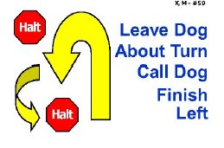

Refer to Rally Novice Sign #8, also Rally Advanced Sign #33 as examples About U Turn

 

Or Remove the sign image all together and have description only as per example below of   
Sign 46 & Sign 57



**DOGS QLD**

**64. Circle Spin at Heel –** The dog to complete a circle spin away from the heel position and then to return to heel. The Handler does not stop moving. The team must maintain continuous motion throughout the turn without partially sitting or stopping.

**Proposal: 64. Circle Spin at Heel –** The dog to complete a circle spin away from the heel position and then to return to heel. The Handler ~~does~~ should not stop moving. The ~~team~~ dog must maintain continuous motion throughout the turn without partially sitting or stopping.

**Rationale:** For handlers with large dogs, the spin can take some time to complete leaving the dog behind as it completes the spin if the handler continues to move forward. Changing ‘does’ to ‘should; allows for momentary cessation of motion by the handler to either allow the dog to catch up before the next station or for the handler to stay close as the dog completes the spin. An appropriate penalty can then be applied depending on how much the motion of the handler was ceased.

We already have a Station, Station Number 52 Halt-dog Circles Handler, where the Handler ceases movement whilst the dog continues moving, which is considered a moving station and therefore this station would maintain that status.

The principal feature is for the dog to keep moving to complete the spin without stopping.

**DOGS SA**

**Sign 68. Moving Stand – Leave Dog – Distance Down**

**Proposal: Amend the sign description**

Whilst heeling and without pausing, the Handler commands and/or signals the dog to stand and stay and moves forward 3 metres to the marker, performs an about turn and halts. The handler then commands and/or signals the dog to drop, then returns around the dog and~~, without~~ pauses~~ing~~, **then** continues on with the dog in the heel position. The dog must go directly from the stand position to the down position without sitting or moving forward. The maximum total movement forward from the dog will not exceed 1 body length of the dog from start to finish of the exercise (Stationary exercise)

**Rationale:** This sign is inconsistent with the general approach in other signs, which is that the handler must halt beside the dog. It seems to be a ‘trick’ sign to catch handlers out and not in the spirit of the sport. Amend the sign description so that the handler pauses after they return to the dog

**DOGS NSW**

**Sign 69. Moving Down - Walk Around Dog**

Whilst heeling and without becoming stationary, the Handler will down the dog and walk around the dog to the left at normal pace, returning to heel position. Once the Handler has reached the dog’s front left shoulder, the dog **should be** in a down and not break position. The Handler must become stationary in heel position after returning to the dog. The dog must move forward from the down position with the Handler at completion. (Stationary exercise)

**Proposal:** Sign 69. Moving Down - Walk Around Dog

Whilst heeling and without becoming stationary, the Handler will down the dog and walk around the dog to the left at normal pace, returning to heel position. Once the Handler has reached the dog’s front left shoulder, the dog **must be** in a down and not break position. The Handler must become stationary in heel position after returning to the dog. The dog must move forward from the down position with the Handler at completion. (Stationary exercise)

**Rationale:** Change from “Should be” to “Must be” in a down and not break position.

Consistency across similar signs.

“Should” is a suggestion, “must” means it is required.

This leaves difficulty for judges when wording is open to interpretation or discussion.

**DOGS NSW**

**70. Moving Sit – Walk Around Dog**

Whilst heeling and without becoming stationary, the Handler will sit the dog and walk around the dog to the left at normal pace, returning to heel position. Once the Handler has reached the dog’s front left shoulder, the dog **should be** in a sit and not break position. The Handler must become stationary in heel position after returning to the dog. The dog must move forward from the sit position with the Handler at completion. (Stationary exercise)

**Proposal:** 70. Moving Sit – Walk Around Dog

Whilst heeling and without becoming stationary, the Handler will sit the dog and walk around the dog to the left at normal pace, returning to heel position. Once the Handler has reached the dog’s front left shoulder, the dog **MUST** **be** in a sit and not break position. The Handler must become stationary in heel position after returning to the dog. The dog must move forward from the sit position with the Handler at completion. (Stationary exercise)

**Rationale:** Change from “Should be” to “Must be” in a sit and not break position

Consistency across similar signs.

“Should” is a suggestion, “must” means it is required.

This leaves much difficulty for judges when wording is open to interpretation.

**DOGS NSW**

**Sign 72. Backup 3 Steps**

Whilst heeling, the Handler reverses direction walking backward at least 3 steps, without first stopping, then continues heeling forward. The dog **moves** backward parallel to the Handler and must maintain heel position throughout the exercise without sitting or turning its body to face the Handler.

**Proposal:** Sign 72. Backup 3 Steps

Whilst heeling, the Handler reverses direction walking backward at least 3 steps, without first stopping, then continues heeling forward. The dog **WALKS** backward parallel to the Handler and must maintain heel position throughout the exercise without sitting or turning its body to face the Handler.

**Rationale:** Change to “The Dog Walks Backward”. The word “Move” currently allows for the dog to bounce or hop backwards, which would make it difficult to maintain heel position.

**DOGS NSW**

**Sign 73. Stand – Pivot Right – Forward**

The Handler commands and/or signals the dog to Stand as Handler comes to a halt. With the dog standing, the Handler pivots 90º to the right and the dog moves with the Handler. The dog does not sit. The Handler must become stationary before the team heels forward. The Handler is required to pivot by turning in place. (Stationary exercise)

**Proposal: \*** Name change of Sign to - **73. Stand – Pivot Right – Stand**

* Change of sign Image to reflect the sign name amendment

**Rationale:** The current name of this sign is confusing for handlers. It is a progression from the Advanced   
Sign 37 Halt - 90° Pivot Right – Halt, the only difference is this sign is performed in at stand. The word “forward” raises many questions, the forward is only part of the exercise to heel toward the next station. Stand, Pivot Right, Stand is the exercise.

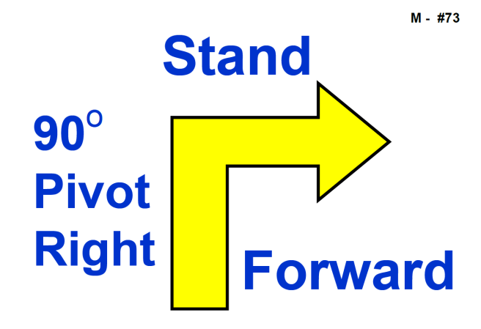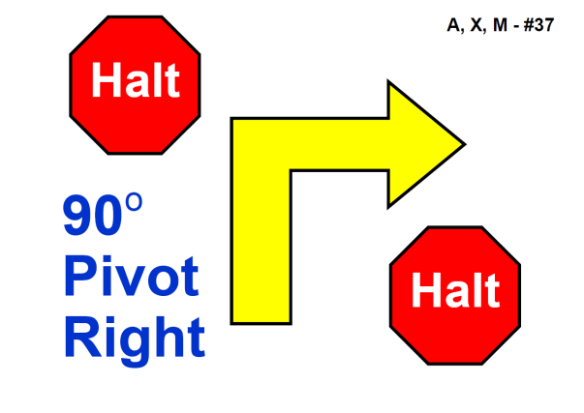

**PROPOSED NEW SIGN IMAGE**

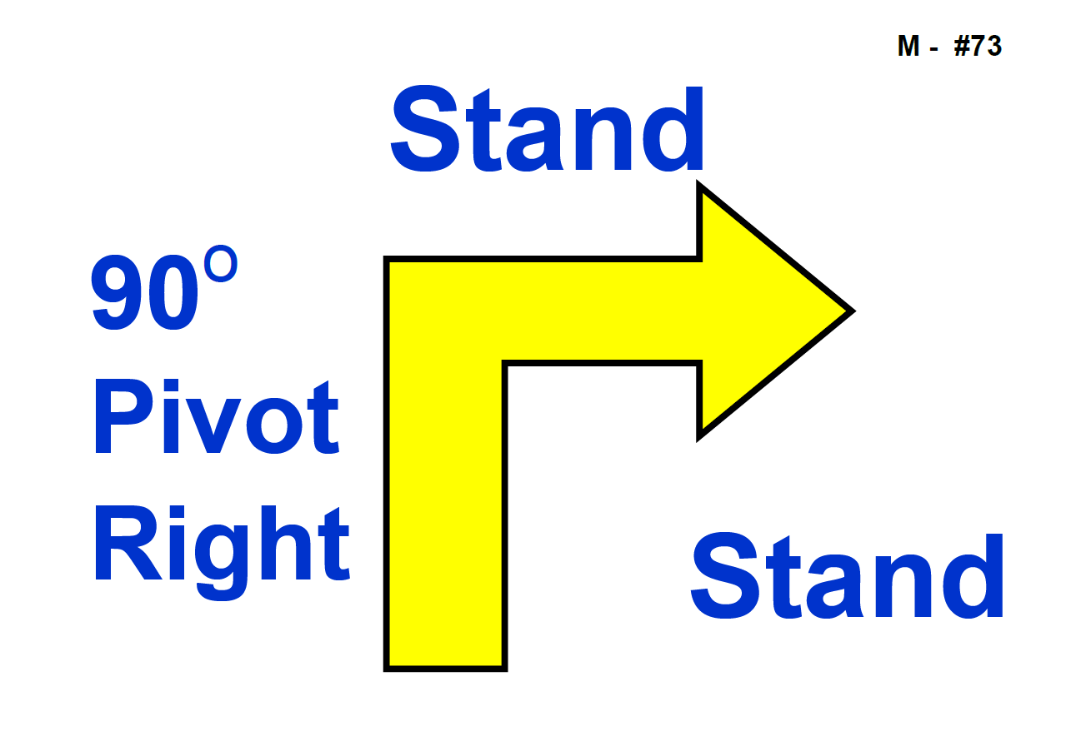

**DOGS QLD**

**73. Stand – Pivot Right – Forward –** The Handler commands and/or signals the dog to Stand as Handler comes to a halt. With the dog standing, the Handler pivots 90º to the right and the dog moves with the Handler. The dog does not sit. The Handler must become stationary before the team heels forward. The Handler is required to pivot by turning in place. (Stationary exercise)

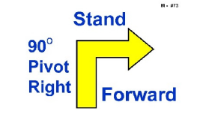

**Proposal: 73. Stand – Pivot Right – ~~Forward~~ Stand –** The Handler commands and/or signals the dog to Stand as Handler comes to a halt. With the dog standing in heel position, the Handler pivots 90º to the right and halts. The dog moves with the Handler. The dog does not sit. ~~The Handler must become stationary before the team heels forward.~~ The Handler is required to pivot by turning in place and must not take any steps forward. (Stationary exercise)

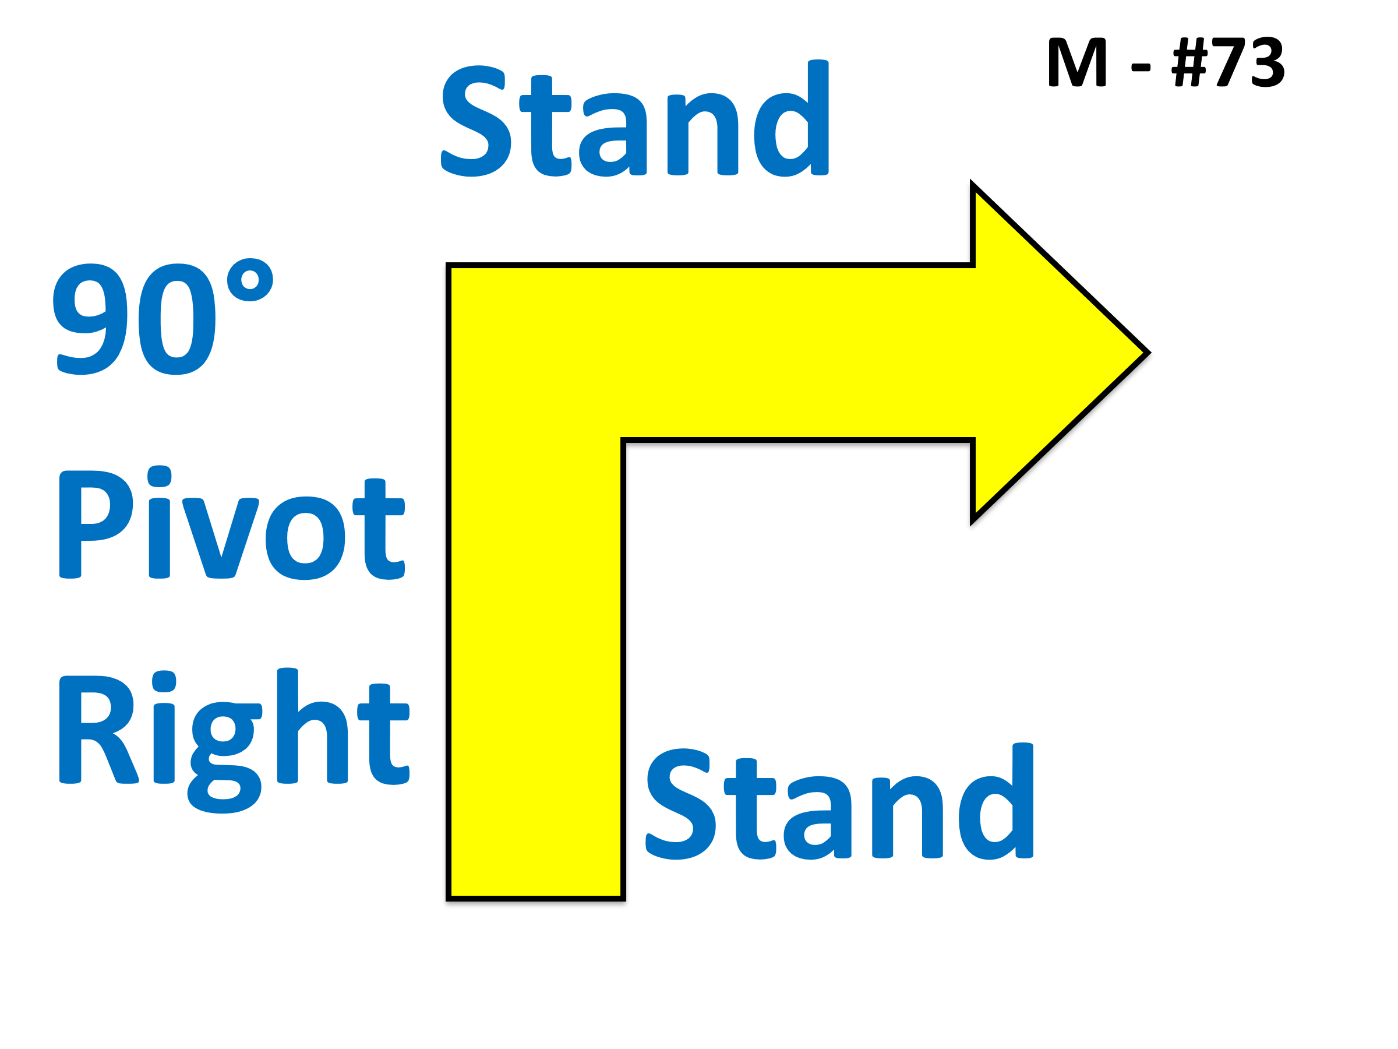

**Rationale:** To standardise the wording with the sitting pivot turns (#38, #39, #43, #44) as much as possible. The sign only shows one stand which has caused confusion with Handlers not stopping after the turn. The sign should be amended to replace the word “Forward” with the word “Stand”. This will standardise the all the pivot exercises and signs as much as possible.

**DOGS NSW**

**74. Stand – Pivot Left – Forward**

The Handler commands and/or signals the dog to Stand as Handler comes to a halt. With the dog standing, the Handler pivots 90º to the left and the dog moves with the Handler. The dog does not sit. The Handler must become stationary before the team heels forward. The Handler is required to pivot by turning in place. (Stationary exercise)

**Proposal:**

* 1. Name change of Sign to - **73. Stand – Pivot Left– Stand**

* 2. Change of sign Image to reflect the sign name amendment

**Rationale:** The current name of this sign is confusing for handlers. It is a progression from the Advanced   
38. Halt - 90° Pivot Left - Halt, the only difference is this sign is performed in at stand. The word “forward” raises many questions, the forward is only part of the exercise to heel toward the next station. Stand, Pivot Left, Stand is the exercise.

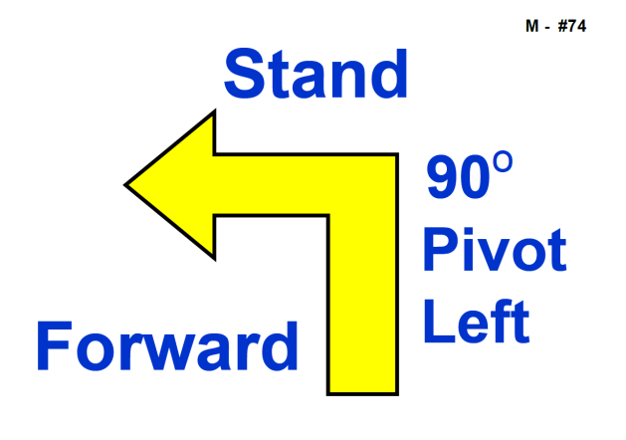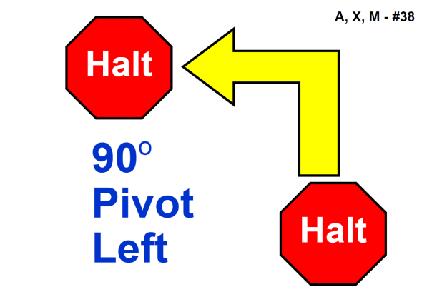

**PROPOSED SIGN IMAGE**

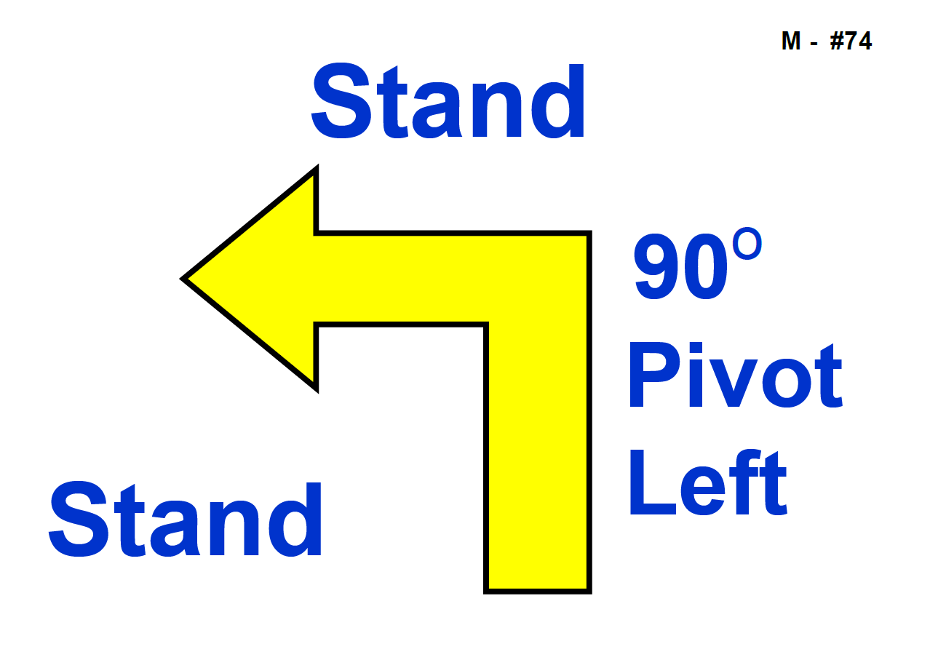

**DOGS QLD**

**74. Stand – Pivot Left – Forward –** The Handler commands and/or signals the dog to Stand as Handler comes to a halt. With the dog standing, the Handler pivots 90º to the left and the dog moves with the Handler. The dog does not sit. The Handler must become stationary before the team heels forward. The Handler is required to pivot by turning in place. (Stationary exercise)

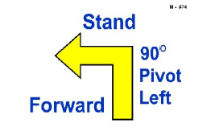

**Proposal: 74. Stand – Pivot Left – ~~Forward~~ Stand –** The Handler commands and/or signals the dog to Stand as Handler comes to a halt. With the dog standing in heel position, the Handler pivots 90º to the left and halts. The dog moves with the Handler. The dog does not sit. ~~The Handler must become stationary before the team heels forward.~~ The Handler is required to pivot by turning in place and must not take any steps forward. (Stationary exercise)

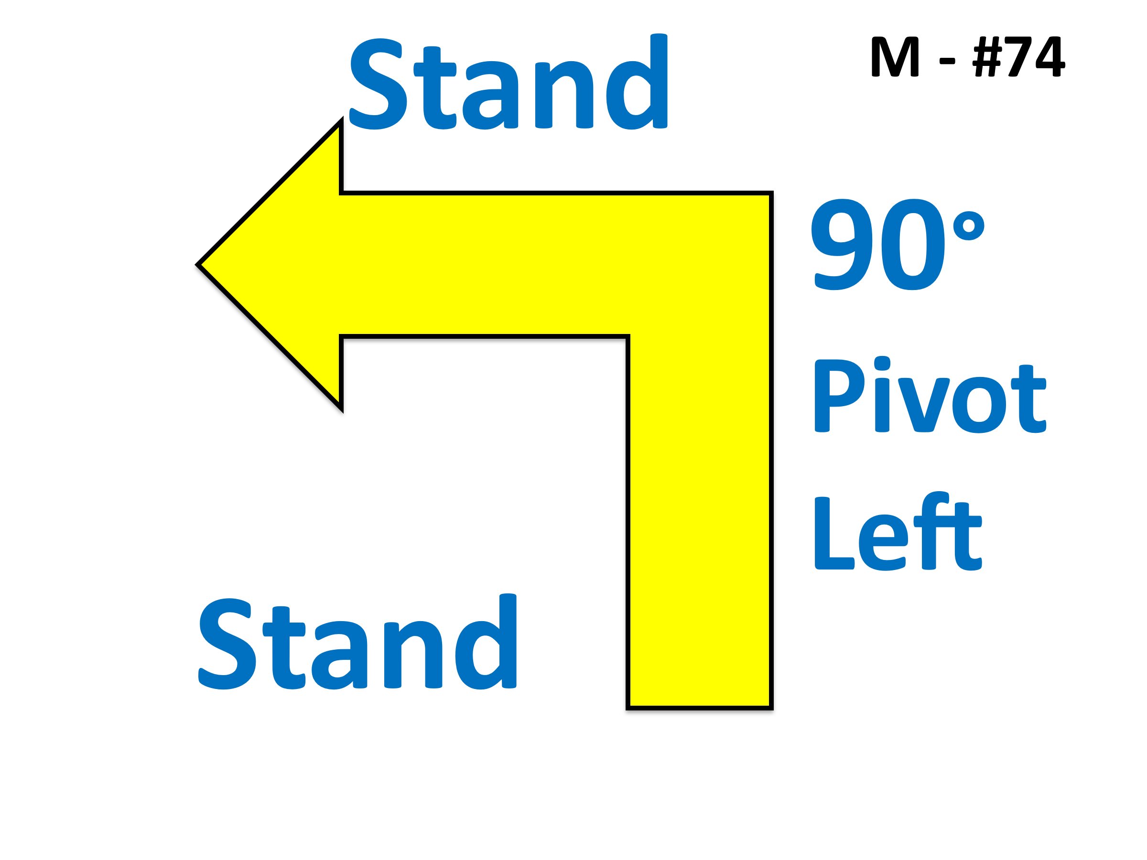

Modified Sign

**Rationale:** To standardise the wording with the sitting pivot turns (#38, #39, #43, #44) as much as possible. The sign only shows one stand which has caused confusion with Handlers not stopping after the turn. The sign should be amended to replace the word “Forward” with the word “Stand”. This will standardise the all the pivot exercises and signs as much as possible.

**DOGS NSW**

**Sign 76. 180 Turn Left – Heel on Right – 180 Turn Right**

The Handler, whilst moving, signals the dog to complete a 180 degree turn to the left, at the same time turning 180 (left) toward the dog. The dog is to 'heel' on the right for a minimum of three steps. The Handler then signals the dog to turn 180 to the right, at the same time turning 180 to the right. Dog is returned to heel position.

**Proposal:** Sign 76. 180 Turn Left – Heel on Right – 180 Turn Right

The Handler, whilst moving, signals the dog to complete a 180 degree turn to the left, at the same time turning 180 (left) toward the dog. The dog is to 'heel' on the right for a minimum of **three steps** **of the handler**. The Handler then signals the dog to turn 180 to the right, at the same time turning 180 to the right. Dog is returned to heel position.

**Rationale:** Change to “three steps of the handler…” The description of the sign is unclear, is the handler to make 3 steps, or the dog?

Handler is concentrating on the dog moving in the forward position, it is much easier to make this wording consistent across the signs which require steps of the handler, and not the dog.

Example of similar

72. Backup 3 Steps - Whilst heeling, the *Handler reverses direction walking backward at least 3 steps*, without first stopping, then continues heeling forward. The dog moves backward parallel to the Handler and must maintain heel position throughout the exercise without sitting or turning its

body to face the Handler.

**The following exercises may be used in Novice, Advanced, Excellent and Master Classes:**

|  |  |
| --- | --- |
| **NOVICE** |  |
| **1. Start** - Indicates the beginning of the course. Dog does not have to be sitting at start but must be under effective control. |  |
| **2. Finish** - Indicates the end of the course - timing stops. |  |
| **3. Halt - Sit** - Whilst heeling, the Handler halts and the dog sits in heel position. The team then moves forward, with the dog in heel position. (Stationary exercise) |  |
| **4.**  **Halt - Down** - Whilst heeling, the Handler halts and the dog sits in heel position. The Handler then commands and/or signals the dog to down. The Handler must return to an upright stationary position before moving forward. (Stationary exercise) |  |
| **5.** **\* Right Turn** - Performed as a 90° turn to the right, as in traditional obedience. |  |
| **6**. **\* Left Turn** - Performed as a 90° turn to the left, as in traditional obedience. |  |
| **7.** **\*About Turn Right** - Whilst heeling, the team makes a 180° about turn to the Handler’s right. The team must maintain continuous motion throughout the turn without partially sitting or stopping. |  |
| **8.** **\*About U Turn** **Left** - Whilst heeling, the team makes a 180° turn to the Handler’s left. The team must maintain continuous motion throughout the turn without partially sitting or stopping. |  |
| **9.** **\*270° Right Turn** - Whilst heeling, the team makes a 270° turn to the Handler’s right. 270° turns are performed as a tight circle appropriate to the size of the dog, but not around the exercise sign. The team must maintain continuous motion throughout the turn without partially sitting or stopping. |  |
| **10.** **\*270° Left Turn** - Whilst heeling, the team makes a 270° turn to the Handler’s left. 270° turns are performed as a tight circle appropriate to the size of the dog but not around the exercise sign. The team must maintain continuous motion throughout the turn without partially sitting or stopping. |  |
| **11. 360° Right Turn** - Whilst heeling, the team makes a 360° turn to the Handler’s right. 360° turns are performed as a tight circle appropriate to the size of the dog but not around the exercise sign. The team must maintain continuous motion throughout the turn without partially sitting or stopping. |  |
| **12. 360° Left Turn** - Whilst heeling, the team makes a 360° turn to the Handler’s left. 360° turns are performed as a tight circle appropriate to the size of the dog but not around the exercise sign. The team must maintain continuous motion throughout the turn without partially sitting or stopping. |  |
| **13. Call Dog Front - Finish Right - Forward** - Whilst heeling, the Handler stops forward motion and calls the dog to the front position (dog sits in front and faces the Handler). The Handler may take several steps backward as the dog turns and moves to sit in the front position. Second part of the exercise directs the Handler to command and/or signal the dog to change from the front position by moving to the Handler’s right, around behind the Handler, toward heel position. As the dog clears the Handler’s path, the Handler moves forward before the dog has completely returned to the heel position. The dog does not sit before moving forward in heel position with the Handler. (Stationary exercise) |  |
| **14. Call Dog Front - Finish Left - Forward** - Whilst heeling, the Handler stops forward motion and calls the dog to the front position (dog sits in front and faces the Handler). The Handler may take several steps backward as the dog turns and moves to sit in the front position. Second part of the exercise directs the Handler to command and/or signal the dog to change from the front position by moving to the Handler’s left toward heel position. As the dog clears the Handler’s path, the Handler moves forward before the dog has completely returned to the heel position. The dog does not sit before moving forward in heel position with the Handler. (Stationary exercise) |  |
| **15. Call Dog Front - Finish Right - Halt** - Whilst heeling, the Handler stops forward motion and calls the dog to the front position (dog sits in front and faces the Handler). The Handler may take several steps backward as the dog turns and moves to sit in the front position. Second part is the finish to the right, where the dog must return to heel position by moving around the right side of the Handler. Dog must sit in heel position before moving forward with the Handler. (Stationary exercise) |  |
| **16. Call Dog Front – Finish Left - Halt** - Whilst heeling, the Handler stops forward motion and calls the dog to the front position (dog sits in front and faces the Handler). The Handler may take several steps backward as the dog turns and moves to a sit in front position. Second part is the finish to the left where the dog must move to the Handler’s left, and sit in the heel position. Dog must sit in the heel position before moving forward with the Handler. (Stationary exercise) |  |
| **17. *Slow Pace** - Dog and Handler must slow down noticeably. This must be followed by a normal pace unless it is the last station on the course. |  |
| **18. * Fast Pace** - Dog and Handler must speed up noticeably. This must be followed by a normal pace unless it is the last station on the course. |  |
| **19. * Normal Pace** - Dog and Handler must move forward, walking briskly and naturally. |  |
| **20. Moving Sidestep Right** - Whilst heeling, the Handler takes one step diagonally to the right, leading with the right foot, and continues moving forward along the newly established line. The dog moves with the Handler. The exercise shall be performed just after the exercise sign. |  |
| **21. Spiral Right - Dog Outside** - This exercise requires three pylons or posts placed in a straight line with spaces between them of approximately 2.0 – 2.5 metres. Spiral right indicates the Handler must turn to the right when moving around each pylon or post. This places the dog on the outside of the turns. The exercise sign is placed near or on the first pylon or post where the spiral is started. |  |
| **22. Spiral Left - Dog Inside** - This exercise requires three pylons or posts placed in a straight line with spaces between them of approximately 2.0 – 2.5 metres. Spiral left indicates that the Handler must turn to the left when moving around each pylon or post. This places the dog on the inside of the turns. The exercise sign is placed near or on the first pylon or post where the spiral is started. |  |
| **23. Straight Figure 8 Weave Twice** - This exercise requires four pylons or posts placed in a straight line with spaces between them of approximately 2.0 – 2.5 metres. The exercise sign is placed near or on the first pylon or post where the exercise is started. Entry into the weaving pattern is with the first pylon or post at the dog/Handler’s left side. The dog and Handler must complete the entire exercise by passing the last pylon or post. |  |
| **24. Serpentine Weave Once** - This exercise requires pylons or posts placed in a straight line with spaces between them of approximately 2.0 – 2.5 metres. The exercise sign is placed near or on the first pylon or post where the exercise starts. Entry into the weaving pattern is with the first pylon or post at the dog/Handler’s left side. The dog and Handler must complete the entire exercise by passing the last pylon or post. It should be noted that in this exercise, the team does not weave back through the obstacles as they do in the Straight Figure 8. |  |
| **25. Halt - 1, 2 and 3 Steps Forward** - The Handler halts and the dog sits in heel position to begin the exercise. The Handler takes one step forward and halts with the dog maintaining heel position. The dog sits when the Handler halts. This is followed by two steps forward - halt, and three steps forward - halt, with the dog heeling each time the Handler moves forward and sitting each time the Handler halts. (Stationary exercise) |  |
| **26. Call Front - 1, 2 and 3 Steps Backward** - Whilst heeling, the Handler stops forward motion and calls the dog to the front position (dog sits in front and faces the Handler). The Handler may take several steps backward as the dog turns and moves to a sit in the front position. With the dog in the front position, the Handler takes one step backward and halts. The dog moves with the Handler and sits in the front position as the Handler halts. This is followed by the Handler taking two steps backward and a halt, and three steps backward and a halt. Each time, the dog moves with the Handler to the front position and sits as the Handler halts. The Handler then commands and/or signals the dog to resume heel position. As the dog clears the Handler’s path, the Handler moves forward before the dog has completely returned to the heel position. The dog does not sit before moving forward in heel position with the Handler. (Stationary exercise). |  |
| **27. Down** - Whilst heeling with the dog in heel position, the Handler commands and/or signals the dog to down as the Handler comes to a stop next to the dog. Once the dog is completely down, the Handler must return to an upright stationary position before moving forward. (Stationary exercise) |  |
| **28. Halt - Fast Forward from Sit** - The Handler halts and the dog sits in heel position. With the dog sitting in heel position, the Handler commands and/or signals the dog to heel and immediately moves forward at a fast pace. This must be followed by a normal pace unless it is the last station on the course. (Stationary exercise) |  |
| **29. Left About Turn** - Whilst moving with the dog in heel position, the Handler makes an about turn to the left, Whilst at the same time, the dog must move around the Handler to the right and into heel position. The dog does not sit before moving forward in heel position with the Handler. |  |
| **30. Halt - Walk Around Dog** - The Handler halts and dog sits. With the dog sitting in heel position, the Handler commands and/or signals the dog to stay, then proceeds to walk around the dog to the left, returning to heel position. The Handler must become stationary in heel position before moving forward to the next station. (Stationary exercise) |  |
| **31. Halt - Down - Walk Around Dog** – The Handler halts and dog sits. With the dog sitting in heel position, the Handler commands and/or signals the dog to down and stay, then proceeds to walk around the dog to the left, returning to heel position. The Handler must become stationary in heel position before moving forward to the next station. The dog heels forward from the down position. (Stationary exercise) |  |
| **32. Stand** - Whilst moving with the dog in heel position, the Handler commands and/or signals the dog to stand as the Handler comes to a stop next to the dog. Once the dog is completely paused in a stand, the Handler moves forward, commanding the dog to move forward from stand position. (Stationary exercise) |  |
| **ACT (NEW)**  **N ? Loop Turn Right -** Whilst heeling, the team makes a tight circle turn (loop) to the Handler’s right. Loop turns are performed as a tight circle appropriate to the size of the dog, but not around the exercise sign. The team must maintain continuous motion throughout the turn without partially sitting or stopping. The turn must be between 180° and 270°.  **(ACT) Rationale**  To increase options for direction changes to enable more flexibility in courses and more movement-based options. |  |
| **ACT (NEW)**  **N. ? Loop Turn Left -** Whilst heeling, the team makes a tight circle turn (loop) to the Handler’s left. Loop turns are performed as a tight circle appropriate to the size of the dog, but not around the exercise sign. The team must maintain continuous motion throughout the turn without partially sitting or stopping. The turn must be between 180° and 270°.  **(ACT) Rationale**  To increase options for direction changes to enable more flexibility in courses and more movement-based options. |  |
| **ACT (NEW)**  **N. ? Diagonal Right –** While heeling, the team make an angled turn to the handler’s right. The dog must move with the handler. The turn may be up to 90°.  **(ACT) Rationale**  To increase options for direction changes to enable more flexibility in courses and more movement-based options. |  |
| **ACT (NEW)**  **N. ? Diagonal Left –** While heeling, the team make an angled turn to the handler’s left. The dog must move with the handler. The turn may be up to 90°.  **(ACT) Rationale**  To increase options for direction changes to enable more flexibility in courses and more movement-based options. |  |
| **ACT (NEW)**  **N?. Halt – Handler Front – Finish Right -** The Handler halts and dog sits. With the dog sitting in heel position, the handler commands and/or signals the dog to stay, moves one step forward, and then does an about turn to the left and halts facing the dog. On command, the dog then moves from the front position around the right of the Handler and sits in heel position. The handler must remain stationary. (Stationary exercise)  **(ACT) Rationale**  To increase options for direction changes to enable more flexibility in courses and more movement-based options. |  |
| **ACT (NEW)**  **N?. Halt – Handler Front – Finish Left -** The Handler halts and dog sits. With the dog sitting in heel position, the handler commands and/or signals the dog to stay, moves one step forward, and then does an about turn to the left and halts facing the dog. On command, the dog then moves from the front position to the Handler’s left and sits in heel position. The handler must remain stationary.  (Stationary exercise).  **(ACT) Rationale**  To increase options for direction changes to enable more flexibility in courses and more movement-based options. |  |
| **ADVANCED** |  |
| **33. Halt - About “U” Turn and Forward** – The Handler halts and dog sits. With the dog sitting in heel position, the team turns 180° to the left and immediately moves forward. (Stationary exercise) |  |
| **34. Halt - About Turn Right and Forward** – The Handler halts and dog sits. With the dog sitting in heel position, the team turns 180° to the right and immediately moves forward. (Stationary exercise) |  |
| **35. Halt - Turn Right One Step - Call to Heel - Halt** – The Handler halts and dog sits. With the dog sitting, the Handler commands and/or signals the dog to stay. The Handler then turns to the right, while taking one step in that direction, and halts. The dog must maintain the stay until it is directed to the new heel position and must move and sit in the new location before moving forward to the next station. (Stationary exercise) |  |
| **36. Halt - Stand Dog - Walk Around** – The Handler halts and dog sits. With the dog sitting in heel position, the Handler stands the dog, commands and/or signals the dog to stay as the Handler walks around the dog to the left, returning to heel position. The Handler must become stationary in heel position before moving forward to the next station. (Stationary exercise) |  |
| **37. Halt - 90° Pivot Right - Halt** – The Handler halts and dog sits. With the dog sitting in heel position, the Handler pivots 90° to the right and halts. The dog moves with the Handler and sit*s* in heel position. The Handler is required to pivot by turning in place and must not take any steps forward. (Stationary exercise) |  |
| **38. Halt - 90° Pivot Left - Halt** – The Handler halts and dog sits. With the dog sitting in heel position, the Handler pivots 90° to the left and halts. The dog moves with the Handler and sits in heel position. The dog must back into position, not turn into the Handler. The Handler is required to pivot by turning in place and must not take any steps forward. (Stationary exercise) |  |
| **39. Offset Figure 8** - This exercise requires two pylons or posts placed about 2.45 – 3.00 metres apart, around which the team will perform a complete Figure 8, crossing the centre line three times. Two distractions will be arranged to the sides of the Figure 8 about 1.55 – 1.85 metres apart. Entry may be between the pylons or posts and the distraction on either side. The distractions will consist of two securely covered containers with tempting dog treats; however, dog toys may replace one or both containers, or may be placed next to the containers. The exercise sign may be placed on or near the cone where entry is made into the Offset Figure 8. |  |
| **40. Halt - Side-step Right – Halt** - The Handler halts and dog sits*.* With the dog sitting in heel position, the Handler moves one step directly to the right and halts*.* The dog moves with the Handler and sits in heel position when the Handler halts. The exercise shall be performed just past the exercise sign. (Stationary exercise) |  |
| **41. Halt - Call Dog Front - Finish Right** – The Handler halts and dog sits. With the dog sitting in heel position, the Handler calls the dog to front and the dog sits in the front position, facing the Handler. On command, the dog then moves from the front position around the right of the Handler and sits in heel position. Handler must remain stationary. (Stationary exercise) |  |
| **42. Halt - Call Dog Front - Finish Left** – The Handler halts and dog sits*.* With the dog sitting in heel position, the Handler calls the dog to front and the dog sitsin the front position facing the Handler. On command, the dog then moves to the Handler’s left and sitsin heel position. Handler must remain stationary. (Stationary exercise) |  |
| **43. Halt - 180° Pivot Right - Halt** – The Handler halts and dog sits. With the dog sitting in heel position, the Handler pivots 180° to the right and halts. The dog moves with the Handler and sitsin heel position. The Handler is required to pivot by turning in place and must not take any steps forward. (Stationary exercise) |  |
| **44. Halt - 180° Pivot Left - Halt** *–* The Handler halts and dog sits. With the dog sitting in heel position, the Handler pivots 180° to the left and halts. The dog moves with the Handler and sitsin heel position*.* The dog must back into position, not turn into the Handler. The Handler is required to pivot by turning in place and must not take any steps forward. (Stationary exercise) |  |
| **45. Halt - Down - Sit** – The Handler halts and dog sits. With dog sitting in heel position, the Handler commands and/or signals the dog to down. The Handler must return to an upright stationary position before commanding and or signalling the dog to sit. The Handler does not physically handle the dog or move forward or backward. The Handler then commands and/or signals the dog to heel forward from the sitting position. (Stationary exercise) |  |
| **46. Halt – Leave Dog - Recall** - The Handler commands and/or signals the dog to sit and stay, then moves forward 3 metres to the marker, performs an about turn, halts and commands and/or signals the dog to come. The dog shall sit in front of the Handler. The Handler shall return to the right side of the dog by either a step back to the side or around the dog. The Handler must become stationary in heel position before moving forward to the next station. (Stationary exercise). |  |
| **47. Double Right U Turn -** Whilst moving forward and without pausing, the Handler and dog will complete a right U turn, heel approximately two (2) metres and then, repeat the right U turn and continue forward. The team must maintain continuous motion throughout the turn without partially sitting or stopping. |  |
| **48. Double Left U Turn -** Whilst moving forward and without pausing, the Handler and dog perform a left U turn, heel approximately two (2) metres and then, repeat the left U turn and continue forward. The team must maintain continuous motion throughout the turn without partially sitting or stopping. |  |
| **49. Double Left About Turn –** Whilst moving forward and without pausing, the Handler and dog will complete a left about turn, heel approximately two (2) metres and then repeat the left about turn and continue forward. The team must maintain continuous motion throughout the turn without partially sitting or stopping. |  |
| **50. Call front, Handler Reverses Three Steps - Finish** The Handler calls the dog to the front, reverses three steps, with the dog moving with Handler. The dog returns to heel and continues heeling forward without stopping. The dog does not sit during this exercise. The team must maintain continuous motion throughout the turn without partially sitting or stopping.  **(ACT) Proposed Change: Appendix A (50)**  **50. Call front, Handler Reverses Three Steps - Finish** The Handler calls the dog to the front, reverses at least three steps, with the dog moving with Handler. The dog returns to heel and continues heeling forward without stopping. The dog does not sit during this exercise. The team must maintain continuous motion throughout the turn without partially sitting or stopping.  **(ACT) Rationale: Appendix A (50)**  To clarify how many steps the handler should take. Currently it’s unclear as to whether the handler completes calling the dog to front and then reverses three steps; or whether the handler reverses for a total of three steps during the entire performance. The requirements need to be clarified so the exercise can be trained correctly and judged consistently.  The criteria of at least three steps also makes it more achievable for large dogs and handlers with physical limitations to perform the exercise**.** |  |
| **51. Leave Dog - About Turn – Return to Dog -** The Handler halts and dog sits. The Handler leaves dog and walks forward 5 metres to the marker. The Handler performs an about turn then, facing the dog and without pausing, walks back toward dog. The Handler will return around the back of the dog to heel position. The Handler must become stationary and then command/cue the dog to move forward from the sit position. The dog must not move from the sit position and must not change position. (Stationary exercise)  **(ACT) Proposed Change: Appendix A (51**)  **51. Leave Dog - About Turn – Return to Dog -** The Handler halts and dog sits. The Handler leaves dog and walks forward 5 metres to the marker. The Handler performs an about turn (either to the left or to the right) then, facing the dog and without pausing, walks back toward dog. The Handler will return around the back of the dog to heel position. The Handler must become stationary and then command/cue the dog to move forward from the sit position. The dog must not move from the sit position and must not change position. (Stationary exercise)  **(ACT) Rationale: Appendix A (51)**  This exercise provides a bridge between the 3m RA recall and the 5m RE recall. It tests the dog’s stability when the handler briefly goes further away from the dog (5m instead of 3m). It’s not a test of the handler’s ability to perform a right about turn. Currently this exercise is being judged inconsistently due to differing interpretations as to whether the sign requires the handler to execute a right about turn, or whether it’s up to the handler to execute either a right about or left about turn. The requirements of the exercise need to be clear so it can be trained correctly and judged consistently. |  |
| **52. Halt – Dog circles handler – Forward -** The Handler halts and, without the dog pausing or sitting, sends the dog in a circle to the right so that the dog moves around the back of the Handler and returns to the heel position. The Handler then moves forward to the next station. The dog does not pause or sit before it is sent around the Handler or when returning to the heel position. |  |
| **53. *Send Over Jump - Handler Passes By** - Whilst moving with the dog in heel position, the Handler directs the dog to take the jump as the Handler passes by the jump without any pause, hesitation or stopping. The Handler may increase speed or run while passing by the jump. When the dog has completed the jump in the proper direction, it is called to heel position and the team continues to the next exercise. A Retry shall not be permitted on this exercise if the bar is knocked from a bar jump or the dog walks on a broad jump.  **(ACT) Proposed Change: Appendix A (53)**  **53. *Send Over Jump - Handler Passes By -** Whilst moving with the dog in heel position, the Handler directs the dog to take the jump as the Handler passes by the jump without any pause, hesitation or stopping. The Handler may increase speed or run while passing by the jump. When the dog has completed the jump in the proper direction, it is called to heel position and the team continues to the next exercise. A Retry shall not be permitted on this exercise if the bar is knocked from a bar jump ~~or the dog walks on a broad jump~~.  **(ACT) Rationale Appendix A (53)**  Consequential amendment if the proposal to discontinue use of the Broad Jump is successful. |  |
| **EXCELLENT** |  |
| **54. Halt - Stand - Sit** – The Handler halts and dog sits*.* With dog sitting in heel position, the Handler will stand the dog (without physical handling or moving forward),then command and/or signal the dog to sit. The Handler then commands and/or signals the dog to heel forward from the sitting position. (Stationary exercise) |  |
| **55. Halt - Stand - Down** – The Handler halts and dog sits*.* With dog sitting in heel position, the Handler will stand the dog (without physical handling or moving forward)*,* then command and/or signal the dog to down*.* The Handler must return to an upright stationary position before commanding and/or signalling the dog to heel forward from the down position.(Stationary exercise) |  |
| **56. Moving Stand - Walk Around Dog -** Whilst heeling and without pausing or stopping, the Handler will stand the dog and walk around the dog to the left at an even pace, returning to heel position. Once the Handler has reached the dog’s front left shoulder, the dog should be in a stand and not break position. The Handler must become stationary in heel position after returning to the dog. Dog must move forward from the standing position. (Stationary exercise) |  |
| **57. Halt – Leave Dog - Recall -** The Handler commands and/or signals the dog to sit and stay, then moves forward 5 metres to the marker, performs an about turn, halts and commands and/or signals the dog to come. The dog shall sit in front of the Handler. The Handler shall return to the right side of the dog by either a step back to the side or around the dog. Handler must become stationary upon returning to the dog. (Stationary exercise) |  |
| **58. Leave Dog - About Turn – Recall Dog – Finish Right -** The Handler halts and dog sits. Handler leaves dog and walks forward 5 metres to the marker and does an about turn to face dog. Handler recalls dog. Dog comes briskly to sit in front of handler. The dog must return to heel position by moving around the right side of the Handler. Dog must sit in heel position before moving forward with the Handler. The dog must not anticipate the recall. (Stationary exercise)  **(ACT) Proposed Changes Appendix A (58)**  **58. Leave Dog - About Turn – Recall Dog – Finish Right -** The Handler halts and dog sits. Handler leaves dog and walks forward 5 metres to the marker and does an about turn (either to the left or to the right) to face dog. Handler recalls dog. Dog comes briskly to sit in front of handler. The dog must return to heel position by moving around the right side of the Handler. Dog must sit in heel position before moving forward with the Handler. The dog must not anticipate the recall. (Stationary exercise)  **(ACT) Rationale Appendix A (58)**  This exercise tests the team’s ability to add a Finish Right to the end of a recall. It’s not a test of the handler’s ability to perform a left about turn. Currently this exercise is being judged inconsistently due to differing interpretations as to whether the sign requires the handler to execute a left about turn, or whether it’s up to the handler to execute either a right about or left about turn. The requirements of the exercise need to be clear so it can be trained correctly and judged consistently. |  |
| **59. Leave Dog - About Turn – Recall Dog – Finish Left -** The Handler halts and dog sits. Handler leaves dog and walks forward 5 metres to the marker and does an about turn to face dog. Handler recalls dog. Dog comes briskly to sit in front of handler. The dog must return to heel position by moving around the left side of the Handler. Dog must sit in heel position before moving forward with the Handler. The dog must not anticipate the recall. (Stationary exercise)  **(ACT) Proposed Changes Appendix A (59)**  **59. Leave Dog - About Turn – Recall Dog – Finish Left -** The Handler halts and dog sits. Handler leaves dog and walks forward 5 metres to the marker and does an about turn (either to the left or to the right) to face dog. Handler recalls dog. Dog comes briskly to sit in front of handler. The dog must return to heel position by moving around the left side of the Handler. Dog must sit in heel position before moving forward with the Handler. The dog must not anticipate the recall. (Stationary exercise)  **(ACT) Rationale Appendix A (59)**  This exercise tests the team’s ability to add a Finish Left to the end of a recall. It’s not a test of the handler’s ability to perform a left about turn. Currently this exercise is being judged inconsistently due to differing interpretations as to whether the sign requires the handler to execute a left about turn, or whether it’s up to the handler to execute either a right about or left about turn. The requirements of the exercise need to be clear so it can be trained correctly and judged consistently. |  |
| **60. Right U Turn – Left About Turn -** Whilst moving forward and without pausing, the Handler and dog will complete a right U turn, travel approximately two (2) metres and then complete a left about turn and continue forward. The team must maintain continuous motion throughout the turn without partially sitting or stopping. |  |
| **61. Left U Turn – Left About Turn -** Whilst moving forward and without pausing, the Handler and dog will complete a left U turn, travel approximately two (2) metres and then complete a left about turn and continue forward. The team must maintain continuous motion throughout the turn without partially sitting or stopping. |  |
| **62. Left About Turn – Right U Turn -** Whilst moving forward and without pausing, the Handler and dog will complete a left about turn, travel approximately two (2) metres and then complete a right U turn and continue forward. The team must maintain continuous motion throughout the turn without partially sitting or stopping. |  |
| **63. Left About Turn – Left U Turn -** Whilst moving forward and without pausing, the Handler and dog will complete a left about turn, travel approximately two (2) metres and then complete a left U turn and continue forward. The team must maintain continuous motion throughout the turn without partially sitting or stopping. |  |
| **64. Circle Spin at Heel** – The dog to complete a circle spin away from the heel position and then to return to heel. The Handler does not stop moving. The team must maintain continuous motion throughout the turn without partially sitting or stopping. |  |
| **65. Four Cone Figure 8** **–** This exercise requires four cones to be placed in a square, each 1.5 metres from the centre point. The team must negotiate each opposite pair of cones as a Figure 8. The exercise sign shall be placed at the cone at which the team will negotiate the first Figure 8. (May be used as a change of direction). |  |
| **ACT (NEW)**  **E? Circle Handler – Right Turn – Forward**  Whilst heeling, the handler sends the dog in a circle to the right, and then turns 90º to the right. The dog moves around the back of the Handler and returns to the heel position. The Handler may pause briefly to allow the dog to complete its return to heel position. The Handler then moves forward to the next station. The dog does not pause or sit before it is sent around the Handler or when returning to the heel position.  **(ACT) Rationale**  To increase options for direction changes to enable more flexibility in courses and more movement-based options. |  |
| **ACT (NEW)**  **E? Circle Handler – Left Turn – Forward**  Whilst heeling, the handler sends the dog in a circle to the right, and then turns 90º to the left. The dog moves around the back of the Handler and returns to the heel position. The Handler may pause briefly to allow the dog to complete its return to heel position. The Handler then moves forward to the next station. The dog does not pause or sit before it is sent around the Handler or when returning to the heel position.  **(ACT) Rationale**  To increase options for direction changes to enable more flexibility in courses and more movement-based options**.** |  |
| **MASTER** |  |
| **66. Halt – Leave Dog – Down – Sit - Distance Commands - Return –** The Handler halts and the dog sits. The handler leaves the dog and moves forward 3 metres to the marker, performs an about turn and halts. The Handler commands and/or signals the dog to down. Once the dog is in down position, the Handler commands and/or signals the dog to sit. Once the dog is in sit position, the Handler returns around back of dog into heel position. The Handler must become stationary in heel position before moving forward to the next station. The maximum total movement forward by the dog will not exceed 1 body length of the dog from start to finish of the exercise. (Stationary exercise). |  |
| **67. Stand – Leave Dog – Down - Sit - Distance Commands – Return -** Whilst moving with the dog in heel position, the Handler commands and/or signals the dog to stand as the Handler comes to a stop next to the dog. With the dog in a stand, the Handler moves forward 3 metres to the marker, performs an about turn and halts. The Handler then commands and/or signals the dog to down. The dog must go directly from the stand to the down position without sitting or moving forward. Once the dog is in down position, the Handler commands and/or signals the dog to sit. Once dog is in sit position, the Handler returns around the back of dog into heel position. Handler must become stationary in heel position before moving forward to the next station. The maximum total movement forward by the dog will not exceed 1 body length of the dog from start to finish of the exercise. (Stationary exercise). |  |
| **68. Moving Stand – Leave Dog - Distance Down –** Whilst heeling and without pausing, the Handler commands and/or signals the dog to stand and stay and moves forward 3 metres to the marker, performs an about turn and halts. The handler then commands and/or signals the dog to drop, then returns around the dog and, without pausing, continues on with the dog in heel position. The dog must go directly from the stand position to the down position without sitting or moving forward. The maximum total movement forward from the dog will not exceed 1 body length of the dog from start to finish of the exercise (Stationary exercise) |  |
| **69. Moving Down - Walk Around Dog -** Whilst heeling and without becoming stationary, the Handler will down the dog and walk around the dog to the left at normal pace, returning to heel position. Once the Handler has reached the dog’s front left shoulder, the dog should be in a down and not break position. The Handler must become stationary in heel position after returning to the dog. The dog must move forward from the down position with the Handler at completion. (Stationary exercise) |  |
| **70. Moving Sit – Walk Around Dog -** Whilst heeling and without becoming stationary, the Handler will sit the dog and walk around the dog to the left at normal pace, returning to heel position. Once the Handler has reached the dog’s front left shoulder, the dog should be in a sit and not break position. The Handler must become stationary in heel position after returning to the dog. The dog must move forward from the sit position with the Handler at completion. (Stationary exercise) |  |
| **71. Halt – Leave Dog - Call To Heel –** The Handler halts and the dog sits. The Handler leaves the dog and moves forward 3 metres to the marker, and without becoming stationary, calls the dog to heel. The dog is expected to catch up into heel position as the Handler moves forward and before the Handler reaches the next station. The dog must not anticipate the recall and must not forge significantly ahead of the Handler when coming into heel position. (Stationary exercise) |  |
| **72. Backup 3 Steps** - Whilst heeling, the Handler reverses direction walking backward at least 3 steps, without first stopping, then continues heeling forward. The dog moves backward **parallel** to the Handler and must maintain heel position throughout the exercise without sitting or turning its body to face the Handler. |  |
| **73. Stand – Pivot Right – Forward** – The Handler commands and/or signals the dog to Stand as Handler comes to a halt. With the dog standing, the Handler pivots 90º to the right and the dog moves with the Handler. The dog does not sit. The Handler must become stationary before the team heels forward. The Handler is required to pivot by turning in place. (Stationary exercise) |  |
| **74. Stand – Pivot Left – Forward** – The Handler commands and/or signals the dog to Stand as Handler comes to a halt. With the dog standing, the Handler pivots 90º to the left and the dog moves with the Handler. The dog does not sit. The Handler must become stationary before the team heels forward. The Handler is required to pivot by turning in place. (Stationary exercise) |  |
| **75. Call Front – Circle Spin Right – Finish Left –** The Handler calls dog to the front, the dog completes right 360  spin in front (Handler continues to move backward until dog has completed spin). Send dog to heel left. |  |
| **76. 180 Turn Left – Heel on Right – 180 Turn Right -** The Handler, whilst moving, signals the dog to complete a 180 degree turn to the left, at the same time turning 180  (left) toward the dog. The dog is to 'heel' on the right for a minimum of three steps. The Handler then signals the dog to turn 180 to the right, at the same time turning 180 to the right. Dog is returned to heel position.  **(ACT) Proposed Changes Appendix A (76) Diagram only**  **(ACT) Rationale: Appendix A (76) (Diagram only)**  The proposed diagram better illustrates the description of the exercise. |  |
|  |

|  |  |
| --- | --- |
| **(ACT) NEW**  **M? Send Around Cone – Right Turn - Call to Heel** - Whilst heeling, upon reaching the sendaway marker, the handler sends the dog around the cone. The dog circles the cone in either direction while the handler turns 90° right. The handler may briefly pause or slow as they command the dog to go around the cone. When the dog has completed the turn around the cone, it is called to heel position and the team continues forward. The dog must catch up into heel position before the handler reaches the next station. The exercise sign is placed near or on the cone, and a marker approx. 1m in front.  **(ACT) Rationale**  To increase options for direction changes to enable more flexibility in courses and more movement-based options. |  |
| **(ACT) NEW**  **M? Send Around Cone – Left Turn –Call to Heel -** Whilst heeling, upon reaching the sendaway marker, the handler sends the dog around the cone. The dog circles the cone in either direction while the handler turns 90° left. The handler may briefly pause or slow as they command the dog to go around the cone. When the dog has completed the turn around the cone, it is called to heel position, returning behind the handler, and the team continues forward. The dog must catch up into heel position before the handler reaches the next station. The exercise sign is placed near or on the cone, and a marker approx. 1m in front.  **(ACT) Rationale**  To increase options for direction changes to enable more flexibility in courses and more movement-based options. |  |

**NEW SIGNS**

**DOGS ACT**

**Proposal:** see Chart of all signs for 6 new Novice signs

**DOGS VIC**

**Proposal: NOVICE**

|  |  |  |
| --- | --- | --- |
|  | **FIGURE 8 - NO DISTRACTIONS** –  This exercise requires two pylons or posts placed about 2.45 – 3.00 metres apart which the team will perform a completed Figure 8, crossing the centre line three times.  Entry must between the pylons or posts, The exercise sign may be placed on or near the cone where entry is made into the Figure 8  (Moving exercise) | AKC Sign |

**Rationale:** New moving station for Novice.

|  |  |
| --- | --- |
|  | The handler will approach the sign toward the right hand corner to enable the 3600 left turn to the to be completed in front of the sign and pass the sign on the right to enable a right diagonal forward motion. |

|  |  |
| --- | --- |
|  | The handler will approach the sign toward the left hand corner to enable the 3600 right turn to the to be completed in front of the sign and pass the sign on the left to enable a left diagonal forward motion |

**Rationale:** to give more flow to courses when a diagonal change of direction is required

|  |  |
| --- | --- |
|  | The handler will complete a u turn to the left at a diagonal |

|  |  |
| --- | --- |
|  | The handler will complete a u turn to the left at a diagonal |

**Rationale**: to introduce a new turn that allows for a diagonal exit,

|  |  |  |
| --- | --- | --- |
|  | **CALL FRONT – RETURN TO HEEL**  While heeling, the Handler stops forward motion and commands/signals the dog to front. The Handler may take several steps backward. The dog must come and sit in front.  The dog must stay sitting while the handler walks around the dog back behind the dog to RETURN to the heel position. The HANDLER MUST PAUSE before heeling forward (Stationary exercise) | AKC Sign 35 |

**ADVANCE**

**DOGS VIC**

**Proposal**: New Sign for Rally Advanced - Down walk around dog

**Down**

**Walk Around Dog**

**Rationale:** Currently we have a down, and a sit, down walk around dog. There is no alternative for judges to use without a sit which in advanced leads to a lot of sits. In masters we have a moving down but no progression through from a down in the heel position to the moving down without a sit. Adding a down walk around dog allows from natural progression though exercises and gives judges more options that do not involve a sit.

**DOGS VIC**

**Proposa**l: New Sign for Rally Advanced -Stand walk around dog.

**Stand**

**Walk Around Dog**

**Rationale**: In novice there is a stand in the heel position and there are various signs incorporating a stand but until dogs hit excellent there is no stand walk around dog, and the excellent sign is a moving stand. Adding a stationary stand walk around dog provides a natural progression through the grades for dog and handler teams and allows judges more options without sits.

**DOGS WEST**

Masters signs new signs proposal, the cone in these descriptions must be approximately 45cm high this will need to be added to the front of The rule book HALT – DOG CIRCLES CONE – FORWARD

-----------

Advance

The handler halts and without stopping the dog leaves the handler And goes around the back of the cone in a clockwise direction. The

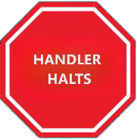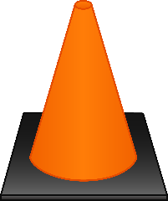

Cone is set 2 metres away. The dog immediately returns to heel and without stopping the dog and handler proceed to the next sign

This station is performed after the sign. The cone is inline with the sign.

Rationale: To add more variation to the Advance courses and increase skills.

**EXCELLENT**

**DOGS ACT**

**Proposal:** see Chart of all signs for 2 new Excellent signs

**DOGS WEST**

**DOG CIRCLES CONE – HALT**

The handler halts and without stopping the dog leaves the handler And goes around the back of the cone in a clockwise direction. The

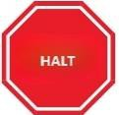

Cone is set 2 metres away. The dog immediately returns to heel position and sits before moving forward with the handler

This station is performed after the sign. The cone is inline with the sign

Rationale: Add more variation to the masters courses and continue to increase skills

-------

Excellent

**DOGS VIC**

Proposal: New station sign for Excellent - **AKC station sign**

|  |  |
| --- | --- |
| **CLOVER LEAF TURN**  This exercise requires three posts or cones placed about 2.5 – 3.00 metres apart, around which the team will perform one right U turn and two left U turns, crossing the centre line four times to form a “clover” pattern. The dog and handler do not stop moving. This station changes course direction. |  |

**DOGS VIC**

**Proposal: New Station for Rally Excellent - Stand, leave dog 3 metres down, return to dog.**  
**Rationale**: In Masters we have a variety of signs with various changes of position at a distance; in advanced we have position changes in the heel position. There’s currently no progression. Adding a single position from a short distance provides a natural progression for dog and handler teams.

**Stand Dog**

**Leave Dog 3 mtr**

**Distance Down**

**Return to Dog**

**DOGS VIC**

**Proposal: New Station for Rally Excellent - Stand, leave dog 3 metres sit, return to dog.**  
**Rationale:**In Masters we have a variety of signs with various changes of position at a distance; in advanced we have position changes in the heel position. There’s currently no progression. Adding a single position from a short distance provides a natural progression for dog and handler teams.

**Stand Dog**

**Leave Dog 3 mtr**

**Distance Sit**

**Return to Dog**

**MASTER**

**DOGS VIC**

**Proposal: Introduce new MASTER stations**

**Stand – Leave Dog - Call To Heel** – The Handler halts and the dog stands. The Handler leaves the dog and moves forward 3 metres to the marker, and without becoming stationary, calls the dog to heel. The dog is expected to catch up into heel position as the Handler moves forward and before the Handler reaches the next station. The dog must not anticipate the recall and must not forge significantly ahead of the Handler when coming into heel position. (Stationary exercise)

**Down – Leave Dog - Call To Heel** – The Handler halts and the dog drops. The Handler leaves the dog and moves forward 3 metres to the marker, and without becoming stationary, calls the dog to heel. The dog is expected to catch up into heel position as the Handler moves forward and before the Handler reaches the next station. The dog must not anticipate the recall and must not forge significantly ahead of the Handler when coming into heel position. (Stationary exercise)

**Rationale:** These two additional stations follow on from station 71 where the dog is left in a sit position. The stations are identical except for the starting position. They add additional challenges for the dogs to remain in position and allow for more flexibility in training.

**DOGS VIC**

**Proposal: Introduce new MASTER stations**

**Moving Stand – Leave Dog 3mtrs – About Turn – Walk Past dog 3 metres – Return to heel** – Whilst heeling and without pausing, the Handler commands and/or signals the dog to stand and stay and moves forward 3 metres to the marker, performs an about turn and returns past the left hand side of the dog another 3 metres. The handler then returns to the dog and without pausing, continues on with the dog in the heel position. The Handler must not become stationary during this station. The dog must not move from the stand position and must not change position.

**DOGS VIC**

**Moving Down – Leave Dog 3mtrs – About Turn – Walk Past dog 3 metres – Return to heel** – Whilst heeling and without pausing, the Handler commands and/or signals the dog to down and stay and moves forward 3 metres to the marker, performs an about turn and returns past the left hand side of the dog another 3 metres. The handler then returns to the dog and without pausing, continues on with the dog in the heel position. The Handler must not become stationary during this station. The dog must not move from the down position and must not change position.

**DOGS VIC**

**Proposal: Moving Sit – Leave Dog 3mtrs – About Turn – Walk Past dog 3 metres – Return to heel** Whilst heeling and without pausing, the Handler commands and/or signals the dog to sit and stay and moves forward 3 metres to the marker, performs an about turn and returns past the left hand side of the dog another 3 metres. The handler then returns to the dog and without pausing, continues on with the dog in the heel position. The Handler must not become stationary during this station. The dog must not move from the sit position and must not change position.

**Rationale:** These three additional stations follow on from station 68 where the dog is left in a stand position and upon return the team move forward without a pause and extend stations 69, 70 and 56. The stations are identical except for the starting position. They add additional challenges for the dogs to remain in position and allow for more flexibility in training. Being non stationary they do not take up a lot of time and keep the flow of the course moving.

**DOGS WEST**

**MASTER**

**MOVING SIDESTEPS 3 STEPS**

**Proposal:** Whilst heeling, the handler takes at least three steps sideways to the right, the dog must maintain heel position and remain parallel with the handler as the handler moves sideways. On completion the dog and handler without stopping will move forward on the newly established line. The exercise shall be performed just after the exercise sign

**Rationale**: Add more variation to the masters courses and continue to increase skills

**DOGS ACT**

**Proposal:** see Chart of all signs for 2 new Excellent signs

**APPENDIX B**

**ANKC LTD RALLY JUDGE’S CHART**

Club: Date:

Class: Judge:

|  |  |  |  |  |  |  |  |  |  |  |
| --- | --- | --- | --- | --- | --- | --- | --- | --- | --- | --- |
| **Cat no.** | **Time** | **Points**  **Lost** | **Score**  **( /100)** | **Q**  **(place)** |  | **Cat no.** | **Time** | **Points**  **Lost** | **Score**  **( /100)** | **Q**  **(place)** |
|  |  |  |  |  |  |  |  |  |  |  |
|  |  |  |  |  |  |  |  |  |  |  |
|  |  |  |  |  |  |  |  |  |  |  |
|  |  |  |  |  |  |  |  |  |  |  |
|  |  |  |  |  |  |  |  |  |  |  |
|  |  |  |  |  |  |  |  |  |  |  |
|  |  |  |  |  |  |  |  |  |  |  |
|  |  |  |  |  |  |  |  |  |  |  |
|  |  |  |  |  |  |  |  |  |  |  |
|  |  |  |  |  |  |  |  |  |  |  |
|  |  |  |  |  |  |  |  |  |  |  |
|  |  |  |  |  |  |  |  |  |  |  |
|  |  |  |  |  |  |  |  |  |  |  |
|  |  |  |  |  |  |  |  |  |  |  |
|  |  |  |  |  |  |  |  |  |  |  |
|  |  |  |  |  |  |  |  |  |  |  |
|  |  |  |  |  |  |  |  |  |  |  |
|  |  |  |  |  |  |  |  |  |  |  |
|  |  |  |  |  |  |  |  |  |  |  |
|  |  |  |  |  |  |  |  |  |  |  |
|  |  |  |  |  |  |  |  |  |  |  |
|  |  |  |  |  |  |  |  |  |  |  |

**Signature of Judge:**

**ANKC LTD RALLY SCORE SHEET - INDIVIDUAL**

CLASS………………………………………………………............

CATALOGUE NUMBER …………………… ……………….........

JUMP HEIGHT .........................……… TIME......................................

POINTS DEDUCTED ...……………….. TOTAL SCORE...………….......................

|  |  |  |  |  |
| --- | --- | --- | --- | --- |
| 1. | 2. | 3. | 4. | 5. |
| 6. | 7. | 8. | 9. | 10. |
| 11. | 12. | 13. | 14. | 15. |
| 16. | 17. | 18. | 19. | 20. |
| 21. | 22. | 23. | 24. | 25. |

|  |  |
| --- | --- |
| **1 POINT**  TIGHT LEAD  DOG INTERFERING WITH HANDLER’S FORWARD MOTION  POOR SITS, DOWNS AND STANDS  SLOW OR RESISTANT RESPONSE  TOUCHING A PYLON, POST OR COURSE DISTRACTIONS  TOUCHING OR HITTING A JUMP WITHOUT DISLODGMENT  OUT OF POSITION  **3 POINTS**  REPEAT OF STATION, MAXIMUM OF TWO (2)*)* RETRIES ALLOWED PER RUN  PYLON / POST KNOCKED OVER (ON FIGURE EIGHT, SPIRAL OR SERPENTINE) BY A DOG AND/OR HANDLER  LACK OF CONTROL  LOUD COMMAND OR INTIMIDATING SIGNAL EXCESSIVE BARKING  COURSE DISTRACTIONS KNOCKED OVER OR DISLODGED   * **1-10 POINTS** * LACK OF TEAMWORK   LACK OF BRISKNESS  HANDLER ERROR  OUT OF POSITION WHEN HEELING BETWEEN STATIONS | **10 POINTS**  INCORRECTLY PERFORMED STATION    **NON-QUALIFYING**  MINIMUM REQUIREMENTS NOT MET  DOG UNMANAGEABLE OR UNCONTROLLED BARKING  CONSISTENTLY TIGHT LEAD  DOG RELIEVING ITSELF IN THE RING  HANDLER ERROR  STATION NOT ATTEMPTED  DISLODGEMENT OF A JUMP  FAILURE OF A DOG TO GO OVER JUMP IN THE PROPER  DIRECTION  ATTEMPTING MORE THAN TWO (2) RETRIES  PERFORMING A STATION OUT OF SEQUENCE  WHERE A STATION IS RENDERED UNUSABLE  COURSE DISTRACTION PICKED UP BY DOG AND REMOVED |

**DOGS QLD**

**INTRODUCTION OF FCI RALLY OBEDIENCE**

The current rules are held by Federation Cynologique International (FCI) for International Rally Obedience Trials (Competitions).

<https://www.fci.be/en/Rally-Obedience-4746.html>

To propose the introduction of FCI Rally Obedience to Australia under the controlling body of the Australian National Kennel Council Ltd (Dogs Australia)

The FCI Rally Obedience Regulations and Rules are to be followed, except where the National country can make subtractions and/or additions to suit their conditions, ethics and guidelines.

The FCI Rally Obedience competitions allow competitors to teach good contact between dog and handler and on achieving the dog’s willingness to obey even when at a distance from the Handler. The Handler and dog should display a good overall relationship.

FCI Rally Obedience Competition Trials.

If Dogs Australia offers a totally new type of rally obedience category (FCI Rally Obedience), this will allow people to enter and perform rally obedience with their dogs in a different format to our current rally obedience exercises.

Our current rally obedience members also have a chance to learn new and exciting exercises and gain more titles for their dogs - therefore keeping them in the rally obedience ring for longer.

Rally numbers have fluctuated over the years. The many newer disciplines may have contributed to this. It seems that dogs are acquiring titles in higher classes at a much younger age and this would also give purpose to those dogs and handlers to continue on in rally obedience competition.

There would also be a monetary gain to the State Canine organisations for judges licences and dog titles, and also to clubs holding additional competitions without too much additional work and of course to gain additional titles to the dogs and their owners.

1. Judging

Initially all Rally judges who currently have held a Rally license for a period of two years, have the opportunity to undergo Judges Training which will involve inviting a representative from FCI to train judges in the areas of FCI Rules and Regulations.

A further ongoing training scheme will take place under the Rally Chair where authorised FCI accredited judge/s, train and educate the new interested judges.

This will also give our Rally judges another license to be maintained, but also an opportunity for invitation to judge overseas.

2. Competitions

Our current dog sport clubs will hold these competitions in conjunction with their Rally competitions.

This will also gain additional income for the club for entries gained for FCI Rally Obedience.

It is also the chance for the state organisations of Dogs Australia to include an FCI trial as a National event for all states to participate. This can also be in conjunction with the current National events.

3. Competitors

All competitors will require an eligibility (eg which National Rally level required) to participate in FCI Rally Obedience Classes.

Competitors will be able to gain additional titles in Rally which is added to the dog’s registered details. This title will be recognised internationally.

Competitors will have the opportunity to grow in areas of Rally by teaching new exercises. Competitors also will also have a new challenge they can move onto once they have completed the ANKC Rally.

International competitors would have an opportunity to participate in FCI Rally Obedience in Australia.

3. Rules and Regulations

FCI Rules and Regulations will be the foundation for ANKC members to follow, however a Rally/Dog Sport Committee may adjust these rules to suit our Australian conditions.

This will include Bitches in season and bitches in breeding - as these rules differ from our current ANKC Rally from FCI Rally Obedience.

Eligibility to participate will also be defined by the Rally/Dog Sport Committee, including age of dog and current level of rally.