**2025 NOTC MTG - ATTACHMENT 7d - DOGS NSW - Rally Elected Submissions 2024**

**Rally Rule Change Submission 1**

**Current Rule**

**TITLES (Page 6)**

**R.A.E. –RALLY ADVANCED EXCELLENT**

To qualify for the title of RAE a dog and Handler team having gained its Rally Excellent (RE) title, must receive an additional minimum of five (5) qualifying scores, in both the Rally Advanced and Rally Excellent Classes at the same trial, of **80** points or more out of a possible perfect score of 100, under at least two different Judges. All qualifications gained in the Advanced B and Excellent B Classes towards an R.A.E. Title that were gained prior to 1st January 2021 will remain valid. From 1st January 2021 any additional qualifying scores required for an R.A.E. Title will be gained from the Advanced & Excellent Classes at the same trial.

**Proposed Change**

TITLES

**R.A.E. –RALLY ADVANCED EXCELLENT**

To qualify for the title of RAE a dog and Handler team having gained its Rally Excellent (RE) title, must receive an additional minimum of five (5) qualifying scores, in both the Rally Advanced and Rally Excellent Classes at the same trial, of **80** points or more out of a possible perfect score of 100, under at least two different Judges. All qualifications gained in the Advanced**~~B~~**and Excellent **~~B~~** Classes towards an R.A.E. Title that were gained prior to 1st January 2021 will remain valid. From 1st January 2021 any additional qualifying scores required for an R.A.E. Title will be gained from the Advanced & Excellent Classes at the same trial.

**Rationale**

Advanced B and Excellent B Class no longer exists, Advanced Class and Excellent Class only.

Housekeeping change only

**Rally Rule Change Submission 2**

**Current Rule**

**CLASSES (Page 7)**

Rally Novice Class – R.N.

Rally Novice

For Dogs six months of age or over and of either sex which are not eligible for the title of Rally Novice (RN). Under no circumstances except where an application for a RN Title has been rejected on a technicality, shall a dog which has competed in a Rally Advanced A Class be eligible to compete in the Rally Novice Class.

All exercises are judged on lead.

Rally Novice must have between ten (10) – fifteen (15) stations (start and finish not included); no more than five (5) stationary exercises.

**Proposed Change**

**CLASSES**

Rally Novice

For Dogs six months of age or over and of either sex which are not eligible for the title of Rally Novice (RN). Under no circumstances except where an application for a RN Title has been rejected on a technicality, shall a dog which has competed in a Rally Advanced**~~A~~** Class be eligible to compete in the Rally Novice Class.

**Rationale**

Advanced A Class no longer exists

Housekeeping change only

**Rally Rule Change Submission 3**

**Current Rule**

**CLASSES (Page 7)**

Rally Novice Class – R.N.

Rally Novice

For Dogs six months of age or over and of either sex which are not eligible for the title of Rally Novice (RN). Under no circumstances except where an application for a RN Title has been rejected on a technicality, shall a dog which has competed in a Rally Advanced A Class be eligible to compete in the Rally Novice Class.

All exercises are judged on lead.

Rally Novice must have between ten (10) – fifteen (15) stations (start and finish not included);

no more than five (5) stationary exercises.

**Proposed Change**

CLASSES

Rally Novice Class – R.N.

Rally Novice

For Dogs six months of age or over and of either sex which are not eligible for the title of Rally Novice (RN). Under no circumstances except where an application for a RN Title has been rejected on a technicality, shall a dog which has competed in a Rally Advanced Class be eligible to compete in the Rally Novice Class.

All exercises are judged on lead.

Rally Novice must have between ten (10) – fifteen (15) stations (start and finish not included), and use **a minimum of two (2)** to a maximum of five (5) stationary exercises.

**Rationale**

The proposed will bring Rally Novice in line with other levels, with a minimum and maximum number of stationary exercises required.

**Rally Rule Change Submission 4**

**Current Rule**

**CLASSES (Page 7)**

**Rally Master Class – R.M.**

Rally Master

This class shall be for dogs that have qualified for the Rally Excellent Title (R.E.). All exercises are judged off lead and there will be no jumps in this class. Rally Master must have between eighteen (18) and twenty four (24) stations (start and finish not included) with no more than ten (10) stationary exercises. The course must contain a minimum of 4 Excellent and 3 Master Class stations.

**Proposed Change**

**CLASSES**

**Rally Master Class – R.M.**

Rally Master

This class shall be for dogs that have qualified for the Rally Excellent Title (R.E.). All exercises are judged off lead and there will be no jumps in this class. Rally Master must have between eighteen (18) and twenty four (24) stations (start and finish not included) **and use a minimum of 3 to a maximum of 10 stationary exercises**. The course must contain a minimum of 4 Excellent and 3 Master Class stations.

**Rationale**

With the introduction of Rally Master class in 2016 there did not seem to be provision included for a “minimum” number of stationary exercises. This amendment is to make it consistent with the Advanced and Excellent classes that there is a **minimum** and **maximum** requirement of stationary exercises.

**Rally Rule Change Submission 5**

**Current Rule**

**Entering and Leaving the Ring (page 9):**

On the Steward's call of the dog's catalogue number, the Handler will enter the Ring and take up position at the "Start Station”. All dogs must enter and leave the ring on lead. In Exercises that require a dog to be off lead, the lead will be taken off upon instruction from the judge, and handed to the Steward.

**Proposed Change**

Entering and Leaving the Ring (page 9):

On the Steward's call of the dog's catalogue number, the Handler will enter the Ring and take up position at the "Start Station”. All dogs must enter and leave the ring on lead. In Exercises that require a dog to be off lead, the lead will be taken off upon instruction from the judge, and handed to the Steward. **For dogs that leave the ring off lead (other than accidental) this will incur a Non-Qualifying Score**

**Rationale**

Other disciplines for a dog that leaves the ring (other than accidental) it is a non-qualifying score. In the Rally Rules Page 9, it mentions that all dogs must enter and leave the ring on lead.

In NSW for a dog that leaves the ring it is a non-qualifying score, however this is not clear within the current rules.

**Rally Rule Change Submission 6**

**Current Rule**

**Retry (Page 9)**

Where a team attempts a station and fails to perform the elements of the station correctly on the first attempt, the Handler may choose to retry that station with a three (3) point deduction. The Handler must clearly indicate to the Judge that they are about to retry the station. The station must be retried immediately**,** in its entirety in the correct position in relation to the station sign.

Retries are not allowed if a team has already committed an error that would result in a non-qualifying score for the course, or if it is specified in an exercise description that retries are not allowed.

Any deductions incurred as the Handler repeats the station are added to the -3 points already incurred for attempting the retry. If the Handler fails to perform the station correctly on the second attempt, they will incur a total deduction of 13 points for that station.

A maximum of two (2) retries are allowed per course. Where a handler attempts more than two (2) retries they will incur a non- qualifying score.

**Proposed Change**

**Retry:**

Where a team attempts a station and fails to perform the elements of the station correctly on the first attempt, the Handler may choose to retry that station with a three (3) point deduction. The Handler must clearly indicate to the Judge that they are about to retry the station. The station must be retried immediately**,** in its entirety in the correct position in relation to the station sign.

Retries are not allowed if a team has already committed an error that would result in a non-qualifying score for the course, or if it is specified in an exercise description that retries are not allowed.

Any deductions incurred as the handler repeats the station are added to the -3 points already incurred for attempting the retry. If the handler fails to perform the station correctly on the second attempt, they may request another retry with a further deduction of -3 points. If the handlers fails to perform the station on the third attempt, they will incur a total deduction of 16 points for that station (2 x retries & 1 x incorrectly performed station).

A maximum of two (2) retries are allowed per course. Where a handler attempts more than two (2) retries they will incur a non- qualifying score.

**Rationale**

The current rule it is not clear if the handler could retry a sign twice. Why couldn’t they? The current wording is a guide only on what the deduction would be if they retried and then performed an incorrectly Performed station, eg 3 points plus 10 points.

**Rally Rule Change Submission 7**

**Current Rule**

Sign 13. Call Dog Front - Finish Right – Forward (Page 17)

Whilst heeling, the Handler stops forward motion and calls the dog to the front position (dog sits in front and faces the Handler). The Handler may take several steps backward as the dog turns and moves to sit in the front position. Second part of the exercise directs the Handler to command and/or signal the dog to change from the front position by moving to the Handler’s right, around behind the Handler, toward heel position. As the dog clears the Handler’s path, the Handler moves forward before the dog has completely returned to the heel position. The dog does not sit before moving forward in heel position with the Handler. (Stationary exercise)

**Proposed Change**

Sign 13. Call Dog Front - Finish Right – Forward

Whilst heeling, the Handler stops forward motion and calls the dog to the front position (dog sits in front and faces the Handler). The Handler may take several steps backward as the dog turns and moves to sit in the front position. **Second part of the exercise, the Handler without moving their feet, commands and/or signal the dog to change from the front position by moving to the Handler’s right, around behind the Handler, toward heel position. As the dog clears the Handler’s path, the Handler moves forward before the dog has completely returned to the heel position.** The dog does not sit before moving forward in heel position with the Handler. (Stationary exercise)

**Rationale**

This is no change to how the sign is performed or judged, only a clearer description.

This is a stationary exercise. Once the dog sits in front of the handler the handler should not be guiding or assisting the dog by moving their feet for the second part of the exercise.

**Rally Rule Change Submission 8**

**Current Rule**

Sign 14. Call Dog Front - Finish Left – Forward (page 17)

Whilst heeling, the Handler stops forward motion and calls the dog to the front position (dog sits in front and faces the Handler). The Handler may take several steps backward as the dog turns and moves to sit in the front position. Second part of the exercise directs the Handler to command and/or signal the dog to change from the front position by moving to the Handler’s left toward heel position. As the dog clears the Handler’s path, the Handler moves forward before the dog has completely returned to the heel position. The dog does not sit before moving forward in heel position with the Handler. (Stationary exercise)

**Proposed Change**

Sign 14. Call Dog Front - Finish Left – Forward

Whilst heeling, the Handler stops forward motion and calls the dog to the front position (dog sits in front and faces the Handler). The Handler may take several steps backward as the dog turns and moves to sit in the front position. **Second part of the exercise, , the Handler without moving their feet, commands and/or signal the dog to change from the front position by moving to the Handler’s left toward heel position. As the dog clears the Handler’s path, the Handler moves forward before the dog has completely returned to the heel position.** The dog does not sit before moving forward in heel position with the Handler. (Stationary exercise)

**Rationale**

This is no change to how the sign is performed or judged, only a clearer description.

This is a stationary exercise. Once the dog sits in front of the handler the handler should not be guiding or assisting the dog by moving their feet for the second part of the exercise.

**Rally Rule Change Submission 9**

**Current Rule**

Sign 15. Call Dog Front - Finish Right – Halt (page 17)

Whilst heeling, the Handler stops forward motion and calls the dog to the front position (dog sits in front and faces the Handler). The Handler may take several steps backward as the dog turns and moves to sit in the front position. Second part is the finish to the right, where the dog must return to heel position by moving around the right side of the Handler. Dog must sit in heel position before moving forward with the Handler. (Stationary exercise)

**Proposed Change**

Sign 15. Call Dog Front - Finish Right – Halt

Whilst heeling, the Handler stops forward motion and calls the dog to the front position (dog sits in front and faces the Handler). The Handler may take several steps backward as the dog turns and moves to sit in the front position. **Second part of the exercise, the Handler without moving their feet, commands and or/or signals the dog to finish to the right, where the dog must return to heel position by moving around the right side of the Handler.** Dog must sit in heel position before moving forward with the Handler. (Stationary exercise)

**Rationale**

This is no change to how the sign is performed or judged, only a clearer description.

This is a stationary exercise. Once the dog sits in front of the handler the handler should not be guiding or assisting the dog by moving their feet for the second part of the exercise.

**Rally Rule Change Submission 10**

**Current Rule**

Sign 16. Call Dog Front – Finish Left – Halt (page 17)

- Whilst heeling, the Handler stops forward motion and calls the dog to the front position (dog sits in front and faces the Handler). The Handler may take several steps backward as the dog turns and moves to a sit in front position. Second part is the finish to the left where the dog must move to the Handler’s left, and sit in the heel position. Dog must sit in the heel position before moving forward with the Handler. (Stationary exercise)

**Proposed Change**

Sign 16. Call Dog Front – Finish Left - Halt

Whilst heeling, the Handler stops forward motion and calls the dog to the front position (dog sits in front and faces the Handler). The Handler may take several steps backward as the dog turns and moves to a sit in front position. **Second part of the exercise, the Handler without moving their feet, commands and or/or signals the dog to finish to the left, and sit in the heel position.** Dog must sit in the heel position before moving forward with the Handler. (Stationary exercise)

**Rationale**

This is no change to how the sign is performed or judged, only a clearer description.

This is a stationary exercise. Once the dog sits in front of the handler the handler should not be guiding or assisting the dog by moving their feet for the second part of the exercise.

**Rally Rule Change Submission 11**

**Current Rule**

Sign 21. Spiral Right - Dog Outside (Page 18)

This exercise requires three pylons or posts placed in a straight line with spaces between them of approximately 2.0 – 2.5 metres. Spiral right indicates the Handler must turn to the right when moving around each pylon or post. This places the dog on the outside of the turns. The exercise sign is placed near or on the first pylon or post where the spiral is started.

**Proposed Change**

Sign 211. Spiral Right - Dog Outside

This exercise requires three pylons or posts placed in a straight line with spaces between them of approximately 2.0 – 2.5 metres. Spiral right indicates the Handler must turn to the right when moving around each pylon or post. This places the dog on the outside of the turns. The exercise sign is placed near or on the first pylon or post where the spiral is started. **The team must maintain continuous motion throughout the spiral without partially sitting or stopping.**

**Rationale**

Consistency across similar stations – left/right turns, 270 left/right turns, about Turn Right/About U Turn left, 360 left/right Turns, where the team must maintain continuous motion throughout the exercise

**Rally Rule Change Submission 12**

**Current Rule**

Sign 22. Spiral Left - Dog Inside (Page 18)

This exercise requires three pylons or posts placed in a straight line with spaces between them of approximately 2.0 – 2.5 metres. Spiral left indicates that the Handler must turn to the left when moving around each pylon or post. This places the dog on the inside of the turns. The exercise sign is placed near or on the first pylon or post where the spiral is started.

**Proposed Change**

Sign 22. Spiral Left - Dog Inside

This exercise requires three pylons or posts placed in a straight line with spaces between them of approximately 2.0 – 2.5 metres. Spiral left indicates that the Handler must turn to the left when moving around each pylon or post. This places the dog on the inside of the turns. The exercise sign is placed near or on the first pylon or post where the spiral is started. **The team must maintain continuous motion throughout the entire station without partially sitting or stopping.**

**Rationale**

Consistency across similar stations – left/right turns, 270 left/right turns, about Turn Right/About U Turn left, 360 left/right Turns, where the team must maintain continuous motion throughout the exercise

**Rally Rule Change Submission 13**

**Current Rule**

Sign 23. Straight Figure 8 Weave Twice (Page 18)

This exercise requires four pylons or posts placed in a straight line with spaces between them of approximately 2.0 – 2.5 metres. The exercise sign is placed near or on the first pylon or post where the exercise is started. Entry into the weaving pattern is with the first pylon or post at the dog/Handler’s left side. The dog and Handler must complete the entire exercise by passing the last pylon or post.

**Proposed Change**

Sign 23. Straight Figure 8 Weave Twice

This exercise requires four pylons or posts placed in a straight line with spaces between them of approximately 2.0 – 2.5 metres. The exercise sign is placed near or on the first pylon or post where the exercise is started. Entry into the weaving pattern is with the first pylon or post at the dog/Handler’s left side. The dog and Handler must complete the entire exercise by passing the last pylon or post. **The team must maintain continuous motion throughout the entire station without partially sitting or stopping.**

**Rationale**

Consistency across similar stations – left/right turns, 270 left/right turns, about Turn Right/About U Turn left, 360 left/right Turns, where the team must maintain continuous motion throughout the exercise

**Rally Rule Change Submission 14**

**Current Rule**

Sign 23. Straight Figure 8 Weave Twice (Page 18)

This exercise requires four pylons or posts placed in a straight line with spaces between them of approximately 2.0 – 2.5 metres. The exercise sign is placed near or on the first pylon or post where the exercise is started. Entry into the weaving pattern is with the first pylon or post at the dog/Handler’s left side. The dog and Handler must complete the entire exercise by passing the last pylon or post.

**Proposed Change**

NAME CHANGE OF SIGN TO

**Sign 23. SERPENTINE WEAVE TWICE**

This exercise requires four pylons or posts placed in a straight line with spaces between them of approximately 2.0 – 2.5 metres. The exercise sign is placed near or on the first pylon or post where the exercise is started. Entry into the weaving pattern is with the first pylon or post at the dog/Handler’s left side. The dog and Handler must complete the entire exercise by passing the last pylon or post.

**Rationale**

Sign 23 Straight Figure 8 Weave Twice and Sign 24 Serpentine Weave Once are almost identical exercises, except one sign the team weaves once and the other they weave twice (up & back).

It is very confusing for handlers as they are named so different. Proposal for **Sign #23 STRAIGHT FIGURE 8 WEAVE TWICE** to be renamed to **Sign #23 SERPENTINE WEAVE TWICE**. This will make it clearer for handlers to distinguish between the two signs.

**Rally Rule Change Submission 15**

**Current Rule**

Sign 24. Serpentine Weave Once (Page 18)

This exercise requires pylons or posts placed in a straight line with spaces between them of approximately 2.0 – 2.5 metres. The exercise sign is placed near or on the first pylon or post where the exercise starts. Entry into the weaving pattern is with the first pylon or post at the dog/Handler’s left side. The dog and Handler must complete the entire exercise by passing the last pylon or post. It should be noted that in this exercise, the team does not weave back through the obstacles as they do in the Straight Figure 8.

**Proposed Change**

Sign 24. Serpentine Weave Once

This exercise requires pylons or posts placed in a straight line with spaces between them of approximately 2.0 – 2.5 metres. The exercise sign is placed near or on the first pylon or post where the exercise starts. Entry into the weaving pattern is with the first pylon or post at the dog/Handler’s left side. The dog and Handler must complete the entire exercise by passing the last pylon or post. It should be noted that in this exercise, the team does not weave back through the obstacles as they do in the Straight Figure 8. **The team must maintain continuous motion throughout the entire station without partially sitting or stopping.**

**Rationale**

Consistency across similar stations – left/right turns, 270 left/right turns, about Turn Right/About U Turn left, 360 left/right Turns, where the team must maintain continuous motion throughout the exercise

**Rally Rule Change Submission 16**

**Current Rule**

Sign 36. Halt - Stand Dog - Walk Around (page 21)

The Handler halts and dog sits. With the dog sitting in heel position, the Handler stands the dog, commands and/or signals the dog to stay as the Handler walks around the dog to the left, returning to heel position. The Handler must become stationary in heel position before moving forward to the next station. (Stationary exercise)

**Proposed Change**

Sign 36. Halt - Stand Dog - Walk Around

The Handler halts and dog sits. With the dog sitting in heel position, the Handler **will stand the dog (without physical handling or moving forward)**, **then** commands and/or signals the dog to stay as the Handler walks around the dog to the left, returning to heel position. The Handler must become stationary in heel position before moving forward to the next station. (Stationary exercise)

**Rationale**

This sign previous in 2016 rules the handler was allowed to take a step forward to encourage the dog to stand, this wording has since been removed from the 2021 however there is still much confusion.

Additional wording will also be in line with similar stations within Excellent for consistency within the rules.

See below example of similar wording of sign within the Excellent class:

55. Halt - Stand - Down

The Handler halts and dog sits. With dog sitting in heel position, the Handler will stand the dog (without physical handling or moving forward), then command and/or signal the dog to down. The Handler must return to an upright stationary position before commanding and/or signalling the dog to heel forward from the down position. (Stationary exercise)

**Rally Rule Change Submission 17**

**Current Rule**

Sign 39. Offset Figure 8 (Page 22)

This exercise requires two pylons or posts placed about 2.45 – 3.00 metres apart, around which the team will perform a complete Figure 8, crossing the centre line three times. Two distractions will be arranged to the sides of the Figure 8 about 1.55 – 1.85 metres apart. Entry may be between the pylons or posts and the distraction on either side. The distractions will consist of two securely covered containers with tempting dog treats; however, dog toys may replace one or both containers, or may be placed next to the containers. The exercise sign may be placed on or near the cone where entry is made into the Offset Figure 8.

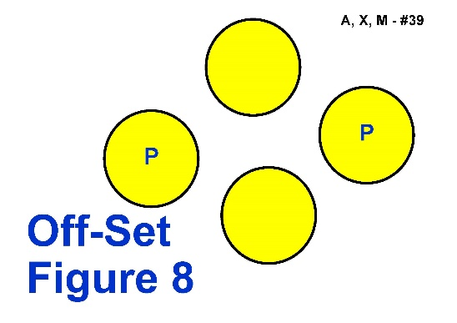

**Proposed Change**

Sign 39. Offset Figure 8 - Change of sign Image only, no change to description

**Rationale**

The current sign image is confusing for handlers, showing the Pylons/Posts on the wrong side to where they should be if approaching the sign from the front.

*PROPOSED NEW SIGN IMAGE*

This amended image will clearly depict what at the posts/pylons and also the distractions.

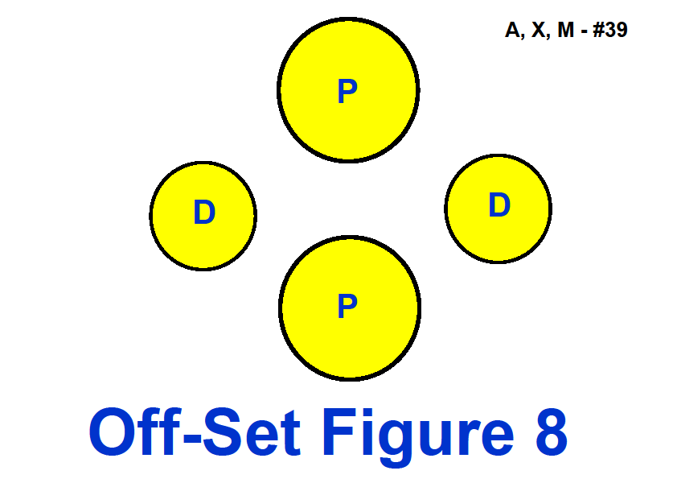

**Rally Rule Change Submission 17**

**Current Rule**

Sign 41. Halt - Call Dog Front - Finish Right (page 22)

The Handler halts and dog sits. With the dog sitting in heel position, the Handler calls the dog to front and the dog sits in the front position, facing the Handler. On command, the dog then moves from the front position around the right of the Handler and sits in heel position. Handler must remain stationary. (Stationary exercise)

**Proposed Change**

Sign 41. Halt - Call Dog Front - Finish Right

The Handler halts and dog sits. With the dog sitting in heel position, **and without the handler moving their feet**, the Handler calls the dog to front and the dog sits in the front position, facing the Handler. **Without the handler moving their feet, the handler commands and/or signals the dog to move** from the front position around the right of the Handler and sits in heel position. Handler must remain stationary. (Stationary exercise)

**Rationale**

This is no change to how the sign is performed or judged, only a clearer description.

This is a stationary exercise. Once the dog sits in heel position the handler should not be guiding or assisting the dog by moving their feet for any parts of the exercise.

**Rally Rule Change Submission 19**

**Current Rule**

42. Halt - Call Dog Front - Finish Left (Page 22)

The Handler halts and dog sits. With the dog sitting in heel position, the Handler calls the dog to front and the dog sits in the front position facing the Handler. On command, the dog then moves to the Handler’s left and sits in heel position. Handler must remain stationary. (Stationary exercise)

**Proposed Change**

42. Halt - Call Dog Front - Finish Left

The Handler halts and dog sits. With the dog sitting in heel position, **and without the handler moving their feet,** the Handler calls the dog to front and the dog sits in the front position facing the Handler. **Without the handler moving their feet, the handler commands and/or signals the dog to move** to the Handler’s left and sits in heel position. Handler must remain stationary. (Stationary exercise)

**Rationale**

This is no change to how the sign is performed or judged, only a clearer description.

This is a stationary exercise. Once the dog sits in heel position the handler should not be guiding or assisting the dog by moving their feet for any parts of the exercise.

**Rally Rule Change Submission 20**

**Current Rule**

50. Call front, Handler Reverses Three Steps – Finish (Page 24)

The Handler calls the dog to the front, reverses three steps, with the dog moving with Handler. The dog returns to heel and continues heeling forward without stopping. The dog does not sit during this exercise. The team must maintain continuous motion throughout the turn without partially sitting or stopping

**Proposed Change**

50. Call front, Handler Reverses Three Steps – Finish

The Handler calls the dog to the front, reverses **at least** three steps, with the dog moving with Handler. The dog returns to heel and continues heeling forward without stopping. The dog does not sit during this exercise. The team must maintain continuous motion throughout the turn without partially sitting or stopping

**Rationale**

Moving back exactly 3 steps becomes a balancing act for the handler rather than a training issue for the team. Also, in the space of exactly 2 steps many large dogs have barely moved into position and do not have a chance to move with the handler. Making the station “at least 3 steps” gives the handler a chance to change direction when they are balanced and permits them to move backwards with the dog in position in front before moving forward again.

**Rally Rule Change Submission 21**

**Current Rule**

51. Leave Dog - About Turn – Return to Dog (page 24)

The Handler halts and dog sits. The Handler leaves dog and walks forward 5 metres to the marker. The Handler performs an about turn then, facing the dog and without pausing, walks back toward dog. The Handler will return around the back of the dog to heel position. The Handler must become stationary and then command/cue the dog to move forward from the sit position. The dog must not move from the sit position and must not change position. (Stationary exercise)

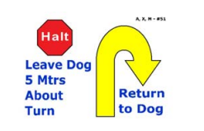

**Proposed Change**

51. Leave Dog - About Turn – Return to Dog

The Handler halts and dog sits. The Handler leaves dog and walks forward 5 metres to the marker. The Handler performs an **ABOUT TURN** **RIGHT** then, facing the dog and without pausing, walks back toward dog. The Handler will return around the back of the dog to heel position. The Handler must become stationary and then command/cue the dog to move forward from the sit position. The dog must not move from the sit position and must not change position. (Stationary exercise)

**Rationale**

The description of this sign says “About Turn”, however the image depicted on this sign shows “About Turn Right”, in Rally Terminology for signage..

In Rally, the Handlers have always followed the direction of the arrows in all of the signs, however since the introduction of these new signs the descriptions do not match the depicted images and require modification as it is causing confusion with handlers.

*Refer to Rally Novice Sign #7 and Rally Advanced Sign #34 below for some examples*

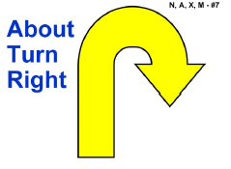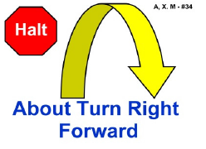

**Rally Rule Change Submission 22**

**Sign 53 – Send Over Jump (Page 24)**

No Current or Proposed Rule.

Housekeeping change only

**Sign 53 in Rule book (Page 24) still has #46 next to it, and not #53.**

**Full size signs for printing are ok, just the image within the rule book**

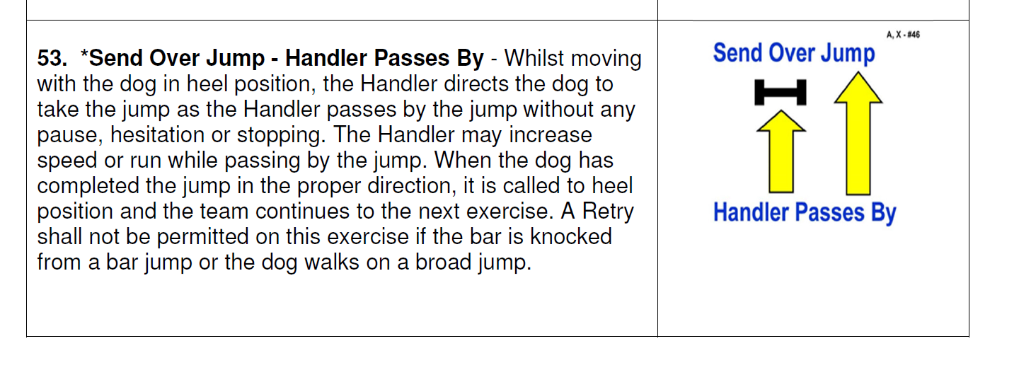

**Rally Rule Change Submission 23**

**Current Rule**

Sign 56. Moving Stand - Walk Around Dog (Page 25)

Whilst heeling and without pausing or stopping, the Handler will stand the dog and walk around the dog to the left **at an even pace**, returning to heel position. Once the Handler has reached the dog’s front left shoulder, the dog should be in a stand and not break position. The Handler must become stationary in heel position after returning to the dog. Dog must move forward from the standing position. (Stationary exercise)

**Proposed Change**

Sign 56. Moving Stand - Walk Around Dog

Whilst heeling and without pausing or stopping, the Handler will stand the dog and walk around the dog to the left at **A NORMAL PACE**, returning to heel position. Once the Handler has reached the dog’s front left shoulder, the dog mustbe in a stand and not break position. The Handler must become stationary in heel position after returning to the dog. Dog must move forward from the standing position. (Stationary exercise)

**Rationale**

Consistency of wording through all the signs

Amendment of wording from “At an even pace” to “At a Normal Pace”. An even pace could mean many things, there are three paces in Rally - slow place, normal pace, fast pace

**Rally Rule Change Submission 24**

**Current Rule**

Sign 56. Moving Stand - Walk Around Dog (Page 25)

Whilst heeling and without pausing or stopping, the Handler will stand the dog and walk around the dog to the left at an even pace, returning to heel position. Once the Handler has reached the dog’s front left shoulder, the dog **should be** in a stand and not break position. The Handler must become stationary in heel position after returning to the dog. Dog must move forward from the standing position. (Stationary exercise)

**Proposed Change**

Sign 56. Moving Stand - Walk Around Dog

Whilst heeling and without pausing or stopping, the Handler will stand the dog and walk around the dog to the left at a normal pace, returning to heel position. Once the Handler has reached the dog’s front left shoulder, the dog **must be** in a stand and not break position. The Handler must become stationary in heel position after returning to the dog. Dog must move forward from the standing position. (Stationary exercise)

**Rationale**

Amendment of wording from “should be” to “must be” in a Stand and not break position.

Consistency of wording through all the signs

“Should” is a suggestion, “must” means it is required.

This leaves difficulty for judges when wording is open to interpretation or discussion.

**Rally Rule Change Submission 25**

**Current Rule**

**Sign 58. Leave Dog - About Turn – Recall Dog – Finish Right** (Page 25))

The Handler halts and dog sits. Handler leaves dog and walks forward 5 metres to the marker and does an about turn to face dog. Handler recalls dog. Dog comes briskly to sit in front of handler. The dog must return to heel position by moving around the right side of the Handler. Dog must sit in heel position before moving forward with the Handler. The dog must not anticipate the recall. (Stationary exercise)

**Proposed Change**

Sign 58. Leave Dog - About Turn – Recall Dog – Finish Right

The Handler halts and dog sits. Handler leaves dog and walks forward 5 metres to the marker and does an **ABOUT U TURN** to face dog. Handler recalls dog. Dog comes briskly to sit in front of handler. The dog must return to heel position by moving around the right side of the Handler. Dog must sit in heel position before moving forward with the Handler. The dog must not anticipate the recall. (Stationary exercise)

**Rationale**

The description of this sign says “About Turn”, however the image depicted shows “About U Turn”, in Rally Terminology for signage..

In Rally, the Handlers have always followed the direction of the arrows in all of the signs, however since the introduction of these new signs the descriptions do not match the depicted images and require modification as it is causing much confusion.

Signs 58 and 59, the Handlers objection is that the description says “About Turn”, and in traditional

obedience this is a “Right About Turn”, however the image is an “About U Turn”.

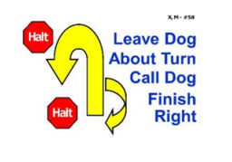

Refer to Rally Novice Sign #8, also Rally Advanced Sign #33 as examples about “About U Turn”

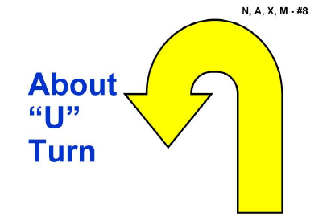 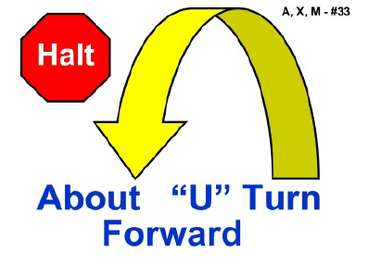

Or Remove the sign image all together and have description only as per example below of   
Sign 46 & Sign 57

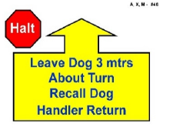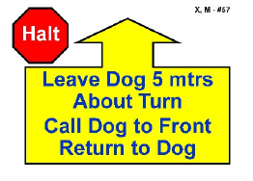

**Rally Rule Change Submission 26**

**Current Rule**

**Sign 59. Leave Dog - About Turn – Recall Dog – Finish Left (page 26)**

The Handler halts and dog sits. Handler leaves dog and walks forward 5 metres to the marker and does an about turn to face dog. Handler recalls dog. Dog comes briskly to sit in front of handler. The dog must return to heel position by moving around the left side of the Handler. Dog must sit in heel position before moving forward with the Handler. The dog must not anticipate the recall. (Stationary exercise)

**Proposed Change**

Sign 59. Leave Dog - About Turn – Recall Dog – Finish Left

The Handler halts and dog sits. Handler leaves dog and walks forward 5 metres to the marker and does an ABOUT U TURN to face dog. Handler recalls dog. Dog comes briskly to sit in front of handler. The dog must return to heel position by moving around the left side of the Handler. Dog must sit in heel position before moving forward with the Handler. The dog must not anticipate the recall. (Stationary exercise)

**Rationale**

The description of this sign says “About Turn”, however the image depicted shows “About U Turn”, in Rally Terminology for signage..

In Rally, the Handlers have always followed the direction of the arrows in all of the signs, however since the introduction of these new signs the descriptions do not match the depicted images and require modification as it is causing much confusion.

Signs 58 and 59, the Handlers objection is that the description says “About Turn”, and in traditional

obedience this is a “Right About Turn”, however the image is an “About U Turn”

Refer to Rally Novice Sign #8, also Rally Advanced Sign #33 as an example.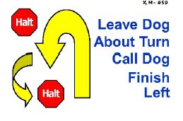

Refer to Rally Novice Sign #8, also Rally Advanced Sign #33 as examples About U Turn

 

Or Remove the sign image all together and have description only as per example below of   
Sign 46 & Sign 57



**Rally Rule Change Submission 27**

**Current Rule**

Sign 69. Moving Down - Walk Around Dog (page 28)

Whilst heeling and without becoming stationary, the Handler will down the dog and walk around the dog to the left at normal pace, returning to heel position. Once the Handler has reached the dog’s front left shoulder, the dog **should be** in a down and not break position. The Handler must become stationary in heel position after returning to the dog. The dog must move forward from the down position with the Handler at completion. (Stationary exercise)

**Proposed Change**

Sign 69. Moving Down - Walk Around Dog

Whilst heeling and without becoming stationary, the Handler will down the dog and walk around the dog to the left at normal pace, returning to heel position. Once the Handler has reached the dog’s front left shoulder, the dog **must be** in a down and not break position. The Handler must become stationary in heel position after returning to the dog. The dog must move forward from the down position with the Handler at completion. (Stationary exercise)

**Rationale**

Change from “Should be” to “Must be” in a down and not break position.

Consistency across similar signs.

“Should” is a suggestion, “must” means it is required.

This leaves difficulty for judges when wording is open to interpretation or discussion.

**Rally Rule Change Submission 28**

**Current Rule**

70. Moving Sit – Walk Around Dog (page 28)

Whilst heeling and without becoming stationary, the Handler will sit the dog and walk around the dog to the left at normal pace, returning to heel position. Once the Handler has reached the dog’s front left shoulder, the dog **should be** in a sit and not break position. The Handler must become stationary in heel position after returning to the dog. The dog must move forward from the sit position with the Handler at completion. (Stationary exercise)

**Proposed Change**

70. Moving Sit – Walk Around Dog

Whilst heeling and without becoming stationary, the Handler will sit the dog and walk around the dog to the left at normal pace, returning to heel position. Once the Handler has reached the dog’s front left shoulder, the dog **MUST** **be** in a sit and not break position. The Handler must become stationary in heel position after returning to the dog. The dog must move forward from the sit position with the Handler at completion. (Stationary exercise)

**Rationale**

Change from “Should be” to “Must be” in a sit and not break position

Consistency across similar signs.

“Should” is a suggestion, “must” means it is required.

This leaves much difficulty for judges when wording is open to interpretation.

**Current Rule**

Sign 72. Backup 3 Steps (page 28)

Whilst heeling, the Handler reverses direction walking backward at least 3 steps, without first stopping, then continues heeling forward. The dog **moves** backward parallel to the Handler and must maintain heel position throughout the exercise without sitting or turning its body to face the Handler.

**Proposed Change**

Sign 72. Backup 3 Steps

Whilst heeling, the Handler reverses direction walking backward at least 3 steps, without first stopping, then continues heeling forward. The dog **WALKS** backward parallel to the Handler and must maintain heel position throughout the exercise without sitting or turning its body to face the Handler.

**Rationale**

Change to “The Dog Walks Backward”. The word “Move” currently allows for the dog to bounce or hop backwards, which would make it difficult to maintain heel position.

**Rally Rule Change Submission 30**

**Current Rule**

Sign 73. Stand – Pivot Right – Forward (Page 29)

The Handler commands and/or signals the dog to Stand as Handler comes to a halt. With the dog standing, the Handler pivots 90º to the right and the dog moves with the Handler. The dog does not sit. The Handler must become stationary before the team heels forward. The Handler is required to pivot by turning in place. (Stationary exercise)

**Proposed Changes**

* Name change of Sign to - **73. Stand – Pivot Right – Stand**

* Change of sign Image to reflect the sign name amendment

**Rationale**

The current name of this sign is confusing for handlers. It is a progression from the Advanced   
Sign 37 Halt - 90° Pivot Right – Halt, the only difference is this sign is performed in at stand. The word “forward” raises many questions, the forward is only part of the exercise to heel toward the next station. Stand, Pivot Right, Stand is the exercise.

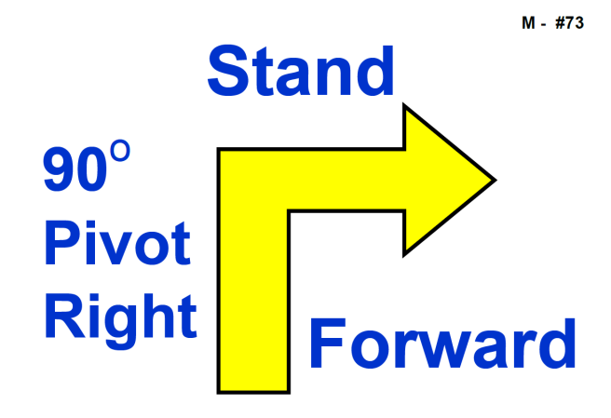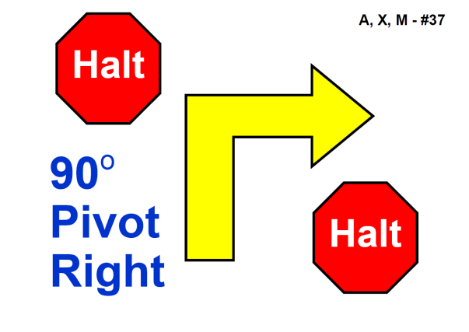

**PROPOSED NEW SIGN IMAGE**

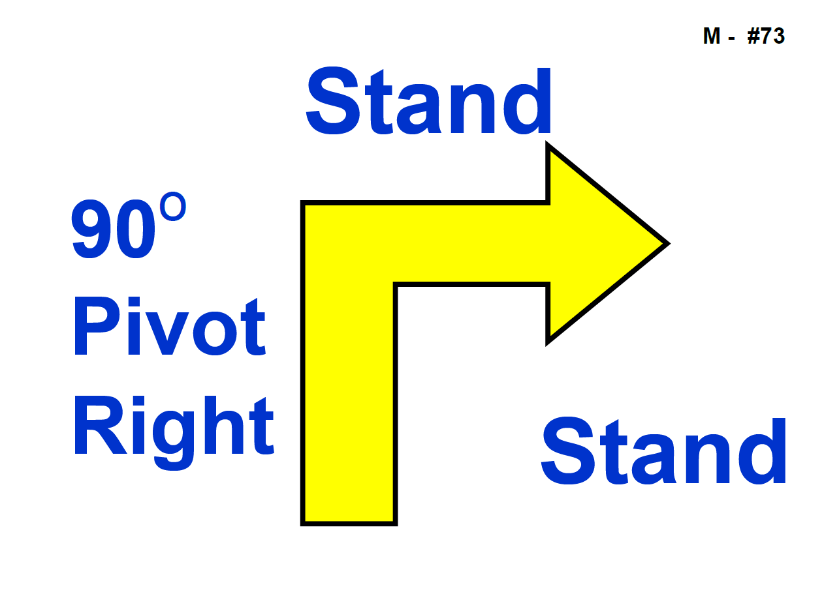

**Rally Rule Change Submission 31**

**Current Rule**

74. Stand – Pivot Left – Forward (Page 29)

The Handler commands and/or signals the dog to Stand as Handler comes to a halt. With the dog standing, the Handler pivots 90º to the left and the dog moves with the Handler. The dog does not sit. The Handler must become stationary before the team heels forward. The Handler is required to pivot by turning in place. (Stationary exercise)

**Proposed Changes**

* 1. Name change of Sign to - **73. Stand – Pivot Left– Stand**

* 2. Change of sign Image to reflect the sign name amendment

**Rationale**

The current name of this sign is confusing for handlers. It is a progression from the Advanced   
38. Halt - 90° Pivot Left - Halt, the only difference is this sign is performed in at stand. The word “forward” raises many questions, the forward is only part of the exercise to heel toward the next station. Stand, Pivot Left, Stand is the exercise.

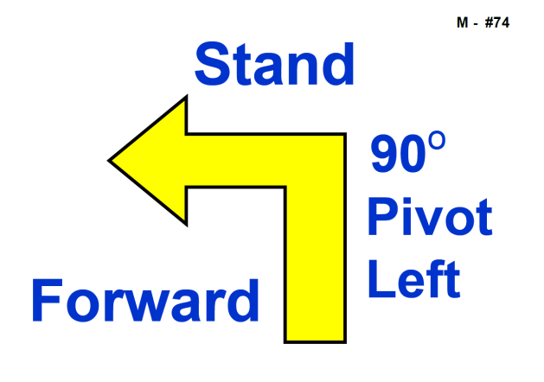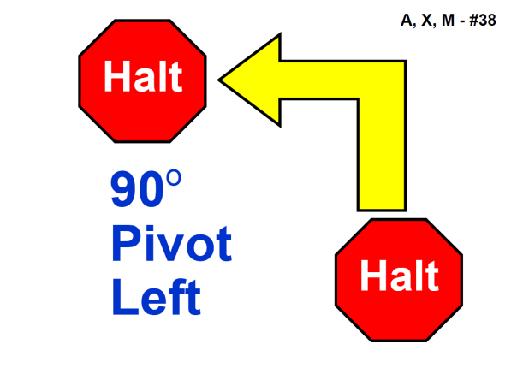

**PROPOSED SIGN IMAGE**

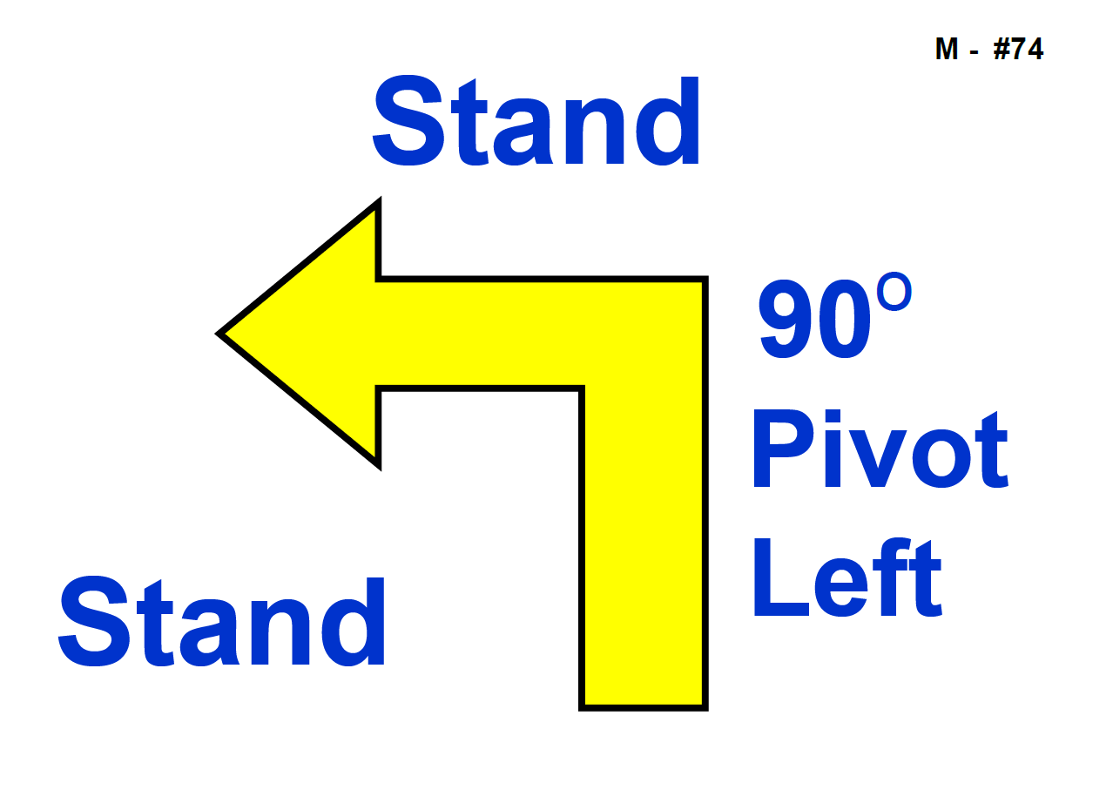

**Rally Rule Change Submission 32**

**Current Rule**

Sign 76. 180 Turn Left – Heel on Right – 180 Turn Right (page 29)

The Handler, whilst moving, signals the dog to complete a 180 degree turn to the left, at the same time turning 180 (left) toward the dog. The dog is to 'heel' on the right for a minimum of three steps. The Handler then signals the dog to turn 180 to the right, at the same time turning 180 to the right. Dog is returned to heel position.

**Proposed Change**

Sign 76. 180 Turn Left – Heel on Right – 180 Turn Right

The Handler, whilst moving, signals the dog to complete a 180 degree turn to the left, at the same time turning 180 (left) toward the dog. The dog is to 'heel' on the right for a minimum of **three steps** **of the handler**. The Handler then signals the dog to turn 180 to the right, at the same time turning 180 to the right. Dog is returned to heel position.

**Rationale**

Change to “three steps of the handler…” The description of the sign is unclear, is the handler to make 3 steps, or the dog?

Handler is concentrating on the dog moving in the forward position, it is much easier to make this wording consistent across the signs which require steps of the handler, and not the dog.

Example of similar

72. Backup 3 Steps - Whilst heeling, the *Handler reverses direction walking backward at least 3 steps*, without first stopping, then continues heeling forward. The dog moves backward parallel to the Handler and must maintain heel position throughout the exercise without sitting or turning its

body to face the Handler.

**Rally Rule Change Submission 33**

**JUDGING PROCEDURES**

**CURRENT RULE (Page 12):**

**Certificates:** A Rally Trial Certificate, signed by the Judge, showing the total number of points awarded, must be available to each qualifying exhibit in each Class.

**PROPOSED RULE:**

**Certificates**: A Rally Trial Certificate, **bearing the name of the Judge**, showing the total number of points awarded, must be available to each qualifying exhibit in each Class.

**RATIONALE:**

There has been a marked increase in the use of technology by both exhibitors and club officials in the running of not only Clubs but the events they hold. Schedules, entries, catalogues, exhibit cards and results are now commonly available on a number of increasingly sophisticated online sites. This has greatly reduced the workload which has been falling on a dwindling number of organisers within club affiliates.

Where it is possible for certificates to be produced and/or issued electronically Member Bodies should be able to take advantage of time and cost savings to their affiliates conducting trials.

* * * END * * *