**2025 NOTC MTG - ATTACHMENT 7c - DOGS QLD - RALLY RULES REVIEW SUBMISSIONS 2024**

**QUEENSLAND RALLY RULES REVIEW SUBMISSIONS 2024**

**(QLD) OLD RULE**

**TITLES**

Only the highest Rally Title awarded to the dog will be used after the name of the dog or in the case of Rally Champion before the name of the dog. However Rally Advanced Excellent (RAE) and Rally Master (RM) Titles may appear together after the name of the dog.

Applications for RN, RA, RE, and RAE titles must be lodged indicating qualifying scores under at least two (2) different Judges.

Applications for RM and R Ch titles must be lodged indicating qualifying scores under at least three (3) different Judges.

The Member Body will receive applications for the title “Dual Champion” in connection with each dog which, having gained its title of Conformation Ch. and Rally Champion (R. Ch.)

**Class Titles and Qualifying Performance:**

All dogs eligible to be entered in Rally Trials in accordance with these Rules shall be eligible to receive Class Title Certificates upon qualification and application.

The Member Body will receive applications for the use of the letters:

**R.N.** – signifying Rally Novice - Three (3) qualifying scores of **75** points or more must be earned under at least two different Judges in Novice class to earn a title.

**R.A.** – signifying Rally Advanced - Three (3) qualifying scores of **80** points or more must be earned under at least two different judges in Advanced Class to earn a title.

**R.E.** – signifying Rally Excellent - Five (5) qualifying scores of **80** points or more must be earned under at least two different Judges in Excellent class to earn a title.

**R.A.E**. – signifying Rally Advanced Excellent - To qualify for the title of RAE a dog and Handler team must receive a minimum of five (5) qualifying scores, in both the Rally Advanced and Rally Excellent Classes at the same trial, of **80** points or more out of a possible perfect score of 100, under at least two different Judges.

All qualifications gained in the Advanced B and Excellent B Classes towards an R.A.E. Title that were gained prior to 1st January 2021 will remain valid. From 1st January 2021 any additional qualifying scores required for an R.A.E. Title will be gained from the Advanced & Excellent Classes at the same trial.

**R.M.** – signifying Rally Master - Seven (7) qualifying scores of **85** points or more must be earned under at least three different judges in Master class to earn a title.

**R. CH** - signifying Rally Champion **-** Upon having been granted the Rally Master Title, in order to receive the R.CH Title, a dog must qualify a further ten (10) times with qualifying scores of **90** or more points in the Rally Master Class under at least (3) different Judges.

Applications for all titles must be accompanied by the prescribed fee (where applicable) and, upon approval, a Certificate will be issued to the applicant authorising the use of the letters concerned.

**NOTES:** An Exhibit which has gained sufficient awards to qualify for the title of RN, RA, or RE shall NOT be eligible to compete in a higher class at a Rally Trial until such time as the owner/s have lodged an application for recognition of the title with the Member Body in the State or Territory in which the registered owner/s reside.

**(QLD) NEW RULE**

**TITLES**

Only the highest Rally Title awarded to the dog will be used after the name of the dog or in the case of Rally Champion before the name of the dog. However, Rally Advanced Excellent (RAE) and Rally Master (RM) Titles may appear together after the name of the dog.

Applications for RN., R.I., R.A., R.E., and R.A.E. titles must be lodged indicating qualifying scores under at least two (2) different Judges.

Applications for R.M. and R. CH. titles must be lodged indicating qualifying scores under at least three (3) different Judges.

The Member Body will receive applications for the title “Dual Champion” in connection with each dog which, having gained its title of Conformation Ch. and Rally Champion (R. CH.)

**Class Titles and Qualifying Performance:**

All dogs eligible to be entered in Rally Trials in accordance with these Rules shall be eligible to receive Class Title Certificates upon qualification and application.

The Member Body will receive applications for the use of the letters:

**R.N.** – signifying Rally Novice - Three (3) qualifying scores of **75** points or more must be earned under at least two different Judges in Novice class to earn a title.

**R.I.** – Signifying Rally Intermediate – Three (3) qualifying scores of **80** points or more must be earned under at least two different Judges in Intermediate class to earn a title.

**R.A.** – signifying Rally Advanced - Three (3) qualifying scores of **80** points or more must be earned under at least two different judges in Advanced Class to earn a title.

**R.E.** – signifying Rally Excellent - Five (5) qualifying scores of **80** points or more must be earned under at least two different Judges in Excellent class to earn a title.

**R.A.E**. – signifying Rally Advanced Excellent - To qualify for the title of RAE a dog and Handler team must receive a minimum of five (5) qualifying scores, in both the Rally Advanced and Rally Excellent Classes at the same trial, of **80** points or more out of a possible perfect score of 100, under at least two different Judges.

All qualifications gained in the Advanced B and Excellent B Classes towards an R.A.E. Title that were gained prior to 1st January 2021 will remain valid. From 1st January 2021 any additional qualifying scores required for an R.A.E. Title will be gained from the Advanced & Excellent Classes at the same trial.

**R.M.** – signifying Rally Master - Seven (7) qualifying scores of **85** points or more must be earned under at least three different judges in Master class to earn a title.

**R. CH.** - signifying Rally Champion **-** Upon having been granted the Rally Master Title, in order to receive the R.CH Title, a dog must qualify a further ten (10) times with qualifying scores of **90** or more points in the Rally Master Class under at least (3) different Judges.

Applications for all titles must be accompanied by the prescribed fee (where applicable) and, upon approval, a Certificate will be issued to the applicant authorising the use of the letters concerned.

**NOTES:** An Exhibit which has gained sufficient awards to qualify for the title of R.N., R.A., or R.E. shall NOT be eligible to compete in a higher class at a Rally Trial until such time as the owner/s have lodged an application for recognition of the title with the Member Body in the State or Territory in which the registered owner/s reside.

**Rationale**

This is a new class to bridge the gap between Novice and Advanced. Presently there are 3 extra levels of skills required for the move from Novice to Advanced. Currently, the dog and handler are required to go Off Lead; to perform more difficult stations; and to perform more stations in progressing from Novice to Advanced. All other classes progress with only 2 increases in skills required being: more difficult stations and more stations in total.

Please see in ‘CLASSES’ for what this class could look like.

**(QLD) NEW RULE**

**Rally Masters R.M.- Multiplier suffixes** may be awarded for multiples of seven (7) Certificates gained with qualifying scores of **85** points or better and must be earned under at least three different judges in Master class to earn a title e.g. 21 Rally Masters qualifications is equal to RM 3.

**Rationale for Rally Masters Multiplier suffixes:**

Rally is a dog competition open to all dogs and handlers. The sport requires a good rapport between dog and Handler.

The aim of this competition is for a Handler to direct his dog around a course of different obstacles to assess and enhance the ability of the dog and Handler to work as a team. It is an educational and sporting activity intended to improve the dog's integration into society.

This will encourage a continued graded progression through the sport.

To encourage continued participation of current and future competitors and the continuance of Rally as a unique canine discipline.

To encourage an increased level of fitness for dog and Handler.

To encourage safe and pleasant competition for all.

To have Rally Masters R.M.- Multiplier suffixes will align with other ANKC Disciplines such as in Agility where ADM/JDM and ADE/JDE can be applied for multiplier suffixes.

**SUBMISSION 1**

**(QLD) NEW RULE**

**Rally Grand Champion Title:**

The Member Body will receive applications for the title of RALLY GRAND CHAMPION (R.GR.CH.) in connection with each dog, which has gained its Rally Masters Title (R.M.) and Rally Champion Title (R.CH.) and thereafter gains a further ten (10) qualifying scores of 95 points or better in the Rally Masters Class under at least three (3) different Judges.

The Member Body will, upon approval of such Title and payment of the prescribed fee, issue to the applicant an Australian National Kennel Council Ltd RALLY GRAND CHAMPION Certificate. The title of RALLY GRAND CHAMPION ‘R.GR.CH.' is to appear before the name of the dog.

**Rationale for Rally Grand Champion:**

Grand Champion will provide a continued graded progression through the sport in which the dog must consistently perform to a higher standard.

It will also encourage continued participation of current and future competitors and the continuance of Rally as a unique canine discipline.

This will align Rally with other ANKC Disciplines which already provide a Grand Champion title as part of their sport. Rally has been going successfully for enough time to warrant this progression of titles.

**SUBMISSION 2**

**(QLD) NEW RULE**

**Rally Grand Champion Title:**

The Member Body will receive applications for the title of RALLY GRAND CHAMPION (R.GR.CH.) in connection with each dog, which has gained its Rally Masters Title (R.M.) and Rally Champion Title (R.CH.) and thereafter gains a further five (5) qualifying scores of 95 points or better in the Rally Masters Class under at least three (3) different Judges.

The Member Body will, upon approval of such Title and payment of the prescribed fee, issue to the applicant an Australian National Kennel Council Ltd RALLY GRAND CHAMPION Certificate. The title of RALLY GRAND CHAMPION ‘R.GR.CH.' is to appear before the name of the dog.

**Rationale for Rally Grand Champion :**

Grand Champion will encourage a continued graded progression through the sport.

To encourage continued participation of current and future competitors and the continuance of Rally as a unique canine discipline.

This will align Rally with other ANKC Disciplines which already provide a Grand Champion title as part of their sport. Rally has been going successfully for enough time to warrant this progression of titles.

**SUBMISSION 3**

**(QLD) NEW RULE**

**Rally Grand Champion Title:**

The Member Body will receive applications for the title of RALLY GRAND CHAMPION (R.GR.CH.) in connection with each dog, which has gained its Rally Masters Title (R.M.) and Rally Champion Title (R.CH.) and thereafter gains a further five (5) qualifying scores of 90 points or better in the Rally Masters Class under at least three (3) different Judges.

The Member Body will, upon approval of such Title and payment of the prescribed fee, issue to the applicant an Australian National Kennel Council Ltd RALLY GRAND CHAMPION Certificate. The title of RALLY GRAND CHAMPION ‘R.GR.CH.' is to appear before the name of the dog

**Rationale for Rally Grand Champion :**

Rally is a dog competition open to all dogs and handlers. The sport requires a good rapport between dog and Handler.

The aim of this competition is for a Handler to direct his dog around a course of different obstacles to assess and enhance the ability of the Dog and Handler to work as a team. It is an educational and sporting activity intended to improve the dog's integration into society.

This will encourage a continued graded progression through the sport.

To encourage continued participation of current and future competitors and the continuance of Rally as a unique canine discipline.

To encourage an increased level of fitness for dog and Handler.

To encourage safe and pleasant competition for all.

This will align Rally with other ANKC Disciplines for example : ANKC Obedience where they can apply for the title of OBEDIENCE GRAND CHAMPION (O.GR.CH.) in connection with each dog, which has gained its Obedience Champion Title (O.CH.) and its Utility Dog Excellent (U.D.X.)Title and thereafter gains a further five (5) scores in the Utility Dog Excellent ring with earning the same points value qualifying score as which they achieved for their Obedience Champion Title (O.Ch) Title under at least three different Judges.

Dances with Dogs Freestyle Grand Champion/Heelwork to Music Grand Champion in connection with, and before the name of, each dog which has gained its FS.Ch or HTM.Ch title respectively and thereafter gains a further five (5) Qualifying Certificates in the Advanced class in the relevant division, earning qualifying aggregate scores, under at least two (2) different Judging Panels.

**(QLD) OLD RULE**

***Rally Novice Class – R.N.***

**Rally Novice**

For Dogs six months of age or over and of either sex which are not eligible for the title of Rally Novice (RN). Under no circumstances except where an application for a RN Title has been rejected on a technicality, shall a dog which has competed in a Rally Advanced A Class be eligible to compete in the Rally Novice Class.

**(QLD) NEW RULE**

***Rally Novice Class – R.N.***

**Rally Novice**

For Dogs ~~six~~ twelve months of age or over and of either sex which are not eligible for the title of Rally Novice (RN). Under no circumstances except where an application for a RN Title has been rejected on a technicality, shall a dog which has competed in a Rally Advanced A Class be eligible to compete in the Rally Novice Class.

**RATIONALE:**

A dog must be a minimum of twelve (12) months of age to enter in a Rally Trial.

The education of dog breeding, psychology, growth and behaviour is more available to consumers today.

Education on the welfare of dogs, including their growth patterns, their mental abilities, and their physicality, gives proof that we should not put stress on the dog’s mental ability or physical structure until the growth plates have occurred.

Dogs Australia should be promoting the welfare and care of our dogs so that they have a long and healthy life.

**(QLD) OLD RULE**

**CLASSES**

All classes must be available for competition at the Trial and included on the Trial Schedule unless special permission is granted by the Member Body. No classes other than the following shall be provided or withdrawn without the special permission of the Member Body. Qualifications up to and including the date of closing of entry shall count as eligibility to compete in any class.

***Rally Novice Class – R.N.***

**Rally Novice**

For Dogs six months of age or over and of either sex which are not eligible for the title of Rally Novice (RN). Under no circumstances except where an application for a RN Title has been rejected on a technicality, shall a dog which has competed in a Rally Advanced A Class be eligible to compete in the Rally Novice Class.

All exercises are judged on lead.

Rally Novice must have between ten (10) – fifteen (15) stations (start and finish not included);

no more than five (5) stationary exercises.

***Rally Advanced Class – R.A.***

**Rally Advanced**

This class shall be for dogs that have qualified for the Rally Novice (RN) Title.

All exercises are judged off lead.

Rally Advanced must have between twelve (12) – seventeen (17) stations (start & finish not included) and use a minimum of 3 to a maximum of 10 stationary exercises; and requires one jump. Courses shall have a minimum of 4 Advanced level stations, including the jump.

***Rally Excellent Class – R.E.***

**Rally Excellent**

This class shall be for dogs that have qualified for the Rally Advanced (RA) Title.

All exercises are judged off lead.

The Excellent class must have fifteen (15) - twenty (20) stations (not including Start and Finish) and use a minimum of 3 to a maximum of 10 stationary exercises and requires two jumps (not consecutive). Courses shall have a minimum of 6 Advanced level stations and a minimum of 4 Excellent level stations, including the jumps.

Jumps may be a Broad Jump, Solid Jump, Bar Jump.

A station consists of a single jump.

One or two types of jump may be used on the course.

A single jump may be used in two stations.

Jumps must not be used consecutively on the course.

***Rally Master Class – R.M.***

**Rally Master**

This class shall be for dogs that have qualified for the Rally Excellent Title (R.E.).

All exercises are judged off lead and there will be no jumps in this class.

Rally Master must have between eighteen (18) and twenty four (24) stations (start and finish not included) with no more than ten (10) stationary exercises. The course must contain a minimum of 4 Excellent and 3 Master Class stations.

**(QLD) NEW RULE**

**CLASSES**

All classes must be available for competition at the Trial and included on the Trial Schedule unless special permission is granted by the Member Body. No classes other than the following shall be provided or withdrawn without the special permission of the Member Body. Qualifications up to and including the date of closing of entry shall count as eligibility to compete in any class.

***Rally Novice Class – R.N.***

**Rally Novice**

For Dogs six months of age or over and of either sex which are not eligible for the title of Rally Novice (RN). Under no circumstances except where an application for a RN Title has been rejected on a technicality, shall a dog which has competed in a Rally Advanced A Class be eligible to compete in the Rally Novice Class.

All exercises are judged on lead.

Rally Novice must have between ten (10) – fifteen (15) stations (start and finish not included); no more than five (5) stationary exercises.

***Rally Intermediate Class – R.I.***

This class shall be for dogs that have qualified for the Rally Novice (R.N.) Title.

All exercises are judged on lead.

Rally Intermediate must have between twelve (12) – seventeen (17) stations (start and finish not included) and use a minimum of three (3) to a maximum of ten (10) stationary exercises; Courses shall have a minimum of three (3) Advanced level stations. Stations are to be drawn from the Novice and Advanced levels, with the exception of stations 46, 51 and 53 which are not to be used in this level.

***Rally Advanced Class – R.A.***

**Rally Advanced**

This class shall be for dogs that have qualified for the ~~Rally Novice (RN)~~ Rally Intermediate Title.

All exercises are judged off lead.

Rally Advanced must have between twelve (12) – seventeen (17) stations (start & finish not included) and use a minimum of 3 to a maximum of 10 stationary exercises; and requires one jump. Courses shall have a minimum of 4 Advanced level stations, including the jump.

***Rally Excellent Class – R.E.***

**Rally Excellent**

This class shall be for dogs that have qualified for the Rally Advanced (RA) Title.

All exercises are judged off lead.

The Excellent class must have fifteen (15) - twenty (20) stations (not including Start and Finish) and use a minimum of 3 to a maximum of 10 stationary exercises and requires two jumps (not consecutive). Courses shall have a minimum of 6 Advanced level stations and a minimum of 4 Excellent level stations, including the jumps.

Jumps may be a Broad Jump, Solid Jump, Bar Jump.

A station consists of a single jump.

One or two types of jump may be used on the course.

A single jump may be used in two stations.

Jumps must not be used consecutively on the course.

***Rally Master Class – R.M.***

**Rally Master**

This class shall be for dogs that have qualified for the Rally Excellent Title (R.E.).

All exercises are judged off lead and there will be no jumps in this class.

Rally Master must have between eighteen (18) and twenty four (24) stations (start and finish not included) with no more than ten (10) stationary exercises. The course must contain a minimum of 4 Excellent and 3 Master Class stations.

**Rationale**

This class would provide a logical progression from Novice to Advance. It requires the dog/handler team to learn more difficult stations and perform on a longer course without adding the off lead or jumping component. The Advance would still introduce new stations i.e. the Recall, Stay and Jump in addition to being off lead. This brings the progression into line with the other class progressions introducing 2 new skills at each level.

**(QLD) OLD RULE**

**Rings**

Unless special permission of the Member Body is obtained, the minimum size of an outdoor ring must be fifteen (15) metres by forty five (45) metres**.** If the trial is held indoors the ring shall be a minimum of fifteen (15) metres by thirty (30) metres**.** Where possible rings will have an entry and an exit gate. The non-slip floor covering or ground surface must be the same as would be suitable for an ANKC Ltd Obedience Trial.

**(QLD) NEW RULE**

**RINGS**

Unless special permission of the Member Body is obtained, the minimum size of an outdoor ring must be fifteen (15) metres by forty five (45) metres, with at least two (2) metres around the perimeter of the ring**.** If the trial is held indoors the ring shall be a minimum of fifteen (15) metres by thirty (30) metres, with at least one (1) metre around the perimeter of the ring**.** Where possible rings will have an entry and an exit gate. The non-slip floor covering or ground surface must be the same as would be suitable for an ANKC Ltd Obedience Trial.

**Rationale**

Currently there is no minimum distance between rings specified in the rules. Obedience has a recommendation of 2 metres, as do Tricks and Agility is 3 metres around rings.

As the rules currently stand 2 rings could share a boundary, which is definitely a concern with dogs potentially walking directly towards each other and being expected to pass each other shoulder to shoulder. We recognise that dogs need a reasonable distance from each other to feel safe as evidenced by giving 2.5m for stays in Obedience. It is therefore, in terms of safety, not reasonable to expect dogs, especially those in Novice, to move directly towards and to pass so close to another dog and maintain their attention on their handler, as could happen with the absence of this amendment

**(QLD) OLD RULE**

**Entering and Leaving the Ring:**

On the Steward's call of the dog's catalogue number, the Handler will enter the Ring and take up position at the "Start Station”. All dogs must enter and leave the ring on lead. In Exercises that require a dog to be off lead, the lead will be taken off upon instruction from the judge and handed to the Steward.

**(QLD) NEW RULE**

**Entering and Leaving the Ring:**

On the Steward's call of the dog's catalogue number, the Handler will enter the Ring and take up position at the "Start Station”. All dogs must enter and leave the ring on lead. In Exercises that require a dog to be off lead, the lead will be taken off upon instruction from the judge and ~~handed to the Steward~~ placed securely on the handler’s person. If the lead is dropped on the ground during the run, the team will incur a ten (10) point deduction.

**Consequential changes**

The list of deductions under **Scoring (all Classes)** and the **Score Sheet – Individual** will be required to be updated to include the ten (10) point deduction – Handler dropping the lead.

**Rationale -** The requirement for the Handler to hold on to the lead was brought in during COVID as a temporary rule. It has been successful in operation and there is a desire to make it permanent. It means the Handler has the lead ready in case there is an incident and does not have to rely on the Steward to return the lead or collect the dog. The ten (10) point deduction is because a dropped lead can be a safety hazard and a distraction to both Handler and dog.

**(QLD) OLD RULE**

**Retry:**

Where a team attempts a station and fails to perform the elements of the station correctly on the first attempt, the Handler may choose to retry that station with a three (3) point deduction. The Handler must clearly indicate to the Judge that they are about to retry the station. The station must be retried immediately, in its entirety in the correct position in relation to the station sign.

**(QLD) NEW RULE**

**Retry:**

Where a team attempts a station and fails to perform the elements of the station correctly on the first attempt, the Handler may choose to retry that station with a three (3) point deduction. The Handler must clearly indicate to the Judge that they are about to retry the station. The station must be retried immediately, in its entirety in the correct position in relation to the station sign, including the heeling from the previous station.

**Rationale -** There are several exercises that require movement (heeling) at the start or leading into the exercise. Therefore, that heeling should also be judged during a retry and following on, for consistency, all retries should start from the previous sign.

**(QLD) OLD RULE**

***Collars and Leads:***

The minimum length of lead will be 750 mm and it will be fitted with a quick release fastener. The lead must be made of fabric or leather and must be long enough to provide adequate slack. All dogs must have a slip or fixed collar which fits loosely around only the dog's neck and which must remain on the dog at all times.

**(QLD) NEW RULE**

***Collars and Leads:***

The minimum length of lead will be 750 mm and it will be fitted with a quick release fastener for the Novice Class. All other classes may have a lead fitted with a quick release fastener or be a slip lead. The lead must not be made of ~~fabric or leather~~ chain and must be long enough to provide adequate slack. All dogs must have a slip or fixed collar which fits loosely around only the dog's neck and which must remain on the dog at all times.

**Rationale**

Leads are removed in all classes except Novice. For dogs with long hair, it often takes quite some time to find the collar and attach the lead. It would be simpler to slip a lead over the dog’s head. The dog would still need to wear a collar.

These days leads are often made of many materials, biothane being one. Under the current rules these would not be allowed as they are not made of material or leather. I believe the original intent was for the leads to not be chain leads as these could hurt handler’s hand.

**(QLD) OLD RULE**

**Scores:**

**Non-qualifying (NQ) scores shall be given for:**

- Handler error

**(QLD) NEW RULE**

**REMOVE:**

**Scores:**

**Non-qualifying (NQ) scores shall be given for:**

~~- Handler error~~

**RATIONALE:**

The Handler error deduction is contradictory in the rules as the same descriptor is in both the 1-10 point penalty and non-qualifying penalty. It is proposed that it be removed as a non-qualifying penalty.

**Consequential Change**

Remove from Score sheet

**(QLD) OLD RULE**

**APPENDIX A**

***Appendix A - Rally Signs & Explanations:***

General Regulations:

• Heeling is from sign to sign in a continuous performance. Heeling from sign to sign is Judged. A minimum deduction will be one point.

• Handlers may praise and pat their dogs, repeating commands and signals if necessary.

• The Novice Class is performed on lead, using exercises 1 - 32. It consists of 10-15 stations (not including Start and Finish), with a maximum of 5 stationary exercises.

• The Advanced Class is performed off lead, using exercises 1 - 53. It consists of 12-17 stations (not including Start and Finish) with a minimum of 3 to a maximum of 10 stationary exercises. Courses shall have a minimum of 4 Advanced level stations, including one jump.

• The Excellent Class is performed off lead using exercises 1 - 65. It consists of 15-20 stations (not including Start and Finish) with a minimum of 3 to a maximum of 10 stationary exercises. Courses shall have a minimum of 6 Advanced level stations and a minimum of 4 Excellent level stations including two jumps.

• The Master Class is performed off lead using exercises 1 - 76. It consists of 18 – 24 stations (not including Start and Finish) with no more than 10 stationary exercises. The course must contain a minimum of 4 Excellent level stations and 3 Master level stations.

• Exercises marked with an asterisk (*) may be used more than once on a Rally course.

• Scoring – Each team begins with 100 points.

• The performance is timed.

The following exercises may be used in Novice, Advanced, Excellent and Master Classes:

**(QLD) NEW RULE – Consequential Change**

**APPENDIX A**

***Appendix A - Rally Signs & Explanations:***

General Regulations:

• Heeling is from sign to sign in a continuous performance. Heeling from sign to sign is Judged. A minimum deduction will be one point.

• Handlers may praise and pat their dogs, repeating commands and signals if necessary.

* The Novice Class is performed on lead, using exercises 1 - 32. It consists of 10-15 stations (not including Start and Finish), with a maximum of 5 stationary exercises.
* The Intermediate Class is performed on lead, using exercises 1 – 52 with the exception of 46 and 51. It consists of 12 -17 stations (not including Start and Finish) with a minimum of 3 to a maximum of 10 stationary exercises. Course shall have a minimum of 3 Advanced level stations.

• The Advanced Class is performed off lead, using exercises 1 - 53. It consists of 12-17 stations (not including Start and Finish) with a minimum of 3 to a maximum of 10 stationary exercises. Courses shall have a minimum of 4 Advanced level stations, including one jump.

• The Excellent Class is performed off lead using exercises 1 - 65. It consists of 15-20 stations (not including Start and Finish) with a minimum of 3 to a maximum of 10 stationary exercises. Courses shall have a minimum of 6 Advanced level stations and a minimum of 4 Excellent level stations including two jumps.

• The Master Class is performed off lead using exercises 1 - 76. It consists of 18 – 24 stations (not including Start and Finish) with no more than 10 stationary exercises. The course must contain a minimum of 4 Excellent level stations and 3 Master level stations.

• Exercises marked with an asterisk (*) may be used more than once on a Rally course.

• Scoring – Each team begins with 100 points.

• The performance is timed.

The following exercises may be used in Novice, Intermediate, Advanced, Excellent and Master Classes:

**Rationale**

The new class Rally Intermediate will use the Rally Advanced stations, with the exception, of the Recall Station (46), the Stay and Return Station (51) and the Handler Passes by (Jump Station 53). All other stations can be performed safely on lead. The length of course and difficulty of stations are the same as those for Advanced without the added skill of being off lead. As such it provides a logical progression from Novice to Advanced.

Although a new class, it would require very little change to go from Advanced to Intermediate or vice versa for course changes and therefore add very little time to the running of a trial. Reducing the minimum number of Advanced Challenges to 3, takes into account that that the 4th challenge in Advanced was the Jump, which has been removed.

Going off lead is often daunting for new handlers and this new class would provide an opportunity to master new signs whilst having the security of a lead. With multiple Rally Trials on the same weekend, it is quite possible for a dog/handler team to gain their Novice title in a couple of weekends, leaving them to currently go off lead, learn new signs, maintain connection for longer and add in a jump.

As dogs can start competing at 6 months, it is quite possible for a dog to gain its Novice title soon after 6 months and then be expected to start jumping. This is not desirable for young dogs. This new class allows them to remain competing without the jumping.

**(QLD) OLD RULE**

**SIGNS**

**ADVANCED**

**50.** **Call front, Handler Reverses Three Steps – Finish.** The Handler calls the dog to the front, reverses three steps, with the dog moving with the handler. The dog returns to heel and continues forward without stopping. The dog does not sit during this exercise. The team must maintain continuous motion throughout the turn without partially sitting or stopping.

**(QLD) NEW RULE**

**50. Call front, Handler Reverses Three Steps – Finish** - The Handler calls the dog to the front, reverses at least three steps, with the dog moving with Handler. The dog returns to heel and continues heeling forward without stopping. The dog does not sit during this exercise. The team must maintain continuous motion throughout the turn without partially sitting or stopping.

**Rationale –** This exercise is currently hard to perform and judge – where exactly does the call front finish and the three reversing steps start? In Exercises #13, #14, #15 & #16 the handler “may take several steps backward” to perform the call front. In Exercise #72 the handler “reverses direction walking backward at least 3 steps”. There is differing interpretations of this exercise between various States, therefore adding the wording “at least” will provide consistency with the other exercises mentioned and clarify the differing interpretations.

**(QLD) OLD RULE**

**EXCELLENT**

**64. Circle Spin at Heel –** The dog to complete a circle spin away from the heel position and then to return to heel. The Handler does not stop moving. The team must maintain continuous motion throughout the turn without partially sitting or stopping.

**(QLD) NEW RULE**

**64. Circle Spin at Heel –** The dog to complete a circle spin away from the heel position and then to return to heel. The Handler ~~does~~ should not stop moving. The ~~team~~ dog must maintain continuous motion throughout the turn without partially sitting or stopping.

**Rationale**

For handlers with large dogs, the spin can take some time to complete leaving the dog behind as it completes the spin if the handler continues to move forward. Changing ‘does’ to ‘should; allows for momentary cessation of motion by the handler to either allow the dog to catch up before the next station or for the handler to stay close as the dog completes the spin. An appropriate penalty can then be applied depending on how much the motion of the handler was ceased.

We already have a Station, Station Number 52 Halt-dog Circles Handler, where the Handler ceases movement whilst the dog continues moving, which is considered a moving station and therefore this station would maintain that status.

The principle feature is for the dog to keep moving to complete the spin without stopping.

**(QLD) OLD RULE**

**MASTERS**

**73. Stand – Pivot Right – Forward –** The Handler commands and/or signals the dog to Stand as Handler comes to a halt. With the dog standing, the Handler pivots 90º to the right and the dog moves with the Handler. The dog does not sit. The Handler must become stationary before the team heels forward. The Handler is required to pivot by turning in place. (Stationary exercise)

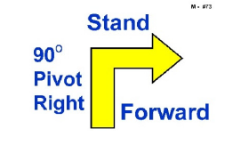

Existing Sign

**(QLD) NEW RULE**

**73. Stand – Pivot Right – ~~Forward~~ Stand –** The Handler commands and/or signals the dog to Stand as Handler comes to a halt. With the dog standing in heel position, the Handler pivots 90º to the right and halts. The dog moves with the Handler. The dog does not sit. ~~The Handler must become stationary before the team heels forward.~~ The Handler is required to pivot by turning in place and must not take any steps forward. (Stationary exercise)

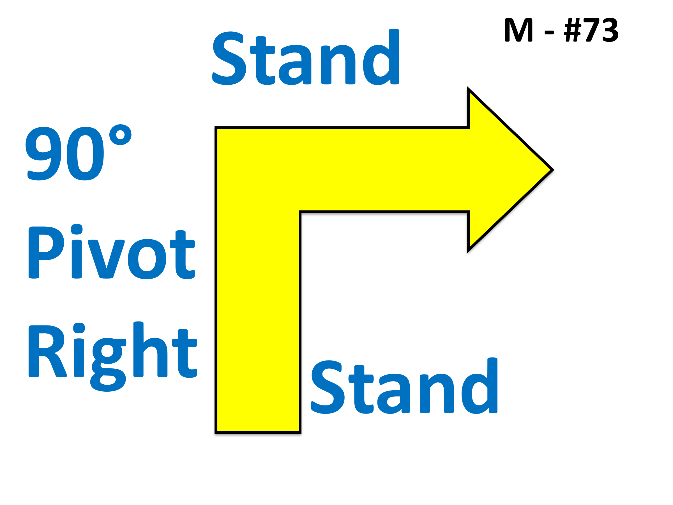

Modified Sign

**Rationale -**To standardise the wording with the sitting pivot turns (#38, #39, #43, #44) as much as possible. The sign only shows one stand which has caused confusion with Handlers not stopping after the turn. The sign should be amended to replace the word “Forward” with the word “Stand”. This will standardise the all the pivot exercises and signs as much as possible.

**(QLD) OLD RULE**

**74. Stand – Pivot Left – Forward –** The Handler commands and/or signals the dog to Stand as Handler comes to a halt. With the dog standing, the Handler pivots 90º to the left and the dog moves with the Handler. The dog does not sit. The Handler must become stationary before the team heels forward. The Handler is required to pivot by turning in place. (Stationary exercise)

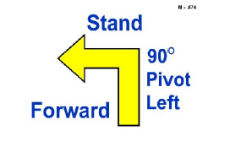

Existing Sign

**(QLD) NEW RULE**

**74. Stand – Pivot Left – ~~Forward~~ Stand –** The Handler commands and/or signals the dog to Stand as Handler comes to a halt. With the dog standing in heel position, the Handler pivots 90º to the left and halts. The dog moves with the Handler. The dog does not sit. ~~The Handler must become stationary before the team heels forward.~~ The Handler is required to pivot by turning in place and must not take any steps forward. (Stationary exercise)

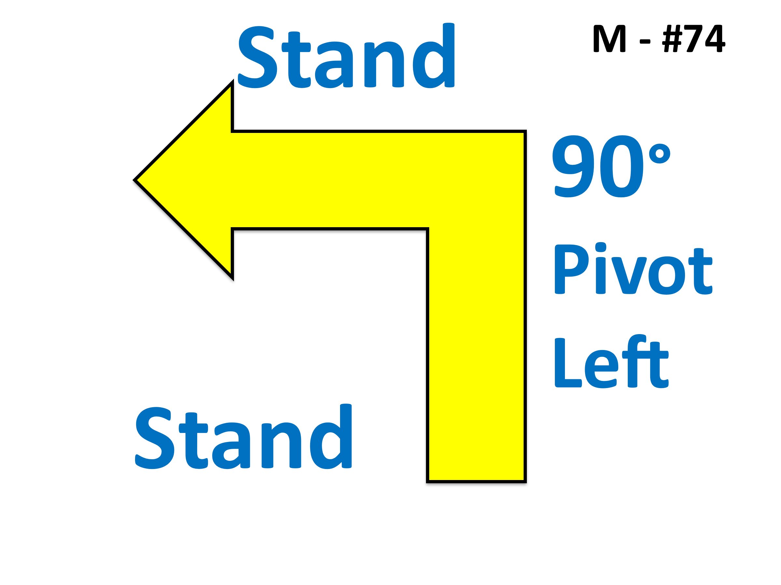

Modified Sign

**Rationale -**To standardise the wording with the sitting pivot turns (#38, #39, #43, #44) as much as possible. The sign only shows one stand which has caused confusion with Handlers not stopping after the turn. The sign should be amended to replace the word “Forward” with the word “Stand”. This will standardise the all the pivot exercises and signs as much as possible.