**2025 NOTC MTG - ATTACHMENT 7b - DOGS WEST - WA Rally Submission doc 3 New Advance and Excellent sign proposals dog circles cone**

MASTERS RALLY SUBMISSION

Advance Rally Submission

-------------------------------------

Rationale: to add more variation to the Advance courses and to increase skills

Masters signs new signs proposal, the cone in these descriptions must be approximately 45cm high this will need to be added to the front of the rule book HALT – DOG CIRCLES CONE – FORWARD

-----------

Advance

The handler halts and without stopping the dog leaves the handler And goes around the back of the cone in a clockwise direction. The

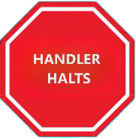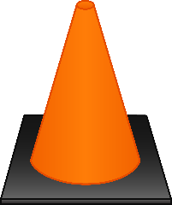

Cone is set 2 metres away. The dog immediately returns to heel and without stopping the dog and handler proceed to the next sign

This station is performed after the sign. The cone is inline with the sign

Excellent Rally submission

HALT – DOG CIRCLES CONE – HALT

New Excellent sign

The handler halts and without stopping the dog leaves the handler And goes around the back of the cone in a clockwise direction. The

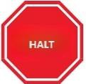

Cone is set 2 metres away. The dog immediately returns to heel position and sits before moving forward with the handler

This station is performed after the sign. The cone is inline with the sign

RATIONALE: Add more variation to the masters courses and continue to increase skills

-------

Excellent